System Requirements Statement (SRS) –

KridaZone

Doc. Ref. :

Version : 0.4

Status : Drafted

Created by : Kenji Tanaka

Date : 04-Dec-2012

1. Introduction 3

2. Functional Requirements 4

2.1 Customer Module 5

2.2 Seller Module 11

2.3 admin Module 17

2.4 message acknoeledgement Module 21

2.5 Use Case Diagram.............................................................................................................................22

THIS DOCUMENT CONTAINS 23 NUMBERED PAGES

# Introduction

This document explains the system requirements and scope for developing KridaZone (Sports Accessories Management System).

KridaZone System could divide the three main parts, Customer part, Seller part and Admin part.

This document describes the system requirement of the Account part.

# Functional Requirements

The Account part of KridaZone System has three modules which are divided 13 processes described as below.

|  |  |  |
| --- | --- | --- |
| **No** | **BRS requirement ID** | **Description** |
| **2.1** | **Customer Module** | |
| **2.1.1** | **F1** | **Account Creation Process** |
| **2.1.2** | **F2** | **Login Process** |
| **2.1.3** | **F3** | **Forgot Password Process** |
| **2.1.4** | **F4** | **Change Password Process** |
| **2.1.5** | **F5** | **Update Account Process** |
| **2.1.6** | **F6** | **Search Product** |
| **2.1.7** | **F7** | **Add To Cart** |
| **2.1.8** | **F8** | **View Cart** |
| **2.1.9** | **F9** | **Confirm Order** |
| **2.1.10** | **F10** | **Order Tracking/Order cancel** |
| **2.1.11** | **F11** | **Payback/ Return** |
| **2.1.12** | **F12** | **Review** |
| **2.2** | **Seller Module** | |
| **2.2.1** | **F16** | **Account Creation Process** |
| **2.2.2** | **F17** | **Login Process** |
| **2.2.3** | **F18** | **Forgot Password Process** |
| **2.2.4** | **F19** | **Change Password Process** |
| **2.2.5** | **F20** | **Update Account Process** |
| **2.2.6** | **F21** | **Search Product** |
| **2.2.7** | **F22** | **Publish Product** |
| **2.2.8** | **F23** | **Update Product** |
| **2.2.9** | **F24** | **Delete Product** |
| **2.2.10** | **F25** | **View Orders** |
| **2.2.11** | **F26** | **Track and Manage Order** |
| **2.2.12** | **F27** | **Read Reviews** |
| **2.2.13** | **F28** | **Payment to Admin** |
| **2.3 Admin Module** | | |
| **2.3.1** | **F29** | **Login Process** |
| **2.3.2** | **F30** | **Forgot Password Process** |
| **2.3.3** | **F31** | **Change Password Process** |
| **2.3.4** | **F32** | **Update Account Process** |
| **2.3.5** | **F33** | **Branded product Categories** |
| **2.3.6** | **F34** | **Report Generation** |
| **2.3.7** | **F35** | **Account Management** |

## Customer Module

* Customer is the user of system who wants to buy the product.

### Account Creation Process

* KridaZone System compels to create the account before using it. So, KridaZone System should provide the function which makes Customer creates new account.
* When Customer creates new account, the function demands information described as below.

1. Login information

* The Login information

The Login information consists of some items described as below.

1. Mobile Number
2. First Name
3. Last Name
4. Password
5. E-mail address
6. User Type
   * All items are compulsory demanded.
   * Mobile Number

* The Mobile Number should be unique 10-digit number. Only 1 account can be registered using 1 mobile number.
  + Password
* The Password has constraints which makes the Password consists of more than or equal 8 and less than or equal 16 characteristics including characters described as below.

1. Numeric figure (at least one)
2. Capital alphabet (A-Z)(at least one)
3. Small alphabet (a-z)(at least one)
4. Special character (#, $, %, &, etc.) (at least one)

* The Password is masked by dummy characters. The re-entering Password is demanded.
* The Password must be encrypted in KridaZone System.
  + User Type

The User Type falls into three categories described as below.

1. Customer
2. Seller
3. Administrator

* The User Type defines also three types of users; "Customer user", "Seller user", and "Administrator user”.
* In an Account Creation Process, the user can select Customer.
* No one could select The Administrator, because Administrator is implemented to KridaZone System in advance.
* The Security Question information

The Security Question information is needed when Customer lost their Password. This information consists of two items described as below.

1. Selected Question
2. Answer
   * All items are compulsory demanded.
   * Some questions which are difficult to answer for anyone else are prepared in advance.

E.g. which color do you like most?

* + A question should be selected from options by the Customer, and the Answer is registered by the Customer.
* Login information should be entered on one screen, and then Customer information and Security Question information should be entered on another screen.

### Login Process

* KridaZone System always compels user authentication before using itself except when a new account is successfully created.
* The user authentication demands Mobile Number and Password. The Mobile Number and the Password should be checked in three ways.
  + First, The Mobile Number and the Password should be existed and correct.
* If The Mobile Number and the Password are not equal to what the user has registered, the user authentication cannot be provided.
  + Second, the User Type linked to the Mobile Number should be "Customer".
* When the User Type is "Customer", then user can be placed on “Customer Home”.
  + Finally, Mobile Number should be available.
* The Administrator can decide whether the Mobile Number is available or suspended – Refer to the SRS of the Admin part.
* If Customer is rejected, user authentication is not provided for system user.
* The Customer account should alive for so long as the duration decided by Admin.
* Only when the three checks are successfully completed, Customer can be placed on respected page.
* The “Customer Home” provides some items described as below.

1. A trigger to logout
2. A trigger to update Account
3. A trigger to Change Password
4. A trigger to Search Product
5. A trigger to View Product
6. A trigger to Add Product to Cart

### Forgot Password Process

* When system user lost their Password, the recovery method should be provided by KridaZone system.

The recovery method is described as below.

* + First, system user enters their Mobile Number for KridaZone System.
  + Next, KridaZone System demands the Answer which has been registered since when the Account was created.
  + Only when the Answer is correct, Customer get the new password by E-mail which also has been registered since when the Account was created.
  + The new password is automatically generated by KridaZone System.
* Of course, the new password should consist of more than or equal 8 and less than or equal 16 characteristics including at least a numeric figure, a capital alphabet, a small alphabet, and a special character.
* As a consequence, The Customer could get the Customer authentication using the new password.
  + Then, the Customer had better change the new password manually.
* If the Answer is not correct, otherwise, the correct Answer is demanded for user again.
  + In that case, Of course, Customer couldn’t get the new password.

### Change Password Process

* When Customer wants to change their Password, the measure should be provided by KridaZone System.
* Therefore, KridaZone System should provide the function which is available after getting the Customer authentication.
* The function demands the current password and the new password.
  + Of course, the new password should consist of more than or equal 8 and less than or equal 16 characteristics including at least a numeric figure, a capital alphabet, a small alphabet, and a special character.
  + The current password and the new password are masked by using dummy characters.
  + The new password is demanded to enter twice to avoid a typing error.
* Only when the current password is correct, Customer could change their Password.
* When the current password is changed into new password, KridaZone System compels user authentication again.

### Update Account Process

* KridaZone System should provide the function which makes the account updated for Customer.
* The information Customer could update is described below.

1. Login information
2. User information
3. Security Question Information

* The Login information

The updatable items as described below.

1. First Name
2. Last Name
3. E-mail address
   * All items are compulsory demanded, but updating is optional.

* The User information

The updatable items as described below.

1. User Name
2. User Phone No
3. E-mail address
4. Permanent address
   * All items are compulsory demanded, but updating is optional.

* The Security Question information

The updatable items as described below.

1. Selected Question
2. Answer
   * All items are compulsory demanded, but updating is optional.

### Search product

* Search conditions are described as below.

1. Product category
2. Price

### Add To Cart

* Customer can add the product to cart they want to buy.

### View Cart

* View Cart consists of
  1. Product name
  2. Price
  3. Product category
  4. Quantity
  5. Photo
* Customer can remove the product added to cart
* Customer can add quantity of the product

### Confirm Order

* Confirm Order defines available shipping methods and associated costs.
* Customer need to provide address.
* Specify the types of payment methods –

1. Credit cards
2. Debit Cards
3. UPI
4. Pay on Delivery

### Order Tracking and Order Cancel

* Order tracking specifies the information about the product delivery status
  1. Order status
  2. Estimated delivery date
  3. Tracking order
* Order cancel defines the timeframe within customer can cancel order.

### Payback/Return

* Return provides the eligibility criteria for returning product (e.g., timeframe, product condition).
* Define the return process (e.g., initiation process, return shipping instructions).
* Payback specify the options for providing refunds (e.g., original payment method, store credit).

### Review

• provides customer to add reviews and rating of the product they purchased.

#### Seller Module

### Account Creation Process

* KridaZone System compels to create the account before using it. So, KridaZone System should provide the function which makes Seller creates new account.
* When Seller creates new account, the function demands four information described as below.

1. Login information

2.Contact Details

3.Security Question Information

4.Payment information.

* The Login information

The Login information consists of some items described as below.

5.UserID

6.Password

7.First Name

8.Last Name

9.E-mail address

10.User Type

* + All items are compulsory demanded.
  + UserID
* The UserID should be unique. If the UserID correspond with not case-sensitive to other which is previously registered, the UserID should not be registered as an account.
  + Password
* The Password has constrains which makes the Password consists of more than or equal 8 and less than or equal 16 characteristics including characters described as below.

1.Numeric figure (at least one)

2.Capital alphabet (A-Z)(at least one)

3.Small alphabet (a-z)(at least one)

4.Special character (#, $, %, &, etc.) (at least one)

* The Password is masked by dummy characters. The re-entering Password is demanded.
* The Password must be encrypted in KridaZone System.
  + User Type

The User Type falls into three categories described as below.

1.Customer

2.Seller

3.Administrator

* The User Type defines also three types of user; " Seller user", "Seller user", and "Administrator user”.
* In an Account Creation Process, the user can select Seller.
* No one could select The Administrator, because Administrator is implemented to KridaZone System in advance.
* Contact Details
* The Contact Detail consists of some items described as below.

1.Permanent Address

2.Contact Phone No

* + All items are compulsory demanded.
  + Permanent Address
* Permanent Address should be filled.
* But only the state should be selected from options.
* The Security Question information

The Security Question information is needed when Seller lost their Password. This information consists of two items described as below.

1. Selected Question
2. Answer
   * All items are compulsory demanded.
   * Some questions which are difficult to answer for anyone else are prepared in advance.

E.g. which color do you like most?

* + A question should be selected from options by the Seller, and the Answer is registered by the Seller.
* Login information should be entered on one screen, and then Seller information and Security Question information should be entered on another screen.

### Login Process

* KridaZone System always compels Seller authentication before using itself except when a new account is successfully created.
* The user authentication demands UserID and Password. The UserID and the Password should be checked in three ways.
  + First, The UserID and the Password should be existed and correct.
* If The UserID and the Password are not equal to what the user has registered, the user authentication cannot be provided.
  + Second, the User Type linked to the UserID should be "user".
* When the User Type is " Seller ", user can be placed on “Seller Home”.
  + Finally, UserID should be available.
* The Administrator can decide whether the UserID is available or suspended – Refer to the SRS of the Admin part.
* If user is rejected, user authentication is not provided for Seller.
* The Seller account should alive for so long as the duration decided by Admin.
* Only when the three checks are successfully completed, Seller can be placed on respected page.
* The “Seller Home” provides some items described as below.

1. A trigger to logout
2. A trigger to update Account
3. A trigger to Change Password
4. A trigger to Search Product
5. A trigger to Publish Product for sale
6. A trigger to Update Product Information
7. A trigger to Delete Product

### Forgot Password Process

* When Seller lost their Password, the recovery method should be provided by KridaZone system.

The recovery method is described as below.

* + First, Seller enters their UserID for KridaZone System.
  + Next, KridaZone System demands the Answer which has been registered since when the Account was created.
  + Only when the Answer is correct, Seller get the new password by E-mail which also has been registered since when the Account was created.
  + The new password is automatically generated by KridaZone System.
* Of course, the new password should consist of more than or equal 8 and less than or equal 16 characteristics including at least a numeric figure, a capital alphabet, a small alphabet, and a special character.
* As a consequence, The Seller could get the user authentication using the new password.
  + Then, the Seller had better change the new password manually.
* If the Answer is not correct, otherwise, the correct Answer is demanded for Seller again.
  + In that case, Of course, Seller couldn’t get the new password.

### Change Password Process

* When Seller wants to change their Password, the measure should be provided by KridaZone System.
* Therefore, KridaZone System should provide the function which is available after getting the Seller authentication.
* The function demands the current password and the new password.
  + Of course, the new password should consist of more than or equal 8 and less than or equal 16 characteristics including at least a numeric figure, a capital alphabet, a small alphabet, and a special character.
  + The current password and the new password are masked by using dummy characters.
  + The new password is demanded to enter twice to avoid a typing error.
* Only when the current password is correct, Seller could change their Password.
* When the current password is changed into new password, KridaZone System compels Seller authentication again.

### Update Account Process

* KridaZone System should provide the function which makes the account updated for Seller.
* The information Seller could update is described below.

1. Login information

2. User information

3. Security Question Information

* The Login information

The updatable items as described below.

1. First Name
2. Last Name
3. E-mail address
   * All items are compulsory demanded, but updating is optional.

* The User information

The updatable items as described below.

1. User Name
2. User Phone No
3. E-mail address
4. Permanent address
   * All items are compulsory demanded, but updating is optional.

* The Security Question information

The updatable items as described below.

1. Selected Question
2. Answer
   * All items are compulsory demanded, but updating is optional.

#### Search Product

• Search conditions are described as below.

1. Product category

2. Price range

• As the result of searching Requirements, Seller could see the list of products which are added.

1. Product name

2. Price

3. Quantity

4. Photos

#### Publish Product

• Publish Product allows sellers to

* 1. Add new Product
  2. Add Description
  3. Images
  4. Prices
  5. Details

**2.2.8 Update Product**

• update product allows seller to modify the information for their existing products.

**2.2.9 Delete Product**

• Delete Product allows sellers to remove products which they want.

**2.2.10 View Orders**

• **View Order functionality enables seller to view and manage customer orders placed.**

**2.2.11 Track and Manage Order**

* Track and mange order allows sellers to
  1. View Orders
  2. **Update status**
  3. **Track Shipments**
  4. **Manage Returns**

**2.2.12 Read Reviews**

• This enables seller to view customer reviews and ratings for their products.

**2.2.13 Payment to Admin**

• This functionality refers to process of payment to Admin by Sellers paying platform fees or commission to admin.

#### Admin Module

**•** Administratorshould be responsible for following activities**,**

### Login Process

* KridaZone System always compels user authentication before using itself except when a new account is successfully created.
* The user authentication demands UserID and Password. The UserID and the Password should be checked in three ways.
  + First, The UserID and the Password should be existed and correct.
* If The UserID and the Password are not equal to what the admin has registered, the Admin authentication cannot be provided.
  + Second, the User Type linked to the UserID should be "Admin".
* When the User Type is "Admin", user can be placed on “Admin Home”.
  + Finally, UserID should be available.
* The Administrator can decide whether the UserID is available or suspended – Refer to t
* .0he SRS of the Admin part.
* If user is rejected, user authentication is not provided for system user.
* The Admin account should alive for so long as the duration decided by Admin.
* Only when the three checks are successfully completed, Admin can be placed on respected page.
* The “Admin Home” provides the some items described as below.

1. A trigger to logout
2. A trigger to update Account
3. A trigger to Change Password
4. A trigger to Search Product
5. A trigger to Publish Product for sale
6. A trigger to Update Product Information
7. A trigger to Delete Product

### Forgot Password Process

* When Admin lost their Password, the recovery method should be provided by KridaZone system.

The recovery method is described as below.

* + First, Admin enters their UserID for KridaZone System.
  + He will enter the E-mail id since when the Account was created.
  + Only when the E-mail Id is correct, Admin get the new password by E-mail which also has been registered since when the Account was created.
  + The new password is automatically generated by KridaZone System.
* Of course, the new password should consist of more than or equal 8 and less than or equal 16 characteristics including at least a numeric figure, a capital alphabet, a small alphabet, and a special character.
* As a consequence, The Admin could get the Admin authentication using the new password.
  + Then, the Admin had better change the new password manually.

### Change Password Process

* When Admin wants to change his Password, the measure should be provided by KridaZone System.
* Therefore, KridaZone System should provide the function which is available after getting the Admin authentication.
* The function demands the current password and the new password.
  + Of course, the new password should consist of more than or equal 8 and less than or equal 16 characteristics including at least a numeric figure, a capital alphabet, a small alphabet, and a special character.
  + The current password and the new password are masked by using dummy characters.
  + The new password is demanded to enter twice to avoid a typing error.
* Only when the current password is correct, Admin could change his Password.
* When the current password is changed into new password, KridaZone System compels user authentication again.

### Update Account Process

* KridaZone System should provide the function which makes the account updated for Admin.
* The information Admin could update is described below.

1. Login information
2. User information
3. Security Question Information

* The Login information

The updatable items as described below.

1. First Name
2. Last Name
3. E-mail address
   * All items are compulsory demanded, but updating is optional.

* The User information

The updatable items as described below.

1. User Name
2. User Phone No
3. E-mail address
4. Permanent address
   * All items are compulsory demanded, but updating is optional.

* The Security Question information

The updatable items as described below.

1. Selected Question
2. Answer
   * All items are compulsory demanded, but updating is optional.

#### Branded products Categories

• This functionality allows admin add or update branded products added by seller for better management and to avoid data redundancy.

#### Record Generation

• Admin should able to see all the records from any users.

• Daily report of enrolment to admin.

• Monthly report of enrolment as per the states to admin.

#### Accounts Management

• Admin should able to manage all the accounts with following activities,

1. Enable accounts

2. Disable accounts.

#### 2.5 Use Case Diagram

**Admin:**

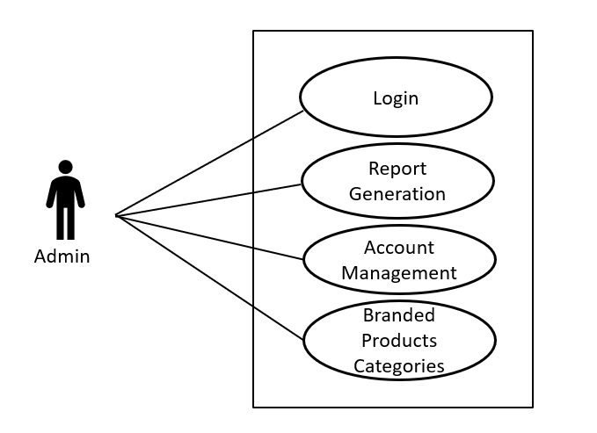

*Fig. Use case diagram for admin*

1. In Admin use case diagram Admin is the Actor.
2. Admin can handle following use cases:
3. Login
4. Report Generation
5. Account Management
6. Branded Products Categories

**Customer:**

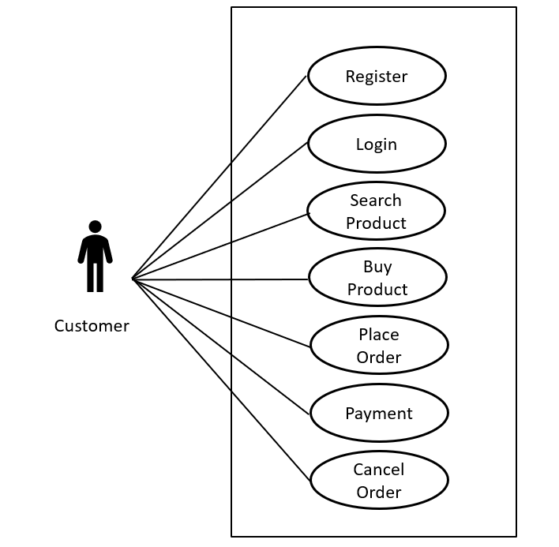

*Fig. Use case diagram for Customer*

1. In Customer use case diagram Customer is the Actor.
2. Customer can handle following use cases:
3. Register
4. Login
5. Search Product
6. Buy Product
7. Place Order
8. Payment
9. Cancel Order

**Seller:**

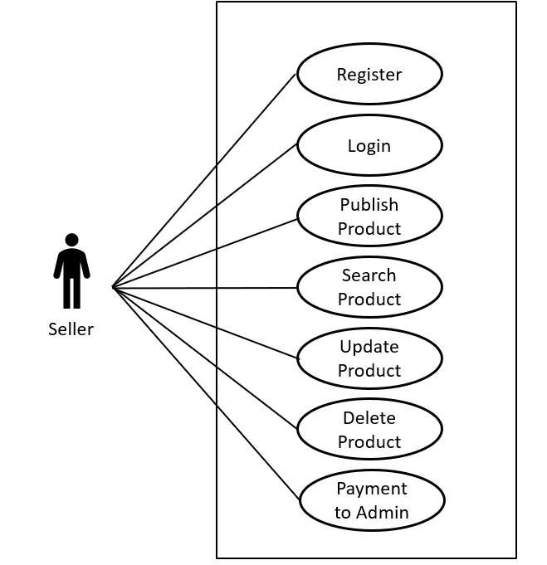

*Fig. Use case diagram for Seller*

1. In Seller use case diagram Seller is the Actor**.**
2. Seller can handle following use cases:
3. Register
4. Login
5. Publish Product
6. Search Product
7. Update Product
8. Delete Product
9. Payment to Admin