Project modules
For our Financial Analyst Assistant Portal, where we're working with multiple modules, it’s crucial to organize the project in a professional, maintainable way. Below is a suggested project structure that aligns with Flask, Jupyter Notebooks for prototyping, and scalability for future modules.
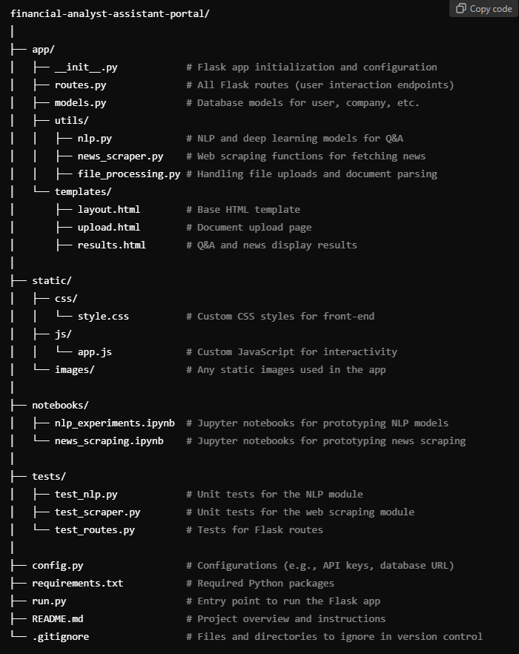

Explanation of Key Components:
- app/ Directory: Contains all application-related code.
  - __init__.py: Initializes the Flask app and configures the app settings.
  - routes.py: Defines the endpoints (like file upload, Q&A, and news retrieval).
  - models.py: Database models if you're using something like SQLAlchemy for handling users, companies, etc.
  - utils/: Modularize your utility functions:
    - nlp.py: Functions for your NLP and deep learning tasks.
    - news_scraper.py: Code for scraping news related to specific companies.
    - file_processing.py: Handles document uploads and any parsing you might need for analysis.
  - templates/: HTML templates for rendering your front-end.
- static/ Directory: Static assets such as CSS, JavaScript, and images.
  - css/: Contains style files for the user interface.
  - js/: JavaScript for any front-end functionality (e.g., dynamic content).
- notebooks/ Directory: This is where you'll keep your Jupyter notebooks for experimenting with code before finalizing it into Python scripts.
- tests/ Directory: Unit and integration tests. Writing tests will help ensure that your modules work correctly when integrated.
  - test_nlp.py: Tests for the Q&A and NLP functionalities.
  - test_scraper.py: Tests for the web scraping functionality.
  - test_routes.py: Tests to ensure the Flask routes work as expected.
- Configuration (config.py): Centralized configurations like API keys, database settings, and environment variables.
- requirements.txt: All the Python dependencies. As your project grows, you can freeze the libraries to ensure consistent environments.
- run.py: The entry point for the Flask app. This file runs the app when executed.
- README.md: Detailed project documentation for setup, running the app, and the features included.

Workflow:
- Prototyping:
  - Use the notebooks/ folder to experiment with your models (e.g., document analysis using NLP or scraping news) before moving the final code into the corresponding utility files.
- Developing Core Modules:
  - Break down each module into its own script in the utils/ folder (e.g., nlp.py, news_scraper.py).
  - Handle Flask routes in routes.py, calling these utility functions as needed.
- Deployment:
  - The Flask app (app/) structure is scalable and can easily be deployed using services like Heroku or Dockerized for cloud deployments.

