# 

# **MIS605 Systems Analysis and' Design**

# **Harshkumar Maniya**

# **Assessment 2**

# **A00143249**

Contents

Question 1: 3

Context Diagram 4

Question 2: 7

Level 0 Data Flow Diagram (DFD) 7

Question 3: 8

1. Decomposition of Customer Interaction (Level 1 DFD): 8

2. Decomposition of Web Portal Management (Level 1 DFD): 10

3. Decomposition of Invoice and Payment Processing (Level 1 DFD): 12

Question 4: 14

ER Diagram 14

Question 5**:** 17

Question 6: 20

References 21

# Question 1:

## Context Diagram

1. **Customer Interactions with the Platform:**

* Customers access the Doing Good Rewards Platform through various channels, such as a website or mobile app.
* Upon accessing the platform, customers can:
* View available offers and promotions from participating merchants.
* Select and activate special offers, agreeing to the terms and conditions set by the merchant.
* Submit payments for products or services purchased from merchants.
* View their transaction history, including details of payments and associated discounts or donations.

1. **Web Portal for Merchants:**

* The Web Portal for Merchants is a secure online platform provided by Doing Good Rewards for registered businesses.
* Merchants log in to the portal to manage their account and interact with the Doing Good Rewards Platform.
* Within the portal, merchants can:
* Upload invoice information, including details of transactions and payment due dates.
* Specify the percentage split of discounts between savings and donations to charity.
* Select the default charity for donations, or choose from a list of supported charities.
* Receive notifications and alerts regarding payments received and associated discounts.

1. **Bank Feeds Service:**

* The Bank Feeds Service is a third-party service integrated with the Doing Good Rewards Platform.
* It accesses the bank feeds of registered merchants to monitor incoming payments.
* The service identifies payments made by customers through bank transfers or Bpay, matching them to invoices uploaded by merchants.
* Upon detecting a payment, the Bank Feeds Service triggers actions within the Doing Good Rewards Platform, such as processing the associated discount and sending notifications to merchants and customers.

1. **Invoice and Payment Processing System:**

* This system is a core component of the Doing Good Rewards Platform responsible for processing invoices and payments.
* When a payment is detected by the Bank Feeds Service, the Invoice and Payment Processing System:
* Verifies the payment against the corresponding invoice uploaded by the merchant.
* Calculates the discount amount based on the agreed percentage split.
* Allocates the discount as savings and/or donations to charity, according to the merchant's preferences.
* Generates email alerts to notify both the merchant and the customer of the payment and associated discount.
* Updates transaction records and reports within the platform for transparency and auditability.

1. **Objective:**

* The primary objective of the workflow is to streamline the process of identifying, processing, and allocating discounts on payments made by customers to merchants.
* By automating the discount allocation process and integrating with open banking services, the Doing Good Rewards Platform aims to:
* Encourage charitable giving by providing incentives to both customers and merchants.
* Enhance transparency and efficiency in payment processing for participating businesses.
* Foster a sense of social responsibility and community engagement among users of the platform.

# Question 2:

## Level 0 Data Flow Diagram (DFD)

1. **Processes**:

* **Customer Interaction:** Represents the process of customers interacting with the platform.
* **Web Portal Management**: Manages the web portal for merchants, allowing them to upload invoice information and manage accounts.
* **Bank Feeds Monitoring**: Monitors bank feeds for invoice/EFT payments made by customers.
* **Invoice and Payment Processing**: Handles processing of invoices and payments within the platform.

1. **External Entities**:

* **Customers**: External users interacting with the platform.
* **Web Portal for Merchants**: External interface for merchants to interact with the platform.
* **Bank Feeds Service**: External service providing bank feed data to the platform.

1. **Data Stores:**

* **Customer Data Store**: Stores customer-related data such as account information and transaction history.
* **Invoice Data Store**: Stores invoice-related data such as invoice details and payment statuses.
* **Payment Data Store**: Stores payment-related data such as payment statuses, discounts, and donation allocations.

1. **Bidirectional Data Flows:**

* **Between Customer Interaction and Customer Data Store**: Represents the exchange of customer-related data between the platform and the data store.
* **Between Web Portal Management and Invoice Data Store**: Represents the bidirectional exchange of invoice-related data between the platform and the data store.
* **Between Invoice and Payment Processing and Payment Data Store**: Represents the bidirectional exchange of payment-related data between the processing component and the data store.

# Question 3:

## 1. Decomposition of Customer Interaction (Level 1 DFD):

Customer Interaction

Customer Account Management

View Offers

Make Payments

* Display available offers
* Filter offers based on criteria
* View offer detail
* Select payment method
* Enter payment details
* Confirm payment

#### Customer Account Management:

* This sub process manages customer accounts within the Doing Good Rewards Platform.
* Functionality includes:
* Creating new accounts.
* Updating account information.
* Managing account preferences.
* Deleting accounts.

#### View Offers:

* Allows customers to view available offers from participating merchants.
* Features include:
* Displaying available offers.
* Filtering offers based on criteria such as category or location.
* Viewing detailed information about specific offers.

#### Make Payments:

* Enables customers to make payments for products or services.
* Functionality includes:
* Selecting a payment method (e.g., credit card, bank transfer).
* Entering payment details such as card information or bank account details.
* Confirming the payment transaction.

The Customer Account Management sub process acts as the central hub for overseeing customer accounts within the Doing Good Rewards Platform, serving as the foundation for a smooth and efficient user experience. Its pivotal role encompasses a range of essential functionalities vital for customer interaction. These include creating new accounts, ensuring accurate and up-to-date account information, facilitating the management of account preferences to tailor the user experience, and overseeing account deletion processes when required. Through meticulous account management, the platform can maintain a high standard of user satisfaction and engagement, fostering long-term relationships with its customers.

## 2. Decomposition of Web Portal Management (Level 1 DFD):

Web Portal Management

Account Management

Invoice Mangement

Offer Mangement

* Upload new invoices
* Update invoice details
* Delete invoices
* Create new offers
* Edit existing offers
* Remove offers

#### Account Management:

* Manages merchant accounts within the web portal.
* Features include:
* Uploading new invoices for processing.
* Updating invoice details such as payment due dates or amounts.
* Deleting invoices that are no longer valid.

#### Invoice Management:

* Handles the management of invoices uploaded by merchants.
* Functionality includes:
* Uploading new invoices.
* Updating invoice details.
* Deleting invoices.

#### Offer Management:

* Manages offers and promotions available to customers within the platform.
* Features include:
* Creating new offers for products or services.
* Editing existing offers to adjust terms or conditions.
* Removing offers that are no longer available or valid.

Following the Customer Account Management sub process, the platform's operations extend into the intricate realm of Invoice and Payment Management. This multifaceted process is pivotal for maintaining a streamlined transactional flow between merchants and customers.

**Invoice Management** orchestrates the handling of invoices uploaded by merchants, ensuring accuracy and completeness in every transaction. Its functionalities encompass the uploading of new invoices, updates to invoice details, and the necessary protocols for removing outdated invoices, thereby maintaining a clean and organized database.

**Offer Management** complements these operations by curating a dynamic marketplace experience for customers. By enabling merchants to create, edit, and remove offers seamlessly, the platform fosters an environment where businesses can adapt their offerings in real-time to meet evolving consumer demands. This responsiveness not only enhances customer satisfaction but also promotes agility and innovation within the marketplace.

## 3. Decomposition of Invoice and Payment Processing (Level 1 DFD):

Invoice and Payment Processing

Payment Verification and Processing

Payment Verification

Payment Processing

* Verify payment authenticity
* Validate payment information
* Detect fraudulent activities
* Process credit card transaction
* Validate bank transfers
* Handle payment errors

Discount Calculation

Discount Allocation

* Calculate discounts
* Determine donation allocation
* Allocate discounts and donations
* Update transaction logs

#### Payment Verification and Processing:

* This main process verifies the authenticity of payments and processes them accordingly.
* It decomposes into two sub processes:
* Payment Verification: Verifies payment authenticity, validates payment information, and detects fraudulent activities.
* Payment Processing: Processes credit card transactions, validates bank transfers, and handles payment errors.

#### Payment Verification:

* Sub process responsible for verifying the authenticity of payments and ensuring they meet validation criteria.
* Tasks include verifying payment authenticity, validating payment information, and detecting fraudulent activities.

#### Payment Processing:

* Sub process responsible for processing verified payments and handling various payment methods.
* Tasks include processing credit card transactions, validating bank transfers, and managing payment errors.

#### Discount Calculation:

* Sub process responsible for calculating applicable discounts based on offer terms.
* Tasks include calculating discounts based on offer terms and determining donation allocation.

#### Discount Allocation:

* Sub process responsible for allocating discounts and donations to appropriate recipients.
* Tasks include allocating discounts and donations based on merchant preferences and updating transaction logs accordingly.

Following the meticulous handling of Payment Verification and Processing, the platform advances into Discount Calculation and Allocation, crucial for optimizing customer benefits and facilitating charitable contributions.

**Discount Calculation** process computes applicable discounts based on merchant terms, ensuring precise savings for customers. It also determines donation allocations, balancing benefits and charitable impact effectively.

**Discount Allocation** is Serving as a conduit between transactions and social impact, this process allocates discounts and donations according to merchant preferences. It updates transaction logs for transparency and accountability.

# Question 4:

## ER Diagram

1. **Customer**:

* Represents individuals who interact with the Doing Good Rewards Platform by making purchases, receiving offers, and making payments.
* Each customer is identified by a unique CustomerID and has attributes such as Name, Email, and AccountType.

1. **Merchant**:

* Represents businesses or vendors participating in the platform, offering products or services to customers.
* Each merchant is identified by a unique MerchantID and has attributes like Name, BusinessType, and Email.

1. **Offer**:

* Represents special promotions or discounts provided by merchants to attract customers.
* Each offer is identified by a unique OfferID and is associated with a specific merchant. It includes attributes such as Description, DiscountPercentage, and DonationPercentage.

1. **Invoice**:

* Represents invoices generated by merchants for purchases made by customers.
* Each invoice is identified by a unique InvoiceID and is associated with a customer and a merchant. It includes attributes like TotalAmount and PaymentStatus.

1. **Payment**:

* Represents payments made by customers to settle their invoices.
* Each payment is identified by a unique PaymentID and is associated with an invoice. It includes attributes such as AmountPaid and PaymentMethod.

1. **Charity**:

* Represents charitable organizations that receive donations from the platform.
* Each charity is identified by a unique CharityID and has attributes like Name and Description.

1. **Bank**:

* Represents banks or financial institutions involved in processing payments made by customers.
* Each bank is identified by a unique BankID and includes attributes like Name, Branch, and AccountNumber.

1. **Transaction**:

* Represents individual transactions occurring within the platform, including payments and donations.
* Each transaction is identified by a unique TransactionID and is associated with a payment or donation. It includes attributes like TransactionDate and TransactionAmount.

1. **Donation**:

* Represents donations made by customers to charities as part of their transactions.
* Each donation is identified by a unique DonationID and is associated with a charity and a transaction. It includes the DonationAmount.

1. **BankTransaction**:

* Represents individual transactions processed by banks related to payments made by customers.
* Each bank transaction is identified by a unique BankTransactionID and is associated with a bank and a transaction. It includes attributes like TransactionDate and TransactionAmount.

# Question 5**:**

In the given case study, there are several data stores or files that are not explicitly represented in the Entity Relationship Diagram (ERD). These data stores play a crucial role in the functioning of the system but are not directly linked to specific entities. Here are some examples:

1. **Bank Feeds Data Store:**

**The Bank Feeds Data Store serves as a centralized repository for transactional data obtained from bank feeds, providing a comprehensive view of financial transactions within the system. It collects and stores information about payments made by customers to merchants through bank transfers and Bpay, encompassing a wide range of transaction types and sources. Utilizing APIs or integration mechanisms, the data store retrieves real-time or batched transaction data from financial institutions, ensuring timely and accurate updates to transaction records. Key transaction details such as transaction IDs, dates, amounts, payment sources, and transaction references are meticulously stored within this data store, enabling robust tracking and analysis of financial activities.**

1. **Web Portal Database:**

**The Web Portal Database serves as the backbone of the platform, facilitating the management of merchant accounts, invoice data, offers, and user interactions. It acts as a centralized storage solution for storing and retrieving data related to portal activities, ensuring seamless access to critical information for merchants and users alike. Various tables, such as MerchantAccounts, UploadedInvoices, OfferDetails, and UserActivity, are part of its schema, each serving a specific function in the overall operation of the platform. Through CRUD operations, merchants can efficiently manage their accounts, upload invoices, create offers, and view activity logs, fostering a streamlined and user-friendly experience.**

1. **Discount and Donation Allocation Database:**

**This database plays a pivotal role in managing the allocation of discounts and donations within the platform, ensuring fair and equitable distribution of savings and charitable contributions. It employs sophisticated algorithms and business rules to calculate and track the distribution of discounts and donations based on invoice payments and offer terms, optimizing the utilization of available resources. Its schema includes tables like DiscountAllocations, DonationAllocations, and TransactionHistory, each meticulously designed to capture and store transactional data with precision and accuracy. Through robust transactional processing capabilities, the database ensures the accurate allocation of discounts and donations while maintaining a comprehensive audit trail for accountability and reporting purposes, enabling stakeholders to track and monitor the impact of their contributions effectively.**

1. **Customer Preferences File:**

**The Customer Preferences File serves as a repository for storing personalized settings and preferences for individual customers, enriching the platform's ability to deliver tailored experiences and offerings. It encompasses a wide range of customer preferences, including preferred charities, discount thresholds, notification settings, and communication preferences, providing valuable insights into customer behavior and preferences. Depending on the system architecture, the file may adopt various formats such as structured JSON/XML files or simple text-based configuration files, ensuring compatibility and flexibility in storing and retrieving customer preferences. By aligning offers and contributions with customer preferences, the file enhances user engagement, satisfaction, and loyalty, driving long-term success and growth for the platform.**

1. **Transaction Logs:**

**Transaction Logs serve as comprehensive records of system transactions, offering a detailed and chronological account of payment, donation, and offer redemption activities within the platform. They play a critical role in maintaining data integrity, ensuring accountability, and facilitating analysis of system performance and effectiveness. Capturing critical data such as transaction timestamps, IDs, amounts, outcomes, and user interactions, transaction logs provide valuable insights into system operations, enabling stakeholders to identify trends, patterns, and areas for improvement. Stored in dedicated database tables or structured log files, transaction logs are optimized for efficient retrieval and analysis, empowering stakeholders to make informed decisions and drive continuous improvement across the platform.**

**These components form the foundation of the platform's data infrastructure, enabling robust and efficient management of financial transactions, user interactions, and system operations. By leveraging advanced technologies and best practices in data management and analysis, the platform can deliver seamless experiences, maximize value for stakeholders, and drive positive social impact.**

# Question 6:

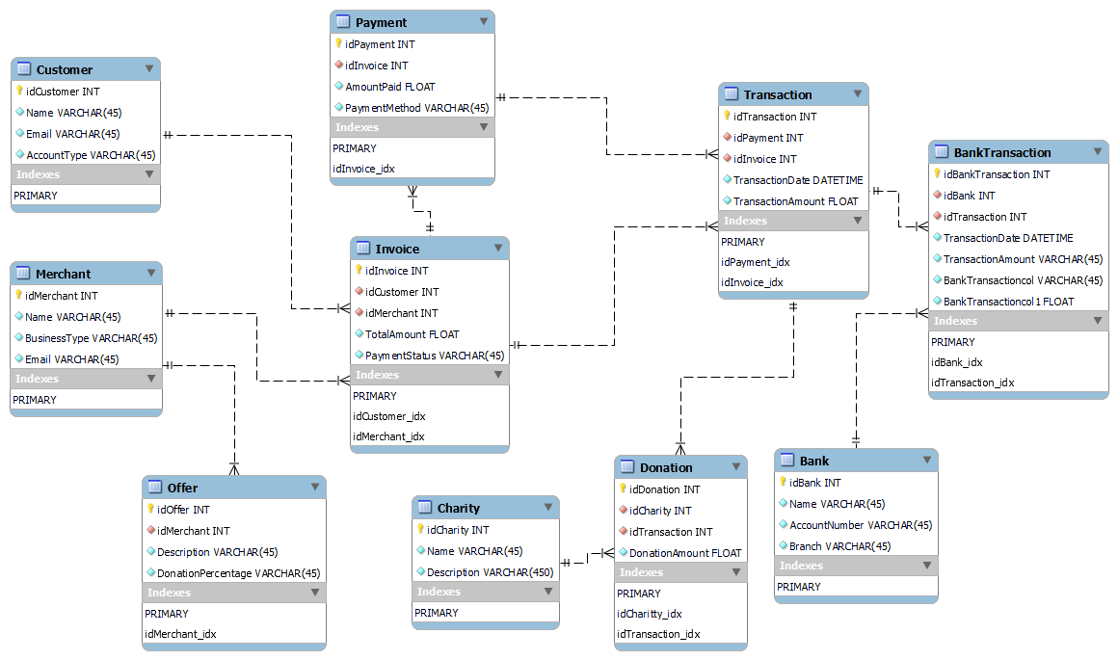

After translating the Entity Relationship Diagram (ERD) into a physical relational database design using Microsoft Workbench, the database schema was normalized to Third Normal Form (3NF). Each table represents a distinct entity identified in the ERD, with appropriate attributes and foreign key constraints established to maintain data integrity and relationships between entities. The database design ensures efficient storage and retrieval of data while adhering to normalization principles for optimal performance and scalability.

# References

|  |  |
| --- | --- |
| [1] | P. B. O. &. T. W. Brad Langdon, “https://doinggoodrewards.com/.,” Doing Good Rewards, (2024). [Online]. Available: https://doinggoodrewards.com/.. [Accessed April 2024]. |
| [2] | “Lucid Chart,” 2024. [Online]. Available: https://www.lucidchart.com/. |
| [3] | “Diagram Maker,” Visual Paradigm, [Online]. Available: https://online.visual-paradigm.com/diagrams/https://online.visual-paradigm.com/diagrams/. [Accessed April 2024]. |
| [4] | “Creately Diagrams Tutorial,” Creately, 2024. [Online]. Available: https://creately.com/guides/er-diagrams-tutorial/. |
| [5] | “Venngage context diagram,” Venngage, 2024. [Online]. Available: https://venngage.com/blog/context-diagram/. |