**Developing a Job Recruitment Platform**

1 .Introduction 3

2. Objectives 3

3. Methodology 5

4. Implementation Details 6

5. Testing and Quality Assurance 9

6. Future Recommendations 10

7. Conclusion 10

References 11

# 1 .Introduction

This assignment was designed to focus on increasing the level of aerobics with Web-developing technologies and solve a real business issue. In keeping with this goal, the team decided to create a job recruitment site because of the mobile application’s crucial role in matching employers with candidates effectively. In this way, choosing this project, the team wanted to demonstrate their strengths in such technologies as HTML, CSS, JavaScript, and PHP and provide the users of the web application with an effective tool (Hangartner et al.).

The core idea of choosing the job recruitment platform as the primary assignment was the relevance and topicality of the given field, as well as the ability to showcase the work of both frontline and backend areas. One of the key objectives of the development process was to minimize the complexity of the process for both employers and employees; that is, employers should be able to create a job posting with minimal effort and employees should be able to find and apply to suitable positions without much difficulty. When writing this report, the various areas covered includes; Description of the development methodology used, strategies used to implement the development process, the challenges experienced and finally the results that were obtained. In this regard, while effectively completing the requirements of this assignment, the team also sought to learn and effectively exercise principles of collaboration in working on a web development (Hosain et al.).

# 2. Objectives

This project entailed the following major goals: Design of an efficient recruitment system for employers as well as a method of searching for a suitable job for employees. First, the team became to work on the web application to make it friendly and as intuitive as possible so the user would be satisfied with the usability of the application. This involved paying much emphasis on designing interfaces that are both aesthetically appealing and easy to use.

Secondly, the platform was created for the benefit of employers, in that they are presented with an effective tool for advertising job vacancies: it would guarantee that all the necessary information can easily be passed on to parties interested in accessing it. In the same manner, job seekers were also offered powerful search tools to help them find and apply themselves towards the jobs that best match their skills and interests in a relatively simple manner.

Moreover, to mitigate certain risks the team paid a great attention to such aspects of the website usability as account management and jobs listing security. This comprised measures that would enhance on user authentication for the protection of data and the provision of managing user permissions to enable the protection of confidential data. The project was intended to achieve these objectives to provide a stable and functional job recruitment platform to enable the interaction between employers and employees to create an ideal setting for recruitment while at the same time ensuring security and ease of use (Delecraz et al.).

# 3. Methodology

Several methodological approaches were used in the development process with an aim of creating and implementing the job recruitment platform; this was done through going through the following phases;First, a requirements analysis was done where detailed consideration of functional an non-functional requirements was provided to define a set of requirements needed to support the platform. It was instrumental in achieving the next steps as this set the benchmark down on what needs to be done together with policies to follow.

After the identification of the necessary requirements, the team moved to the design stage when precious work on the wireframes and UI designs was dedicatedly done. A design based on iterations also enabled the visualization and adjustment of the positioning and appearance of the platform to achieve the most intuitive and aesthetically pleasing layout.

The physical build phase came after the technical design specification by hosting the layout using HTML, styling it using CSS, scripting it using JavaScript, and programming it using php. Vendor: This stage required proper coding and following the correct code writing protocols to develop the required functionality and modularity of the platform (Lukac and Grow).

After the integration, whether automated or manual, there was also thorough testing carried out, using particular units testing that involved rigorous testing of individual modules of the system and user acceptance testing which tested the usability and functionality of the system as a whole. This utilis test was carried out in a cyclic nature with the intention of providing a list of all ill’s and or inconsistencies that may likely be observed in the usage of the tool inorder to arrive at the correct linage to fix so that users could have a conducive experience.

Finally, after compiling and passing the tests, the platform was released and moved to a server for public use that concluded the development stage. This process involved setting up the server and other parameters that were essential for the proper functioning and accessibility of the platform to its users. In totality, the use of the articulated methodology has made the process more structured thus delivering a timely, effective, and user friendly job recruitment application (Lukac and Grow).

# 4. Implementation Details

The job recruitment platform was professionally designed using standard web development tools that enabled the provision of pertinent features that made the website operational and easily navigable as well as expandable when the necessity arises. HTML formed the basis of the architecture due to its effectiveness in the formulation of well-constructed web pages that formed the main shell of the interface of the program. CSS took the center stage here to give enhanced look and feel by applying style sheets and layouts on the HTML documents for greater coherency and uniformly appealing looks.

JavaScript played a significant role in achieving ‘client-side’ dynamic functionality / contents interactions such as enhancing the over-all experience by making the web page interactive and dynamic in its approach to the users. At the same time, PHP was hidden in the background and used a server-side scripting language to allow for basic processing of important back-end functions such as user authorization and databases access. This made it possible to safeguard users’ accounts and job vacancies for a particular user at the same time (Wu et al.).

In the same regard, MySQL was employed as the database software since it is database management system that guarantees scalability in matters concerning accumulation and access to details about user accounts and job postings. Altogether, these technologies created a single integrated stack that could foster the growth of a solid and accessible solution to manage job recruitment, conquering the multiple needs of employers and applicants will benefit from this stack.



Figure: Recruitment Screen

The above Figure shows the Recruitment screen of the website for Job Recruitment Platform



Figure: Register Screen

The above Figure shows the Register screen of the website for Job Recruitment

Platform



Figure: Login Screen

The above Figure shows the Login screen of the website for Job Recruitment Platform



Figure: Add job Screen

The above Figure shows the Add job screen of the website for Job Recruitment Platform

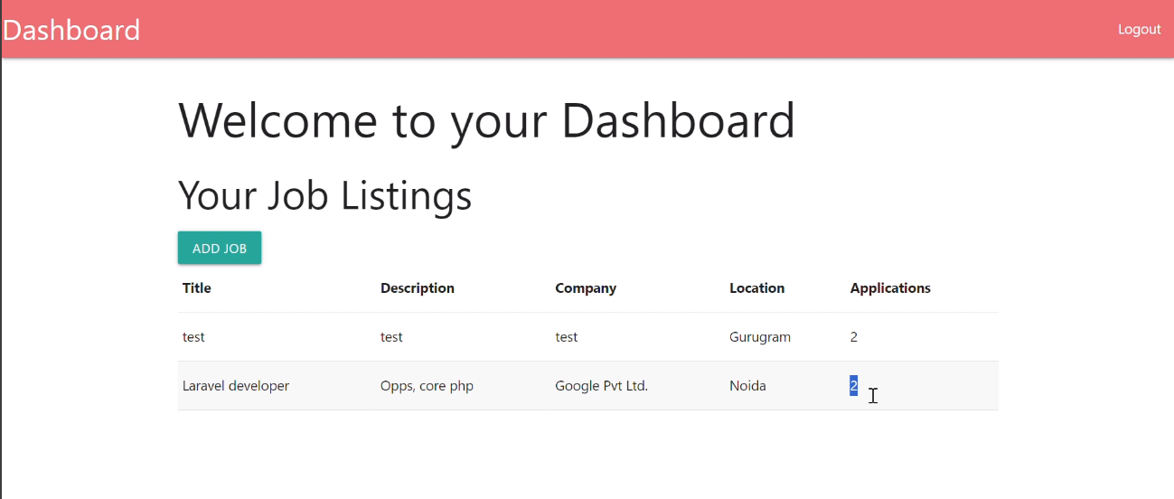

Figure:All job Screen

The above Figure shows the All job screen of the website for Job Recruitment Platform

# 5. Testing and Quality Assurance

During constructing the job recruitment platform, testing and quality assurance were highly considered to help in determining the functionality of the platform and to meet the intended requirements at every stage of the development process. The team followed a detailed test plan and conducted thorough testing performed on different stages and aspects of the developed platform (Cook et al.).

To ensure there is conclusive determination of several components of the project, unit testing was carried out; various actions including users’ registration, login, and job listing were tested. This further ensured that every module was operating to the required capacity as desired for it to be effective in its task. Afterwards, integration testing was done where the functionality of different groups of features, like user management, and job postings was checked. This step required one to determine and solve any problems that may exist due to combination of multiple functions that might be incompatible with each other.

This was critical in checking the user-friendliness of the platform since the checks were done from the perspective of the end user. This could only be done in an attempt to mimic real life usage of the platform, volunteering testers to take their time and test the ease of use, response time and overall feel of the platform. This phase involved the rigorous tests on candidate application complete with checks that applicants were able to post their applications for jobs and employers were able to review and manage posted jobs easily.

Further, strict measures had been in place for quality assurance to maintain commendable code quality, standard coding norms, and efficient performance. End-user feedback from the testers and other stakeholders allowed tweaks and improvements to be made and the application to be honed to become the best and as user-friendly as possible. These elaborate testing and quality control measures were put in place to guarantee the new job recruitment platform could meet the expected level of reliability and functionality and have a pleasing appeal to its users (Berg et al.).

# Future Recommendations

With a view of improving job recruitment platform further, the following suggestions are put forward:

Expand the option of options to be better suited to the search for new jobs.

Embedded an efficient messaging center for interaction between employers and the applicants.

Add twists such as resume parsing to match essential skills with the job requirements and job recommendation algorithms.

Ensure the changes and evolving user requirements and emergence of newer technologies are incorporated as development progress (Ali et al.).

# Conclusion

Thus, the cultivation of the job recruitment platform has given significant experience in the web development system and tools. The production of a web application that can effectively solve the problems outlined in Case 7 was achieved, although the team was faced with some difficulties. Concerning the objectives, the project contributed not only to enhancing the knowledge and practical skills of the team but also to the aspects of the team work and problem-solving.

# References

Ali, Shahmir H., et al. “Social Media as a Recruitment Platform for a Nationwide Online Survey of COVID-19 Knowledge, Beliefs, and Practices in the United States: Methodology and Feasibility Analysis.” BMC Medical Research Methodology, vol. 20, no. 1, 13 May 2020, <https://doi.org/10.1186/s12874-020-01011-0.>

Berg, Annelieke C., et al. “Inclusivity in Online Platforms: Recruitment Strategies for Improving Participation of Diverse Sociodemographic Groups.” Public Administration Review, vol. 80, no. 6, 14 June 2020, pp. 989–1000, <https://doi.org/10.1111/puar.13215.>

Cook, Ryan, et al. “Job Seekers’ Attitudes toward Cybervetting: Scale Development, Validation, and Platform Comparison.” International Journal of Selection and Assessment, 2 Aug. 2020, <https://doi.org/10.1111/ijsa.12300.>

Delecraz, Sebastien, et al. “Responsible Artificial Intelligence in Human Resources Technology: An Innovative Inclusive and Fair by Design Matching Algorithm for Job Recruitment Purposes.” Journal of Responsible Technology, vol. 11, Oct. 2022, p. 100041, <https://doi.org/10.1016/j.jrt.2022.100041.>

Hangartner, Dominik, et al. “Monitoring Hiring Discrimination through Online Recruitment Platforms.” Nature, vol. 589, no. 7843, 20 Jan. 2021, pp. 572–576, https://doi.org/10.1038/s41586-020-03136-0.Hosain, Sajjad, et al. “E-Recruitment: A Social Media Perspective.” Papers.ssrn.com, 1 Dec. 2020, papers.ssrn.com/sol3/papers.cfm?abstract_id=3740302.

Lukac, Martin, and André Grow. “Reputation Systems and Recruitment in Online Labor Markets: Insights from an Agent-Based Model.” Journal of Computational Social Science, vol. 4, no. 1, 1 May 2021, pp. 207–229, link.springer.com/article/10.1007%2Fs42001-020-00072-x, <https://doi.org/10.1007/s42001-020-00072-x.>

Wu, Likang, et al. “Exploring Large Language Model for Graph Data Understanding in Online Job Recommendations.” Proceedings of the ... AAAI Conference on Artificial Intelligence, vol. 38, no. 8, 24 Mar. 2024, pp. 9178–9186, https://doi.org/10.1609/aaai.v38i8.28769. Accessed 10 Apr. 2024.