**Rebuttal for Project-2 Report**

By: Avik Kumar Das and Neel Kanth Kundu

* **CZH**: We thank the reviewer for pointing out the shortcomings.

1. The format of the whole report is not pleasant.

We have made organizational change in the report such as uniformity of the fonts and headings to make it more pleasant to read.

1. The authors introduce a lot about the M-DCNN but did not use it in the experiment. They can try CNN and compare it with traditional machine learning methods.

Though we have introduced M-DCNN and explained why it is becoming popular among researchers and then discussed limitation in current environment. We are rewriting this again

Unlike other fields there is no widely available dataset with labels. As a result, reliability of M-DCNN trained on smaller dataset might be questionable. Moreover, as of now, feature discovered by DCNNs is not easily comprehensible from the point of view of engineers.

Following the suggestion of the reviewer, we have added ‘table 2’ comparing the performance of M-IP and M-DCNN and MDS with non-linear classifier.

* **Cao**: We thank the reviewer for the suggestion

1. The report is written clearly. The experiments are given with detailed results. But please do not write several ideas in the same paragraph or the paragraph would be too long and hard to read.

We have reorganized the paragraphs to ensure it is easier to read.

* **Hanli**: We thank the reviewer for the suggestion

1. The format of report can be better. Some explanation of good and bad results will improve the report

We have reorganized the paragraphs to ensure it is easier to read. Explanation of observations were also added.

* **Jose**: We thank the reviewer the comments
* **Kyle**: We thank the reviewer for the suggestion

1. It seemed quite obvious which images were surface cracks, and which were non - damaged. In a real-life situation, I expect there will be a lot more noise. Hence, the data set may be overly simplified.

This is a preliminary study on application of embeddings + classifier system. This is a very good observation, obviously environmental noise originating from imaging instruments is not studied. However, being a preliminary study dataset, which are not affected by such adverse effects are employed in this study.

* **Shunkang**: We thank the reviewer for the comments

1. I think this work is a little bit less creative. Actually, in this work, they only compare different exits work without any further exploration.

Apart from segregation of cracks we have also explored the possibility of using such a method a) to detect other damages in concrete such as discoloration b) quantify the pictures with maximum damage.

* **Wu Yue:** We thank the reviewer for the comments

1. From the experimental results, we can see dimensionality reduction methods are not proper to separate the dataset into two classes. Maybe the methods used are not efficient for their problem.

The above statement is not true, perhaps the reviewer has reached to such an opinion because size of the dots was too large in figure 3 of the report. We have attached the result with smaller dots inline (figure 1), it is visibly evident that dataset is separable using a non-linear decision boundary (though they are not separate). In figure 1, red denotes non-damaged while blue denotes damaged.

Moreover, we have studied separability scientifically and reported the result in Table 1. It is quite clear irrespective of the choice of the non-linear classifier for MDS the classification accuracy is extremely high (>90%). This is a very reasonable result for a natural dataset.

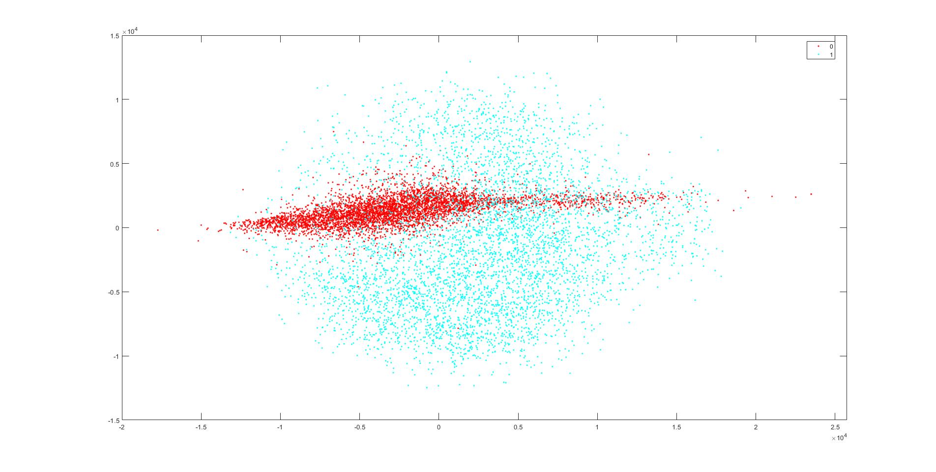

Figure 1 MDS embedding with smaller dots for better visibility

* **Yingxi**: We thank the reviewer for the comments

1. The font of figures and the main body of the report are same size, which is not well-organized. And the subtitles also need to be adjusted

We have made organizational change in the report such as to ensure uniformity of the fonts and headings to make it more pleasant to read.

* **Yixin**: We thank the reviewer for the question

1. Labelled dataset has very obvious differences between the damaged and undamaged. But the definition of crack is slighter and smaller.

In our understanding the reviewer is referring to figure 1. There is no formal definition of cracks defined within the work but generally speaking, damage is most often cracks.

* **Zeng**: We thank the reviewer for the suggestions

1. The report lacks an abstract, which cannot be just mentioned in the introduction part, to show the whole picture of their work. Also, there are some formatting issues e.g. gray words “Formatting...please wait” in 3.1 c), positions of the title of each figure and table are inconsistent, sudden indentation in 4.3.

Thank for pointing it out all such errors are corrected in the final version.