练习2：lmdb数据集练习 评论的二分类

将影评解码输出（0、1、2对应的是特殊符号，统一解成‘？’）

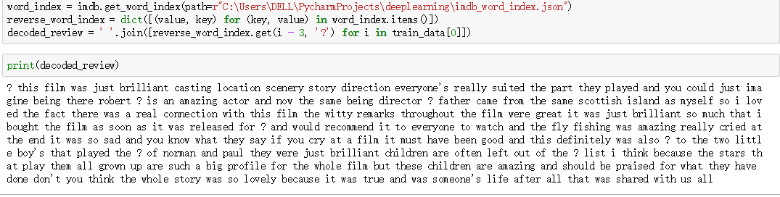

from keras.datasets import imdb

(train_data,train_labels),(test_data,test_labels)=imdb.load_data(path=r"C:\Users\DELL\PycharmProjects\deeplearning\imdb.npz",num_words=10000)

import numpy as np

def vectorize_sequences(sequences, dimension=10000):

results = np.zeros((len(sequences), dimension))

for i, sequence in enumerate(sequences):

results[i, sequence] = 1.

return results

x_train = vectorize_sequences(train_data)

x_test = vectorize_sequences(test_data)

y_train=np.asarray(train_labels).astype('float32')

y_test=np.asarray(test_labels).astype('float32')

from keras import models

from keras import layers

model = models.Sequential()

model.add(layers.Dense(16,activation='relu',input_shape=(10000,)))

model.add(layers.Dense(16,activation='relu'))

model.add(layers.Dense(1,activation='sigmoid'))

model.compile(optimizer='rmsprop',loss='binary_crossentropy',metrics=['accuracy'])

#留出验证集，原始训练数据留出10000个样本作为验证集

x_val=x_train[:10000]

partial_x_train=x_train[10000:]

y_val=y_train[:10000]

partial_y_train=y_train[10000:]

history=model.fit(partial_x_train,

partial_y_train,

epochs=20,

batch_size=512,

validation_data=(x_val,y_val))

#绘制训练损失和验证损失

import matplotlib.pyplot as plt

history_dict=history.history

loss_values=history_dict['loss']

val_loss_values=history_dict['val_loss']

epochs=range(1,len(loss_values)+1)

plt.plot(epochs, loss_values, 'bo', label='Training loss')

plt.plot(epochs, val_loss_values, 'b', label='Validation loss')

plt.title('Training and validation loss')

plt.xlabel('Epochs')

plt.ylabel('Loss')

plt.legend()

plt.show()

#绘制训练精度和验证精度

plt.clf()

acc = history_dict['acc']

val_acc = history_dict['val_acc']

plt.plot(epochs, acc, 'bo', label='Training acc')

plt.plot(epochs, val_acc, 'b', label='Validation acc')

plt.title('Training and validation accuracy')

plt.xlabel('Epochs')

plt.ylabel('Accuracy')

plt.legend()

plt.show()

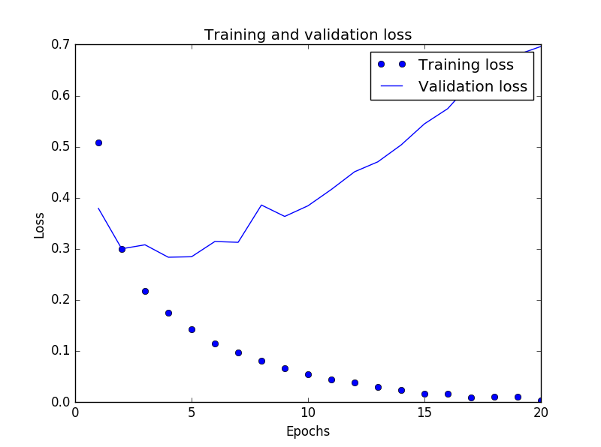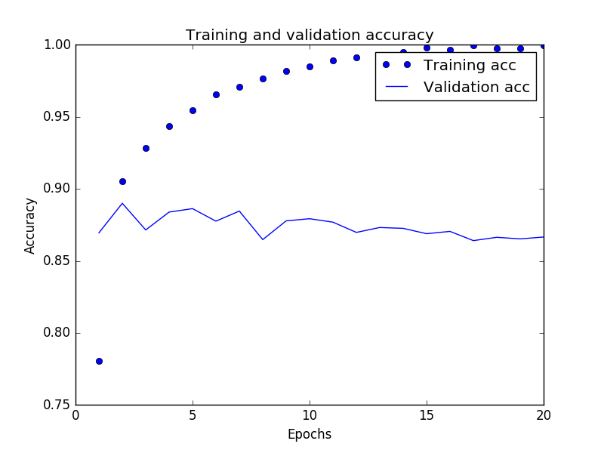

#精度输出结果

可见训练损失越来越少，精度越来越高

但是在测试集上的表现却不是如此，发生了过拟合，应该减少训练次数。将epochs=4 重新训练。