练习1：mnist数据集 的图片分类

代码：

%matplotlib inline

import keras

import numpy as np

import matplotlib.pyplot as plt

plt.rcParams['figure.figsize']=(7,7)

from keras.datasets import mnist

from keras.models import Sequential

from keras.layers.core import Dense,Dropout,Activation

from keras.utils import np_utils

#获取mnist数据集，由于下载原因，选择本地文件读取。

nb_classes= 10

(x_train,y_train),(x_test,y_test)=mnist.load_data(path=r"mnist.npz")

#更改样本形状

x_train=x_train.reshape(60000,784)

x_test=x_test.reshape(10000,784)

x_train=x_train.astype('float32')

x_test=x_test.astype('float32')

x_train/=255

x_test/=255

y_train=np_utils.to_categorical(y_train,nb_classes)

y_test=np_utils.to_categorical(y_test,nb_classes)

#建立神经网络

model=Sequential()

model.add(Dense(512,input_shape=(784,)))

model.add(Activation('relu'))

model.add(Dropout(0.2))

model.add(Dense(512))

model.add(Activation('relu'))

model.add(Dropout(0.2))

model.add(Dense(10))

model.add(Activation('softmax'))

#编译模型

model.compile(loss='categorical_crossentropy',optimizer='adam',metrics=['accuracy'])

#开始训练

model.fit(x_train,y_train,

batch_size=128,epochs=4,

validation_data=(x_test,y_test))

#评估准确性

score = model.evaluate(x_test, y_test,verbose=0)

print('Test score:', score[0])

print('Test accuracy:', score[1])

#预测测试集

predicted_classes = model.predict_classes(x_test)

correct_indices=np.nonzero(predicted_classes == y_test)[0]

incorrect_indices=np.nonzero(predicted_classes != y_test)[0]

#绘制测试图像

plt.figure()

for i, correct in enumerate(correct_indices[:9]):

plt.subplot(3,3,i+1)

plt.imshow(x_test[correct].reshape(28,28), cmap='gray', interpolation='none')

plt.title("Predicted {}, Class {}".format(predicted_classes[correct], y_test[correct]))

plt.figure()

for i, incorrect in enumerate(incorrect_indices[:9]):

plt.subplot(3,3,i+1)

plt.imshow(x_test[incorrect].reshape(28,28), cmap='gray', interpolation='none')

plt.title("Predicted {}, Class {}".format(predicted_classes[incorrect], y_test[incorrect]))

发现问题

出现警告，导致图片输出只有第一例，推测问题可能为predicted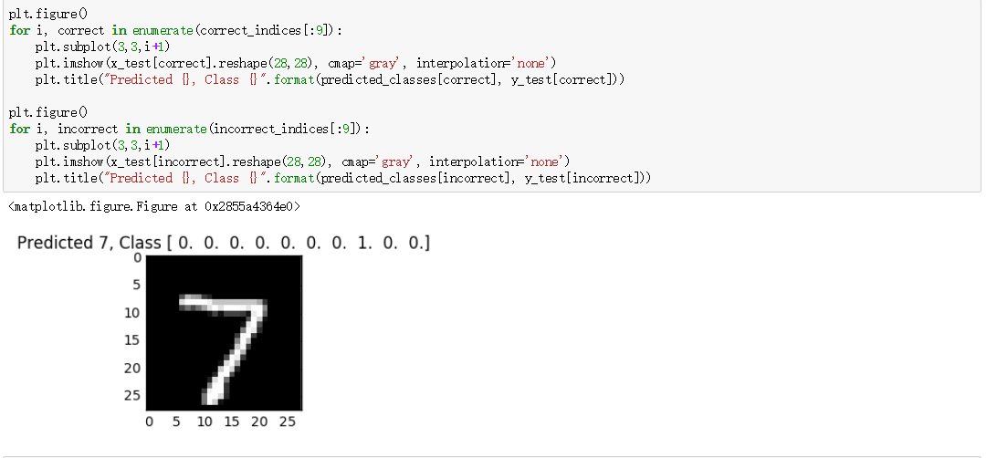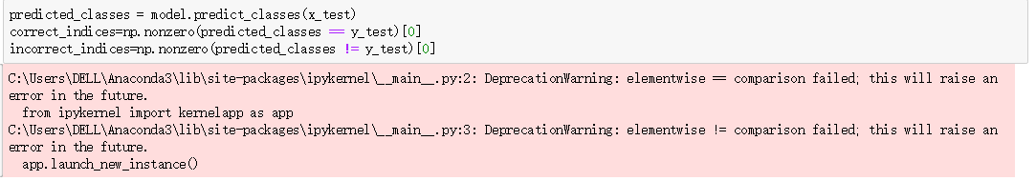_classes 与 y_test 维度不同，仍未解决。