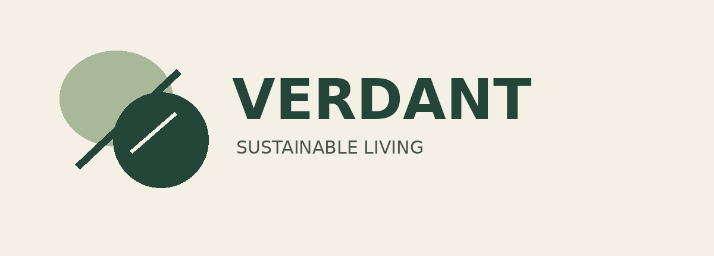
BRAND IDENTITY & STYLE GUIDE
Week 1 • Brand Identity Creation

A visual identity concept for a fictional sustainable lifestyle company

1. Brand Overview
VERDANT is a fictional sustainable lifestyle brand offering reusable everyday essentials and thoughtfully designed home and personal products. The identity aims to make sustainability feel practical, optimistic, and contemporary rather than complicated or exclusive. Its visual language combines botanical symbolism, restrained color, and clear typography.

Mission
To make sustainable living simpler and more accessible through useful, durable products and clear, responsible communication.

Vision
To help make lower-waste habits a natural part of everyday life.

Core values
- Responsibility: Consider materials, product lifespan, packaging, and the impact of everyday choices.
- Simplicity: Make products and messages easy to understand and use.
- Transparency: Communicate claims clearly and avoid unsupported environmental promises.
- Durability: Favor timeless design and long-term usefulness over short-lived trends.

2. Creative Brief
Design challenge: develop a recognizable and flexible identity for an emerging eco-conscious lifestyle brand. The identity should communicate trust, natural materials, and modern simplicity while remaining legible across digital and printed applications. The design should work on product labels, packaging, a website, social media, and basic stationery.

Target audience
Primary audience: environmentally aware adults roughly 20–40 years old, including students, young professionals, and households interested in reusable products and mindful consumption. They value attractive design, convenience, credible information, and products that fit into everyday routines.

Brand personality
Grounded, calm, thoughtful, optimistic, modern, and approachable.

Design goals
- Create a simple symbol that can be recognized at small sizes.
- Use a nature-associated palette without relying on excessive decorative detail.
- Establish a clear typographic hierarchy for accessible reading.
- Define consistent rules for spacing, color, imagery, and logo placement.

3. Logo Concept & Rationale
Concept: a two-leaf mark paired with a strong wordmark. The leaf shapes reference growth and the natural world, while the geometric construction and uppercase lettering bring structure and confidence. The mark is deliberately simple so it can be reproduced on packaging, labels, profile images, and web headers.

Initial exploration
- Direction A — Leaf + wordmark: the selected direction; direct, versatile, and easy to understand.
- Direction B — Circular growth mark: a circular emblem could suggest a product lifecycle, but may become visually dense at small sizes.
- Direction C — Letterform V: a custom V built from leaves could be distinctive, but needs more refinement to remain legible.

Logo usage guidelines
- Use the primary logo on a light linen or white background whenever possible.
- Maintain clear space around the logo equal to at least the height of the V in the wordmark.
- Keep the logo proportional; do not stretch, skew, rotate, or rearrange its parts.
- Do not add shadows, outlines, gradients, or unapproved colors.
- For small digital placements, use the leaf symbol alone only when the brand is already identified nearby.
- Prepare a one-color forest-green or white version for single-ink printing and dark backgrounds.

4. Color Palette
The palette balances a deep, dependable green with a soft botanical green and a warm neutral. Forest green carries the strongest brand recognition; sage softens the system; linen provides breathing room and supports a tactile, natural feel.
Color | HEX | RGB | Primary role
Forest Green | #234638 | 35, 70, 56 | Primary logo, headings, buttons
Sage Green | #A8B99A | 168, 185, 154 | Secondary fills, highlights
Linen | #F4F0E6 | 244, 240, 230 | Backgrounds, packaging
Charcoal | #2F3731 | 47, 55, 49 | Body text, fine details
Accessibility note: use forest green or charcoal for text on linen. Sage is best used for larger areas, accents, or decorative elements; check contrast before using it for small text. CMYK values should be converted and proofed in the chosen print workflow because results vary by paper and printer.

5. Typography System

Primary typeface — Montserrat (or a similar geometric sans serif)
Use for navigation, labels, buttons, captions, and body copy. Its clean forms support a contemporary, practical tone. Suggested weights: Regular for body copy, Medium for labels, and SemiBold for short headings.

Secondary typeface — Lora (or a similar readable serif)
Use selectively for editorial pull quotes or campaign headlines where a warmer, more human expression is useful. The contrast between serif and sans serif adds character without making the system feel inconsistent.

Hierarchy and usage
- H1: 28–36 pt, bold sans serif, forest green.
- H2: 16–22 pt, semi-bold sans serif, forest green.
- Body: 10–12 pt in print; comfortable line spacing and short paragraphs.
- Captions and labels: 8–10 pt, medium weight; never rely on tiny text for essential information.
- Use sentence case for most headings and reserve all caps for short labels or the wordmark.
- Limit the system to two type families and a small set of consistent weights.

6. Graphic Elements & Photography

Graphic language
Use restrained leaf-inspired line art, simple rounded shapes, generous whitespace, and thin divider rules. Decorative elements should support hierarchy rather than compete with product information.

Photography direction
Choose natural daylight, realistic textures, reusable materials, neutral surfaces, and everyday settings. Show products in use and represent sustainability claims accurately. Avoid overly staged imagery, excessive filters, and visual clichés that imply environmental benefits the product cannot substantiate.

Layout principles
- Use a consistent grid and align text and imagery to shared edges.
- Keep clear hierarchy: one primary message, one supporting message, then details.
- Use whitespace to separate sections and improve scanning.
- Keep margins, spacing, and image treatments consistent across applications.

7. Brand Applications

Packaging
Use linen as the base, forest green for the logo and essential product information, and sage for secondary panels or small accents. Keep materials and production claims specific and verifiable. Place product name, key use information, and care instructions in a clear hierarchy.

Social media
Use a consistent template with a clear headline, one strong product or lifestyle image, and a small logo placement. Alternate educational posts, product demonstrations, and practical low-waste tips while retaining the same palette and typography.

Website and stationery
Use forest-green calls to action, linen backgrounds, clear sans-serif navigation, and a limited number of accent elements. On stationery, prioritize legibility and generous margins over decoration.

8. Consistency Checklist
☐ Is the approved logo version used without distortion?
☐ Is sufficient clear space maintained?
☐ Are palette colors used according to their assigned roles?
☐ Are typography sizes and weights consistent?
☐ Is text readable with adequate contrast?
☐ Are images authentic and relevant to the brand?
☐ Are sustainability statements factual and supportable?
☐ Does the layout feel calm, clear, and recognizably VERDANT?

9. Conclusion & Design Rationale
The VERDANT identity uses a restrained visual system to connect the brand with sustainability while preserving clarity and flexibility. The leaf mark provides an immediate natural reference; the dark green establishes trust and contrast; sage and linen introduce softness; and the two-typeface system balances contemporary utility with an editorial touch. The guidelines are intended to make the identity repeatable across print and digital contexts. In a real launch, the concept should be validated through audience feedback, logo legibility tests, accessibility checks, and print proofs before final production.
Prepared as a fictional brand identity exercise for Week 1.

