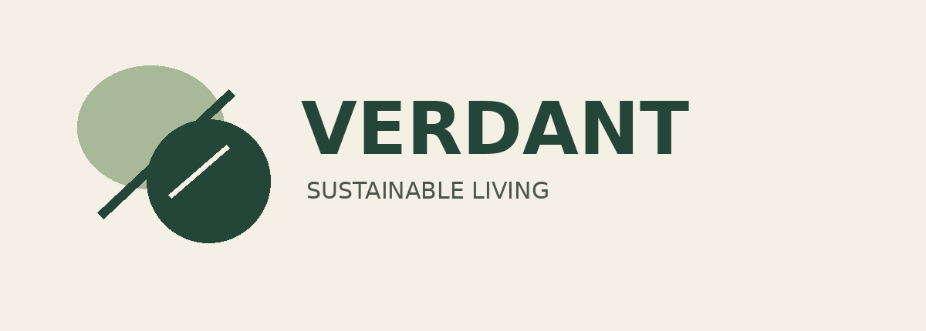
WEEK 4 PROJECT REPORT
Portfolio Website Mockup
VERDANT — Sustainable Living | Graphic Design Portfolio Concept
Prepared by: PATIL DEEP MANOJ

1. Project Overview
This project proposes a clean, modern, and user-friendly portfolio website mockup for showcasing graphic design work. The portfolio is intended to present selected projects, explain the creative process, communicate a consistent personal brand, and help visitors find relevant information quickly. This document outlines the website structure, visual system, page content, annotations, user-experience considerations, and design rationale. The deliverable is a visual mockup and report, not a coded or functioning website.

Project objectives
- Showcase selected design projects in a professional layout.
- Create a consistent visual identity across all website pages.
- Explain the purpose of key interface elements with annotations.
- Plan clear navigation and responsive layouts for different screen sizes.
- Document the design choices and rationale in an organized report.

2. Brand Identity and Design System
The supplied VERDANT logo is the primary identity reference. Its overlapping circular forms and green wordmark suggest nature, balance, and sustainable living. The mockup extends this identity with a restrained palette, generous whitespace, consistent alignment, and clear typography.
Colour | Hex value | Application
Forest Green | #234638 | Headings, navigation, primary buttons
Sage Green | #A8B99A | Secondary accents, tags, highlights
Warm Linen | #F4F0E6 | Main background and open space
Charcoal | #2F3731 | Body copy and supporting text
Typography recommendation: Montserrat Bold for headings and Montserrat Regular for body text. Lora may be used sparingly for editorial emphasis. Maintain a clear hierarchy among page titles, section headings, body text, buttons, and annotations.

3. Sitemap and Navigation
The site contains four main pages connected through a consistent navigation menu: Homepage, About, Portfolio, and Contact. The shared navigation lets visitors move between sections without having to return to the homepage each time.
- Homepage — introduces the designer and highlights selected projects.
- About — presents design interests, skills, and creative approach.
- Portfolio — organizes projects into concise case studies.
- Contact — provides a clear route for inquiries.
Navigation flow: Homepage ↔ About | Portfolio | Contact. Each page should retain the same header and footer for predictable navigation.

4. Homepage Mockup

Suggested on-page text
Navigation: Home | About | Portfolio | Contact
Hero headline: “Design that communicates. Visuals that connect.”
Introduction: “I create thoughtful visual identities, marketing materials, and digital designs that help ideas stand out.”
Primary action: VIEW MY WORK
Secondary action: ABOUT ME
Featured projects: VERDANT Brand Identity; Sustainable Marketing Collateral; Social Media Visual Campaign.
Process: Discover → Explore → Design → Refine.

Annotations
- Header provides consistent navigation.
- Hero communicates the designer’s purpose immediately.
- Calls to action guide visitors toward work and biography.
- Featured project cards give a quick overview of selected work.
- Footer provides a consistent ending and portfolio label.

5. About Page Mockup
Suggested heading: “About Me.” Suggested introduction: “I am an aspiring graphic designer interested in creating clear, meaningful, and visually engaging design experiences.” Include a short design approach statement, skill labels, and a four-step process.
- Skills: Brand Identity, Layout Design, Marketing Collateral, Social Media Graphics, Typography, and Visual Storytelling.
- Process: Discover, Explore, Design, Refine.
- Use a portrait placeholder if no approved portrait is available.
- Include an “Explore My Projects” action to guide visitors to the portfolio.

6. Portfolio Page Mockup
The portfolio page should use a consistent project grid with image areas, project titles, categories, short descriptions, and a “View Project Details” link-style action.
- Project 01 — VERDANT Brand Identity: logo, palette, typography, and identity guidelines.
- Project 02 — VERDANT Marketing Collateral: flyer, business card, and brochure concepts.
- Project 03 — VERDANT Social Media Campaign: Instagram posts, Facebook cover, X header, Stories, and Highlight Covers.
- Case-study sequence: Brief → Concept → Visual Development → Final Design.
Present VERDANT as a fictional or academic project where applicable. Do not claim real clients, awards, or outcomes that have not been verified.

7. Contact Page Mockup
Suggested headline: “Let’s Create Something Meaningful.” Supporting text: “Have a project idea or want to discuss a design opportunity? I would be happy to connect.”
- Form fields: Name, Email, Project Type, Message.
- Button: SEND INQUIRY.
- Use the designer’s actual professional contact details only after confirming them.
- Treat the form as a visual mockup; it will not function unless implemented in a website.

8. Wireframes and Design Development
Begin with low-fidelity wireframes using simple rectangles and text labels to establish content hierarchy and page structure. After reviewing the wireframes, create polished mockups with the VERDANT colour palette, typography, project previews, spacing, and annotations. This sequence helps resolve layout decisions before detailed styling.
Suggested presentation canvas: 1920 × 1080 px (16:9). Suggested desktop website frame: 1440 × 900 px. These are mockup presentation dimensions rather than mandatory dimensions for a coded website.

9. Responsive Design and User Experience
The layout should be planned for desktop, tablet, and mobile use. Illustrative viewport examples are desktop 1440 × 900 px, tablet 768 × 1024 px, and mobile 390 × 844 px.
- Keep navigation labels consistent on every page.
- Use readable type sizes, adequate spacing, and strong text/background contrast.
- Make primary actions visually distinct and descriptive.
- Change project grids from multiple columns to fewer columns on smaller screens.
- Scale images proportionally and avoid horizontal scrolling.
- Use clear form labels and touch-friendly controls.
- Keep content order logical when layouts stack vertically.

10. Personal Branding and Design Rationale
The portfolio’s minimalist visual style aims to present the designer as thoughtful, organized, and consistent. The VERDANT logo provides a recognizable identity anchor, while forest green, sage green, warm linen, and charcoal create a coherent visual system. The Homepage introduces the designer and directs visitors to selected work; the About page explains skills and process; the Portfolio page demonstrates practical applications; and the Contact page provides a clear inquiry route. Typography, whitespace, alignment, and consistent components support readability and usability. Annotations make the purpose of interface elements clear to reviewers. Responsive planning demonstrates awareness that visitors may view the portfolio on different devices.

11. Final PDF Assembly Checklist
- Cover page with VERDANT logo and portfolio title.
- Sitemap and navigation flow.
- Homepage wireframe and polished mockup with annotations.
- About page wireframe and polished mockup with annotations.
- Portfolio page wireframe and polished mockup with annotations.
- Contact page wireframe and polished mockup with annotations.
- Responsive examples for desktop, tablet, and mobile.
- Design rationale and user-experience explanation.
- Proofread all text and check alignment, contrast, and readability.
- Export the complete presentation as one PDF.

Conclusion
This report defines a consistent, user-focused direction for the Week 4 portfolio website mockup. The proposed structure, visual system, annotations, and responsive considerations are intended to make the portfolio easy to navigate and effective at presenting design work. The final presentation should combine the sitemap, wireframes, polished page mockups, and rationale into one clearly organized PDF.

