**Problem statement:** Create an address book application where API users can create, update and delete addresses. The address should:

- contain the coordinates of the address.

- be saved to an SQLite database.

- be validated

API Users should also be able to retrieve the addresses that are within a given distance and

location coordinates.

**Solution:** I have solved this problem statement by modulation approach. I break this problem in 3 steps :

1. To find the details for any given coordinates of the address.
2. After getting details from first step a way to handle in DB layer.
3. After sorting in database, a way to access these details by REST API’s endpoint.
4. App module where I used these 3 modules to run aur API application.

Details from any given coordinates: (apiendpoint.py module)

I have used a free API end point which is “ <http://api.positionstack.com> “, I passed access key and coordinate (latitude, longitude) to get details such as city, country, area, place name. ( this is handled in apiendpoint.py module)

Handling at DB layer: (db.py module)

I used SQLITE3, I have created db.py module for this purpose, I used different functions such as:

1) start_db (To created table in database if table is not present)

2) insert_item (To insert records in table or in DB)

3) display_records (to fetch all records from DB)

4) delete_record (It is used to delete record on the bases of coordinate (latitude, longitude))

5) fetch_by (To fetch only that record which matched with given pair of coordinate)

6)update_by (It is used to update db values on the bases of coordinate)

Accessing a way to call RESTFUL API’s: (data.py module)

I used Flask and Flask restful extension for this purpose. From the Flask framework I used request class to get input in the form of JSON which I passed in step1(position stack end point) to get details which I stored in DB.

From Flask-restful extension I used Resource base class to provide features to my classes which I used for controlling API end point, followings are the classes which is used in my module:

1. Class Insert_data : This class call will take coordinate and then it will call insert_item function of db.py module to insert data in DB.
2. Class Display_data : This class call will display_records function of db.py module to fetch all records from DB.
3. Class Delete_data : This class call will take coordinate and then it will call fetch_by function of db.py module to check weather record is present in Db for those coordinates or not if yes then it will used delete_record function of db.py module and then that function will delete record from DB.
4. Class Fetch_data : This class call will take coordinate and then it will call fetch_by function of db.py module to fetch record from DB for that coordinate
5. Class Update_data: This class will take coordinate as well as the fields value which we want to update then I have called update_by function of db.py module which will update records

App Module:

In this module I use Flask class from flask framework, API class from Flask-restful extension Insert_data,display_data,Delete_data,Fetch_data and Update_data from data module which I have created in 3 step.

In this module I have created following endpoint of address API’s as follows:

For insert address endpoint is : “Localhost:5000/add_address “

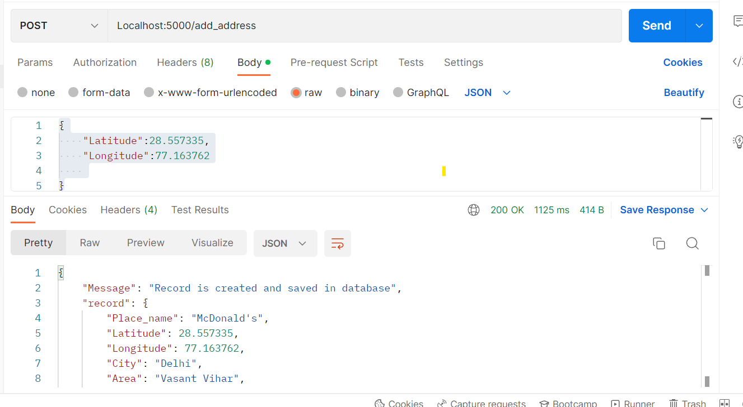

I used this coordinate only this endpoint will work with coordinates in this format

{

    "Latitude":28.557335,

    "Longitude":77.163762

}

For fetching all addressed stored from DB endpoint is : “Localhost:5000/view_all_address”

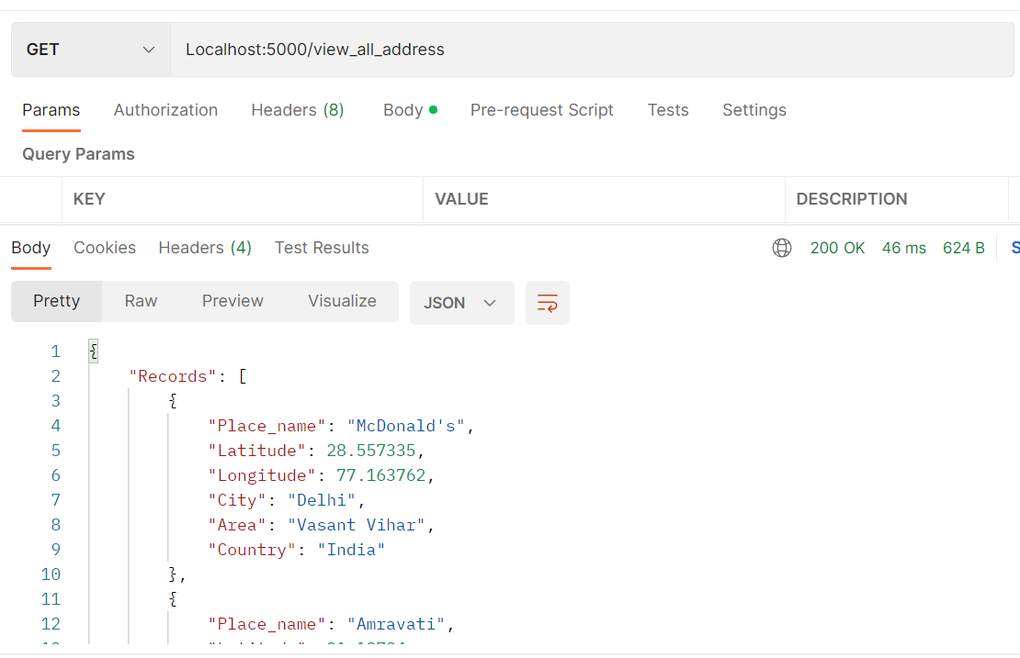

No need to pass any parameters for this request.

For fetching record on the bases of coordinate endpoint is :“Localhost:5000/view_by_lon_lat”

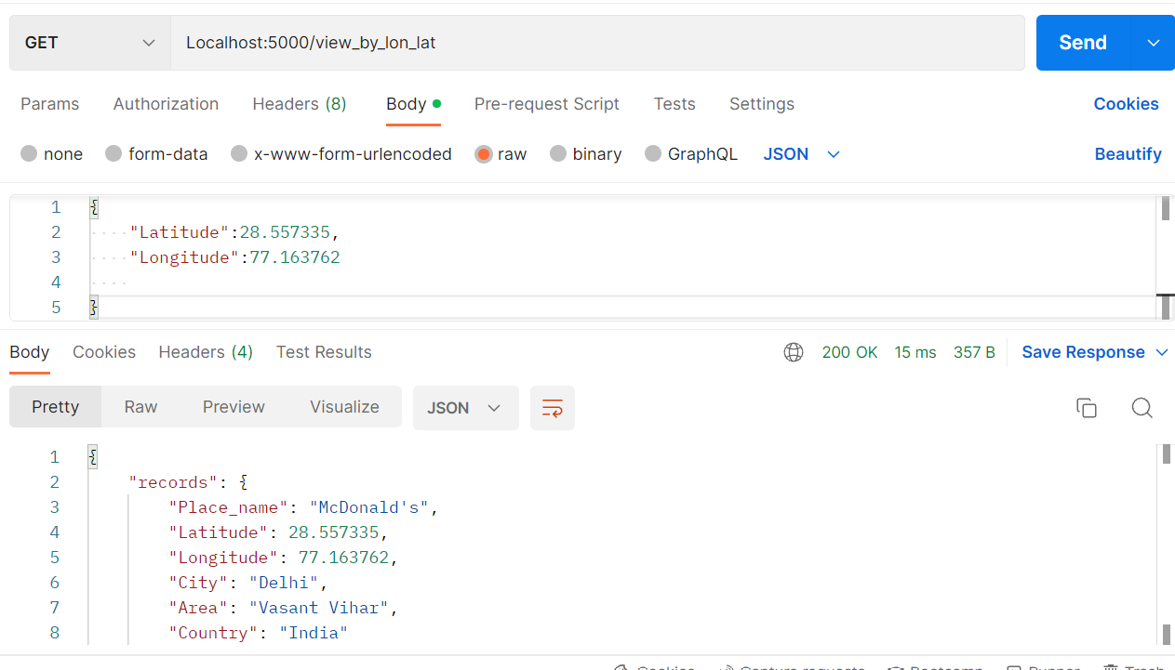

I used this coordinate only this endpoint will work with coordinates in this format

{“Latitude":28.557335,

    "Longitude":77.163762}

For updating DB values, I used this endpoint:” Localhost:5000/update_record”

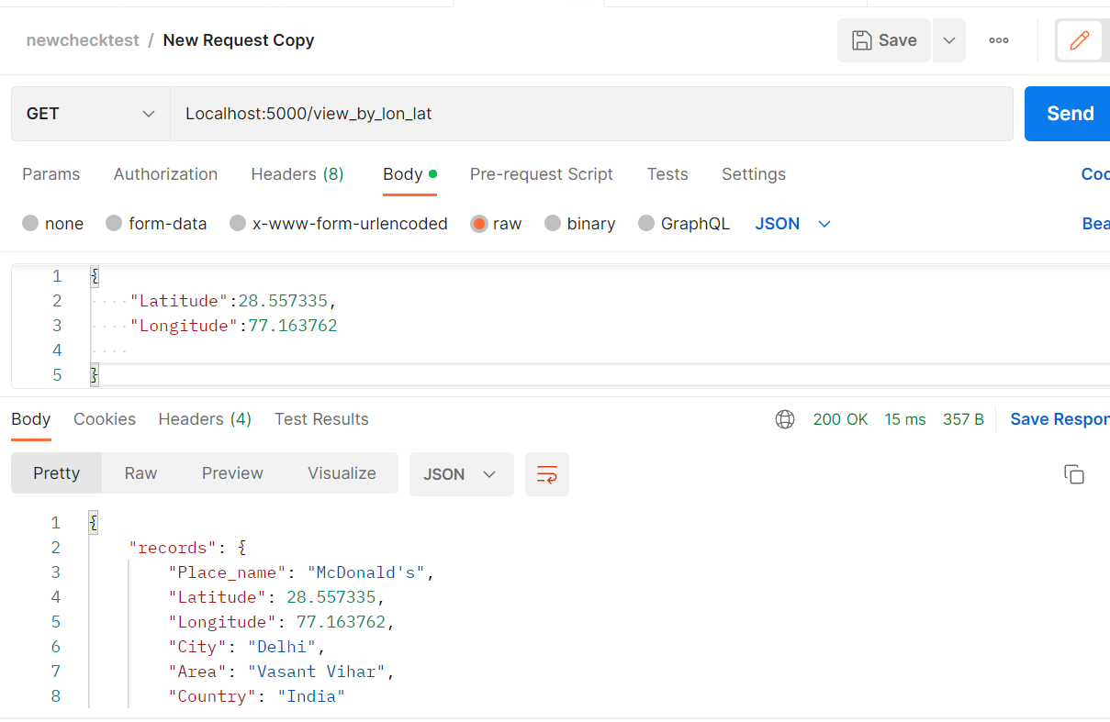Before update record was:

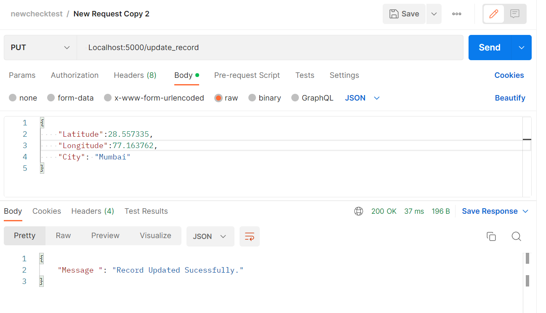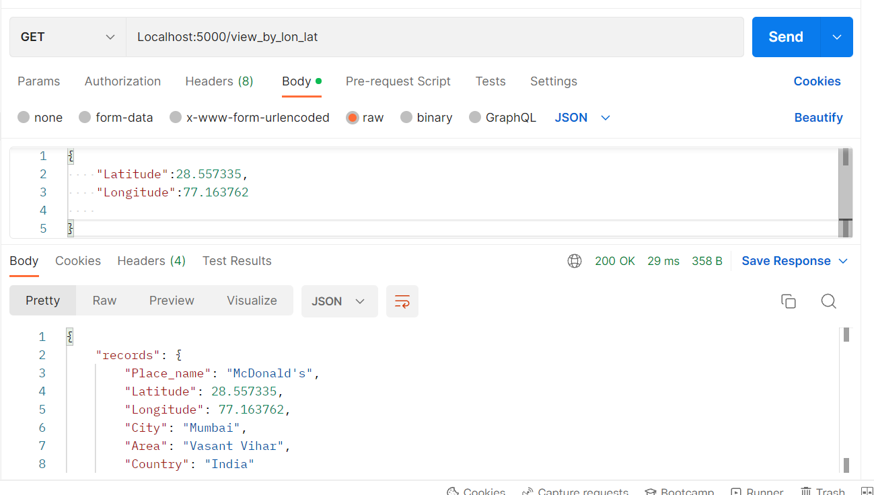After update date endpoint

I used this coordinate only this endpoint will work with coordinates in this format

{“Latitude":28.557335,

    "Longitude":77.163762,

"City": "Mumbai"

}

Latitude and longitude are need and also all the values which we want to update.

Delete records from DB on the bases of coordinate,the endpoint is “localhost:5000/delete_address”

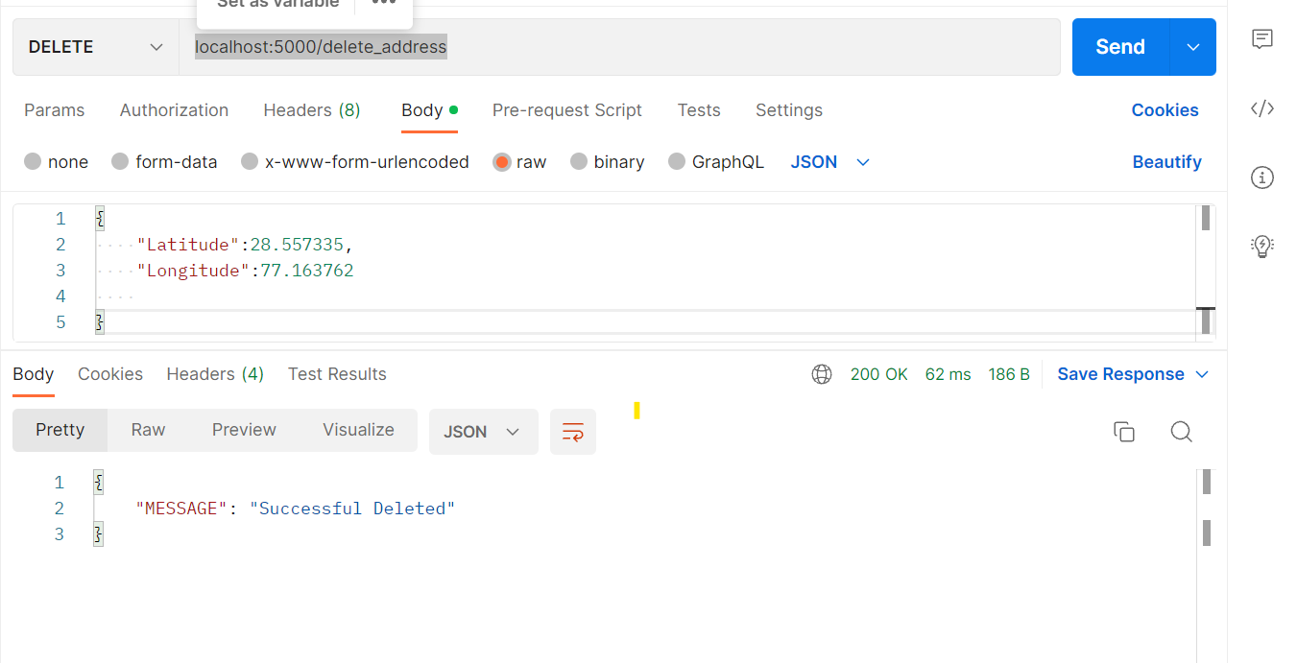

I used this coordinate only this endpoint will work with coordinates in this format

{“Latitude":28.557335,

    "Longitude":77.163762,

}