JANUN (জানুন)
Sami Workstream - VERIFIED DATA COLLECTION ONLY
Identity, Civil Registration, Police & Legal Services | Bangladesh
Verified cut-off: 25 October 2026
Verification rule used in this edition: Only facts supported by an official Government of Bangladesh portal, law, official notice, citizen charter, or official manual are included. Unverified nationwide fees, processing times, and local-document checklists are intentionally excluded.

1. How to use this file in JANUN
- Each service record contains only verified facts, the main official source URL, and additional official references.
- Dynamic fields such as fees, local requirements and processing times should keep a last_verified_at date in the app.
- For location-dependent certificates, JANUN must ask the user’s local authority before showing a fixed checklist or fee.
- QR/source cards in Appendix A are visual source references, not screenshots of private user data.

2. Verified service records

A1 - নতুন জন্ম নিবন্ধনের আবেদন
Authority | Office of Registrar General, Birth & Death Registration / local registrar
Main official URL | https://bdris.gov.bd/br/application
Verified information | - BDRIS provides the official online birth-registration application.  - The ORGBDR citizen charter instructs birth registration within 45 days of birth.  - The application collects child, parent and address information and accepts supporting image attachments.  - BDRIS support: 16152; help@bdris.gov.bd.
Additional official sources | https://orgbdr.gov.bd/pages/office-citizen-charters/6922d8a2933eb65569df96da  https://orgbdr.gov.bd/pages/static-pages/birth-and-death-registration-rule-2018-w20ft9-69ca49704c09aebb3cb2f77d

A2 - জন্ম নিবন্ধনের তথ্য সংশোধন
Authority | BDRIS / responsible registrar
Main official URL | https://bdris.gov.bd/br/correction
Verified information | - BDRIS has a dedicated birth-information correction service.  - The applicant must identify the existing record and submit documentary evidence supporting the requested correction.  - Registrar review/decision is required; approval is not automatic.  - BDRIS support: 16152.
Additional official sources | https://orgbdr.gov.bd/pages/office-citizen-charters/6922d8a2933eb65569df96da

A3 - নাম, জন্মতারিখ ও পিতা-মাতার তথ্য সংশোধন
Authority | BDRIS / responsible registrar
Main official URL | https://bdris.gov.bd/br/correction
Verified information | - Name, date of birth and parent-data corrections are handled through the official BDRIS correction route.  - Supporting evidence is required for the field being corrected.  - The corrected civil record should be used before updating dependent identity documents.
Additional official sources | https://orgbdr.gov.bd/pages/static-pages/6922e065933eb65569e26d6e

A4 - জন্ম নিবন্ধন সনদ যাচাই / পুনঃমুদ্রণ
Authority | Office of Registrar General / BDRIS
Main official URL | https://everify.bdris.gov.bd/
Verified information | - Official birth-record verification uses the 17-digit birth registration number and date of birth.  - Verification is available through the government eVerify service.  - Reprint services are accessed through BDRIS/local registrar workflow.
Additional official sources | https://bdris.gov.bd/

A5 - মৃত্যু নিবন্ধনের আবেদন ও সংশোধন
Authority | BDRIS / local registrar
Main official URL | https://bdris.gov.bd/dr/application
Verified information | - BDRIS provides the official online death-registration application.  - ORGBDR citizen guidance instructs death registration within 45 days.  - Death-record correction is handled through the official BDRIS framework.  - BDRIS support: 16152.
Additional official sources | https://orgbdr.gov.bd/pages/static-pages/6922dd63933eb65569e14d9c

A6 - NID সংক্রান্ত সেবা - মূল পোর্টাল
Authority | Bangladesh Election Commission / NID Wing
Main official URL | https://services.nidw.gov.bd/nid-pub/
Verified information | - This is the Election Commission/NID Wing citizen portal for NID-related online services.  - Citizens can use it for account-based NID services including registration/correction/reissue workflows where available.  - NID support helpline: 105.
Additional official sources | https://www.nidw.gov.bd/  https://ecs.gov.bd/

A7 - নতুন NID নিবন্ধন
Authority | Bangladesh Election Commission
Main official URL | https://services.nidw.gov.bd/nid-pub/
Verified information | - The NID portal includes the official route for new registration.  - Election Commission publishes the prescribed national identity registration forms and field-office Citizen Charter.  - Applicants must provide identity/civil-registration and address evidence according to the current EC process.  - Helpline: 105.
Additional official sources | https://ecs.gov.bd/page/forms-related-to-national-identity-registration-5125856174  https://asset.ecs.gov.bd/media/uploaded_files/notices/2026/07/3b504b25-6d15-4a22-8115-47b95f43da9a.pdf

A8 - NID নাম, জন্মতারিখ, ঠিকানা ও অন্যান্য তথ্য সংশোধন
Authority | Bangladesh Election Commission / NID Wing
Main official URL | https://services.nidw.gov.bd/nid-pub/
Verified information | - NID correction requires supporting evidence for the specific field.  - EC guidance lists records such as SSC certificate, birth registration, passport, driving licence, marriage/divorce documents, affidavit/newspaper notice or service book depending on the case.  - 2026 EC fee notice: visible NID data correction - 1st Tk 200 + VAT 30; 2nd Tk 300 + VAT 45; later Tk 400 + VAT 60.  - 2026 EC fee notice: other stored information correction - 1st Tk 100 + VAT 15; 2nd Tk 200 + VAT 30; later Tk 300 + VAT 45.  - Helpline: 105.
Additional official sources | https://asset.ecs.gov.bd/media/uploaded_files/notices/2026/07/29199fa6-4ca1-4458-a68e-df9f9820eb52.pdf  https://ecs.gov.bd/page/form-prescribed-under-the-national-identity-registration-rules-1710564329

A9 - হারানো বা নষ্ট NID পুনরায় সংগ্রহ
Authority | Bangladesh Election Commission / NID Wing
Main official URL | https://services.nidw.gov.bd/nid-pub/
Verified information | - Election Commission publishes the official reissue/duplicate route and forms.  - 2026 EC fee notice: normal duplicate - 1st Tk 200, 2nd Tk 300, subsequent Tk 500; 15% VAT applies.  - 2026 EC fee notice: urgent duplicate - 1st Tk 300, 2nd Tk 500, subsequent Tk 1000; 15% VAT applies.  - Helpline: 105.
Additional official sources | https://ecs.gov.bd/page/forms-related-to-national-identity-registration-5125856174  https://asset.ecs.gov.bd/media/uploaded_files/notices/2026/07/29199fa6-4ca1-4458-a68e-df9f9820eb52.pdf

A10 - NID তথ্য যাচাই ও সহায়তা
Authority | Bangladesh Election Commission
Main official URL | https://services.nidw.gov.bd/nid-pub/
Verified information | - Citizens use the NID portal for their own account/service information.  - Election Commission publishes separate prescribed forms for formal verification/data-supply workflows.  - Public users should not be told that they can freely query another person’s NID data.  - Helpline: 105.
Additional official sources | https://ecs.gov.bd/page/form-prescribed-under-the-national-identity-registration-rules-1710564329

A11 - নাগরিকত্ব / স্থায়ী বাসিন্দা / স্থানীয় প্রত্যয়নপত্র
Authority | Local Government authority / Prottoyon where covered
Main official URL | https://www.prottoyon.gov.bd/register/citizen
Verified information | - Prottoyon is a government-backed online citizen-certificate platform used by covered local authorities.  - Citizen profile and address information are used for certificate applications.  - Certificate availability depends on whether the relevant Union/Municipality/local authority is covered.  - Local authority approval is required.
Additional official sources | https://www.prottoyon.gov.bd/faq  https://www.prottoyon.gov.bd/union/covered  https://www.prottoyon.gov.bd/municipality/covered

A12 - বিবাহ নিবন্ধন ও সরকারি রেকর্ড
Authority | Law & Justice Division / registrar
Main official URL | https://marriage.gov.bd/
Verified information | - Marriage.gov.bd is the official Marriage & Divorce Registration System.  - For Muslim marriages, the Muslim Marriages and Divorces (Registration) Act 1974 requires registration.  - If a Muslim marriage is solemnized by someone other than the Nikah Registrar, the bridegroom must report it to the concerned Nikah Registrar within 30 days.  - The portal provides citizen registration using identity information.
Additional official sources | https://marriage.gov.bd/registration  https://bdlaws.minlaw.gov.bd/act-print-476.html

A13 - বিবাহবিচ্ছেদ নিবন্ধন ও সংশ্লিষ্ট প্রক্রিয়া
Authority | Nikah Registrar / local Chairman / court as applicable
Main official URL | https://bdlaws.minlaw.gov.bd/act-305/section-13539.html?lang=en
Verified information | - Under section 7 of the Muslim Family Laws Ordinance 1961, after pronouncing talaq the husband must give written notice to the Chairman and a copy to the wife.  - Talaq generally does not become effective until 90 days after delivery of notice to the Chairman, subject to the statutory pregnancy rule.  - The Chairman constitutes an Arbitration Council within 30 days to attempt reconciliation.  - Divorce registration by Nikah Registrar is governed by section 6 of the 1974 registration law.
Additional official sources | https://bdlaws.minlaw.gov.bd/act-print-476/section-print-12227.html  https://marriage.gov.bd/

A14 - উত্তরাধিকার / ওয়ারিশ সনদ
Authority | Local authority / Prottoyon where covered
Main official URL | https://www.prottoyon.gov.bd/register/citizen
Verified information | - Prottoyon supports ওয়ারিশ/উত্তরাধিকার certificate services in covered local authorities.  - Applicant registration uses mobile number and identity information; local authority approval is required.  - Prottoyon has an official integration notice relating online heir-certificate verification with e-Mutation.
Additional official sources | https://www.prottoyon.gov.bd/faq  https://prottoyon.gov.bd/notice/17/crc32

A15 - নাম পরিবর্তন / নথিপত্র সংশোধনের সঠিক রুট
Authority | Authority depends on the document
Main official URL | https://bdris.gov.bd/br/correction
Verified information | - There is no single government service that changes a person’s name across every record at once.  - Birth-record correction uses BDRIS; NID correction uses the Election Commission/NID process.  - Supporting evidence requirements depend on the target document and type of change.  - Dependent records should be updated after the foundational record is corrected.
Additional official sources | https://services.nidw.gov.bd/nid-pub/  https://www.nidw.gov.bd/  https://www.dpp.gov.bd/bgpress/bangla/

B1 - Police Clearance Certificate (PCC)
Authority | Bangladesh Police
Main official URL | https://pcc.police.gov.bd/
Verified information | - Bangladesh Police provides the official online PCC portal.  - The portal requires an online application, passport/address documentation and fee-payment proof according to applicant type.  - Current portal fee: Tk 1,500 via Treasury Challan/online payment plus applicable service charge.  - Status SMS format shown by portal: PCC S <reference> to 26969.
Additional official sources | https://www.police.gov.bd/

B2 - সাধারণ ডায়েরি (GD)
Authority | Bangladesh Police
Main official URL | https://gd.police.gov.bd/
Verified information | - Bangladesh Police provides the official Online GD system.  - Citizens submit identity/contact, incident/lost-item details and supporting evidence where available.  - The official user manual explains account/application workflow.  - For immediate danger/emergency, use 999 rather than a routine GD.
Additional official sources | https://gd.police.gov.bd/UserManual/%E0%A6%85%E0%A6%A8%E0%A6%B2%E0%A6%BE%E0%A6%87%E0%A6%A8%20%E0%A6%9C%E0%A6%BF%E0%A6%A1%E0%A6%BF%20%E0%A6%87%E0%A6%89%E0%A6%9C%E0%A6%BE%E0%A6%B0%20%E0%A6%AE%E0%A7%8D%E0%A6%AF%E0%A6%BE%E0%A6%A8%E0%A7%81%E0%A7%9F%E0%A6%BE%E0%A6%B2.pdf  https://www.police.gov.bd/

B3 - হারানো কাগজপত্র রিপোর্ট
Authority | Bangladesh Police / Online GD
Main official URL | https://gd.police.gov.bd/
Verified information | - Online GD supports reporting lost documents/items.  - Users provide item/document identifying details, place/time/circumstances and supporting evidence where available.  - The acknowledgement/reference can be used in subsequent replacement processes where the receiving authority requires it.
Additional official sources | https://www.police.gov.bd/

B4 - নথিপত্র সত্যায়ন ও যাচাই
Authority | Notary / MOFA / issuing authority depending on use
Main official URL | https://bdlaws.minlaw.gov.bd/act-308/section-13719.html?lang=bn
Verified information | - The Notaries Ordinance authorizes notaries to verify, authenticate, certify or attest instruments and perform other statutory functions.  - For documents for foreign use, the appropriate MOFA/e-Consular or mission route depends on the document and destination.  - For government-issued records, use the issuing authority’s own verification system when available.
Additional official sources | https://econsular.mofa.gov.bd/a/  https://www.mygov.bd/

B5 - নোটারি ও হলফনামা
Authority | Government-appointed Notary Public
Main official URL | https://bdlaws.minlaw.gov.bd/act-308.html?lang=en
Verified information | - Notaries are governed by the Notaries Ordinance 1961.  - A notary may authenticate/certify/attest instruments, administer oaths and take affidavits within statutory authority.  - A receiving authority may or may not require an affidavit; JANUN should only recommend it when the target authority requires it.
Additional official sources | https://bdlaws.minlaw.gov.bd/act-308/section-13719.html?lang=bn  https://lawjusticediv.gov.bd/

B6 - সরকারি আইনগত সহায়তা
Authority | Bangladesh Legal Aid authority
Main official URL | https://nlaso.gov.bd/
Verified information | - Government legal aid is available under the Legal Aid Services Act 2000 (as amended) for eligible justice-seekers.  - Applications can be made through the official online system or prescribed LA Form-01/district legal-aid office.  - The application collects applicant, income/occupation, case/dispute and supporting-document information.  - Current 2026 homepage helpline: 16699.
Additional official sources | https://db.nlaso.gov.bd/Pages/OnlineApplications.aspx  https://nlaso.gov.bd/site/forms/c022ed43-3575-4380-8d35-8334e8679202/%E0%A6%86%E0%A6%87%E0%A6%A8%E0%A6%97%E0%A6%A4-%E0%A6%B8%E0%A6%B9%E0%A6%BE%E0%A7%9F%E0%A6%A4%E0%A6%BE-%E0%A6%AA%E0%A7%8D%E0%A6%B0%E0%A6%BE%E0%A6%AA%E0%A7%8D%E0%A6%A4%E0%A6%BF%E0%A6%B0-%E0%A6%86%E0%A6%AC%E0%A7%87%E0%A6%A6%E0%A6%A8  https://nlaso.gov.bd/pages/laws/%E0%A6%86%E0%A6%87%E0%A6%A8%E0%A6%97%E0%A6%A4-%E0%A6%B8%E0%A6%B9%E0%A6%BE%E0%A7%9F%E0%A6%A4%E0%A6%BE-%E0%A6%AA%E0%A7%8D%E0%A6%B0%E0%A6%A6%E0%A6%BE%E0%A6%A8-%E0%A6%86%E0%A6%87%E0%A6%A8-%E0%A7%A8%E0%A7%A6%E0%A7%A6%E0%A7%A6-%E0%A6%B8%E0%A6%82%E0%A6%B6%E0%A7%8B%E0%A6%A7%E0%A6%A8%E0%A7%80%E0%A6%B8%E0%A6%B9-c74df8-6922da03933eb65569e01d72

B7 - নাগরিক অভিযোগ / GRS
Authority | Cabinet Division Grievance Redress System
Main official URL | https://www.grs.gov.bd/
Verified information | - GRS is the official government grievance system for complaints about government service delivery.  - Citizens can lodge a complaint by selecting office/service/location, describing the grievance and attaching evidence.  - The current complaint form allows evidence attachments up to 10 MB in supported formats.  - GRS provides appeal/escalation mechanisms under its guideline.
Additional official sources | https://www.grs.gov.bd/complainWithoutLogin.do  https://www.grs.gov.bd/assets/grs_user_manual.pdf  https://www.grs.gov.bd/assets/grs_guideline.pdf

B8 - পরিচয়পত্রের তথ্যের মধ্যে অসামঞ্জস্য সংশোধন
Authority | BDRIS / Election Commission / other issuing authority
Main official URL | https://bdris.gov.bd/br/correction
Verified information | - The correction route depends on which foundational record is wrong.  - If the birth record is wrong, use BDRIS correction.  - If NID is wrong while the foundational civil record is correct, use the EC/NID correction process with supporting evidence.  - After the foundational record is corrected, dependent documents should be updated with their issuing authorities.  - BDRIS support: 16152; EC support: 105.
Additional official sources | https://services.nidw.gov.bd/nid-pub/  https://www.nidw.gov.bd/

3. Data intentionally NOT included as verified facts
- Exact nationwide BDRIS birth/death correction or reprint fees where the current official fee table was not reliably captured.
- One fixed nationwide processing time for registrar-based birth/death corrections.
- One fixed national fee/document checklist for citizenship, permanent-resident and heir certificates; these vary by local authority.
- One exact nationwide marriage/divorce registration fee in the current portal where a current official citizen fee schedule was not confirmed.
- One fixed nationwide Notary Public/affidavit fee.
- One universal “name change” workflow covering Birth Registration, NID, passport and academic records - each authority has a separate process.

4. Official PDF / manual sources for the research archive
- Election Commission - 2026 NID service fee notice (PDF): https://asset.ecs.gov.bd/media/uploaded_files/notices/2026/07/29199fa6-4ca1-4458-a68e-df9f9820eb52.pdf
- Election Commission - field-office Citizen Charter (PDF): https://asset.ecs.gov.bd/media/uploaded_files/notices/2026/07/3b504b25-6d15-4a22-8115-47b95f43da9a.pdf
- Election Commission - NID correction form (PDF): https://asset.ecs.gov.bd/media/uploaded_files/page_tables/2026/06/d7d13a99-d023-4b01-9cbd-25b92d2ee0f3.pdf
- Online GD User Manual (PDF): https://gd.police.gov.bd/UserManual/%E0%A6%85%E0%A6%A8%E0%A6%B2%E0%A6%BE%E0%A6%87%E0%A6%A8%20%E0%A6%9C%E0%A6%BF%E0%A6%A1%E0%A6%BF%20%E0%A6%87%E0%A6%89%E0%A6%9C%E0%A6%BE%E0%A6%B0%20%E0%A6%AE%E0%A7%8D%E0%A6%AF%E0%A6%BE%E0%A6%A8%E0%A7%81%E0%A7%9F%E0%A6%BE%E0%A6%B2.pdf
- GRS User Manual (PDF): https://www.grs.gov.bd/assets/grs_user_manual.pdf
- GRS Guidelines (PDF): https://www.grs.gov.bd/assets/grs_guideline.pdf
- Muslim Marriages & Divorces Registration Act 1974 (PDF): https://old.bdlaws.minlaw.gov.bd/upload/bdcodeact/2023-12-24-09-39-13-9.-Muslim-Marriages-and-Divorces-%28Registration%29-Act%2C-1974.pdf
- Muslim Family Laws Ordinance 1961 (PDF): https://old.bdlaws.minlaw.gov.bd/upload/bdcodeact/2023-12-14-10-00-49-335.-THE-MUSLIM-FAMILY-LAWS-ORDINANCE%2C-1961-1986_final-24.12.2.pdf
- Prottoyon User Manual (PDF): https://www.prottoyon.gov.bd/frontend/user_manual.pdf

Appendix A - Main Source URL + Information + Source Image Cards
Each image below contains the main official URL, a QR code and the verified key facts used for JANUN.

BDRIS - Birth & Death Registration
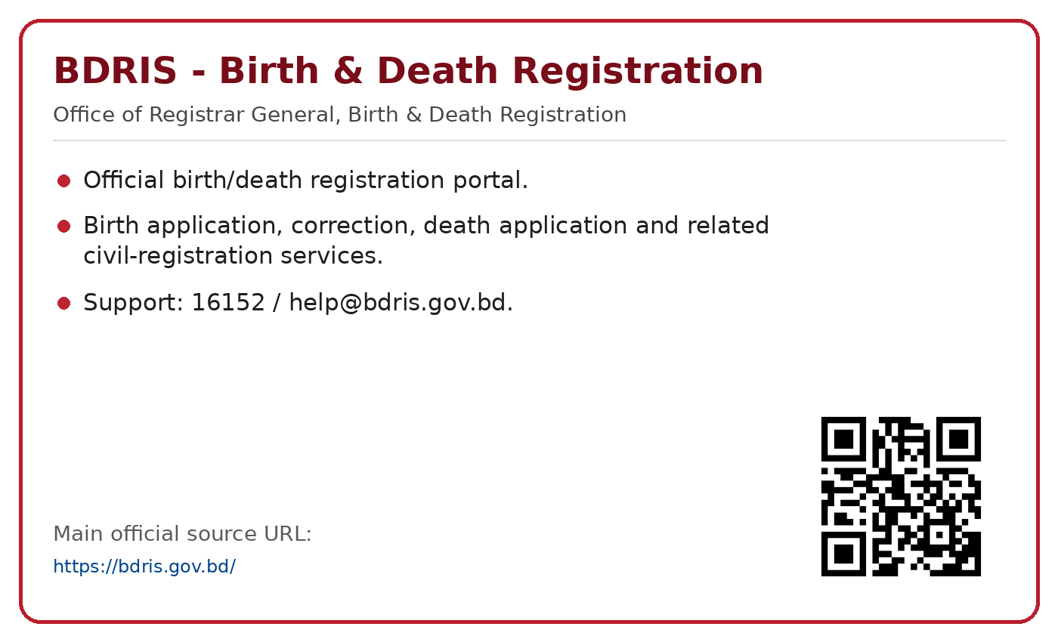
Official source: https://bdris.gov.bd/

NID Online Services
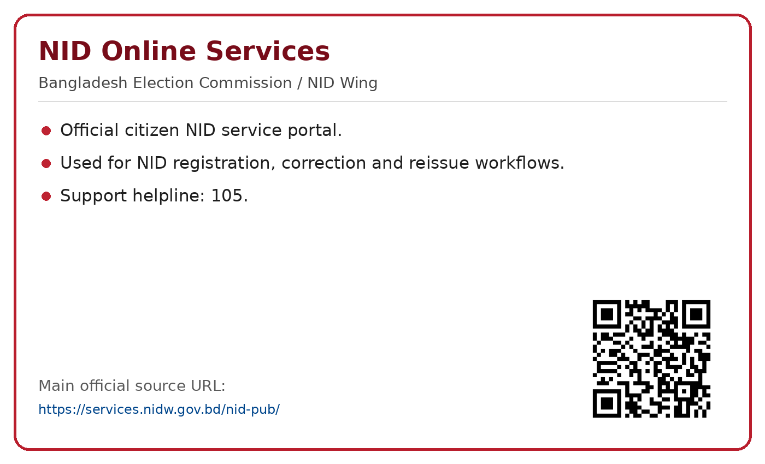
Official source: https://services.nidw.gov.bd/nid-pub/

Police Clearance Certificate
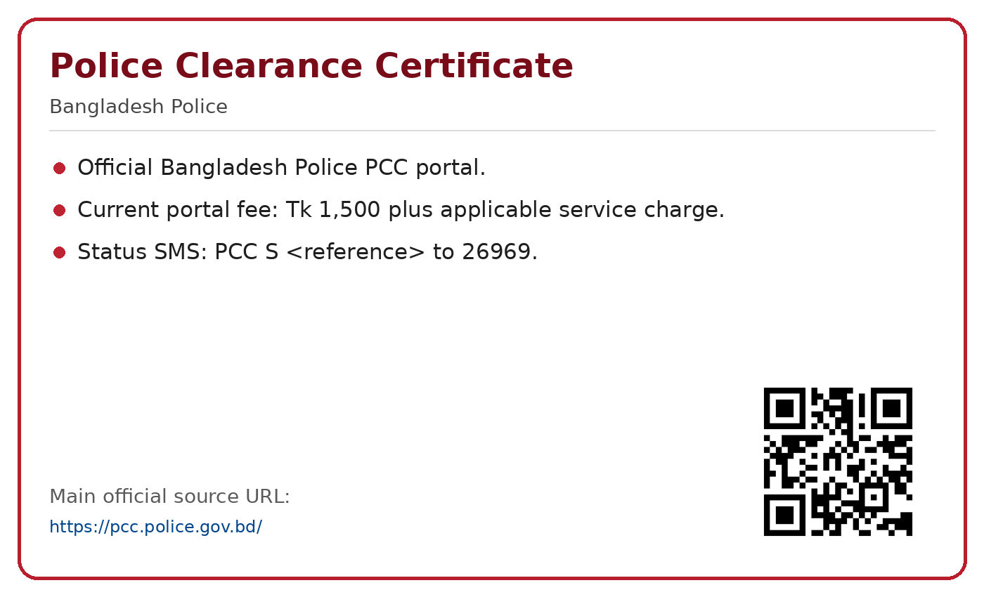
Official source: https://pcc.police.gov.bd/

Online GD
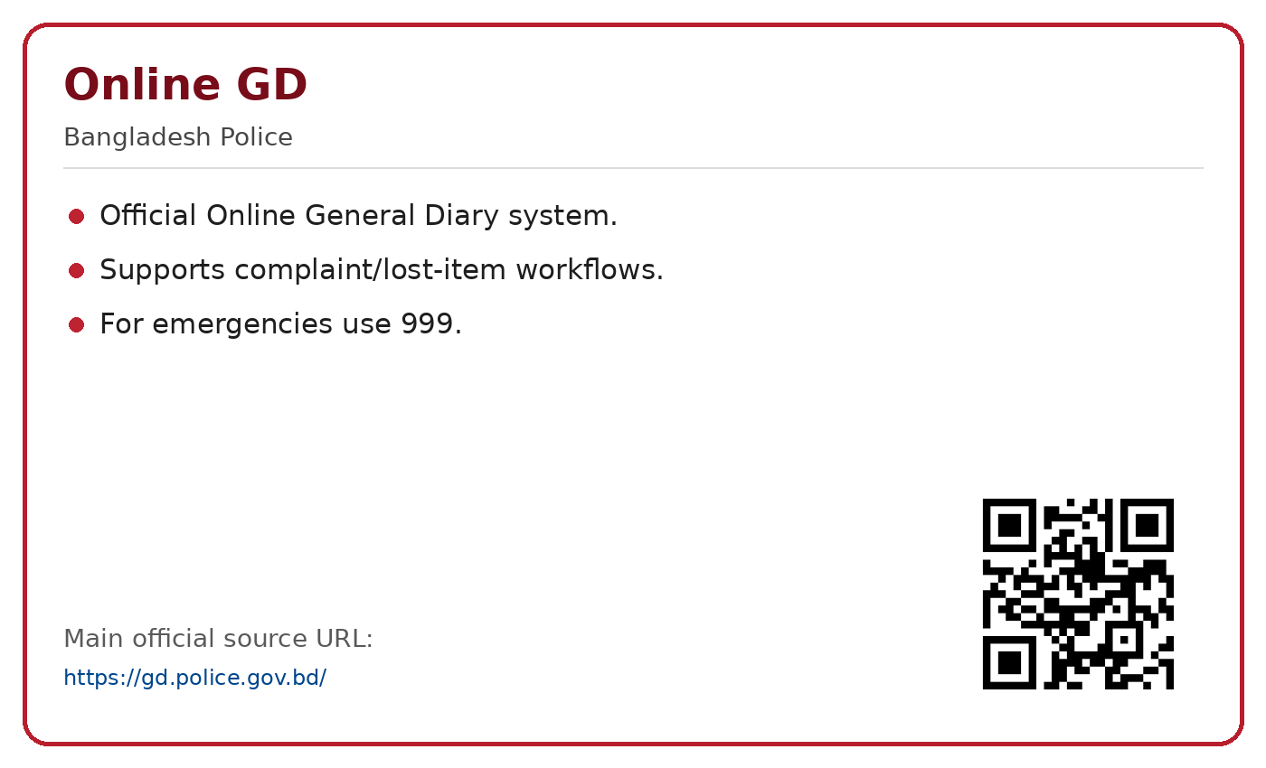
Official source: https://gd.police.gov.bd/

Marriage & Divorce Registration
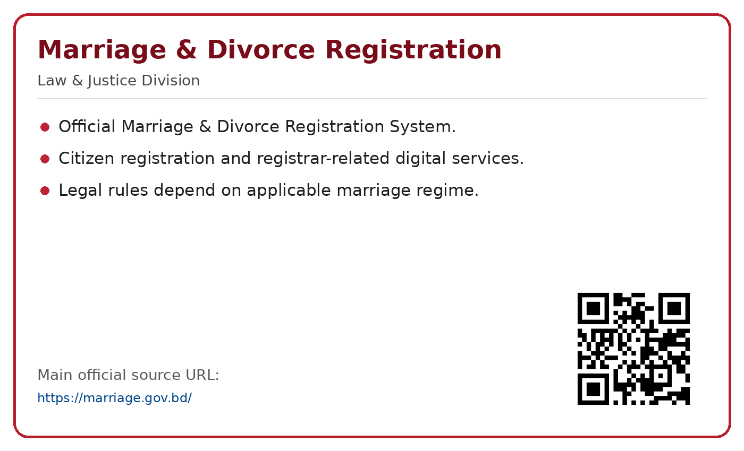
Official source: https://marriage.gov.bd/

Prottoyon
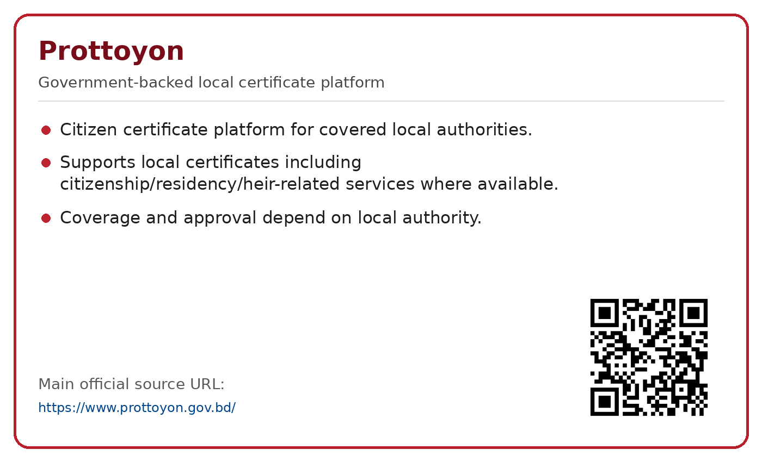
Official source: https://www.prottoyon.gov.bd/

Government Legal Aid
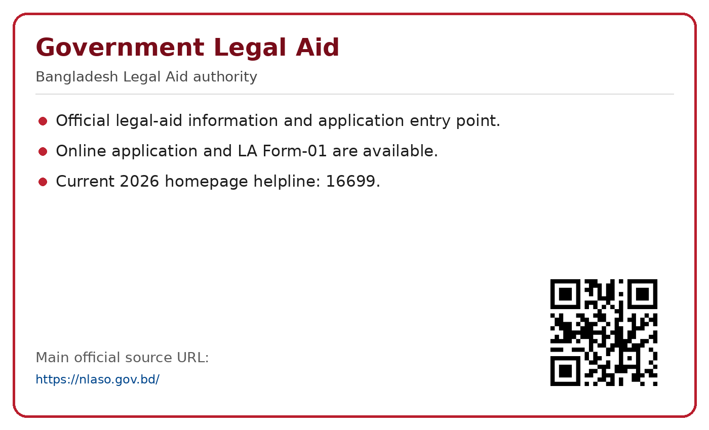
Official source: https://nlaso.gov.bd/

GRS - Government Grievance Redress
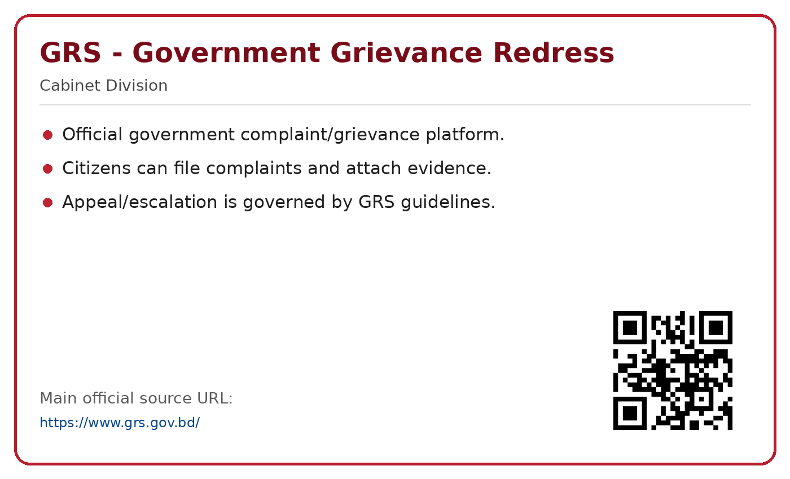
Official source: https://www.grs.gov.bd/

