Jomidarpan Concept Note
  - LandTech 2026 | P5 Citizen Pre Purchase Verification
জমিদর্পণ

Project summary
Jomidarpan is a Bengali-first citizen pre-purchase land-document comparison prototype built for the LandTech 2026 P5 problem statement. It lets a buyer search a 500-record demonstration database, review information extracted from a seller's PDF or CSV, and compare 21 fields with evidence for every match, difference or missing value. Pretrained OCR supports reading, while an optional Gemini assistant explains concepts without changing the deterministic result; agreement with the sample database is not legal ownership certification.

Problem in the Bangladesh context
A land buyer receives details such as an owner's name, plot number, khatian, deed dates, land area and mutation status from a seller, often across scanned Bangla documents. The specific failure addressed by Jomidarpan is that the buyer has no simple, consistent way to compare all of those supplied values against a selected reference record and identify the exact discrepancy before proceeding. Manual reading can miss a changed owner, an inconsistent area or an absent field, while a single overall status hides the reason for disagreement.
The rulebook identifies forged deeds, conflicting survey-generation records and fragmented registration/mutation information as relevant land-management problems. The proposed contribution is a clear buyer-facing comparison step, with the reason for every disagreement visible before a purchase decision.

Objectives and intended users
The primary user is a buyer who needs help reading and comparing seller-supplied land information. The prototype aims to reduce overlooked discrepancies, make OCR corrections explicit, and explain the evidence in Bengali. An assisted-service workflow is a future delivery option, subject to lawful data access and user validation.
Scope | Current implementation
Reference and documents | 500 demo records and 50 paired PDF/CSV cases
Decision | 21 required reviewed fields compared deterministically
Boundary | Agreement with sample records does not establish legal title

System architecture and mechanism
The buyer selects a reference, reviews values extracted in the browser, confirms them and receives a field-by-field comparison from the Worker API. Search and comparison read the same versioned D1 corpus; a partial corpus blocks a successful verdict.
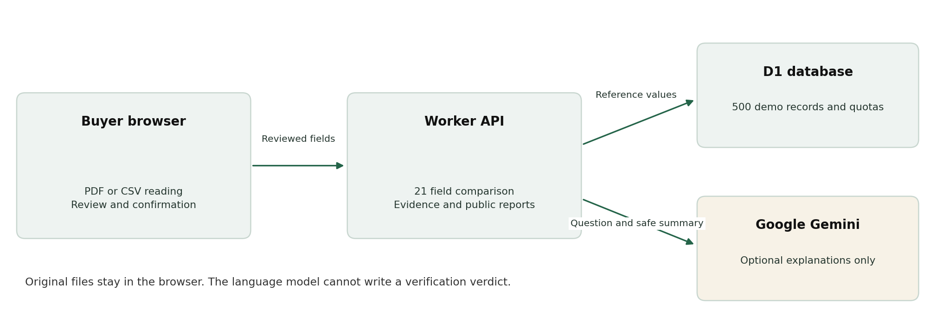
Architecture and data boundaries of the working prototype
Layer | Implementation
Interface | Bengali HTML/CSS/JavaScript studio, React/Vinext shell and mobile navigation
Reading | PDF.js, pretrained Tesseract Bangla/English; experimental Qwen ONNX/WebGPU path
API and data | TypeScript routes, Cloudflare Workers, D1 and Drizzle migrations
Explanation | Optional server-side Gemini through AI SDK; no decision-writing capability
Validation | Node tests, Happy DOM, TypeScript and Miniflare

Key features
Identifier search supports Bengali/English digits. The buyer edits and confirms OCR/CSV fields before comparison. Evidence separates matched, different and missing values. Public sample crime reports have an independent search. A nine-step tour, larger Bengali controls and current-result downloads support the buyer workflow. No saved-report archive is implemented.

Demonstration data and evaluation
The supplied v5 demonstration corpus contains 500 reference records. Fifty paired cases are available in PDF and CSV: 001-030 match and 031-050 deliberately differ or omit fields. The team must confirm that the corpus satisfies the competition requirement for team-created synthetic or organizer-provided samples.
Check | Observed evidence
PDF document suite | 50 files produce 30 verified and 20 unverified outcomes
CSV document suite | 50 files produce the same 30/20 outcomes
Node suites | 10 tests passed in the 18 October local run
Worker integration | 500 records, 30/20 API results, quotas and incomplete-corpus rejection
Type and build checks | TypeScript and production build passed

These designed fixtures establish behavior on the supplied cases, not real-world fraud-detection accuracy. OCR CER/WER, low-cost-device performance, independent fresh-machine setup and real user-task outcomes remain unmeasured.

Privacy security and the AI boundary
Original files stay in the browser. Reviewed fields go to the comparison API; the app does not persist uploaded originals or a saved-report archive. Gemini receives the user question and optional allowlisted counts/field names. Credentials remain server-side, answers render as plain text, and D1-backed quotas and request limits bound assistant use. Cloud/Google processing is not guaranteed to remain in Bangladesh.

Limitations
There is no government/police integration, authoritative pending-case/khas/acquisition clearance, digital-signature authenticity check or trained fraud classifier. Inconsistent or missing information is not itself a finding of fraud. Any real-document demonstration would require the anonymization and organizer approval specified in the rulebook.

Countrywide implementation plan
Begin with permitted synthetic samples and moderated Bengali usability sessions. Expand document/terminology coverage using consented or organizer-approved material. Before institutional adoption, define authoritative interfaces, access agreements, authorization, retention, professional review and recovery requirements. Validate cost, latency, accessibility and abuse resistance on the team's own prototype before a controlled pilot.

Validation roadmap
Stage | Next evidence required
Independent reading benchmark | Held-out permitted scans; OCR and per-field extraction accuracy
Usability study | Parcel-selection errors, correction effort, completion and verdict comprehension
Operational review | Load/error/latency measurements, monitoring, recovery and security review
Controlled pilot | Approved data access, domain review and measurable user value

Team and mentor details
Role | Name or entry to complete
Team name | [Team name]
Student leader | Deep Mitra [confirm team role]
Second student | [Full name]
Faculty mentor | [Full name and affiliation]
Industry mentor | [Full name and affiliation]

Links sources and disclosures
Repository: https://github.com/deepmitra2002/jomidarpan
Live prototype: https://jomidarpan.dncorleone1211.chatgpt.site
Source: LandTech 2026 Rule Book, English sections 3 and 7-11; supplied project source and test-report.json. OpenAI ChatGPT/Codex assisted code, UI, tests and documentation. Gemini is an optional runtime explanation provider; OCR and experimental handwriting use third-party pretrained models. No custom ML training is claimed. Team members remain responsible for explaining the code and confirming data permission.

