Jomidarpan Project Report
  - Architecture verification evidence and competition implementation

Jomidarpan helps a buyer compare reviewed seller-document information against a selected demonstration land record and inspect the evidence. This report describes the working implementation, measured fixture results, privacy and AI boundaries, setup, operational gaps and the proposed validation path.
Project information | Value
Competition | LandTech 2026 Digital Land Records Verification and Digitization
Primary problem | P5 Citizen Pre Purchase Verification
Evidence date | 18 October 2026
Maintainer | Deep Mitra
Repository | https://github.com/deepmitra2002/jomidarpan
Live prototype | https://jomidarpan.dncorleone1211.chatgpt.site

The prototype compares 21 fields against 500 demonstration records. Verification indicates dataset agreement, not authoritative legal title or transaction safety. Commercial and countrywide implementation plans are hypotheses to validate.

Report guide
Sections 1-7 explain the user problem, implemented workflow, AI roles and evidence. Sections 8-14 cover privacy, security, operations, business assumptions, validation and limitations. Sections 15-20 provide the stack, setup, configuration, deployment, tests and source map. Disclosures identify the data, external components and AI assistance.
Evidence references used throughout are the supplied LandTech rulebook, the application source, the actual PDF/CSV test report, and the 18 October local validation results. The home image is an unedited screenshot supplied by the hosting platform for deployed version 5; some SVG/illustration assets are not displayed in that capture.

1 The problem
A buyer may receive an owner's name, khatian, plot/dag number, deed dates, mutation status and land area from a seller. Those details are spread across different documents and offices. Reading a scanned Bangla record is difficult; manually checking every field makes discrepancies easy to overlook.
The supplied LandTech rulebook identifies forged deeds, conflicting khatians across survey generations and the separation between registration and mutation records as relevant problems. Jomidarpan's bounded problem is to make seller-to-reference comparison understandable before a buyer commits to a transaction. It helps the buyer locate a candidate record, review extracted information and see exactly what differs.
We do not claim that a matching sample record proves authenticity. Authoritative title, pending-case and acquisition verification require approved data access and professional validation beyond this prototype.

2 What Jomidarpan does
The buyer searches for a land record, selects the intended parcel, uploads one seller document, reviews the extracted fields and confirms a comparison. The result includes evidence for each field.
Result | Trigger | Buyer sees
Verified | All 21 required reviewed values agree with the selected record after supported normalization | Matched fields with reference/document values and provenance
Unverified | At least one field differs or is missing | The specific difference or missing-information reason
Unavailable | The request cannot be completed, including an incomplete reference database | An error; no successful verification claim

Try LND-0001 / plot 2001 with submission-001.pdf or .csv: 21 matches. Try LND-0031 with submission 031: 20 matches and an owner difference. The filename does not control the result; actual reviewed values do.

3 Features
Capability | What works now | Boundary
Land search | Record, plot/dag, khatian and deed search; Bangla/English digits | Explicit selection required when multiple candidates exist
PDF/CSV intake | PDF.js text extraction, Tesseract fallback, shared CSV parser | OCR can be wrong; buyer review is required
Field comparison | 21 fields; matched, different and missing evidence | Database agreement only
Crime search | Independent number search and eligible public sample reports | No report found means none in this dataset
Claim analysis | Separate rule-based discrepancy/claim analysis | Not an authoritative fraud finding
Document reader | Printed Bangla/English OCR; experimental WebGPU handwriting path | Hardware/model support and handwriting accuracy vary
AI assistant | Gemini explains concepts and allowlisted result summaries | Cannot change comparison decisions
Rural-friendly UX | Bengali-first copy, flag, rice/land logo, village illustration and larger controls | Usability with rural participants remains unmeasured
Mobile and guidance | Responsive bottom navigation, phone-width preview, nine-step tour | Desktop preview is not a physical-device test
Evidence and samples | Current evidence download/print, 500-record CSV and all 100 files | No saved-report archive or uploaded-original storage

App screenshots
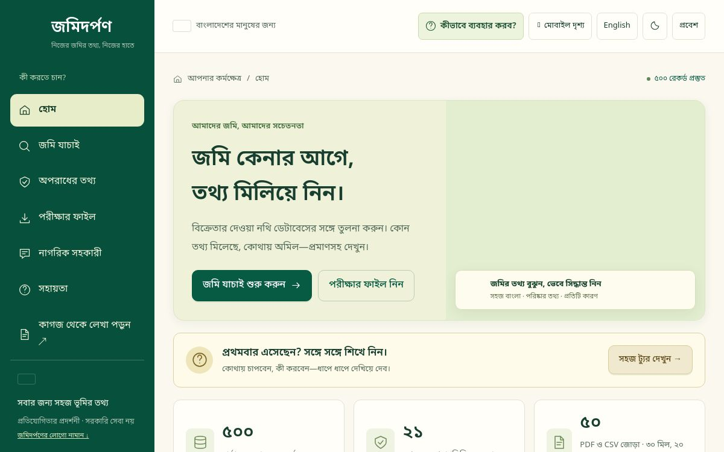
Actual hosted home screen from deployed version 5
Actual hosting-platform capture of deployed version 5; some SVG/illustration assets are not displayed in this capture. It has not been edited.
Land Verification, Crime Search, Sample Files, AI Assistant, mobile and tour screenshots remain pending supported browser capture. The banner is an illustration, not an app screenshot. See capture provenance and checklist. No screenshots from Thamun are used as Jomidarpan evidence.

4 How it works
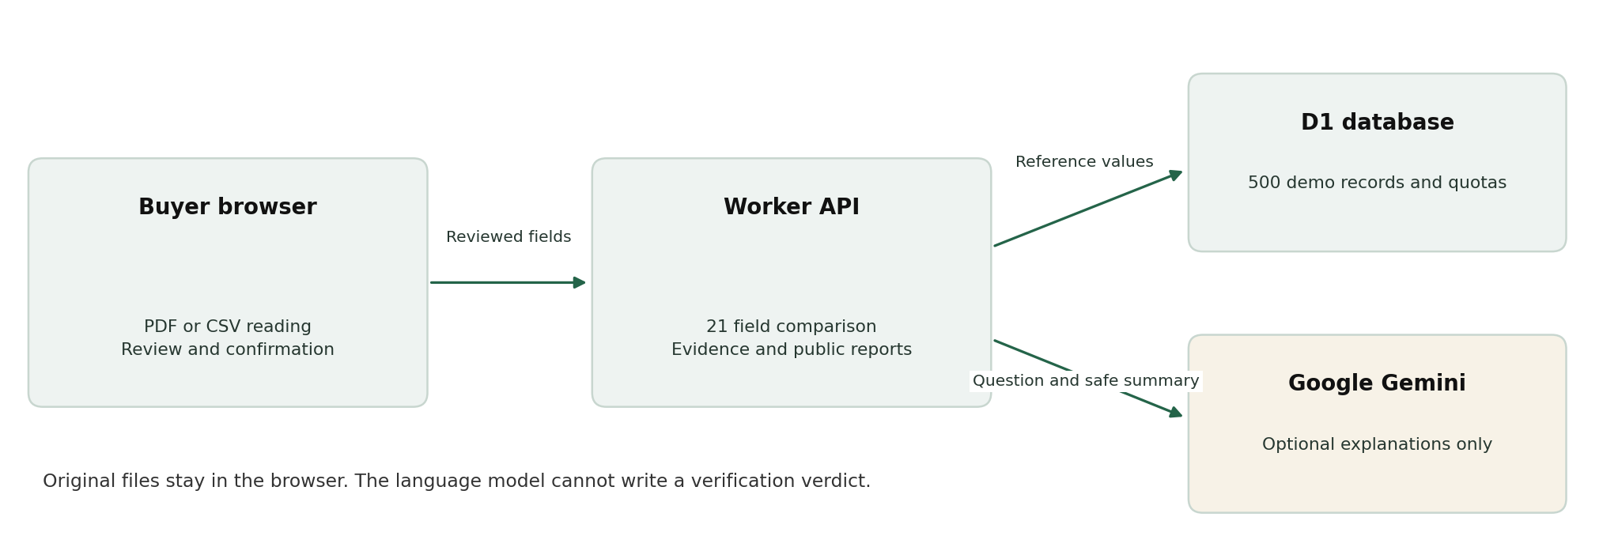
System components and boundaries
The file is processed in the browser. The server receives reviewed values, the selected reference ID and provenance. It reads the same D1 dataset that powers search, then applies deterministic comparison rules. Missing values stay visible; they are not filled from the reference to manufacture a match.
The corpus is inserted idempotently after schema migrations create the tables. A partially populated corpus blocks verification. Normalization supports Bangla/English digits, whitespace, valid supported dates, numeric shares and supported area units. See Architecture, API contracts and dataset assumptions.

5 AI and ML depth
Jomidarpan combines pretrained AI for reading and explanation with deterministic code for the decision. It does not train a custom fraud classifier.
Layer | Technology and role | Training/evaluation status
Embedded PDF text | PDF.js reads existing text | Parsing, not ML
Printed Bangla/English OCR | Tesseract uses pretrained language assets | No team-trained model; representative OCR character/word error rates unmeasured
Experimental handwriting | Retained browser Qwen3.5-2B ONNX path through Transformers.js/WebGPU | Third-party pretrained model; device support and accuracy unmeasured
Field extraction | Label-based parser and CSV schema handling | Deterministic rules; exercised against the supplied corpus
Record comparison | Shared normalization and 21-field comparator | No learning/training, no probability score
Citizen assistant | Server-side Gemini through AI SDK | Optional general explanation; no fine-tuning or measured legal-answer accuracy

Measured now: the document suite extracts all 50 PDFs and parses all 50 CSVs, giving 30 verified and 20 unverified outcomes for each format. These are designed fixture outcomes, not a real-world accuracy percentage. No AUC, precision/recall, training curve, SHAP analysis or model superiority claim is made because the prototype has no fitted fraud classifier.
Next evaluation: assemble a permitted synthetic/anonymized scan corpus; separate clean printed text, noisy scans and handwriting; measure OCR CER/WER, per-field extraction accuracy, correction effort, missed discrepancies and incorrect mismatch alerts. Keep comparison fixtures separate from that independent reading benchmark. Evaluation plan.

6 Explainability and the LLM boundary
Every compared field carries a rule identifier, document value, reference value, status, reference/version metadata and source provenance. The buyer can inspect the difference rather than accepting a single unexplained score.
Decision component | Can affect Verified/Unverified? | Explanation
Reviewed input and selected reference | Yes | The buyer confirms what is being compared
Normalization and field rules | Yes | A missing or unequal required field prevents a match
Separate claim analysis | No direct replacement of the comparison verdict | Additional rule-based context, not legal proof
Gemini answer | No | Explains concepts/result counts; has no decision-writing tool

The assistant may receive only an explicit question and optional allowlisted counts/field names. It does not automatically receive a document, owner name, reference ID or actual field value. Model output is rendered as text, not executable HTML. A provider failure does not prevent deterministic comparison.

7 Customer experience and alert fatigue
Land-document review is a deliberate buyer action, rather than a background stream of payment alerts. The design goal is to make discrepancies actionable without presenting every data gap as fraud.
Choice | Purpose
Search before upload and explicit record selection | Reduce comparisons against the wrong parcel
Review screen before confirmation | Catch OCR errors before they become apparent mismatches
Matched/different/missing evidence | Distinguish a missing value from contradictory information
No automatic fraud accusation | Keep disagreement separate from criminal/legal conclusions
Edits invalidate old results | Prevent a stale verdict from remaining visible
Nine-step optional tour, Back/Skip/Escape and reduced motion | Help new users while allowing experienced users to proceed
Large Bengali controls and mobile bottom navigation | Reduce navigation and reading effort

Task completion, correction time, mistaken record selection and warning comprehension have not yet been measured with real participants. We do not reuse Thamun's alert-fatigue statistics. Proposed user-testing measures are in Validation.

8 Privacy and data residency
Data/process | Current boundary
Original PDF/CSV | Browser processing; the rebuilt app does not upload/store the original
Reviewed fields | Sent to the application's Worker comparison endpoint
Reference corpus | Synthetic/sample data in source/downloads and D1
Gemini question | Sent to Google's configured Developer API when submitted
Optional Gemini summary | Counts and allowlisted field names only
Usage counters | Time-bucket counters keyed by a daily IP hash in D1
Saved reports and AI chat history | Not persisted by the application

Bangladesh-only residency is not guaranteed. The hosted Worker/D1 infrastructure and optional Google processing are external services. Browser OCR avoids sending the document to Gemini, but that is not a claim that all application processing stays within Bangladesh. Experimental handwriting may download model assets from a third-party host.
The rulebook prohibits real personal/land records, government scraping and unauthorized third-party security testing. Use approved synthetic/sample data only. The supplied v5 bundle is treated as demonstration data; its precise provenance as team-created or organizer-provided must be confirmed by the team before submission. Security/privacy notes.

9 Security
Control | Implemented behavior
Credential separation | Gemini key is a server secret, excluded from source and browser code
Input handling | Allowlisted comparison fields and bounded request bodies
Database access | Prepared D1 statements
Corpus integrity checks | Expected version/count; incomplete data blocks verification
Public report filtering | Ineligible/private QA report details omitted from public API results
Assistant origin check | Different explicit Origin rejected
Assistant abuse limits | D1-backed visitor/global quotas, bounded output and timeout
Output safety | Escaped application text, plain-text AI answers and sanitized provider failures
Invalidated evidence | Editing reviewed fields requires a new comparison

Not claimed: penetration testing, signed land documents, QR authenticity, immutable ledger, comprehensive audit logging, complete production authorization or certification. A quota counter is not a full security monitoring system. Retained Sites sign-in does not mean every demo data route requires authentication. Demonstrate security only on this team's own prototype; do not probe government systems. Security policy.

10 Scalability and monitoring
Static UI/OCR assets are separate from the Worker APIs. D1 stores versioned reference records and assistant quotas; PDFs are processed in the browser rather than on the Worker. This limits server document-processing work in the current design.
Area | Current evidence | Next work
Dataset health | /api/status, 500-record assertion and partial-corpus failure test | Operational health alerts and migration/seed observability
Request handling | Isolated Worker integration checks | Representative concurrency/load tests
AI service | Timeouts, quotas and sanitized failure codes | Latency/error dashboards, budget monitoring and alert thresholds
Search | Exact search across the 500-record corpus | Indexed lookup and query plans before larger authorized corpora
Browser OCR | Work stays on the user's device | Low-cost Android memory/network/time benchmarks
Operations | Basic sanitized warnings and quota cleanup | Structured metrics, retention policy, recovery drills and SLOs

No requests-per-second, p95 latency, availability target or countrywide capacity result has been measured. Serverless hosting alone does not prove scale. A future load test must state hardware/runtime, corpus, concurrency, durations, failure rates and percentile latency.

11 Business model
Proposed, not validated: a buyer-facing comparison service with an institutional subscription for permitted land-service/help-desk workflows. The demonstration remains a free prototype; no payments, subscription enforcement or commercial partner integration is implemented.
Question | Working hypothesis
Who benefits? | Buyers who need clearer document comparison; assisted-service providers handling permitted records
Who might pay? | An institution subscribing for workflow/volume and support, subject to validation and lawful data access
What stays accessible? | Basic Bengali guidance and an understandable evidence summary
Cost drivers | OCR asset delivery, hosting/database use, AI requests, support, review and authorized-data integration
Sustainable design | Browser processing, optional AI and quotas to bound variable cost
Impact to measure | Time to review, overlooked discrepancy rate, correction effort, comprehension and cost per completed comparison

No revenue, willingness-to-pay, prevented fraud loss or customer adoption result is claimed. A pilot should test value and costs before setting prices. Business assumptions.

12 Validation roadmap and user testing
1. Completed: deterministic fixture checks on all 100 documents, AI boundary tests, simulated-interface/tour tests and isolated Worker/D1 integration.
2. Next: independent OCR benchmark on permitted synthetic/anonymized scans, including noisy print and handwriting.
3. Next: moderated usability sessions with consent, using dummy documents; include rural Bengali readers and low-cost Android devices.
4. Later: domain-professional review of the evidence wording and permitted authoritative-data integration design.
5. Before pilot: identity/authorization, retention, abuse/load testing, operational monitoring and security review.
A proposed usability session asks participants to find the intended parcel, identify the owner mismatch in case 031, explain what Verified means and export evidence. Record completion, errors, time, corrections and understanding; do not collect real land records or unnecessary personal data. No participant count or study result is claimed yet. Detailed validation plan.

13 Changes documented before the final round
The rulebook requires a README summary of changes between rounds. The available material does not identify a verified Round 1 submission commit, so this is a dated development summary, not a certified diff against the submitted version.
Update documented on 18 October 2026 | Result
Rebuilt buyer flow around the coherent v5 corpus | 500 server records and corresponding reference CSV
Seller-document comparison | Review/confirmation and evidence for 21 fields
Data package | 50 PDFs + 50 CSVs with 30 matching / 20 nonmatching cases
Separate searches | Land lookup and public sample crime-report lookup
Report behavior | Removed saved-report archive; current evidence export remains
Branding and access | জমিদর্পণ identity, Bangladesh visual cues, mobile controls and guided tour
AI integration | Server-only Gemini explanations independent of verdicts
Repository presentation | Source folders, setup/testing docs and competition disclosure map

The team should identify the actual Round 1 commit/video and review this summary against it. Existing GitHub history is preserved; imported source commits are exports from the prior Sites workflow, not reconstructed historical authorship. Provenance and Changelog.

14 Limitations
- The 500 records and 50 paired cases are demonstration fixtures; provenance/competition permission needs team confirmation.
- Dataset agreement is not legal title verification, document authenticity, case clearance or acquisition clearance.
- P5 pending cases, khas and acquisition status are not comprehensively checked against authoritative sources.
- OCR, handwriting, smartphone performance and rural usability are not independently benchmarked.
- No custom ML training, real-world fraud-detection accuracy, clinical-style validation or production-scale load result exists.
- No government/police APIs, restored private case system, staff workflow, immutable ledger or digital-signature verification is implemented.
- Cloud/Google processing is not guaranteed to remain in Bangladesh.
- Additional app-tab/mobile screenshots and independent fresh-machine validation remain open items.

15 Technology stack
Layer | Technology
Main interface | Bengali-first HTML/CSS/JavaScript, SVG branding and responsive navigation
Application shell | React 19, Vinext, Next.js-compatible routes, TypeScript and Vite
Runtime | Cloudflare Workers through ChatGPT Sites
Database | D1, Drizzle schema and SQL migrations
Document reading | PDF.js, Tesseract Bangla/English assets
Experimental handwriting | Transformers.js, Qwen3.5 ONNX and WebGPU
GenAI | AI SDK 7 and Google provider
Tests | Node test runner, Happy DOM, TypeScript and Miniflare
Package management | pnpm with a committed lockfile

The exact versions are in package.json and pnpm-lock.yaml. Retained starter components may be present without being used by the main studio.

16 Installation and setup
Use Node.js 22.18+, Git and the pnpm version pinned in package.json. No Python API or requirements.txt is part of this application's server stack.
git clone https://github.com/deepmitra2002/jomidarpan.git
cd jomidarpan
pnpm install --frozen-lockfile
# Restore executable bits for the retained shell helpers on Linux/macOS.
chmod +x scripts/*.sh
pnpm dev
The portable development command defaults to http://localhost:5173. Open /studio.html. Runtime bindings are declared in vite.config.ts; the app needs a local D1 DB binding for database routes. A clean clone defaults to the portable profile; ignored .sites-runtime state belongs to the original managed checkout.
For a fresh local database, build first and apply the two initial SQL migrations once. These exact local schema commands were exercised in the managed checkout; they never use --remote. Do not rerun initial CREATE TABLE files on an already provisioned database. The built local Worker uses the same .wrangler/state path.
pnpm build
node --import ./scripts/sites-env.mjs ./node_modules/wrangler/bin/wrangler.js d1 execute DB --local --config dist/server/wrangler.json --persist-to .wrangler/state --file drizzle/0000_wooden_exodus.sql
node --import ./scripts/sites-env.mjs ./node_modules/wrangler/bin/wrangler.js d1 execute DB --local --config dist/server/wrangler.json --persist-to .wrangler/state --file drizzle/0001_third_captain_universe.sql
pnpm start
For the separately isolated integration test, run node scripts/test-server.mjs after building. It creates its own D1 database, applies migrations, seeds 500 records and mocks Google.
The hosted deployment is working; an independent clean-machine development setup is not yet validated. See setup notes rather than assuming an HTML-only server supplies the APIs.

17 Environment variables
Name | Purpose | Default/requirement
GEMINI_API_KEY | Server-only Google credential | Required only for live AI answers; never commit
GEMINI_BASE_URL | Gemini Developer API base URL | https://generativelanguage.googleapis.com/v1beta
GEMINI_MODEL | Model available to the configured Google project | Current code fallback: gemini-3.8-flash; availability is account-dependent
DB | D1 runtime binding | Binding, not a client environment variable

See .env.example for non-secret names/defaults. Use ignored .dev.vars for local Worker secrets and Sites runtime secrets in production. Do not prefix a key for client exposure or put it in a screenshot/request example. Core comparison does not require Gemini.

18 Deployment
The live version is hosted by ChatGPT Sites on Cloudflare Workers/D1. GitHub is the source-review destination, not an automatic production-deployment trigger.
1. Preserve .openai/hosting.json, existing source identity, Sites build adapters and migration history when updating the existing Site.
2. Build the exact source with the supported Sites build workflow.
3. Push/package that exact source, save a version and deploy it with the existing audience.
4. Configure DB and server-side Gemini secrets in the hosting platform; do not embed a live key in the repository.
5. Check dataset health and exercise a matching and nonmatching case after deployment.
On another host, provision compatible Worker/D1 bindings and adapt identity/build settings. Vercel/Render commands from Thamun do not deploy this different stack unchanged. Database backups, recovery and production monitoring are future operational requirements. Architecture.

19 Testing
pnpm exec tsc --noEmit
node --test tests/documents.test.mjs tests/assistant.test.mjs tests/interface.test.mjs
pnpm build
node scripts/test-server.mjs
Evidence | Observed result | What it establishes
Document suite | 50 PDFs: 30 verified / 20 unverified; 50 CSVs: same | Shared extraction/parsing and comparison behavior on the supplied cases
All three Node suites | 10 tests passed in the 18 October local run | Normalization, missing/changed values, public-report filtering, AI safety and simulated UI
Isolated Worker/D1 integration | 500 seeded records; 30/20 comparison API outcomes | Built API flow, quotas, cross-origin rejection and partial-dataset failure
TypeScript and production build | Passed | Current implementation type/build checks

The document test regenerates test-report.json. It does not read a filename/manifest flag to choose the runtime outcome. AI tests mock Google; Happy DOM is not a real browser/device. The tests do not establish legal correctness, broad OCR accuracy or load capacity.

Judgefriendly demo sequence
Step | Do this | Expect
1 | Search 2001 or ২০০১ in land verification | Same plot search result
2 | Select LND-0001; upload submission-001.pdf/csv; review and confirm | 21 matched fields, Verified
3 | Select LND-0031; upload submission-031.pdf/csv | Owner difference, 20 matches, Unverified
4 | Remove or change a reviewed value | Previous result invalidated; new missing/different evidence after comparison
5 | Search available public sample reports | Eligible report details or no eligible report found
6 | Ask “খতিয়ান কী?” in the assistant | Explanation, separate from database evidence
7 | Run the tour and use phone-width view | Cross-tab guidance and responsive navigation

Full coverage/limits: Testing, Data, Validation.

20 Project structure
The application uses its actual Vinext/Worker structure. It is not renamed to imitate Thamun's Python folders.
Path | Main contents
app/api/land/route.ts | Identifier search
app/api/compare/route.ts | Confirmed reviewed-field comparison
app/api/crime/route.ts | Public sample-report filtering
app/api/assistant/route.ts | Gemini endpoint and quota handling
app/api/status/route.ts | Dataset/session health
app/, app/p5/ | Layout, identity helpers and studio redirects
lib/jomi/ | Canonical fixtures, normalization, extraction, comparator and claim rules
lib/ai/assistant.ts | Question validation, model request and error sanitization
public/studio.*, public/tour.js | Main UI, mobile layout and nine-step guide
public/reader.html, reader scripts | OCR/experimental handwriting interface
public/vendor/ | Local PDF/OCR/runtime assets and language models
public/downloads/ | Reference CSV, 50 PDF/CSV pairs, bundles and test evidence
db/, drizzle/, drizzle/meta/ | D1 schema, migrations and migration metadata
components/, hooks/, vendor/ | Retained UI support and third-party styling assets
tests/, scripts/test-server.mjs | Document, AI, simulated-interface and Worker checks
build/, scripts/, .openai/ | Sites/Vinext build integration and configuration
docs/ | Competition alignment, architecture, APIs, validation and guides
examples/d1/ | Retained starter D1 example, separate from active land routes

See Architecture for responsibilities and Contributing for change expectations.

Disclosures
- Data: user-supplied LandTech v5 demonstration bundle. It is not a live official registry. Older v2/SYN datasets are excluded from active comparison. Confirm permitted provenance before competition submission.
- AI tools: OpenAI ChatGPT/Codex assisted with rebuilding code, UI, tests and documentation. Google Gemini is an optional runtime explanation provider. Tesseract and the experimental Qwen path use third-party pretrained models; no custom training is claimed.
- External components: React, Vinext, Next.js-compatible tooling, Vite, Cloudflare Workers/D1 tooling, Drizzle, AI SDK/Google provider, PDF.js, Tesseract, Transformers.js, Qwen/ONNX assets, Happy DOM and retained UI/style packages. Exact versions and license notices remain in source. No new blanket license is assigned to third-party assets.
- Authorship/history: GitHub commits are preserved. Earlier native Sites history is separate; see Provenance. This README does not reconstruct earlier authorship or certify a Round 1 submission diff.
- Reference presentation: Thamun's README was consulted for documentation organization only. Jomidarpan has a different problem, implementation and evidence; no Thamun metrics, screenshots, team roster or model claims are presented as ours.
- Rulebook: LandTech 2026 rulebook, supplied by the user. Competition alignment records implemented scope and remaining deliverables; it is not organizer approval.

Evidence references
1. LandTech 2026 Rule Book, supplied PDF. English sections 1 and 3 describe the context/problem statements; sections 7-11 cover development, data/privacy/security, AI disclosure, submissions and presentation. This report does not verify later organizer announcements.
2. public/downloads/test-report.json and tests/documents.test.mjs. Designed paired-case outcomes are 30 verified and 20 unverified for each of PDF and CSV.
3. tests/assistant.test.mjs, tests/interface.test.mjs and scripts/test-server.mjs. These cover mocked AI behavior, simulated-interface behavior and isolated Worker/D1 integration respectively.
4. Active implementation in app/api, lib/jomi, lib/ai, public/studio files and public/tour.js. The code, not the expected-result manifest, determines comparison outcomes.
5. Hosting platform screenshot for deployed version 5, source commit e6d950821b038bab1c86520ecc46030b0fc7b9ed, retrieved on 18 October 2026. Additional tab/mobile captures remain pending.

