magicmaus: certainty-bounded, score-committed assignment of methyl NMR resonances
Structural bioinformatics

magicmaus: certainty-bounded, score-committed assignment of methyl NMR resonances
Donghan Lee ^{1,*}
¹ Korea Basic Science Institute, Ochang, Republic of Korea.
* To whom correspondence should be addressed.
Associate Editor: (to be assigned)

Abstract
Summary: Automated assignment of methyl NMR probes in large proteins is approached in two irreconcilable ways: as a constraint-satisfaction problem (MAUS), which returns for every peak the set of methyls consistent with all hard constraints and provably never excludes the correct one, but abstains on any residual degeneracy; and as a scoring problem (MAGIC), which commits to a single best assignment but, over the full candidate space, does so on a near-flat objective and is frequently wrong. We present magicmaus, a hybrid that uses the satisfiability layer to bound the search to a certifiably truth-containing set of per-peak candidates, then applies an intensity-weighted NOE score within those bounds to commit to a single, globally coherent, injective assignment carrying a per-peak confidence tier. On maltose-binding protein (192 methyls), scored on an identical intensity NOESY, magicmaus assigns 72.9% of methyls correctly (79.7% with ambiguous-NOE evidence) versus 5.7% for the scoring method alone, while retaining the constraint method’s 100% never-exclude guarantee as an explicit ambiguity envelope.
Availability and implementation: magicmaus is implemented in Python 3 (NumPy, PySAT) and released under the MIT license at https://github.com/deepnmr/magicmaus, with tutorials and the benchmark data.
Contact: kbsi.bionmr@gmail.com

1 Introduction
Methyl groups are the workhorse probes of solution NMR on large proteins and molecular machines: methyl-TROSY spectroscopy yields sharp signals well beyond 100 kDa (Tugarinov et al., 2003). Exploiting them requires assigning each observed methyl ¹H/¹³C HMQC cross peak to a specific methyl in the protein structure, a laborious step that has motivated several automated, structure-based methods driven by methyl–methyl NOEs.
Two paradigms dominate. MAGIC (Monneau et al., 2017) scores a global peak→methyl map with a confidence-weighted NOE objective and returns the highest scorer — a single answer per peak. MAUS (Nerli et al., 2021) casts the same problem as subgraph isomorphism and solves it with a SAT solver, returning for each peak the set of methyls consistent with every hard constraint, and provably never excluding the correct assignment.
The two have complementary failure modes. MAUS is safe but indecisive: where the data do not force a unique answer — geminal methyl pairs, shift-degenerate peaks — it reports the full option set and commits to nothing. MAGIC is decisive but, searching the entire type-matched candidate space, sits on an objective whose runner-up assignments lie within ~1–2% of the true optimum on structure-derived NOE data (Monneau et al., 2017), so its bounded search commits to near-optimal-but-wrong answers for most peaks. Neither is dominant. We show that the natural synthesis — bound the space with certainty, then score within the residual degeneracy — is both simple and decisively better than either parent.

2 Approach
magicmaus runs the two layers in sequence (Fig. 1A).
Layer 1 (bound). The MAUS SAT encoding is reused verbatim: variables map each HMQC peak to a candidate methyl of the matching residue type; hard clauses enforce exactly-one assignment per peak, injectivity, and that every firm NOE cross peak lands on a structural contact within the distance cutoff. For each peak the set of methyls appearing in at least one satisfying assignment is enumerated with the solver’s assumption interface (Glucose; Audemard and Simon, 2009). Because the correct global assignment is itself a model, the true methyl is present in every peak’s option set — the never-exclude guarantee — and the option sets prune each peak’s candidates from up to ~60 to typically 1–3.
Layer 2 (commit). The per-peak option sets are enumerated independently, so their product is not jointly realizable and does not identify a single best map. This is precisely the question a score answers. Restricting every peak’s domain to its option set — which removes only methyls appearing in no satisfying map, and so preserves the solution space and the truth — magicmaus obtains one jointly-consistent assignment from the SAT solver and refines it by feasibility-preserving coordinate ascent on a MAGIC-style objective: each firm NOE contributes intensity·(1/r⁶) for the structural contact it is placed on, so a strong NOE is driven onto a close contact. Every move stays injective and NOE-consistent, so the output is always a valid bijection — a property a naïve per-cluster search cannot guarantee on the single 138-peak degeneracy cluster of the benchmark below. Optionally, the ambiguous NOE cross peaks MAUS discards are folded back in as diluted, intensity-weighted soft evidence.
Each peak is reported three ways (Fig. 1A): the committed single call; its MAUS option set, retained as an explicit ambiguity envelope; and a confidence tier from the local scoring margin — unique (forced by hard constraints), scored (resolved by the NOE score), or ambiguous (a tied alternative exists, i.e. a genuine symmetry). Because the scored search runs only over the tiny pruned domains, the whole pipeline completes in ~1 s for 192 methyls.

3 Results
We benchmarked on E. coli maltose-binding protein (MBP) using experimental methyl ¹³C/¹H shifts from BMRB entry 7114 and structure PDB 1ANF (192 methyls: 44 Ala, 22 Ile, 60 Leu, 6 Met, 20 Thr, 40 Val). As BMRB deposits no NOESY peak list, a 3D (H)CCH network was simulated from 1ANF geometry with 1/r⁶ intensities; the identical network was supplied to all three engines (Fig. 1B).
The scoring method (MAGIC) assigned 5.7% of methyls correctly (10.4% at residue level), consistent with its reported 4–10% on structure-simulated NOESY and with the near-flat-landscape limitation of full-space scoring. The constraint method (MAUS) resolved 26.6% of peaks uniquely — all correct — and abstained on the remaining 73%, with the truth in the option set for 100% of peaks; its result was unchanged by the intensity column, as its boolean constraints cannot use it. magicmaus committed a single answer for all 192 peaks at 72.9% correct (79.2% at residue level), rising to 79.7% (85.4%) when the discarded ambiguous NOEs were included, while preserving the 100% never-exclude envelope throughout. The residual errors are dominated by geminal methyl pairs and shift-degenerate peaks — genuine symmetries an achiral NOE network cannot resolve — which magicmaus flags as ambiguous and reports as full option sets rather than guessing. Running the same scoring inside the MAUS bounds thus yields ~13× the single-answer accuracy of scoring over the full space, at no cost to the certainty guarantee.

4 Conclusion
magicmaus shows that constraint satisfaction and scoring are not competing solutions to methyl assignment but complementary stages of one: SAT to bound the answer with certainty, an intensity-weighted NOE score to commit within the bound. The result is a single, coherent assignment with calibrated per-peak confidence and an always-correct ambiguity envelope, obtained in seconds. The scoring layer is intensity-aware, so the approach improves directly with the information content of the NOESY — from a boolean network to real intensities to 4D experiments — and accepts tentative anchors that propagate through both layers. The two clean-room parent implementations and magicmaus are released together to support reuse and further hybridization.

Acknowledgements
The author thanks the maintainers of PySAT and the BMRB.

Funding
None declared.
Conflict of Interest: none declared.

References
Audemard,G. and Simon,L. (2009) Predicting learnt clauses quality in modern SAT solvers. In Proc. IJCAI, pp. 399–404.
Ignatiev,A., Morgado,A. and Marques-Silva,J. (2018) PySAT: a Python toolkit for prototyping with SAT oracles. In Proc. SAT, pp. 428–437.
Monneau,Y.R. et al. (2017) Automatic methyl assignment in large proteins by the MAGIC algorithm. J. Biomol. NMR, 69, 215–227.
Nerli,S., De Paula,V.S., McShan,A.C. and Sgourakis,N.G. (2021) Backbone-independent NMR resonance assignments of methyl probes in large proteins. Nat. Commun., 12, 691.
Tugarinov,V., Hwang,P.M., Ollerenshaw,J.E. and Kay,L.E. (2003) Cross-correlated relaxation enhanced ¹H–¹³C NMR spectroscopy of methyl groups in very high molecular weight proteins and protein complexes. J. Am. Chem. Soc., 125, 10420–10428.

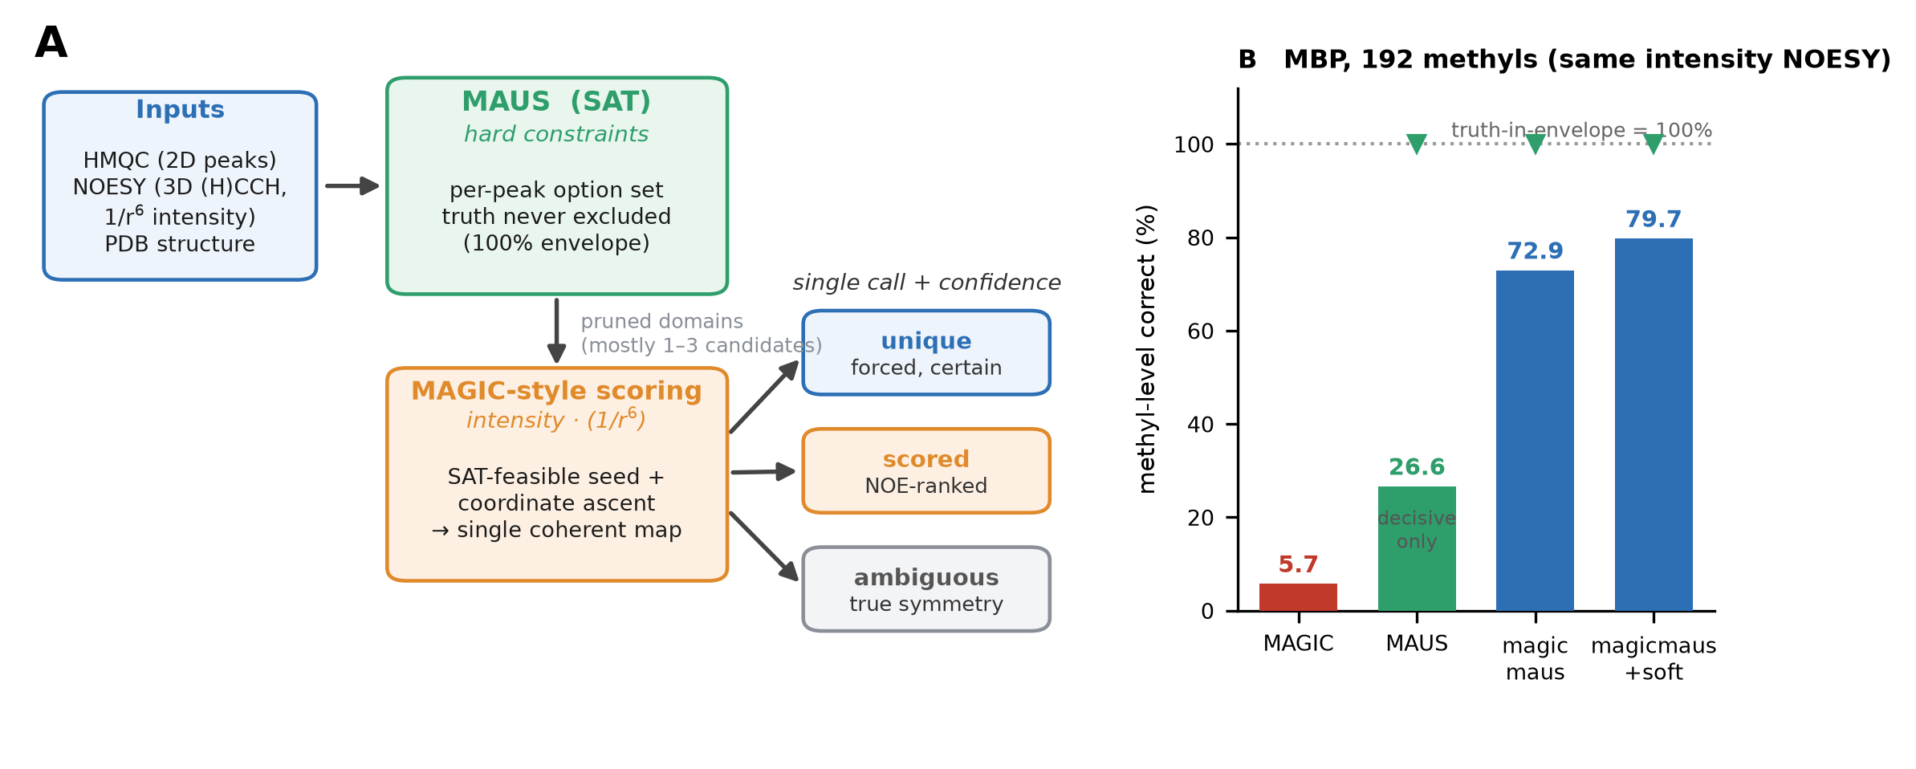
Fig. 1. (A) The magicmaus pipeline. A SAT layer (MAUS) bounds each peak to a per-peak option set that provably contains the truth (100% envelope) and prunes candidates from up to ~60 to 1–3; an intensity-weighted NOE score (MAGIC-style), applied only within those bounds via a SAT-feasible seed and feasibility-preserving coordinate ascent, commits to a single coherent map with a per-peak confidence tier (unique / scored / ambiguous). (B) Methyl-level accuracy on maltose-binding protein (192 methyls), all engines scored on the same 1/r⁶ intensity NOESY. MAUS is decisive on 26.6% of peaks (rest abstain); MAGIC and magicmaus commit on all 192. Green markers denote the 100% truth-in-envelope guarantee, preserved by MAUS and magicmaus.

