A Lineshape Correlation Coefficient for Robust Similarity of Two-Dimensional HSQC NMR Spectra
Donghan Lee
NMR Spectroscopy | Research Article
Korea Basic Science Institute (KBSI), Ochang, Republic of Korea. * Correspondence: kbsi.bionmr@gmail.com

Abstract. Quantitative comparison of two-dimensional $​^{1}$H–X HSQC spectra underlies ligand screening, chemical-shift-perturbation mapping, higher-order-structure comparability of protein biotherapeutics, and molecular fingerprinting, yet the established similarity measures each fail in one of two opposite ways: histogram-binning scores are brittle to the small peak drifts a titration induces, whereas tree- and nearest-neighbour scores saturate because in any crowded window every peak finds a coincidental near neighbour. Here we introduce the Lineshape Correlation Coefficient (LCC), which renders both spectra onto a single shared grid, blurs each by the physical NMR linewidth combined with the expected shift drift, and scores the pair by the mean-centred, zero-lag normalized cross-correlation of the two images. The Gaussian render supplies graded, physically-tunable shift tolerance while mean-centring actively penalizes intensity that is not co-located. On two deliberately opposite benchmarks — a dense protein $​^{1}$H–$​^{15}$N amide fingerprint and a sparse small-molecule $​^{1}$H–$​^{13}$C set — LCC gives the widest same/different separation in both regimes (0.75 dense, 0.78 sparse on a $[0,1]$ scale), significantly outscoring the saturating tree and nearest-neighbour measures, which leave the classes overlapping (margin $≤0.09$) in both. A bootstrap shows LCC’s sparse-regime edge over the bin method is within noise at five compounds, while its dense-fingerprint advantage is large and, on an expanded test, keeps both of two decoy proteins below every same-protein titration point; removing the mean-centring step collapses the dense-protein separation from 0.75 to 0.59, yet in the sparse regime — where peaks rarely overlap — centred and un-centred scores coincide (0.78), so mean-centring is the operation that rescues discrimination specifically when peaks crowd. LCC is a two-knob, peak-picking-free, solver-free measure with both knobs set by spectroscopy rather than by tuning.
Keywords: NMR spectroscopy · HSQC · spectral similarity · higher-order structure · chemical-shift perturbation

The comparison of two two-dimensional $​^{1}$H–X HSQC spectra is a deceptively basic operation that sits at the centre of several NMR workflows. In fragment-based and structure-based drug discovery, an amide $​^{1}$H–$​^{15}$N fingerprint is tracked across a ligand titration to read out binding through chemical-shift perturbation,$​^{[1−4]}$ and the quality of that read-out depends on being able to say, quantitatively, how different two fingerprints are. In metabolomics and natural-product chemistry, a small-molecule $​^{1}$H–$​^{13}$C spectrum is matched against a reference — an operation central to 2D-NMR-based dereplication$​^{[5−7]}$ and to searches against community libraries such as the BMRB, NMRShiftDB and HMDB.$​^{[8−10]}$
A third and increasingly prominent setting is the higher-order-structure (HOS) assessment of protein biopharmaceuticals. A protein’s biological activity, stability and immunogenicity are governed not by its amino-acid sequence alone but by its folded secondary, tertiary and quaternary structure, so confirming that this higher-order structure is preserved — between a biosimilar and its originator, across a manufacturing or formulation change, or on storage — has become a central requirement of biochemical characterization and of regulatory comparability.$​^{[11,12]}$ Two-dimensional HSQC is a premier atomic-resolution probe of that structure: each crosspeak reports the local environment of one $​^{1}$H–X pair, so two fingerprints coincide only when the two samples share the same fold, and 2D $​^{13}$C- and $​^{15}$N-HSQC fingerprinting is now an established, high-precision method for the HOS comparability of therapeutic proteins and monoclonal antibodies.$​^{[13,14,16]}$ Deciding how similar two such fingerprints are is exactly the measurement that multivariate and chemometric HOS workflows carry out,$​^{[15]}$ and exactly the primitive the present work makes robust.
In every case the same primitive is required: a single number that is high when two spectra come from the same species and low when they do not.
Three families of measure are in current use, and they fail in two opposite ways. The bin method of Bodis et al. integrates each spectrum over an $n×n$ grid at a range of resolutions and reports a weighted Jaccard (Ružička) index,$​^{[17,18]}$ in the lineage of the binning and normalization schemes long used in NMR metabonomics.$​^{[19,20]}$ Because its bin edges are hard, a peak straddling an edge splits its intensity across neighbouring bins; a small titration drift therefore erodes the score in a discontinuous jump. The measure is shift-brittle. The quad-tree method of Castillo et al. encodes a spectrum as a recursive centre-of-mass tree and compares trees node-by-node with a shift-tolerant node score,$​^{[21]}$ and the peak method of Pierens et al. picks peaks and matches each to its nearest neighbour in the other spectrum.$​^{[22]}$ Both build in genuine shift tolerance — but in a crowded window every peak has some near neighbour and every spectrum a similar mass-centre structure, so both saturate near unity and retain almost no contrast between related and unrelated spectra. They are shift-blind. A measure fit for real HSQC comparison must tolerate the small physical drifts a titration or a solvent change induces, yet still penalize intensity that is genuinely relocated.
We resolve this tension with the Lineshape Correlation Coefficient (LCC), a measure that keeps the physically meaningful ingredients of all three predecessors — area-weighted integration and unit normalization (Bodis), a physical shift tolerance (Castillo), and a lineshape picture of the spectrum (Pierens) — and adds a mean-centred correlation as the discriminating step. Given two spectra compared inside a common window $Ω$ (processed Bruker data from any standard pipeline$​^{[23−27]}$ or peak lists rendered to a grid), LCC proceeds in three steps (Figure 1a).
Render. Negative intensities are clipped, each point is weighted by its local integration area, and both spectra are histogrammed onto a single shared grid, so they are directly comparable irrespective of their native digital resolution. The mass is normalized to unit sum; the final score is invariant to this scale.
Blur. Each image is convolved with a separable Gaussian whose width per axis is the physical linewidth combined with the expected drift, $σ=\sqrt{ℓ^{2}+d^{2}}$. This replaces the bin method’s hard edges with a continuous response. For an isolated peak on a large grid, two copies displaced by $(Δ_{2},Δ_{1})$ correlate as $exp(−Δ_{2}^{2}/4σ_{2}^{2}−Δ_{1}^{2}/4σ_{1}^{2})$ — smooth and monotone in the drift (Figure 1b), so a physical shift costs little while a random relocation ($Δ≫σ$) costs almost everything. The blur width, not a bin count, is the tolerance knob, and it is set by two spectroscopic quantities: the linewidth (the floor) and the expected shift perturbation (the tolerance).
Score. Each image is mean-centred and the similarity is the zero-lag normalized cross-correlation — the Pearson coefficient — of the two centred images, clamped to $[0,1]$. This is the spectral-imaging analogue of the cosine / contrast-angle similarity long used in mass-spectral library search.$​^{[28,29]}$ Mean-centring is what turns overlap into discrimination: a cell where one spectrum has a peak (a value above its mean) and the other is empty (a value below its mean) contributes a negative product and lowers the score, so intensity that is not co-located is actively penalized rather than merely ignored, as it is by the one-way nearest-neighbour distance. No shift search is performed. Aligning the images — as in NMR peak-alignment tools such as icoshift$​^{[30]}$ — would let a genuinely different spectrum slide into registration and re-saturate, reintroducing exactly the failure mode of the tree and nearest-neighbour methods. Scoring at zero lag keeps the position information that carries the discrimination.
The measure has the properties one expects of a similarity: self-similarity is exactly one, the score is exactly symmetric, and it is monotone in the drift of an isolated peak (all verified in the test suite; Supporting Information). The implementation is pure NumPy,$​^{[31]}$ reads processed Bruker data directly, requires neither peak picking nor an external solver, and runs in about 6 ms per spectrum pair on a $250×350$ grid (Apple Silicon, single core). A 26-test suite (all passing) checks self-similarity, related-beats-unrelated ordering, and monotonicity in drift, plus regressions for the mean-centring ablation, the abs baseline and the duplicate-pair guard; figures use Matplotlib.$​^{[32]}$ A full derivation with proofs is given in the Supporting Information.
We benchmarked LCC against the three reference methods on two deliberately opposite regimes, so that any measure claiming general utility must succeed on both (Figure 2; Table 1). We summarize discrimination by the separation (mean same-class score − mean different-class score) and the margin (worst same-class − best different-class score, which is what a single classification threshold actually sees); both are reported on each method’s own $[0,1]$ scale. Every method self-scores exactly 1.00.
Dense protein $​^{1}$H–$​^{15}$N. The reference is the apo spectrum of the phosphatase PRL3, compared with six spectra of the same protein along a ligand titration (which should score high) and with a different protein (which should score low), inside a $​^{1}$H 6.5–10 $×$ $​^{15}$N 105–130 ppm window. LCC scores the same protein 0.94 (range 0.89–0.97) and the different protein 0.18, a margin of 0.71 — three times the bin method’s 0.24, the strongest baseline. Mean-centring earns that gap: replacing it with an un-centred cosine overlap on the same images drops the separation from 0.75 to 0.59. This gain is not a tuned artefact; it holds across the entire physical blur range and even survives coarsening the grid to the bin method’s own resolution (Supporting Information).
A second decoy protein and an independent titration. Because that margin is measured against a single decoy protein, we tested whether LCC’s advantage survives a harder, self-contained design: an independent PRL3 apo→olsalazine titration (23 points, from a 500 µM sample) scored against two distinct decoy folds — OAA and the kinase-domain EphB3 — inside the same window (Table 2; Supporting Information). As ligand is added the chemical-shift perturbation grows and LCC decays smoothly from 0.98 to a plateau near 0.82 — its graded shift tolerance acting on a real titration — while both decoys sit far below every titration point (OAA 0.19, EphB3 0.41). LCC keeps the widest separation (0.57) and the widest margin (0.41): both decoy proteins clear every same-protein score by a comfortable gap, whereas the tree and nearest-neighbour margins are a knife-edge (0.12 and 0.02, a single noisy titration point from crossing). The un-centred cosine trails (0.46 / 0.35), so mean-centring still earns the gap against a genuine negative distribution. This test is harder than the single-decoy benchmark on both axes — a longer titration with larger shifts and a second, tougher decoy — yet the ordering is unchanged, so LCC’s dense-regime margin is not an artefact of one negative spectrum.
Sparse small-molecule $​^{1}$H–$​^{13}$C. To probe the opposite regime — and to replace the single negative spectrum above with a large negative set — we used public HSQC peak lists from the simpleNMR example set$​^{[33]}$ for five compounds each recorded twice (one nominal sixth pair was excluded on inspection as a byte-identical duplicate; Supporting Information), and asked each method to score the 5 same-compound pairs above the 40 different-compound pairs, inside a $​^{1}$H 0–10 $×$ $​^{13}$C 0–165 ppm window. LCC again leads (mean same 0.78, mean different 0.003, separation 0.78). The bin method is far stronger here (0.65) than on the dense fingerprint (0.29): with few, well-separated peaks its hard bins rarely straddle a peak. The tree and nearest-neighbour methods, however, leave the two classes barely separable in this regime too (margins 0.09 and 0.04, despite separations of 0.41 and 0.10): over a wide window a different molecule still supplies a near neighbour for every peak. Their shift tolerance is real — per pair, it keeps two solvent-shifted recordings of the same compound high (0.83–1.00, where the position-sensitive LCC and bin methods drop to 0.30–0.60) — but it tolerates everything, so it never becomes discrimination. LCC recovers that same tolerance controllably, through its blur width, without surrendering the between-compound contrast (Supporting Information). Notably, in this sparse regime the un-centred cosine matches LCC exactly (separation 0.78): where crosspeaks rarely overlap there is no coincidental non-co-located intensity for mean-centring to penalize, so its benefit is specific to the dense fingerprint.
Statistical strength and a retrieval test. Two additions probe how much of this the small samples actually support (Figure 3). First, bootstrapping the sparse-regime separation (resampling the 5 same- and 40 different-compound pairs, ${10}^{4}$ draws) gives LCC 0.78 (95% CI 0.55–0.98), overlapping the bin method’s 0.65 (0.42–0.84) but cleanly above the saturating tree (0.41, 0.34–0.49) and nearest-neighbour (0.10, 0.09–0.11) measures (Figure 3a): on this five-compound set LCC’s edge over the bin method is within noise, while its advantage over the two shift-tolerant methods is significant. Mean-centring is what separates LCC from the un-centred cosine, and only where peaks crowd: the ablation gains $+0.16$ on the dense fingerprint but nothing on the sparse set (Figure 3b). Second, cast as a library search — rank the other nine spectra for each of the ten and ask whether the true same-compound partner ranks first — every method scores top-1 = 1.00 (mean reciprocal rank 1.00): on a small, clean library the correct partner is always the single closest, even for the saturating methods, so retrieval becomes discriminating only under a rejection threshold or at library scale — which is exactly what the separation and margin measure. The dense-protein margin (0.71) remains LCC’s strongest single number, but rather than rest it on one decoy we add an expanded dense test with a second decoy protein (EphB3) and an independent PRL3 titration (Table 2), on which LCC keeps both decoys below every same-protein point; the sparse regime and this retrieval test further broaden the evidence with a larger, public, fully-reproducible negative set.
Across both regimes LCC is thus the only measure that beats the saturating tree and nearest-neighbour methods while retaining their shift tolerance, and it matches or exceeds the bin method — decisively on the dense amide fingerprint (margin 0.71 vs 0.24), comparably on the sparse set (within the bootstrap CI) (Table 1). Its two knobs, the per-axis blur widths, are both physical: the linewidth sets the floor and the expected shift perturbation sets how much drift is tolerated. Two caveats bound the claim honestly. First, LCC measures position-and-intensity coincidence, not molecular identity, so a close structural analogue will score intermediate — the correct behaviour for a similarity, but a caveat for hard classification. Second, the three reference methods are our own representative reimplementations compared inside one common window, and the $​^{1}$H–$​^{13}$C spectra are rendered from peak lists; accordingly the robust ranking, not the exact numerical values, is the result, and this is not a verdict on the original methods as their authors deployed them with per-spectrum windows.
In summary, a single, physically-motivated construction — render onto a shared grid, blur by the NMR linewidth, and take the mean-centred zero-lag correlation — reconciles shift tolerance with discrimination, the two requirements that the incumbent measures satisfy only one at a time. Both of LCC’s knobs are spectroscopic quantities rather than fitting parameters (its self-similarity is exact, as for every method tested), and it needs no peak picking, no alignment search, and no external solver. We are candid about scope: this is a methodological contribution — a robust, reproducible similarity primitive, not a new chemical discovery — and although its most decisive number, the dense-protein margin, was first measured against one decoy, we now show it holds against two decoy proteins on an independent titration (Table 2) and add the larger public sparse benchmark and the retrieval test. Within those bounds LCC is directly useful wherever a robust 2D-HSQC similarity is the bottleneck: automated titration tracking and CSP read-out, library and dereplication searches, quality control of repeated measurements, and the higher-order-structure comparability assessment of protein biotherapeutics and biosimilars, where 2D-NMR fingerprint comparison is already an established readout.$​^{[15,16]}$ The natural next steps are a prospective, at-scale dereplication study against a community library and a formulation/biosimilar HOS comparison, for both of which LCC supplies the scoring primitive. The full derivation, all three benchmark protocols, every numerical table with confidence intervals, and the 26-test suite are provided as Supporting Information; the software is freely available under the MIT license.

Figures
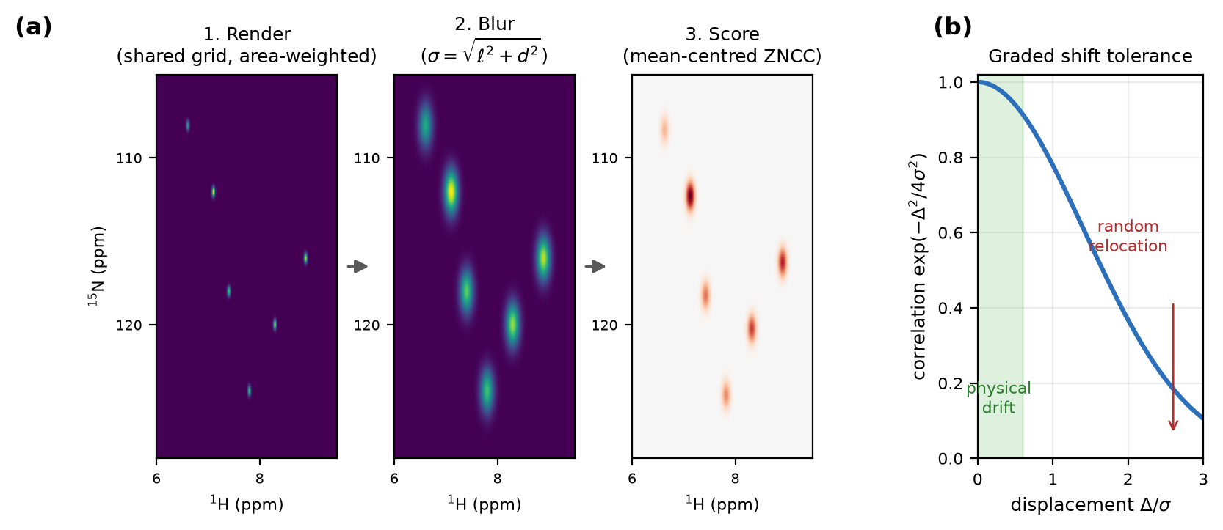
Figure 1. The Lineshape Correlation Coefficient. (a) The three-step construction: area-weighted rendering of both spectra onto one shared grid, a separable Gaussian blur of physical width $σ=\sqrt{ℓ^{2}+d^{2}}$ per axis, and the mean-centred zero-lag normalized cross-correlation of the two images (red/blue = positive/negative contribution to the score). (b) Graded shift tolerance: two copies of an isolated peak displaced by $Δ$ correlate as $exp(−Δ^{2}/4σ^{2})$, smooth and monotone in the drift, so a physical titration drift (shaded) costs little while a random relocation costs almost everything.
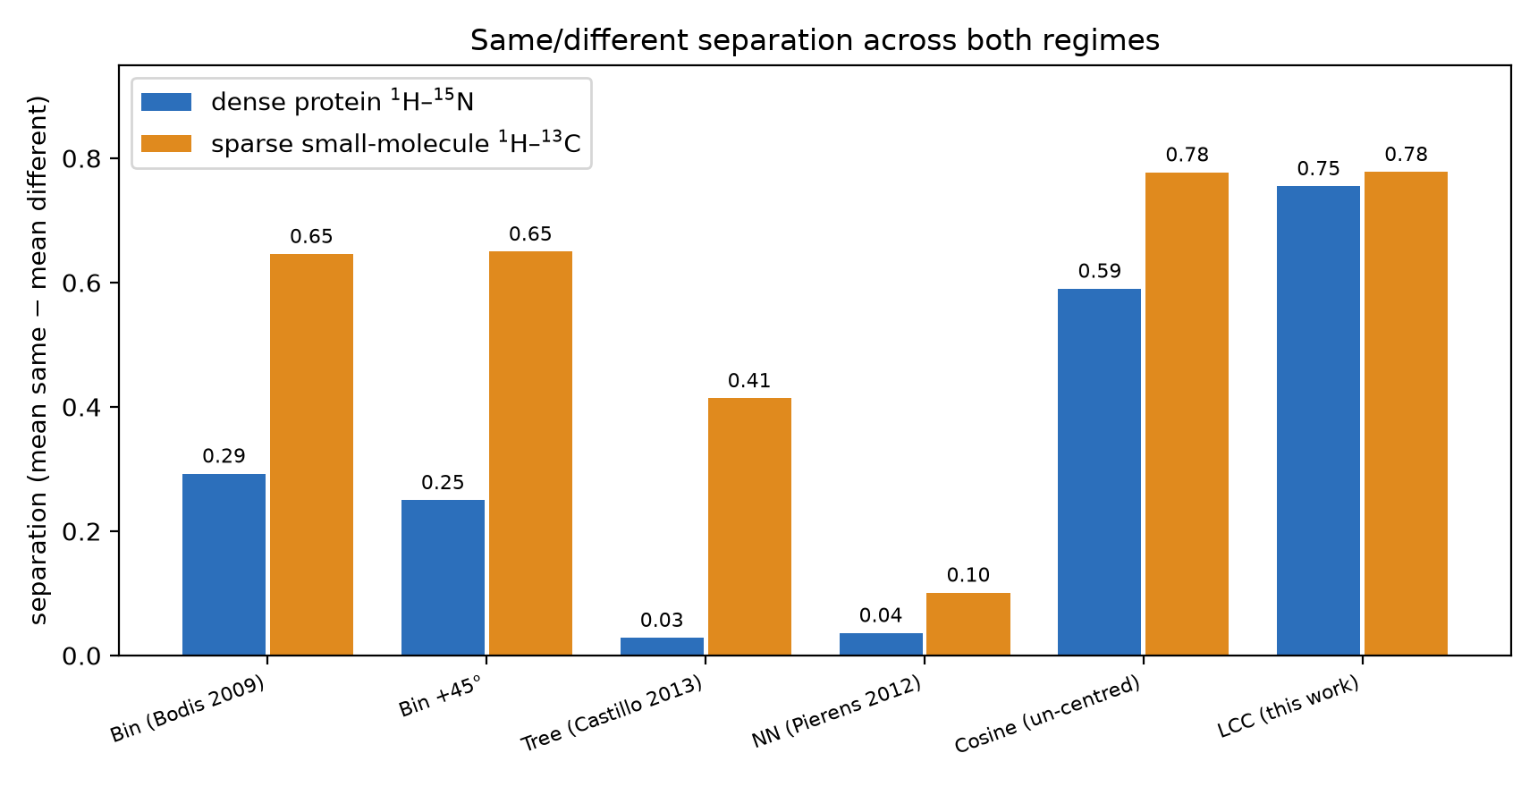
Figure 2. Same/different separation (mean same-class − mean different-class similarity) for every method on the two benchmarks: dense protein $​^{1}$H–$​^{15}$N (left of each pair) and sparse small-molecule $​^{1}$H–$​^{13}$C (right). LCC leads in both regimes; the tree and nearest-neighbour methods saturate in both. The un-centred cosine (an ablation of LCC without mean-centring) matches LCC on the sparse regime but falls from 0.75 to 0.59 on the dense fingerprint, isolating mean-centring as the step that rescues discrimination when peaks crowd.
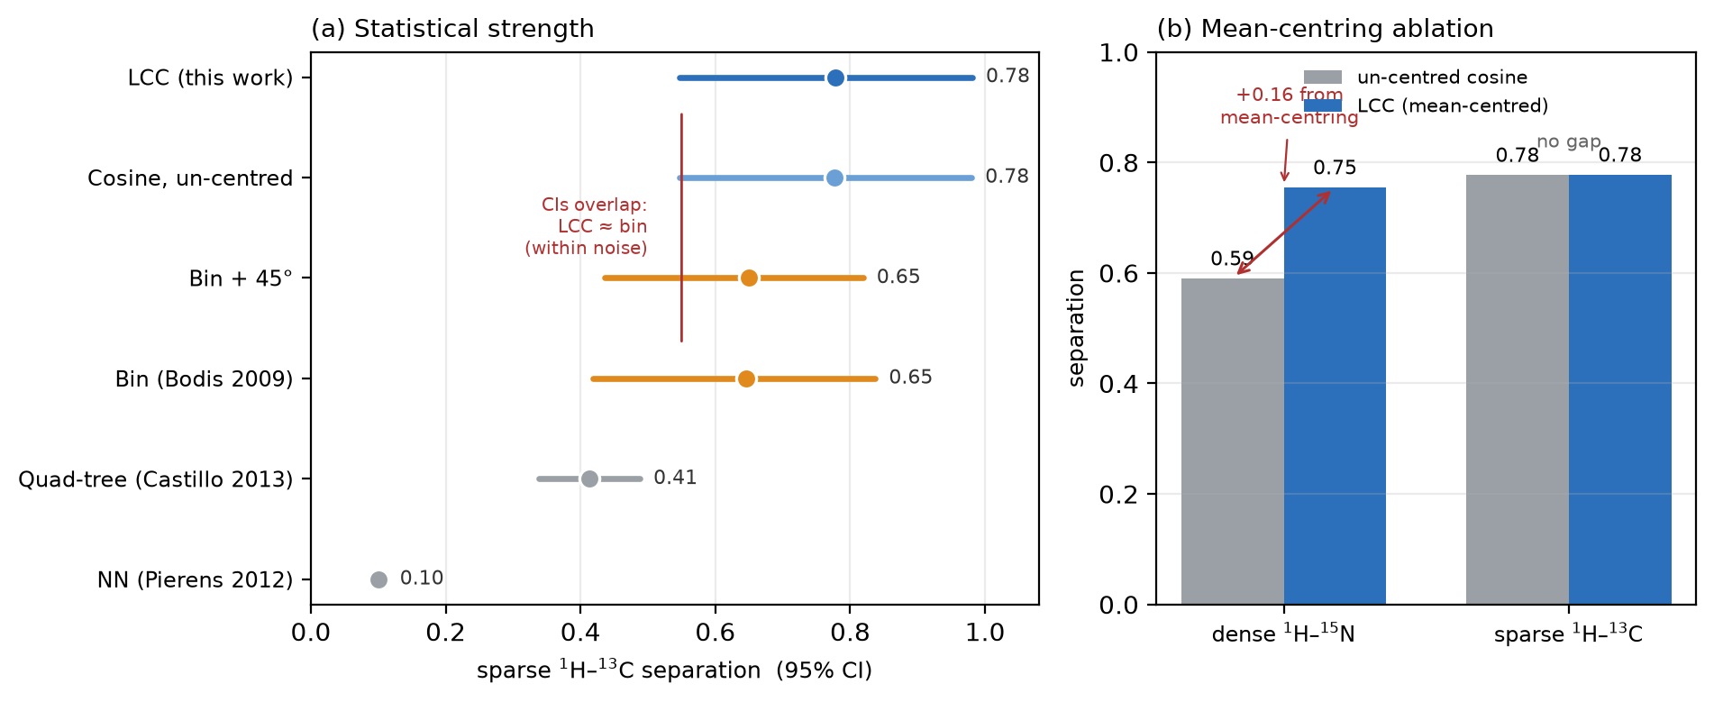
Figure 3. Statistical strength and the mean-centring ablation. (a) Sparse $​^{1}$H–$​^{13}$C separation with a bootstrap 95% CI (${10}^{4}$ resamples of the 5 same- and 40 different-compound pairs): LCC (blue) and the bin method (orange) have overlapping intervals — their difference is within noise at five compounds — while both sit cleanly above the saturating quad-tree and nearest-neighbour measures (grey), and the un-centred cosine (light blue, the LCC ablation) coincides with LCC. (b) Mean-centring ablation by regime: replacing the mean-centred correlation with the un-centred cosine costs 0.16 of separation on the dense protein fingerprint (0.75 → 0.59) but nothing on the sparse set (0.78 → 0.78) — mean-centring rescues discrimination only where peaks crowd.

Table 1
Table 1. Separation and worst-case margin for all methods on both regimes, computed from unrounded scores. Higher is better; every method self-scores 1.00.
Method | $​^{1}$H–$​^{15}$N sep | margin | $​^{1}$H–$​^{13}$C sep | margin
Bin (Bodis, 2009) | 0.29 | 0.24 | 0.65 | 0.20
Bin + 45° rotation | 0.25 | 0.20 | 0.65 | 0.18
Quad-tree (Castillo, 2013) | 0.03 | −0.01 | 0.41 | 0.09
Nearest neighbour (Pierens, 2012) | 0.04 | 0.03 | 0.10 | 0.04
Cosine, un-centred (LCC ablation) | 0.59 | — | 0.78 | 0.37
LCC (this work) | 0.75 | 0.71 | 0.78 | 0.37
The un-centred cosine is LCC without mean-centring, on the same rendered/blurred images; it is an ablation, not an independent method. Its dense-protein margin was not recomputed here (the ablation reports separation only). The $​^{1}$H–$​^{13}$C benchmark uses 5 same-compound pairs and 40 different-compound pairs; a nominal sixth pair (olivetol) was excluded as a byte-identical duplicate. Bootstrap 95% CIs on the sparse separation (${10}^{4}$ resamples): LCC 0.55–0.98, bin 0.42–0.84 (overlapping LCC), tree 0.34–0.49, NN 0.09–0.11 (both below LCC). Cast as a library search over the 10 spectra, all six methods retrieve the correct same-compound partner at rank 1 (top-1 = 1.00, MRR = 1.00) — retrieval on a small clean library does not separate the methods; the thresholded separation/margin does.

Table 2
Table 2. Expanded dense $​^{1}$H–$​^{15}$N benchmark addressing the single-decoy limitation: a PRL3 apo–olsalazine titration (23 same-protein points, exps 4–48) scored against two decoy proteins (OAA, EphB3) in the $​^{1}$H 6.5–10 $×$ $​^{15}$N 105–130 ppm window. Separation = mean same − mean decoy; margin = worst same − worst decoy. Higher is better; every method self-scores 1.00. Reproducible with python3 bench_nhsqc.py.
Method | mean same | min same | OAA | EphB3 | separation | margin
LCC (this work) | 0.87 | 0.82 | 0.19 | 0.41 | 0.57 | 0.41
Cosine, un-centred (LCC ablation) | 0.90 | 0.85 | 0.36 | 0.51 | 0.46 | 0.35
Bin (Bodis, 2009) | 0.82 | 0.75 | 0.46 | 0.50 | 0.34 | 0.25
Bin + 45° rotation | 0.86 | 0.81 | 0.52 | 0.56 | 0.32 | 0.25
Quad-tree (Castillo, 2013) | 0.95 | 0.91 | 0.79 | 0.75 | 0.18 | 0.12
Nearest neighbour (Pierens, 2012) | 0.99 | 0.98 | 0.96 | 0.96 | 0.03 | 0.02
Both decoy proteins score below every one of the 23 titration points for LCC (worst same 0.82 > worst decoy 0.41), so the margin is positive across two distinct folds — the negative side is now a distribution, not a single spectrum. The numbers are lower than the single-decoy benchmark (Table 1) because this test is harder on both axes: the olsalazine titration reaches larger shifts (min same 0.82 vs 0.89) and EphB3 is a tougher decoy than OAA (0.41 vs 0.19); LCC’s ordering is nevertheless unchanged.

Supporting Information
The Supporting Information (full mathematical derivation with proofs, both benchmark protocols, all per-comparison and per-pair numerical tables, robustness sweeps, parameter reference and test-suite description) is available and referenced throughout the text.

Acknowledgements
The author thanks the developers of the simpleNMR project for the public HSQC peak-list example set used in the sparse-regime benchmark.

Conflict of Interest
The author declares no conflict of interest.

Data Availability Statement
The software (LCC, the three reference methods, the un-centred-cosine ablation, all three benchmark harnesses, the tabulated scores and the 26-test suite) is freely available under the MIT license at https://github.com/deepnmr/spectra_similarity_tool. The sparse $​^{1}$H–$​^{13}$C benchmark and the dereplication/retrieval experiment are fully reproducible from public data: the harnesses download the simpleNMR peak lists (https://github.com/EricHughesABC/simpleNMR) automatically and contain no hard-coded paths. The dense $​^{1}$H–$​^{15}$N benchmark uses PRL3 and OAA Bruker spectra available from the author on reasonable request (the harness reads their location from --prl3/--oaa or $PRL3_DIR/$OAA_DIR); a public deposition of the processed spectra is in preparation so that the dense benchmark also becomes independently reproducible. The expanded dense benchmark of Table 2 (PRL3–olsalazine titration and the OAA and EphB3 decoy spectra) is computed by bench_nhsqc.py from the same processed Bruker data and is included in that deposition.

References
[1] S. B. Shuker, P. J. Hajduk, R. P. Meadows, S. W. Fesik, Science 1996, 274, 1531–1534.
[2] M. Pellecchia, I. Bertini, D. Cowburn, C. Dalvit, E. Giralt, W. Jahnke, T. L. James, S. W. Homans, H. Kessler, C. Luchinat, B. Meyer, H. Oschkinat, J. Peng, H. Schwalbe, G. Siegal, Nat. Rev. Drug Discov. 2008, 7, 738–745.
[3] D. A. Erlanson, S. W. Fesik, R. E. Hubbard, W. Jahnke, H. Jhoti, Nat. Rev. Drug Discov. 2016, 15, 605–619.
[4] M. P. Williamson, Prog. Nucl. Magn. Reson. Spectrosc. 2013, 73, 1–16.
[5] S. L. Robinette, R. Brüschweiler, F. C. Schroeder, A. S. Edison, Acc. Chem. Res. 2012, 45, 288–297.
[6] K. Bingol, R. Brüschweiler, Anal. Chem. 2014, 86, 47–57.
[7] B. Worley, R. Powers, Curr. Metabolomics 2013, 1, 92–107.
[8] E. L. Ulrich, H. Akutsu, J. F. Doreleijers, Y. Harano, Y. E. Ioannidis, J. Lin, M. Livny, S. Mading, D. Maziuk, Z. Miller, E. Nakatani, C. F. Schulte, D. E. Tolmie, R. K. Wenger, H. Yao, J. L. Markley, Nucleic Acids Res. 2008, 36, D402–D408.
[9] C. Steinbeck, S. Kuhn, Phytochemistry 2004, 65, 2711–2717.
[10] D. S. Wishart, A. Guo, E. Oler, F. Wang, A. Anjum, H. Peters, R. Dizon, Z. Sayeeda, S. Tian, B. L. Lee, M. Berjanskii, R. Mah, M. Yamamoto, J. Jovel, C. Torres-Calzada, M. Hiebert-Giesbrecht, V. W. Lui, D. Varshavi, D. Varshavi, D. Allen, D. Arndt, N. Khetarpal, A. Sivakumaran, K. Harford, S. Sanford, K. Yee, X. Cao, Z. Budinski, J. Liigand, L. Zhang, J. Zheng, R. Mandal, N. Karu, M. Dambrova, H. B. Schiöth, R. Greiner, V. Gautam, Nucleic Acids Res. 2022, 50, D622–D631.
[11] S. A. Berkowitz, J. R. Engen, J. R. Mazzeo, G. B. Jones, Nat. Rev. Drug Discov. 2012, 11, 527–540.
[12] J. P. Gabrielson, W. F. Weiss IV, J. Pharm. Sci. 2015, 104, 1240–1245.
[13] L. W. Arbogast, R. G. Brinson, J. P. Marino, Anal. Chem. 2015, 87, 3556–3561.
[14] H. Ghasriani, D. J. Hodgson, R. G. Brinson, I. McEwen, L. F. Buhse, S. Kozlowski, J. P. Marino, Y. Aubin, D. A. Keire, Nat. Biotechnol. 2016, 34, 139–141.
[15] L. W. Arbogast, F. Delaglio, J. E. Schiel, J. P. Marino, Anal. Chem. 2017, 89, 11839–11845.
[16] R. G. Brinson, J. P. Marino, F. Delaglio, L. W. Arbogast, et al., mAbs 2019, 11, 94–105.
[17] L. Bodis, A. Ross, E. Pretsch, Chemometr. Intell. Lab. Syst. 2007, 85, 1–8.
[18] L. Bodis, A. Ross, J. Bodis, E. Pretsch, Talanta 2009, 79, 1379–1386.
[19] A. Craig, O. Cloarec, E. Holmes, J. K. Nicholson, J. C. Lindon, Anal. Chem. 2006, 78, 2262–2267.
[20] F. Dieterle, A. Ross, G. Schlotterbeck, H. Senn, Anal. Chem. 2006, 78, 4281–4290.
[21] A. M. Castillo, L. Uribe, L. Patiny, J. Wist, Chemometr. Intell. Lab. Syst. 2013, 127, 1–6.
[22] G. K. Pierens, S. Brossi, Z. Yang, D. C. Reutens, V. Vegh, J. Cheminform. 2012, 4, 25.
[23] F. Delaglio, S. Grzesiek, G. W. Vuister, G. Zhu, J. Pfeifer, A. Bax, J. Biomol. NMR 1995, 6, 277–293.
[24] W. F. Vranken, W. Boucher, T. J. Stevens, R. H. Fogh, A. Pajon, M. Llinas, E. L. Ulrich, J. L. Markley, J. Ionides, E. D. Laue, Proteins 2005, 59, 687–696.
[25] S. P. Skinner, R. H. Fogh, W. Boucher, T. J. Ragan, L. G. Mureddu, G. W. Vuister, J. Biomol. NMR 2016, 66, 111–124.
[26] C. Ludwig, U. L. Günther, BMC Bioinformatics 2011, 12, 366.
[27] J. J. Helmus, C. P. Jaroniec, J. Biomol. NMR 2013, 55, 355–367.
[28] S. E. Stein, D. R. Scott, J. Am. Soc. Mass Spectrom. 1994, 5, 859–866.
[29] K. X. Wan, I. Vidavsky, M. L. Gross, J. Am. Soc. Mass Spectrom. 2002, 13, 85–88.
[30] F. Savorani, G. Tomasi, S. B. Engelsen, J. Magn. Reson. 2010, 202, 190–202.
[31] C. R. Harris, K. J. Millman, S. J. van der Walt, R. Gommers, P. Virtanen, D. Cournapeau, E. Wieser, J. Taylor, S. Berg, N. J. Smith, R. Kern, M. Picus, S. Hoyer, M. H. van Kerkwijk, M. Brett, A. Haldane, J. F. del Río, M. Wiebe, P. Peterson, P. Gérard-Marchant, K. Sheppard, T. Reddy, W. Weckesser, H. Abbasi, C. Gohlke, T. E. Oliphant, Nature 2020, 585, 357–362.
[32] J. D. Hunter, Comput. Sci. Eng. 2007, 9, 90–95.
[33] E. Hughes, A. M. Kenwright, Magn. Reson. Chem. 2024, 62, 556–565.

Table of Contents Entry
Tolerant yet discriminating. Comparing two 2D-HSQC spectra demands tolerance of small chemical-shift drifts and penalization of genuinely relocated intensity — requirements the incumbent binning, tree and nearest-neighbour measures satisfy only one at a time. The Lineshape Correlation Coefficient renders both spectra onto one grid, blurs them by the physical NMR linewidth, and takes the mean-centred zero-lag correlation, giving the widest same/different separation across both dense protein and sparse small-molecule regimes.
Suggested TOC graphic: the separation bar chart (Figure 2) with the three-step LCC schematic inset.

