Supporting Information — A Lineshape Correlation Coefficient for Robust Similarity of Two-Dimensional HSQC NMR Spectra
Donghan Lee
Korea Basic Science Institute (KBSI), Ochang, Republic of Korea. Correspondence: kbsi.bionmr@gmail.com
Software (LCC and the three reference methods), both benchmark harnesses, all tabulated scores and the test suite are freely available under the MIT license at https://github.com/deepnmr/spectra_similarity_tool. LCC is implemented in hsqc_lcc.py.

Contents
- S1 Setup and preprocessing
- S2 Rendering to a shared grid
- S3 Lineshape blur
- S4 Mean-centring and the similarity score
- S5 Properties (with proofs)
- S6 Why LCC beats the existing methods
- S7 Parameters
- S8 Benchmark 1 — dense protein $​^{1}$H–$​^{15}$N
- S9 Benchmark 2 — sparse small-molecule $​^{1}$H–$​^{13}$C
- S10 Robustness and ablation
- S11 Relationship to the source methods
- S12 Software, reproduction and test suite
- S13 Statistical strength: bootstrap CIs and a retrieval test
- S14 Supporting references

S1 Setup and preprocessing
Two spectra $a∈\{x,y\}$ are compared inside a common window $Ω=[δ_{\text{lo}}^{F2},δ_{\text{hi}}^{F2}]×[δ_{\text{lo}}^{F1},δ_{\text{hi}}^{F1}]$ (direct dimension $F2$, e.g. $​^{1}H$; indirect dimension $F1$, e.g. $​^{15}N$ or $​^{13}C$). Each processed point $p$ has shifts $δ_{F2}(p),δ_{F1}(p)$ and intensity $I_{a}(p)$. With the default clip baseline, negative intensities are zeroed and every point is weighted by its local integration area so that spectra of different digital resolution integrate consistently:
$$w_{a}(p) = max​\left(I_{a}(p), 0\right) ⋅ |Δδ_{F1}(p)| ⋅ |Δδ_{F2}(p)|.$$
Negative peaks (edited HSQC). clip is correct for a non-edited spectrum, where negatives are baseline noise. In a multiplicity-edited HSQC, however, the sign encodes multiplicity (CH/CH$​_{3}$ positive, CH$​_{2}$ negative), not absence [2] — clip would silently delete every CH$​_{2}$ crosspeak. For such data use baseline="abs", which weights by $|I_{a}(p)|$ (replacing $max(I_{a},0)$ in Eq. S1) and preserves the CH$​_{2}$ peaks; all methods and the CLI expose this option. The sparse $​^{1}$H–$​^{13}$C peak-list benchmark already renders with $|$intensity$|$ for exactly this reason (§S9).
This is exactly the area weighting of the bin method [1]. The mass is normalized to p​wa(p)=1; the final score is invariant to this scale, so normalization only guards against numerical overflow.
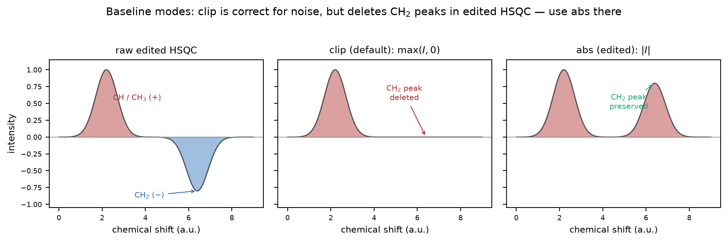
Figure S1. Baseline modes on a multiplicity-edited HSQC cross-section. Left: the raw signal, with a positive CH/CH$​_{3}$ peak and a negative CH$​_{2}$ peak (the sign encodes multiplicity, not absence). Middle (clip, default): $max(I,0)$ zeroes negatives — correct when negatives are baseline noise, but it silently deletes the CH$​_{2}$ crosspeak. Right (abs): $|I|$ preserves the CH$​_{2}$ peak. Use clip for a non-edited spectrum and abs for edited data; the sparse $​^{1}$H–$​^{13}$C benchmark renders with $|$intensity$|$ for exactly this reason (§S9).

S2 Rendering to a shared grid
The window is discretized once into a fixed grid shared by both spectra: $K$ bins along $F1$ of width $Δ_{1}$ (default step_f1 $=0.10$ ppm) and $L$ bins along $F2$ of width $Δ_{2}$ (default step_f2 $=0.01$ ppm). Each spectrum is rendered by summing its weighted points into cells $(k,l)$:
Ra[k,l] =​​p : δ(p) ∈ cell(k,l)​​​wa(p), k=1,…,K, l=1,…,L.
Rendering both spectra onto the same edges is what makes the two images directly comparable regardless of their native resolutions [3]. Optional intensity compression: to stop a single dominant amide from dominating the correlation, the rendered intensities may be raised to a power $ρ$ (--p, default $ρ=1$, i.e. off): $R_{a}[k,l]←R_{a}[k,l]^{ρ}$. Both the unit-mass normalization and this optional compression are the standard scaling/normalization operations of quantitative NMR profiling [4,5].
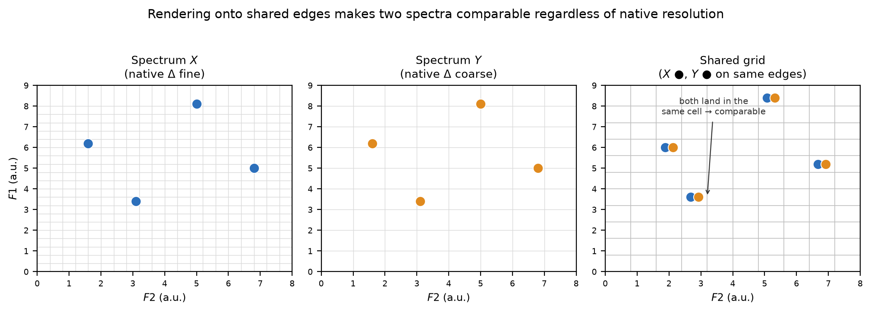
Figure S2. Rendering onto a shared grid. The same four crosspeaks are recorded by two instruments at different native digital resolutions (left, fine $Δ$; middle, coarse $Δ$). Histogramming both onto one shared grid with identical cell edges (right) places corresponding peaks in the same cell, so the two images become directly comparable regardless of their native resolutions (Eq. S2).

S3 Lineshape blur
The discrete image is convolved with a separable Gaussian whose width is the physical NMR linewidth plus the expected chemical-shift drift, one $σ$ per axis:
$$σ_{F2}=\sqrt{ℓ_{F2}^{2}+d_{F2}^{2}}, σ_{F1}=\sqrt{ℓ_{F1}^{2}+d_{F1}^{2}},$$
with linewidth $ℓ$ and expected drift $d$ (defaults $σ_{F2}=0.03$, $σ_{F1}=0.30$ ppm for $​^{1}$H–$​^{15}$N). The 1-D kernel, with $s=σ/Δ$ the width in pixels and radius $r=⌈3s⌉$, is
$$g_{σ}(m) = \frac{exp​\left(−m^{2}/2s^{2}\right)}{\sum_{m^{′}=−r}^{r}{exp}​\left(−m^{′}​^{2}/2s^{2}\right)}, m=−r,…,r,$$
and the blurred (“lineshape-rendered”) image is the separable convolution
$$G_{a} = g_{σ_{F1}} *_{F1} \left( g_{σ_{F2}} *_{F2} R_{a} \right).$$
The continuous Gaussian is precisely what replaces the bin method’s hard bin edges with a soft response (see §S6).
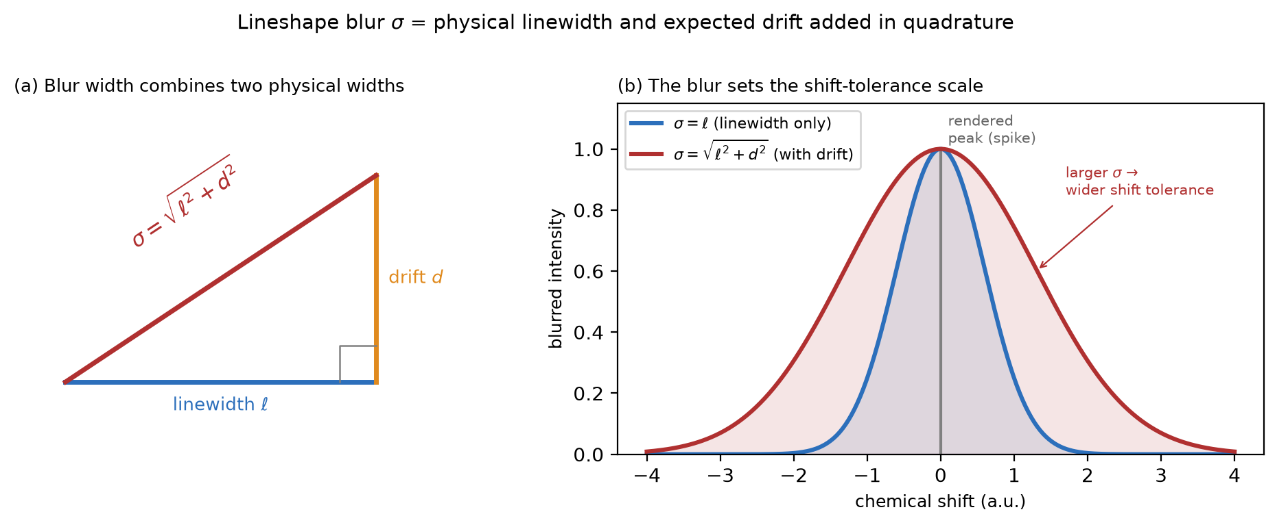
Figure S3. The lineshape blur width. (a) Each axis blur $σ$ combines the physical NMR linewidth $ℓ$ and the expected chemical-shift drift $d$ in quadrature, $σ=\sqrt{ℓ^{2}+d^{2}}$ (Eq. S3). (b) Convolving a rendered peak (a spike) with this Gaussian sets the shift-tolerance scale: a larger $σ$ (linewidth plus drift) tolerates a larger displacement than the linewidth alone would.

S4 Mean-centring and the similarity score
Each image is centred by subtracting its global mean
Ga=1KLk,l​Ga[k,l], Ga[k,l]=Ga[k,l]−Ga,
and the similarity is the mean-centred normalized cross-correlation at zero lag (the Pearson correlation coefficient of the two flattened images), clamped to $[0,1]$:
S(x,y) = max​0, k,l​Gx[k,l] Gy[k,l]k,l​Gx[k,l]2 k,l​Gy[k,l]2
No shift search / alignment is performed — this is deliberate (§S6c).
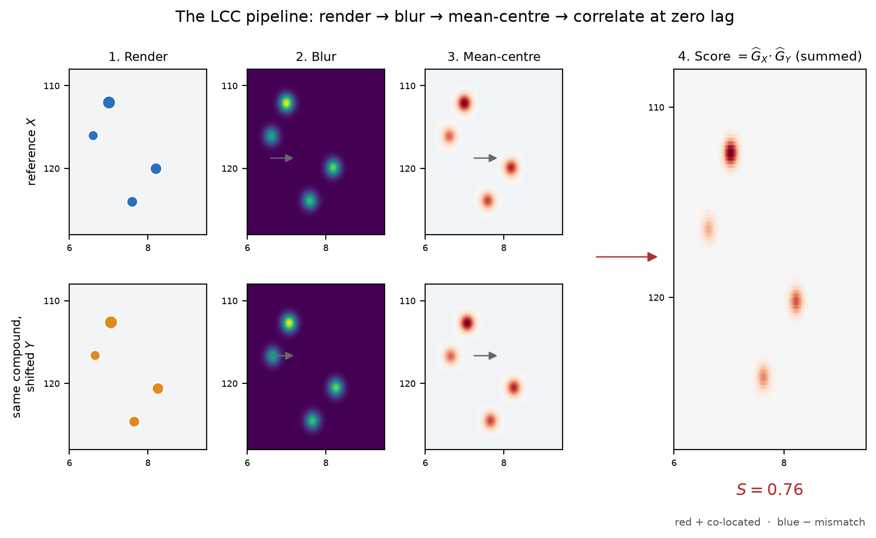
Figure S4. The four LCC steps end to end, on a toy pair. A reference $X$ and a same-compound copy $Y$ with a small titration drift are each (1) rendered as area-weighted points on a single shared grid, (2) blurred by the physical linewidth (a separable Gaussian), and (3) mean-centred (red $=$ above the image mean, blue $=$ below). (4) The similarity is the sum of the elementwise product ${\hat{G}}_{X}​⋅{\hat{G}}_{Y}$ (normalized): co-located intensity gives a positive (red) product and drives the score up, so this same-compound pair scores $S=0.76$. No shift search is performed — the images are correlated at zero lag.

S5 Properties
Self-similarity is exactly 1. For $y=x$ the numerator and each factor of the denominator are the same sum ${\left\|{\hat{G}}_{x}\right\|}^{2}$, so
$$S(x,x)=\frac{{\left\|{\hat{G}}_{x}\right\|}^{2}}{\sqrt{{\left\|{\hat{G}}_{x}\right\|}^{2}} \sqrt{{\left\|{\hat{G}}_{x}\right\|}^{2}}}=1,$$
and the $min(1,⋅)$ clamp in the code absorbs the last-ULP floating-point wobble so an identical spectrum returns 1.0 bit-exactly.
Symmetry. $S(x,y)=S(y,x)$ exactly, since the score is a symmetric inner product of the two centred images.
Range. As a Pearson coefficient $S∈[−1,1]$ before clamping; the clamp maps anticorrelation to $0$, giving $S∈[0,1]$.
Monotonicity in drift. For an isolated peak on a grid large enough that mean-centring is negligible, $S$ is a strictly decreasing function of the displacement magnitude (Eq. S9); this is checked numerically in the test suite.
Degenerate guard. A flat image (${\hat{G}}_{a}≡0$) has zero denominator and returns $0$; the windowing step already excludes empty windows upstream.

S6 Why LCC beats the existing methods
The three source methods fail in opposite ways: the bin method [1] is shift-brittle (a peak straddling a bin edge splits its mass, so a small titration drift drops the score in a discontinuous jump), while the tree [6,8] and nearest-neighbour (NN) [7] methods are shift-blind (in a dense fingerprint every peak has a near neighbour, so both saturate near 1). LCC sits between them via three mechanisms.
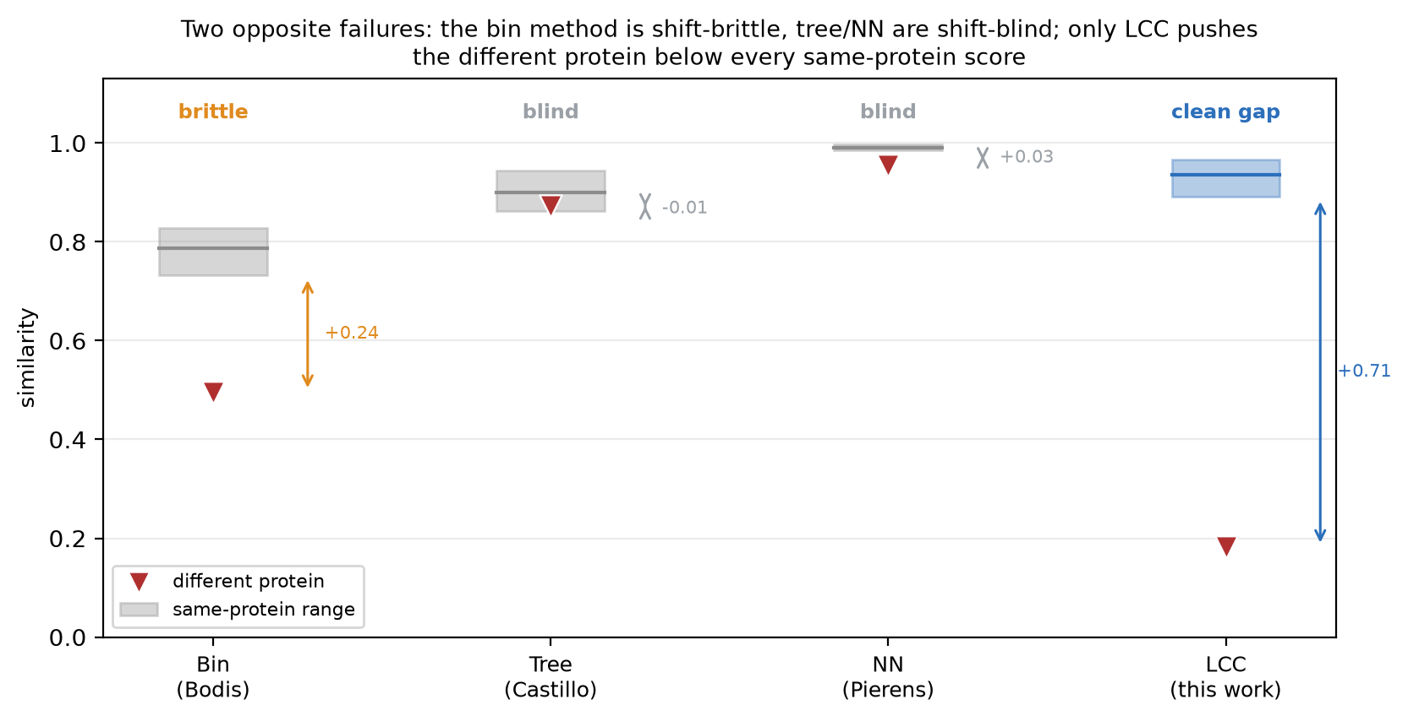
Figure S5. The two opposite failure modes, on the dense $​^{1}$H–$​^{15}$N benchmark (Table S2). For each method the shaded band spans the same-protein similarities (the titration series) and the red marker is the different protein. The bin method is shift-brittle — a physical titration drift erodes its same-protein scores down to 0.73–0.83, the lowest band shown. The tree and NN methods are shift-blind — the different protein sits inside (tree) or right at (NN) the same-protein band, so it is not separated. Only LCC pushes the different protein (0.18) below every same-protein score, opening a wide clean gap.
(a) Graded shift tolerance. Model a peak as a point mass; after the blur it is a Gaussian of width $σ$. Two copies of one peak displaced by $(Δ_{F2},Δ_{F1})$ contribute to the centred, normalized correlation a factor
$$exp​\left(−\frac{Δ_{F2}^{2}}{4σ_{F2}^{2}}−\frac{Δ_{F1}^{2}}{4σ_{F1}^{2}}\right),$$
which is smooth and monotone in the drift — no bin-edge discontinuity. A physical titration drift ($Δ_{​^{1}H}∼0.01$–$0.05$, $Δ_{​^{15}N}∼0.2$–$0.8$ ppm) is a fraction of $σ$ and costs little; a random relocation ($Δ≫σ$) drives the factor toward $0$. The single knob $σ$ sets the tolerance scale (main-text Figure 1b).
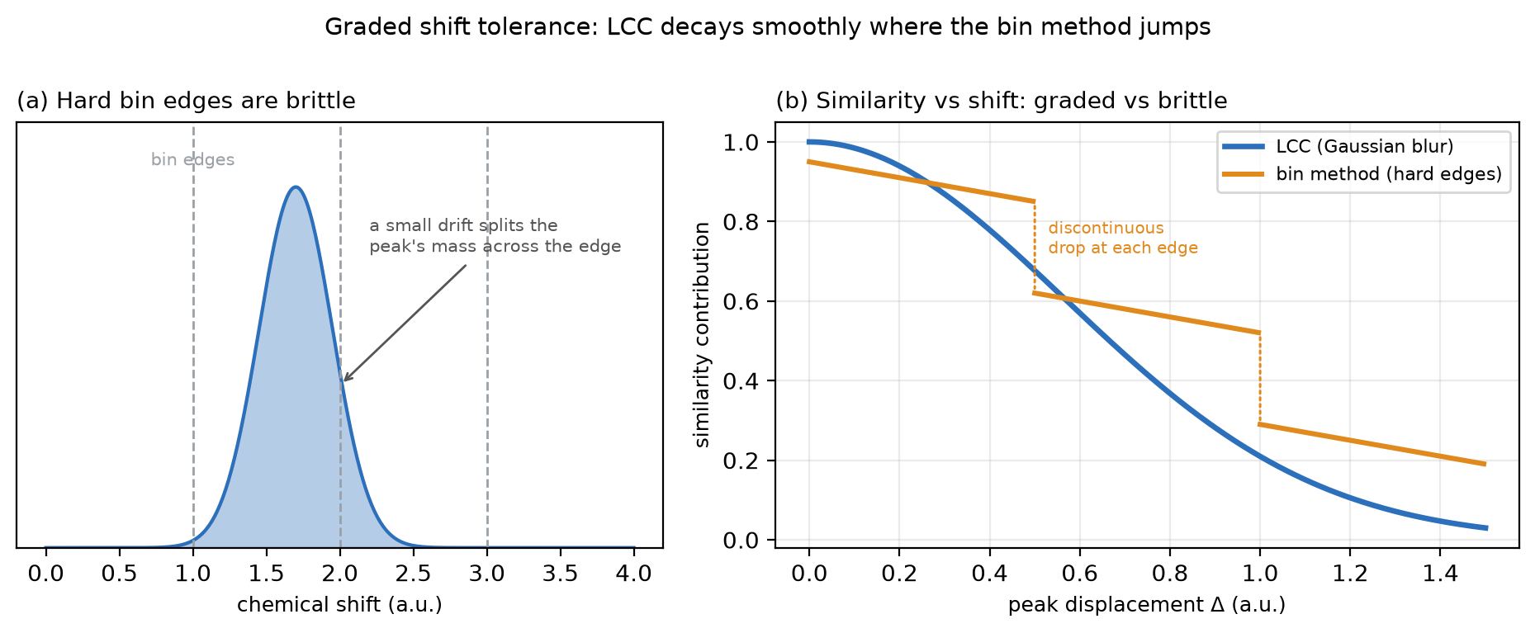
Figure S6. Graded vs brittle response to a shift. (a) The bin method’s edges are hard: as a peak drifts, a small displacement splits its mass across a bin boundary. (b) Similarity contribution vs peak displacement $Δ$. The Gaussian blur makes LCC decay smoothly and monotonically ($exp(−Δ^{2}/4σ^{2})$, blue), so a physical drift costs little; the bin method (orange) instead jumps discontinuously each time the peak crosses an edge — a small drift can cause a sudden score drop. This is why the bin method is shift-brittle and LCC is not.
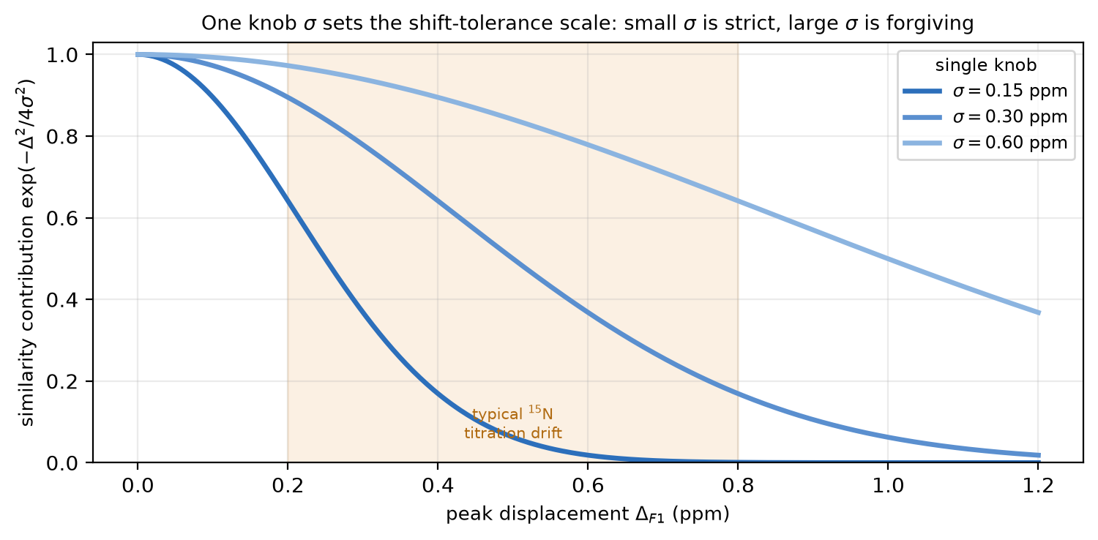
Figure S7. The single tuning knob. The same-peak contribution $exp(−Δ^{2}/4σ^{2})$ (Eq. S9) versus peak displacement $Δ$, for three blur widths $σ$. One number sets the entire tolerance scale: a small $σ$ is strict (a modest drift already costs similarity), a large $σ$ is forgiving. The default is chosen so a typical $​^{15}$N titration drift (shaded) costs little while a random relocation drives the contribution toward zero.
(b) Coverage penalty from mean-centring. Writing the score as a covariance,
S∝cov(Gx,Gy)=1KLk,l​Gx[k,l]−GxGy[k,l]−Gy,
a cell where one spectrum has a peak (value above its mean) and the other is empty (value below its mean) contributes a negative product and lowers $S$. Intensity that is not co-located is therefore actively penalized — a differently-scattered protein cannot hide behind coincidental proximity the way it does under NN’s one-way nearest-neighbour distance. This mean-centring step is worth $≈+0.16$ of separation over an un-centred overlap on the protein benchmark (§S10).
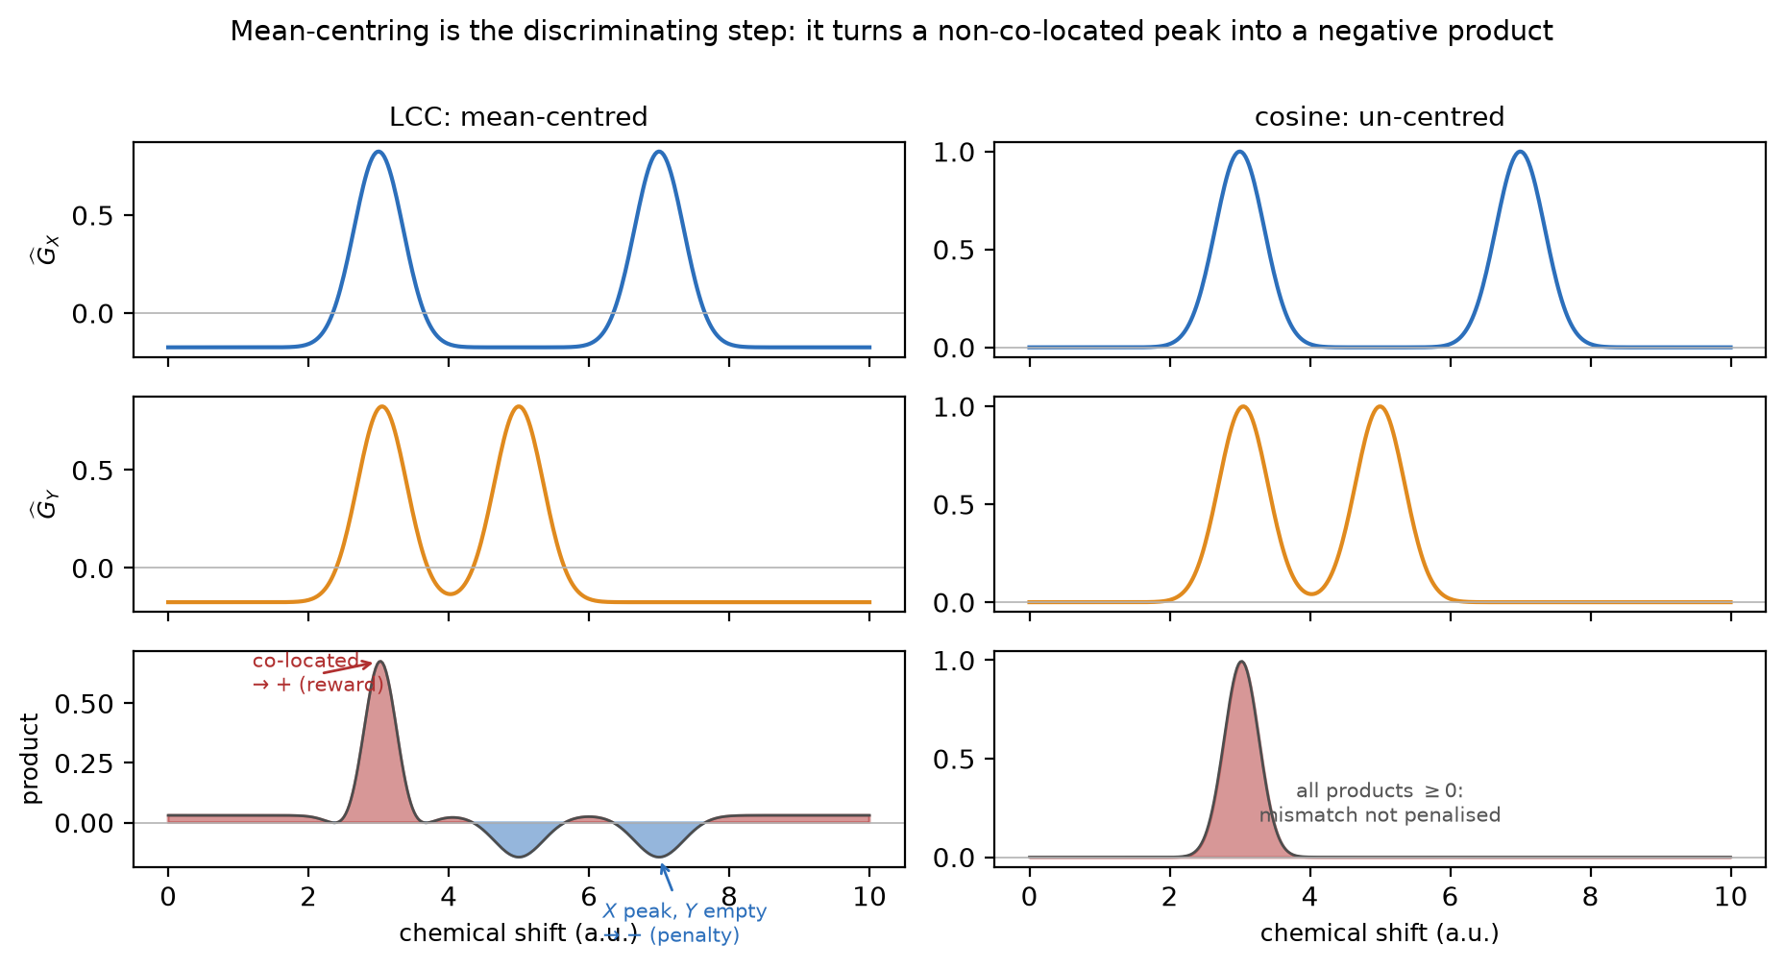
Figure S8. Why mean-centring is the discriminating step (1-D cross-section). Two images ${\hat{G}}_{X}$ (blue) and ${\hat{G}}_{Y}$ (orange) and their elementwise product (red $=$ positive, blue $=$ negative). Left (LCC, mean-centred): where both have a peak the product is positive (reward); where one has a peak and the other is empty, the empty image sits below its mean so the product is negative — non-co-located intensity is actively penalized. Right (un-centred cosine): every product is $≥0$, so a mismatched peak contributes nothing and cannot be penalized. Mean-centring is exactly what converts “overlap” into “discrimination”.
(c) Zero lag on purpose. Adding a global shift search (FFT / block matching), as used in spectral-alignment tools [9], would let a different protein slide into registration and re-saturate — the same failure as tree/NN. Scoring at zero lag keeps the position information that carries the discrimination.
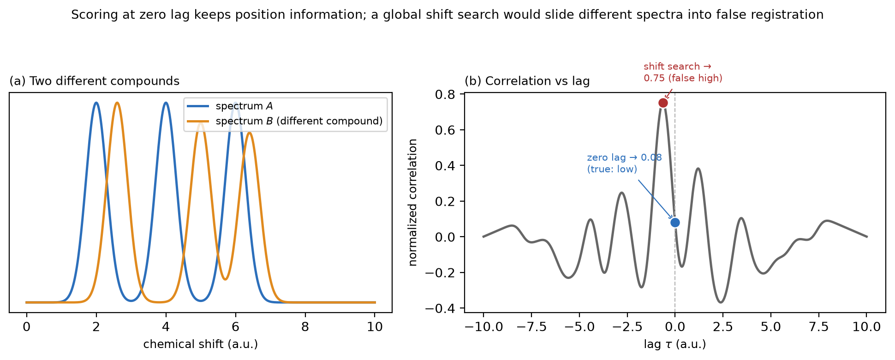
Figure S9. Why the score is read at zero lag. (a) Two genuinely different compounds (unequal peak spacing, so no rigid shift aligns them all). (b) Their normalized correlation as a function of a rigid lag $τ$. At zero lag the score is correctly low (0.08, blue); a global shift search would instead report the maximum over all lags (0.75, red), sliding the different spectra into a partial false registration — the same over-tolerant saturation as tree/NN. LCC scores only at $τ=0$, keeping the position information that carries the discrimination.

S7 Parameters
Table S1. LCC parameters. The two blur widths are the only tuning levers, and both are set by spectroscopy: the linewidth sets the floor, the expected shift perturbation sets the tolerance.
symbol | flag | default ($​^{1}$H–$​^{15}$N) | meaning
$σ_{F2}$​ | --sigma-f2 | 0.03 ppm | $​^{1}$H linewidth + drift blur width (main $F2$ tolerance)
$σ_{F1}$​ | --sigma-f1 | 0.30 ppm | $​^{15}$N/$​^{13}$C linewidth + drift (main tuning lever)
$Δ_{2}$​ | --step-f2 | 0.01 ppm | $F2$ render pixel width ($≥3$ px per $σ$; score grid-invariant)
$Δ_{1}$​ | --step-f1 | 0.10 ppm | $F1$ render pixel width
$ρ$​ | --p | 1.0 | intensity compression exponent (off)
Fixed by design: centring on, shift search off. Negatives are handled by the baseline mode (clip default; use abs for multiplicity-edited HSQC — §S1); center=False gives the un-centred cosine ablation (§S10). For the $​^{1}$H–$​^{13}$C benchmark the blur widths are scaled to that regime ($σ_{​^{1}H}=0.05$, $σ_{​^{13}C}=0.5$ ppm).
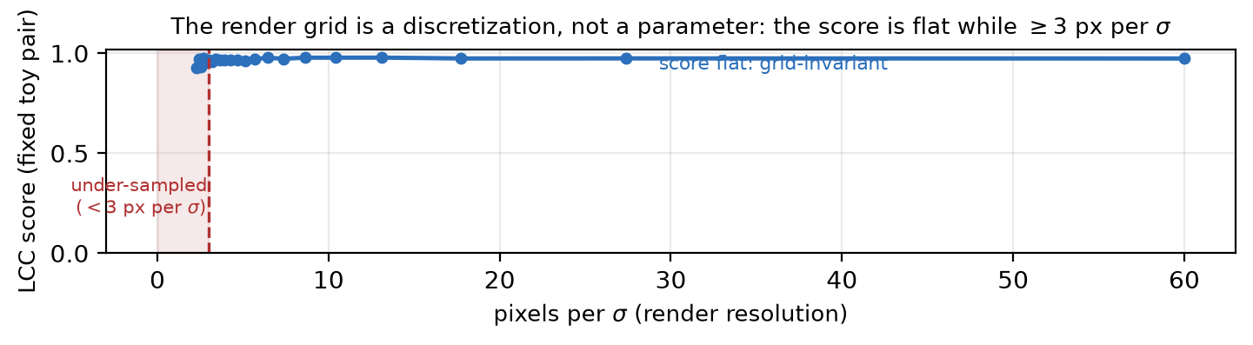
Figure S10. The render grid is a discretization, not a tuning parameter. A fixed same-compound toy pair is scored while the render pixel size is swept: the LCC score is flat while the Gaussian is sampled by $≳3$ pixels per $σ$ (red zone $=$ under-sampled). The choice of grid does not affect the result.

S8 Benchmark 1 — dense protein $​^{1}$H–$​^{15}$N
Design. Reference spectrum: PRL3 experiment 2, a $​^{1}$H–$​^{15}$N HSQC. It is compared with the same protein plus ligand (experiments 4–14, a titration series that should score high — the chemical-shift-perturbation and fragment-based-screening setting [10–13]) and with a different protein (OAA experiment 103, which should score low). This same-protein-versus-different-protein discrimination is the core operation of higher-order-structure (HOS) comparability assessment, for which 2D-HSQC fingerprinting is an established atomic-resolution readout (§S13). Window $F2 6.5$–$10×F1 105$–$130$ ppm. Bin widths for the bin method min_bin_width_f2 = 0.1, min_bin_width_f1 = 1.0; LCC blur $σ_{F2}=0.03$, $σ_{F1}=0.30$ ppm. Separation $Σ={\overline{S}}_{\text{same}}−S_{\text{diff}}$; margin $=\min_{e}S_{\text{same}}−S_{\text{diff}}$.
Table S2. Per-comparison similarity, dense protein $​^{1}$H–$​^{15}$N benchmark. All methods self-score exactly 1.
comparison | Bin (Bodis 2009) | Bin + 45° | Tree (Castillo 2013) | NN (Pierens 2012) | LCC
2 vs 2 (self) | 1.0000 | 1.0000 | 1.0000 | 1.0000 | 1.0000
2 vs 4 (+B12) | 0.8106 | 0.8385 | 0.9401 | 0.9925 | 0.9662
2 vs 6 (+NB91) | 0.7739 | 0.7990 | 0.8619 | 0.9981 | 0.9594
2 vs 8 (+benz) | 0.8274 | 0.8570 | 0.9443 | 0.9877 | 0.9485
2 vs 10 (+GB001) | 0.8164 | 0.8555 | 0.9179 | 0.9848 | 0.8972
2 vs 12 (+PF1) | 0.7637 | 0.7912 | 0.8760 | 0.9978 | 0.9558
2 vs 14 (+PF2) | 0.7320 | 0.7654 | 0.8624 | 0.9851 | 0.8911
2 vs OAA (diff. protein) | 0.4949 | 0.5681 | 0.8721 | 0.9550 | 0.1815
mean same − different (sep.) | 0.29 | 0.25 | 0.03 | 0.04 | 0.75
worst-case margin | 0.24 | 0.20 | −0.01 | 0.03 | 0.71
LCC separates same-protein from different-protein spectra $≈2.6×$ better than the previous best, pushing the different protein (0.18) below every same-protein score. The old bin method left the different protein (0.49) close to the worst same-protein point (0.73); LCC opens a wide gap.
Expanded benchmark — a second decoy protein. The benchmark above scores against a single decoy (OAA). To give the negative side a distribution over distinct folds — and to make the dense test self-contained — we added an independent PRL3 apo→olsalazine titration (500 µM PRL3(4–159), 23 points from exp 4 to exp 48) and a second decoy protein, the kinase domain EphB3, all read as processed Bruker spectra in the same $​^{1}$H 6.5–10 $×$ $​^{15}$N 105–130 window (bench_nhsqc.py). As the ligand is titrated the chemical-shift perturbation grows and LCC decays smoothly from 0.98 to a plateau near 0.82 (Table S9), the graded shift tolerance of §S6a acting on real titration data; both decoy proteins fall far below the entire titration (OAA 0.19, EphB3 0.41), so LCC’s margin (0.41) is positive across two distinct folds and the negative side is a distribution, not one spectrum. Mean-centring still earns the gap (LCC separation 0.57 vs un-centred cosine 0.46), and the tree and NN measures again saturate (margins 0.12, 0.02). The absolute margin is smaller than the six-point single-decoy benchmark (0.71) because this test is harder on both axes — a longer titration reaching larger shifts (min same 0.82 vs 0.89) and a tougher decoy (EphB3 0.41 vs OAA 0.19) — but the method ordering is unchanged.
Table S8. Expanded dense $​^{1}$H–$​^{15}$N benchmark: PRL3 apo–olsalazine titration (23 same-protein points) vs two decoy proteins (OAA, EphB3). Separation $={\overline{S}}_{\text{same}}−{\overline{S}}_{\text{decoy}}$; margin $=\min_{e}S_{\text{same}}−\max_{d}S_{\text{decoy}}$. Every method self-scores 1.
method | mean same | min same | OAA | EphB3 | separation | margin
Bin (Bodis 2009) | 0.817 | 0.753 | 0.461 | 0.500 | 0.337 | 0.253
Bin + 45° | 0.865 | 0.810 | 0.521 | 0.563 | 0.323 | 0.247
Quad-tree (Castillo 2013) | 0.946 | 0.912 | 0.793 | 0.749 | 0.176 | 0.119
Nearest neighbour (Pierens 2012) | 0.986 | 0.983 | 0.959 | 0.962 | 0.026 | 0.021
Cosine, un-centred (LCC ablation) | 0.897 | 0.853 | 0.360 | 0.507 | 0.464 | 0.346
LCC (this work) | 0.871 | 0.820 | 0.195 | 0.414 | 0.567 | 0.405
Table S9. LCC along the PRL3–olsalazine titration (reference = apo exp 2): a smooth, near-monotone decay as ligand — and thus CSP — increases. Every titration point stays above both decoys (OAA 0.19, EphB3 0.41), so the worst same-protein score (0.82) still clears the worst decoy by 0.41.
exp | 4 | 8 | 12 | 16 | 20 | 24 | 28 | 32 | 36 | 40 | 44 | 48
LCC | 0.98 | 0.95 | 0.93 | 0.90 | 0.87 | 0.85 | 0.85 | 0.84 | 0.83 | 0.83 | 0.83 | 0.82

S9 Benchmark 2 — sparse small-molecule $​^{1}$H–$​^{13}$C
Design. Public HSQC peak lists from the simpleNMR example set [14] (EricHughesABC/simpleNMR). Six nominal compounds, each recorded twice (a variant pair — e.g. menthol in two solvents). One nominal pair, olivetol, was excluded: its two source files (Olivetol.json and Olivetol_A.json) are byte-identical (same MD5, identical peak lists), so it was a self-comparison scoring 1.00 for every method — an information-free positive that inflated mean_same. The benchmark now uses the 5 genuinely distinct same-compound pairs (10 spectra) and asks each measure to score them above the 40 different-compound pairs. bench_13c.py raises at load time on any same-pair that renders to an identical image, so a duplicate cannot silently re-enter. Peak lists are rasterized to a synthetic 2D spectrum (one Gaussian per peak, using $|$intensity$|$ so edited-HSQC CH$​_{2}$ peaks are kept — §S1) so every method runs unchanged. Window $​^{1}$H 0–10 $×$ $​^{13}$C 0–165 ppm; LCC blur $σ_{​^{1}H}=0.05$, $σ_{​^{13}C}=0.5$ ppm.
Table S3. Aggregate scores, sparse small-molecule $​^{1}$H–$​^{13}$C benchmark (5 same-compound pairs, 40 different). All methods self-score exactly 1. The un-centred cosine is LCC without mean-centring (§S6b), included here as the ablation baseline (bug-fix: it is now a reproducible benchmark row, not an asserted number).
method | mean same | mean diff | separation | margin
Bin (Bodis 2009) | 0.712 | 0.067 | 0.646 | 0.195
Bin + 45° | 0.740 | 0.091 | 0.650 | 0.181
Quad-tree (Castillo 2013) | 0.907 | 0.494 | 0.414 | 0.089
Nearest neighbour (Pierens 2012) | 0.997 | 0.896 | 0.101 | 0.043
Cosine, un-centred (LCC ablation) | 0.781 | 0.004 | 0.777 | 0.370
LCC (this work) | 0.781 | 0.003 | 0.778 | 0.370
Table S4. Per-pair same-compound scores. Two pairs are genuinely shifted (menthol in two solvents; a rotenone re-measurement); on these the shift-tolerant tree/NN keep the same compound high while the position-sensitive bin/LCC penalize the shift. The catch is that tree/NN tolerate everything, which is why their different-compound scores (Table S3) are also high. The un-centred cosine column is identical to LCC to two decimals — in this sparse regime mean-centring changes nothing (see the ablation, §S10).
pair | Bin | Tree | NN | Cosine | LCC
menthol (two solvents) | 0.60 | 0.96 | 0.99 | 0.58 | 0.58
rotenone (re-measured) | 0.30 | 0.83 | 1.00 | 0.39 | 0.39
santonin | 0.97 | 0.99 | 1.00 | 1.00 | 1.00
chartreusin | 0.80 | 0.83 | 1.00 | 0.94 | 0.94
indanone | 0.89 | 0.93 | 1.00 | 0.99 | 0.99
Over a large common window a different small molecule still supplies some peak near every peak and a similar mass-centre structure, so the NN distance and the tree overlap stay small — the same saturation mechanism as in the protein case.

S10 Robustness and ablation
Ablation — mean-centring is the discriminating step, in the dense regime. Replacing the mean-centred correlation (Eq. S7) with an un-centred cosine overlap on the same rendered/blurred images drops the dense-protein separation from 0.75 to 0.59, confirming mean-centring (§S6b) as the operation that turns overlap into discrimination when the amide fingerprint is crowded. In the sparse $​^{1}$H–$​^{13}$C regime, by contrast, the un-centred cosine and centred LCC coincide (separation 0.777 vs 0.778; Table S3, Table S4): where crosspeaks rarely overlap there is almost no non-co-located intensity for mean-centring to penalize, so its benefit is specific to the dense fingerprint that is the hard case this measure targets. The cosine baseline is a real, reproducible benchmark row in both harnesses (cosine_similarity in hsqc_lcc.py), not an asserted number.
Robustness — the gain is not a tuned parameter. On the protein benchmark LCC beats the bin method across the whole physical blur range: separation is $Σ=0.71$–$0.77$ at $σ=0.02$–$0.04 / 0.20$–$0.40$ ppm, and still $Σ=0.36$ (vs the bin method’s 0.29) when the grid is coarsened all the way to the bin method’s own resolution ($0.10 / 1.0$ ppm).
Table S5. LCC blur sweep, sparse $​^{1}$H–$​^{13}$C benchmark — widening the blur recovers the shifted same-compound pairs while the different-compound mean stays near zero. This is the single physical knob that recovers the tree/NN shift tolerance without surrendering discrimination.
$σ_{​^{1}H} / σ_{​^{13}C}$ (ppm) | mean same | min same | mean diff | separation
0.03 / 0.3 | 0.736 | 0.363 | 0.002 | 0.734
0.05 / 0.5 | 0.781 | 0.392 | 0.003 | 0.778
0.08 / 0.8 | 0.822 | 0.402 | 0.008 | 0.814
0.12 / 1.2 | 0.846 | 0.411 | 0.024 | 0.821
Caveats. (i) In the sparse benchmark, spectra are rendered from peak lists, not measured 2D matrices, so absolute values depend on the render width; the ranking is the result, not the exact numbers. (ii) The tree and NN methods here are the repository’s representative reimplementations run inside one common wide window; the original papers tune per-spectrum windows and parameters, so this is not a verdict on those methods as their authors deployed them — only on how they behave as drop-in global similarity scores. (iii) The between-compound contrast is strong (40 pairs) but the same-compound side is only 5 pairs, of which two (menthol, rotenone) are the genuinely-shifted, discriminating tests; a byte-identical sixth pair (olivetol) was excluded (§S9).

S11 Relationship to the source methods
Table S6. LCC keeps the physically meaningful ingredient of each predecessor and adds the mean-centred zero-lag correlation as the new, discriminating step.
ingredient | taken from
window + negative handling (clip/abs) + area weighting; normalization to unit mass | Bodis et al. 2009 (bins)
physical blur width as shift tolerance ($σ=\sqrt{ℓ^{2}+d^{2}}$) | Castillo et al. 2013 (tree shift-insensitivity)
a peak / lineshape picture of the spectrum | Pierens et al. 2012 (NN peaks)
mean-centred zero-lag correlation (the discriminating step) | this work
The un-centred cosine of the same rendered/blurred images (center=False) is the natural ablation of the last row — it isolates what mean-centring buys (§S10) and is the contrast-angle similarity of mass-spectral library search [15,16].

S12 Software, reproduction and test suite
Implementation. LCC is pure NumPy [17] (hsqc_lcc.py); it reads the processed Bruker data (the 2rr matrix and its procs parameters) directly through the repository’s own reader — without a general-purpose package such as nmrglue [19] — needs no peak picking and no external solver, and runs in about 6 ms per spectrum pair on a $250×350$ grid (Apple Silicon, single core). The processed input can come from any standard NMR processing pipeline [20–23]. Figures use Matplotlib [18].
Reproduction. Both benchmark harnesses are in the repository:
- python3.11 bench.py — dense protein $​^{1}$H–$​^{15}$N benchmark (Table S2), writing results/method_comparison.{csv,json} and results/lcc_comparison.png.
- python3.11 bench_nhsqc.py — expanded dense benchmark with two decoy proteins (Tables S8, S9; main-text Table 2), reading the Nhsqc/ PRL3–olsalazine titration and OAA/EphB3 spectra and writing results/nhsqc_dense.json.
- python3.11 bench_13c.py — sparse small-molecule $​^{1}$H–$​^{13}$C benchmark (Tables S3, S4), downloading the simpleNMR peak lists on first run and writing results/comparison_13c.json. It excludes the byte-identical olivetol pair and raises on any same-pair that renders identically.
- python3.11 bench_retrieval.py — dereplication/retrieval metrics (top-1, MRR) and bootstrap 95% CIs on the sparse regime (Table S7), writing results/retrieval_13c.json.
- python3.11 results/make_plots.py — regenerates Figure 2 (and comparison_13c.png) from the JSON; python3.11 results/make_fig3.py — regenerates Figure 3 (bootstrap CIs + ablation) from retrieval_13c.json; python3.11 results/make_schematic.py — regenerates Figure 1; python3.11 results/make_si_figs.py — regenerates the ten SI method figures (S1–S10).
Test suite. A 26-test suite (all passing) checks the properties proved in §S5 (self-similarity is exactly 1, related spectra score above unrelated ones, monotonicity in drift) plus the three bug-fix regressions: the un-centred cosine scores an unrelated pair higher than mean-centred LCC (so mean-centring is the discriminating step), the abs baseline preserves negative CH$​_{2}$ peaks that clip deletes, and a byte-identical same-pair is rejected. Run with python3.11 -m pytest (files under tests/: test_hsqc_lcc.py, test_hsqc_methods.py, test_hsqc_similarity.py, test_bench_13c.py, test_spectrum_similarity.py).

S13 Statistical strength: bootstrap CIs and a retrieval test
Both additions run on the public sparse $​^{1}$H–$​^{13}$C data and are reproducible with python3.11 bench_retrieval.py (writes results/retrieval_13c.json).
Bootstrap confidence intervals. The sparse-regime separation is resampled ${10}^{4}$ times (independently resampling the 5 same-compound and 40 different-compound pairs) to give a non-parametric 95% CI [24] (Table S7). With only five same-compound pairs the CIs are wide: LCC’s interval overlaps the bin method’s, so on this five-compound set LCC’s edge over the bin method is not statistically resolved — both are strong. LCC’s interval is, however, cleanly above the saturating tree and nearest-neighbour intervals, so its advantage over the two shift-tolerant methods is significant. The honest reading is therefore: in the sparse regime LCC and the bin method are comparable and both beat tree/NN; LCC’s decisive, non-overlapping advantage is in the dense protein regime (margin 0.71). That margin was first measured against a single decoy; the expanded benchmark (§S8, Tables S8–S9) now scores an independent 23-point PRL3 titration against two decoy proteins (OAA and EphB3) and LCC keeps both below every same-protein point (margin 0.41), so the dense result no longer rests on one negative spectrum — while the sparse benchmark and this retrieval test broaden the evidence further with a larger public negative set.
Table S7. Sparse $​^{1}$H–$​^{13}$C separation with a bootstrap 95% CI, and library-retrieval metrics. top-1 = fraction of the 10 query spectra whose rank-1 neighbour is the true same-compound partner; MRR = mean reciprocal rank [25] of that partner.
method | separation | 95% CI | top-1 | MRR
Bin (Bodis 2009) | 0.646 | 0.42–0.84 | 1.00 | 1.00
Bin + 45° | 0.650 | 0.44–0.82 | 1.00 | 1.00
Quad-tree (Castillo 2013) | 0.414 | 0.34–0.49 | 1.00 | 1.00
Nearest neighbour (Pierens 2012) | 0.101 | 0.09–0.11 | 1.00 | 1.00
Cosine, un-centred (LCC ablation) | 0.777 | 0.55–0.98 | 1.00 | 1.00
LCC (this work) | 0.778 | 0.55–0.98 | 1.00 | 1.00
Retrieval (dereplication). Cast as a library search — for each of the 10 spectra, rank the other 9 by similarity and ask whether the true same-compound partner is retrieved first — every method achieves top-1 = 1.00 and MRR = 1.00. This is an honest null result: on a small, clean library the correct partner is always the single most-similar spectrum, even for the saturating tree/NN methods whose different-compound scores are also high. Retrieval accuracy therefore does not discriminate the methods at this scale; the discriminating quantity is the thresholded same/different decision (separation and margin), which is what would matter against a large decoy library or with a rejection threshold. We report the null result rather than omit an experiment that did not favour the proposed method. A prospective, at-scale dereplication study [26,27] against a community library (BMRB [28], HMDB [29], NMRShiftDB [30]) is the natural way to turn this into a discriminating chemical application; LCC provides the scoring primitive, complementary to the multivariate workflows of NMR-based profiling [31]. A second, equally natural application is the higher-order-structure (HOS) comparability of protein biotherapeutics — biosimilar-versus- originator, or before/after a formulation or process change — where the fold is confirmed by matching 2D-HSQC fingerprints and where 2D-NMR is an established, high-precision readout [32–37]; the dense-protein benchmark (§S8) is precisely this same/different discrimination task.

S14 Supporting references
- L. Bodis, A. Ross, J. Bodis, E. Pretsch, Automatic compatibility tests of HSQC NMR spectra with proposed structures of chemical compounds, Talanta 2009, 79, 1379–1386. doi:10.1016/j.talanta.2009.06.017.
- W. Willker, D. Leibfritz, R. Kerssebaum, W. Bermel, Gradient selection in inverse heteronuclear correlation spectroscopy, Magn. Reson. Chem. 1993, 31, 287–292. doi:10.1002/mrc.1260310315.
- L. Bodis, A. Ross, E. Pretsch, A novel spectra similarity measure, Chemometr. Intell. Lab. Syst. 2007, 85, 1–8. doi:10.1016/j.chemolab.2005.10.002.
- A. Craig, O. Cloarec, E. Holmes, J. K. Nicholson, J. C. Lindon, Scaling and normalization effects in NMR spectroscopic metabonomic data sets, Anal. Chem. 2006, 78, 2262–2267. doi:10.1021/ac0519312.
- F. Dieterle, A. Ross, G. Schlotterbeck, H. Senn, Probabilistic quotient normalization as robust method to account for dilution of complex biological mixtures, Anal. Chem. 2006, 78, 4281–4290. doi:10.1021/ac051632c.
- A. M. Castillo, L. Uribe, L. Patiny, J. Wist, Fast and shift-insensitive similarity comparisons of NMR using a tree-representation of spectra, Chemometr. Intell. Lab. Syst. 2013, 127, 1–6. doi:10.1016/j.chemolab.2013.05.009.
- G. K. Pierens, S. Brossi, Z. Yang, D. C. Reutens, V. Vegh, HSQC spectral based similarity matching of compounds using nearest neighbours and a fast discrete genetic algorithm, J. Cheminform. 2012, 4, 25. doi:10.1186/1758-2946-4-25.
- H. Samet, The quadtree and related hierarchical data structures, ACM Comput. Surv. 1984, 16, 187–260. doi:10.1145/356924.356930.
- F. Savorani, G. Tomasi, S. B. Engelsen, icoshift: a versatile tool for the rapid alignment of 1D NMR spectra, J. Magn. Reson. 2010, 202, 190–202. doi:10.1016/j.jmr.2009.11.012.
- M. P. Williamson, Using chemical shift perturbation to characterise ligand binding, Prog. Nucl. Magn. Reson. Spectrosc. 2013, 73, 1–16. doi:10.1016/j.pnmrs.2013.02.001.
- S. B. Shuker, P. J. Hajduk, R. P. Meadows, S. W. Fesik, Discovering high-affinity ligands for proteins: SAR by NMR, Science 1996, 274, 1531–1534. doi:10.1126/science.274.5292.1531.
- M. Pellecchia, I. Bertini, D. Cowburn, C. Dalvit, E. Giralt, W. Jahnke, T. L. James, S. W. Homans, H. Kessler, C. Luchinat, B. Meyer, H. Oschkinat, J. Peng, H. Schwalbe, G. Siegal, Perspectives on NMR in drug discovery: a technique comes of age, Nat. Rev. Drug Discov. 2008, 7, 738–745. doi:10.1038/nrd2606.
- D. A. Erlanson, S. W. Fesik, R. E. Hubbard, W. Jahnke, H. Jhoti, Twenty years on: the impact of fragments on drug discovery, Nat. Rev. Drug Discov. 2016, 15, 605–619. doi:10.1038/nrd.2016.109.
- E. Hughes, A. M. Kenwright, SimpleNMR: an interactive graph network approach to aid constitutional isomer verification using standard 1D and 2D NMR experiments, Magn. Reson. Chem. 2024, 62, 556–565. doi:10.1002/mrc.5441.
- S. E. Stein, D. R. Scott, Optimization and testing of mass spectral library search algorithms for compound identification, J. Am. Soc. Mass Spectrom. 1994, 5, 859–866. doi:10.1016/1044-0305(94)87009-8.
- K. X. Wan, I. Vidavsky, M. L. Gross, Comparing similar spectra: from similarity index to spectral contrast angle, J. Am. Soc. Mass Spectrom. 2002, 13, 85–88. doi:10.1016/S1044-0305(01)00327-0.
- C. R. Harris, K. J. Millman, S. J. van der Walt, R. Gommers, P. Virtanen, D. Cournapeau, E. Wieser, J. Taylor, S. Berg, N. J. Smith, R. Kern, M. Picus, S. Hoyer, M. H. van Kerkwijk, M. Brett, A. Haldane, J. F. del Río, M. Wiebe, P. Peterson, P. Gérard-Marchant, K. Sheppard, T. Reddy, W. Weckesser, H. Abbasi, C. Gohlke, T. E. Oliphant, Array programming with NumPy, Nature 2020, 585, 357–362. doi:10.1038/s41586-020-2649-2.
- J. D. Hunter, Matplotlib: a 2D graphics environment, Comput. Sci. Eng. 2007, 9, 90–95. doi:10.1109/MCSE.2007.55.
- J. J. Helmus, C. P. Jaroniec, Nmrglue: an open source Python package for the analysis of multidimensional NMR data, J. Biomol. NMR 2013, 55, 355–367. doi:10.1007/s10858-013-9718-x.
- F. Delaglio, S. Grzesiek, G. W. Vuister, G. Zhu, J. Pfeifer, A. Bax, NMRPipe: a multidimensional spectral processing system based on UNIX pipes, J. Biomol. NMR 1995, 6, 277–293. doi:10.1007/BF00197809.
- W. F. Vranken, W. Boucher, T. J. Stevens, R. H. Fogh, A. Pajon, M. Llinas, E. L. Ulrich, J. L. Markley, J. Ionides, E. D. Laue, The CCPN data model for NMR spectroscopy: development of a software pipeline, Proteins 2005, 59, 687–696. doi:10.1002/prot.20449.
- S. P. Skinner, R. H. Fogh, W. Boucher, T. J. Ragan, L. G. Mureddu, G. W. Vuister, CcpNmr AnalysisAssign: a flexible platform for integrated NMR analysis, J. Biomol. NMR 2016, 66, 111–124. doi:10.1007/s10858-016-0060-y.
- C. Ludwig, U. L. Günther, MetaboLab — advanced NMR data processing and analysis for metabolomics, BMC Bioinformatics 2011, 12, 366. doi:10.1186/1471-2105-12-366.
- B. Efron, Bootstrap methods: another look at the jackknife, Ann. Stat. 1979, 7, 1–26. doi:10.1214/aos/1176344552.
- E. M. Voorhees, The TREC-8 question answering track report, in Proceedings of the 8th Text REtrieval Conference (TREC-8), NIST Special Publication 500-246, Gaithersburg, MD, 1999, pp. 77–82.
- S. L. Robinette, R. Brüschweiler, F. C. Schroeder, A. S. Edison, NMR in metabolomics and natural products research: two sides of the same coin, Acc. Chem. Res. 2012, 45, 288–297. doi:10.1021/ar2001606.
- K. Bingol, R. Brüschweiler, Multidimensional approaches to NMR-based metabolomics, Anal. Chem. 2014, 86, 47–57. doi:10.1021/ac403520j.
- E. L. Ulrich, H. Akutsu, J. F. Doreleijers, Y. Harano, Y. E. Ioannidis, J. Lin, M. Livny, S. Mading, D. Maziuk, Z. Miller, E. Nakatani, C. F. Schulte, D. E. Tolmie, R. K. Wenger, H. Yao, J. L. Markley, BioMagResBank, Nucleic Acids Res. 2008, 36, D402–D408. doi:10.1093/nar/gkm957.
- D. S. Wishart, A. Guo, E. Oler, F. Wang, A. Anjum, H. Peters, R. Dizon, Z. Sayeeda, S. Tian, B. L. Lee, M. Berjanskii, R. Mah, M. Yamamoto, J. Jovel, C. Torres-Calzada, M. Hiebert-Giesbrecht, V. W. Lui, D. Varshavi, D. Varshavi, D. Allen, D. Arndt, N. Khetarpal, A. Sivakumaran, K. Harford, S. Sanford, K. Yee, X. Cao, Z. Budinski, J. Liigand, L. Zhang, J. Zheng, R. Mandal, N. Karu, M. Dambrova, H. B. Schiöth, R. Greiner, V. Gautam, HMDB 5.0: the Human Metabolome Database for 2022, Nucleic Acids Res. 2022, 50, D622–D631. doi:10.1093/nar/gkab1062.
- C. Steinbeck, S. Kuhn, NMRShiftDB — compound identification and structure elucidation support through a free community-built web database, Phytochemistry 2004, 65, 2711–2717. doi:10.1016/j.phytochem.2004.08.027.
- B. Worley, R. Powers, Multivariate analysis in metabolomics, Curr. Metabolomics 2013, 1, 92–107. doi:10.2174/2213235X11301010092.
- S. A. Berkowitz, J. R. Engen, J. R. Mazzeo, G. B. Jones, Analytical tools for characterizing biopharmaceuticals and the implications for biosimilars, Nat. Rev. Drug Discov. 2012, 11, 527–540. doi:10.1038/nrd3746.
- J. P. Gabrielson, W. F. Weiss IV, Technical decision-making with higher order structure data: starting a new dialogue, J. Pharm. Sci. 2015, 104, 1240–1245. doi:10.1002/jps.24393.
- L. W. Arbogast, R. G. Brinson, J. P. Marino, Mapping monoclonal antibody structure by 2D $​^{13}$C NMR at natural abundance, Anal. Chem. 2015, 87, 3556–3561. doi:10.1021/ac504804m.
- H. Ghasriani, D. J. Hodgson, R. G. Brinson, I. McEwen, L. F. Buhse, S. Kozlowski, J. P. Marino, Y. Aubin, D. A. Keire, Precision and robustness of 2D-NMR for structure assessment of filgrastim biosimilars, Nat. Biotechnol. 2016, 34, 139–141. doi:10.1038/nbt.3474.
- L. W. Arbogast, F. Delaglio, J. E. Schiel, J. P. Marino, Multivariate analysis of two-dimensional $​^{1}$H,$​^{13}$C methyl NMR spectra of monoclonal antibody therapeutics to facilitate assessment of higher order structure, Anal. Chem. 2017, 89, 11839–11845. doi:10.1021/acs.analchem.7b03571.
- R. G. Brinson, J. P. Marino, F. Delaglio, L. W. Arbogast, et al., Enabling adoption of 2D-NMR for the higher order structure assessment of monoclonal antibody therapeutics, mAbs 2019, 11, 94–105. doi:10.1080/19420862.2018.1544454.

