LCC: a lineshape-correlation coefficient for discriminating dense protein $​^{1}$H-$​^{15}$N HSQC fingerprints
Donghan Lee
Korea Basic Science Institute (KBSI), Ochang, Republic of Korea. Correspondence: kbsi.bionmr@gmail.com
Subject area: Structural bioinformatics / NMR spectroscopy

Abstract
Motivation: Quantitative comparison of two-dimensional $​^{1}$H-$​^{15}$N HSQC spectra underlies ligand screening and protein fingerprinting, yet the established similarity measures were designed for sparse small-molecule $​^{1}$H-$​^{13}$C spectra. On the dense amide fingerprint of a protein they fail in two opposite ways: bin-histogram methods lose margin under the small peak drifts that a titration induces, while tree and nearest-neighbour methods saturate high (different-protein score 0.87–0.96) because in a crowded fingerprint every peak finds a coincidental near neighbour, leaving almost no contrast between the same protein and a different one.
Results: We introduce the Lineshape Correlation Coefficient (LCC), which renders each spectrum onto a shared grid, blurs it by the physical linewidth plus the expected shift drift, and scores the two images by their mean-centred normalized cross-correlation at zero lag. The Gaussian render supplies graded shift tolerance while mean-centring penalizes intensity that is not co-located, so a titrated ligand series stays high while a different protein decorrelates; removing the mean-centring drops the separation from 0.75 to 0.59, confirming it as the discriminating step. On a $​^{1}$H-$​^{15}$N HSQC benchmark of six same-protein titration points and one different-protein spectrum, LCC widens the worst-case margin between the two classes to 0.71 (versus 0.24 for the best prior method); the between-protein contrast rests on a single negative spectrum and should be read as indicative pending a larger negative set.
Availability and implementation: Freely available under the MIT license at https://github.com/deepnmr/spectra_similarity_tool; implemented in Python 3 (NumPy; Matplotlib optional for figures); platform independent. The repository includes the three reference methods, a benchmark harness and a test suite.
Contact: kbsi.bionmr@gmail.com

1 Introduction
A recurring task in biomolecular NMR is to score how similar two 2D HSQC spectra are: tracking a $​^{1}$H-$​^{15}$N amide fingerprint across a ligand titration, mapping a chemical shift perturbation on binding (Shuker et al., 1996; Williamson, 2013), or matching a spectrum against a library. Three families of measure are in use. The bin method of Bodis et al. integrates each spectrum over an $n×n$ grid at a range of resolutions and reports a weighted Jaccard (Ružička) index (Bodis et al., 2007, 2009). The tree method of Castillo et al. encodes a spectrum as a recursive centre-of-mass quad-tree and compares the trees node-by-node with a shift-tolerant node score (Castillo et al., 2013). The peak method of Pierens et al. picks peaks and matches each to its nearest neighbour in the other spectrum (Pierens et al., 2012).
All three were developed for sparse small-molecule $​^{1}$H-$​^{13}$C HSQC spectra. The amide fingerprint of a folded protein is the opposite regime: on the order of a hundred crosspeaks (roughly one per residue) crowded into a single $​^{1}$H-$​^{15}$N region. Here the measures fail in two opposite ways. Bin histograms are shift-brittle: a peak straddling a bin edge splits its intensity across neighbouring bins, so the small drifts a titration induces move mass between bins and erode the score. The tree and nearest-neighbour measures are shift-blind: in a crowded fingerprint every peak has some near neighbour and every spectrum has a similar mass-centre structure, so both saturate high and retain almost no contrast (separation 0.03–0.04 below). A measure for this regime must tolerate small physical drifts yet still penalize genuinely relocated intensity.

2 Implementation
LCC keeps the physically meaningful ingredients of the three methods — area-weighted integration and unit normalization (Bodis), a physical shift tolerance (Castillo), a lineshape picture of the spectrum (Pierens) — and adds a mean-centred correlation as the discriminating step. Given two processed Bruker spectra compared inside a common window it proceeds in three steps.
Render. Negative intensities are clipped, each point is weighted by its local integration area, and both spectra are histogrammed onto a single shared grid so they are directly comparable irrespective of their native digital resolution.
Blur. Each image is convolved with a separable Gaussian whose width per axis is the physical linewidth combined with the expected drift, $σ=\sqrt{ℓ^{2}+d^{2}}$ (defaults $σ_{​^{1}H}=0.03$, $σ_{​^{15}N}=0.30$ ppm). This replaces the bin method’s hard edges with a continuous response: for an isolated peak on a large grid (where mean-centring is negligible) two copies displaced by $(Δ_{H},Δ_{N})$ correlate as $exp(−Δ_{H}^{2}/4σ_{H}^{2}−Δ_{N}^{2}/4σ_{N}^{2})$, smooth and monotone in the drift, so a physical titration shift costs little and a random relocation costs a lot.
Score. Each image is mean-centred and the similarity is the zero-lag normalized cross-correlation (the Pearson coefficient) of the two centred images, clamped to $[0,1]$. Mean-centring is the discriminating step: a cell where one spectrum has a peak and the other is empty contributes a negative product and lowers the score, so intensity that is not co-located is actively penalized rather than, as in the nearest-neighbour distance, ignored. No shift search is performed — aligning the images would let a different protein slide into registration and re-saturate, the very failure mode of the tree and nearest-neighbour methods.
Self-similarity is exactly one (as it is for all methods tested); the score is symmetric exactly, and monotone in the drift of an isolated peak (verified in the unit tests). The implementation is pure NumPy, needs no peak picking and no external solver, and runs in about 6 ms per spectrum pair on a $250×350$ grid (Apple Silicon, single core); a 17-test suite (all passing) checks self-similarity, related-beats-unrelated ordering and monotonicity in drift. A full derivation with proofs is provided as Supplementary Material.

3 Results
We benchmarked LCC against the three reference methods on a protein $​^{1}$H-$​^{15}$N HSQC data set. The reference is the apo spectrum of the phosphatase PRL3, compared with six spectra of the same protein along a ligand titration (which should score high) and with the spectrum of a different protein (which should score low). Because the six positives are titration points of one protein–ligand system they form a correlated series, not independent replicates, and the negative class is a single spectrum; the numbers below are therefore descriptive of this set rather than population estimates. All spectra were compared inside $​^{1}$H 6.5–10 ppm $× ^{15}$N 105–130 ppm. We summarize discrimination by the separation (mean same-protein score minus different-protein score) and, because it is what a classification threshold sees, by the worst-case margin (minimum same-protein score minus different-protein score); both are on each method’s own $[0,1]$ score scale (Table 1; Fig. 1).
Similarity of the reference PRL3 spectrum to the same protein (mean over six titration points) and to a different protein. Separation and margin are computed from unrounded scores. All methods self-score 1.00.
Method | mean same | different | separation | margin
Bin (Bodis, 2009) | 0.79 | 0.49 | 0.29 | 0.24
Bin + 45° rotation | 0.82 | 0.57 | 0.25 | 0.20
Quad-tree (Castillo, 2013) | 0.90 | 0.87 | 0.03 | −0.01
Nearest neighbour (Pierens, 2012) | 0.99 | 0.96 | 0.04 | 0.03
LCC (this work) | 0.94 | 0.18 | 0.75 | 0.71
The six same-protein scores span 0.89–0.97 (mean 0.94) and the different protein scores 0.18, so LCC opens a worst-case margin of 0.71 — three times the 0.24 of the bin method, the strongest prior baseline, and well clear of the tree and nearest-neighbour methods, which saturate as expected for this regime. Both LCC and the bin method separate this particular seven-spectrum set with a single threshold; the practical difference is the width of the gap, which governs robustness to an unseen spectrum. The mean-centring is what earns that gap: replacing it with an un-centred cosine correlation on the same images drops the separation from 0.75 to 0.59 and the margin from 0.71 to 0.55. The gain is also not an artefact of one tuned parameter — LCC beats the bin method across the whole physical blur range (separation 0.71–0.77 for $σ_{​^{1}H}$ 0.02–0.04 and $σ_{​^{15}N}$ 0.20–0.40 ppm) and still wins (0.36) when coarsened to the bin method’s own resolution.
The two knobs are the per-axis blur widths, both physical: the NMR linewidth sets the floor and the expected chemical shift perturbation sets how much drift is tolerated; widening $σ_{​^{15}N}$ trades separation for robustness when strong binding-site shifts are anticipated. LCC measures position-and-intensity coincidence rather than protein identity, so a homologue sharing the amide envelope will score intermediate — correct behaviour for a similarity but a caveat for classification. LCC is intended for dense protein fingerprints and titration tracking; the tree and nearest-neighbour methods remain preferable for sparse small-molecule spectra where shift insensitivity is the goal.
Table 1 is regenerated by python3.11 bench.py --prl3 <dir> --oaa <dir> --json (NumPy 2.4.6), which reads the processed Bruker spectra and prints the full per-comparison scores; the same table and Fig. 1 are committed under results/.
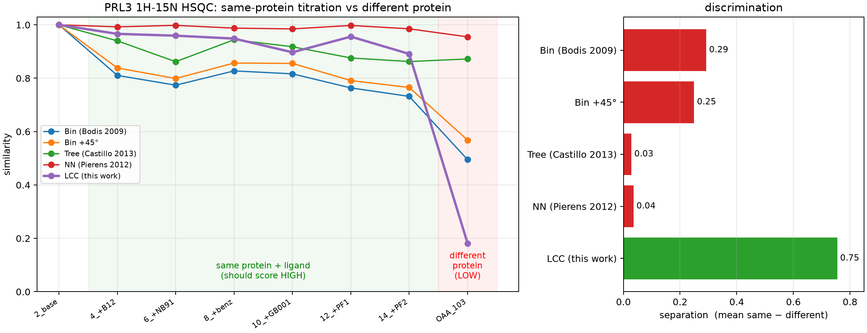
Figure 1. Per-comparison LCC similarity of the reference PRL3 $​^{1}$H-$​^{15}$N HSQC spectrum. Left: similarity along the six-point ligand titration of the same protein (green, should score high, 0.89–0.97) and to a different protein (OAA, red, 0.18), for all five methods; LCC (purple) is the only measure that keeps the titration high while dropping the different protein far below it. Right: the resulting separation (mean same − different) per method.

Data availability
The processed PRL3 and OAA Bruker spectra used for the benchmark are available from the author on reasonable request. The benchmark harness accepts their locations via --prl3/--oaa.

Funding
None declared.

Conflict of interest
None declared.

References
Bodis,L. et al. (2007) A novel spectra similarity measure. Chemometr. Intell. Lab. Syst., 85, 1–8.
Bodis,L. et al. (2009) Automatic compatibility tests of HSQC NMR spectra with proposed structures of chemical compounds. Talanta, 79, 1379–1386.
Castillo,A.M. et al. (2013) Fast and shift-insensitive similarity comparisons of NMR using a tree-representation of spectra. Chemometr. Intell. Lab. Syst., 127, 1–6.
Harris,C.R. et al. (2020) Array programming with NumPy. Nature, 585, 357–362.
Helmus,J.J. and Jaroniec,C.P. (2013) Nmrglue: an open source Python package for the analysis of multidimensional NMR data. J. Biomol. NMR, 55, 355–367.
Pierens,G.K. et al. (2012) HSQC spectral based similarity matching of compounds using nearest neighbours and a fast discrete genetic algorithm. J. Cheminform., 4, 25.
Shuker,S.B. et al. (1996) Discovering high-affinity ligands for proteins: SAR by NMR. Science, 274, 1531–1534.
Williamson,M.P. (2013) Using chemical shift perturbation to characterise ligand binding. Prog. Nucl. Magn. Reson. Spectrosc., 73, 1–16.

