**Lab 1：Introduction**

|  |  |
| --- | --- |
| **Author** | Name：唐心宇lab6 Student ID:11911817  毕云天 12112501 |
| **Introduction**  In this lab, matlab is used to test different systems by creating different input and comparing the output to get properties of the systems. And matlab is used to write function which implements the first-order autoregression equation  Target of this lab:   1. Use matlab to demonstrate discrete-time signal. 2. Learn to represent impulse and step signal using matlab. 3. Learn to verify properties of signals. 4. Learn to apply transformation on signals such as time shift.   **Lab results & Analysis**：  Part 1.4                                              Part 1.5   1. function y = diffeqn(a,x,ynl)      1. xl[n] = 6[n] x2[n] = u[n]        1. xl[n]=u[n]   x2[n]=2u[n]  2y1[n]-y2[n]because y1 with multiple 2 that made one more -1 in the result.   1. y[-1] = 0 y[-1] = 0.5     as you can see output signal is different in the beginning value and increase speed. Also they have the same final value  **Note**: Please indicate meaning of the symbols in all expressions. Please indicate the coordinate and unit in all figures. | |
| **Experience**  Tang finishes the part 1(1.4) Bi finishes the part 2(1.5)  Both finish their own part of this report. | |
| **Score** | Score according to targets in introduction.  1.4: 100 |

**Code:**

**1.4(a)**

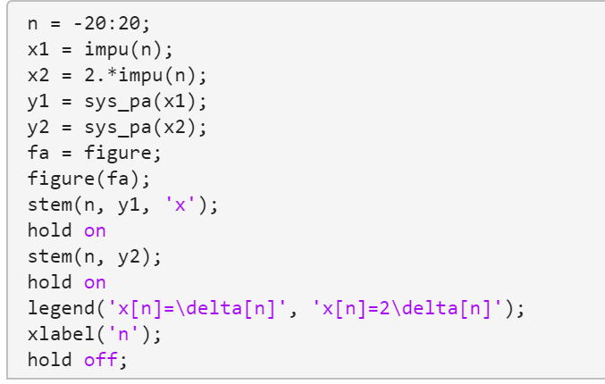

**1.4(b)**

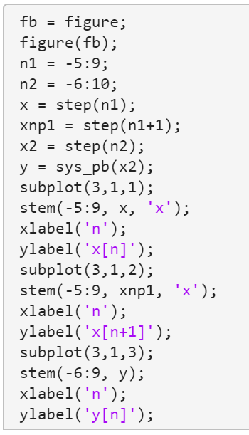

**1.4(c)**

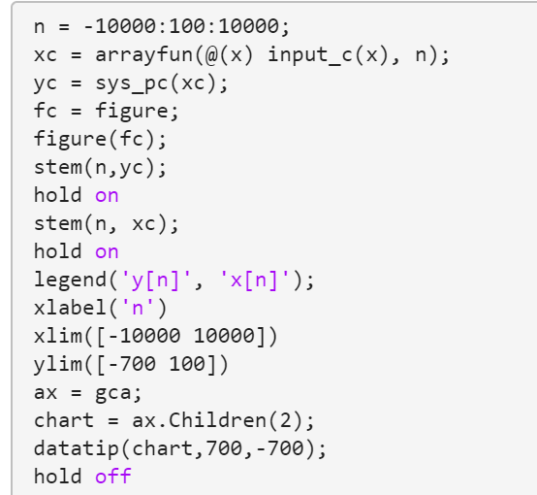

**1.4(d)**

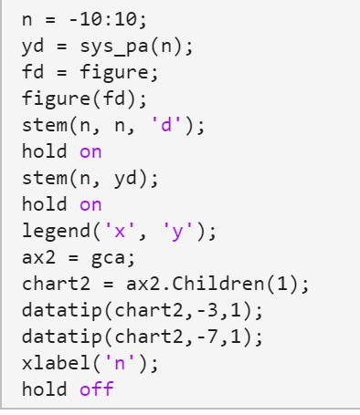

**1.4(e) not linear**

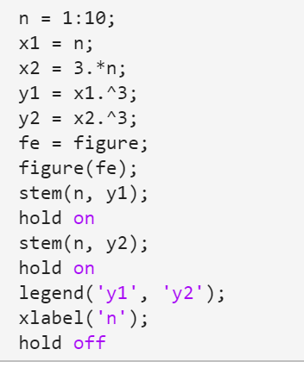

**1.4(f) not time-invariant**

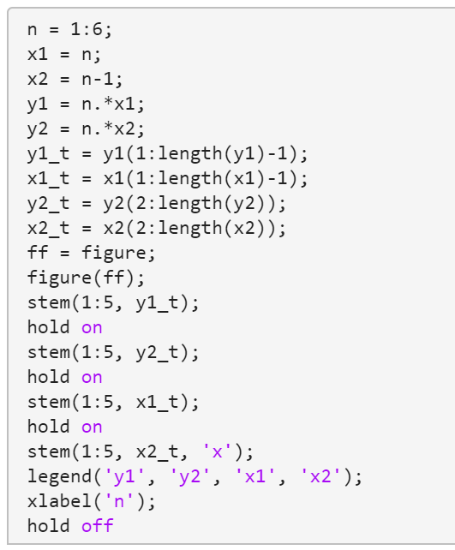

**1.4(f) not stable**

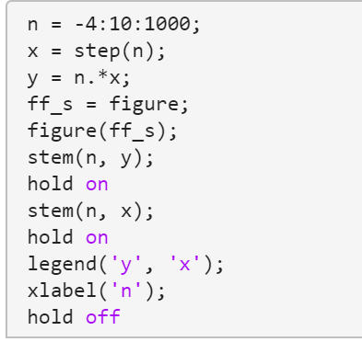

**1.4(f) not invertible**

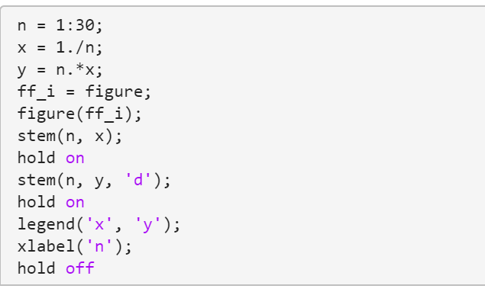

**1.4(g) not time-invariant**

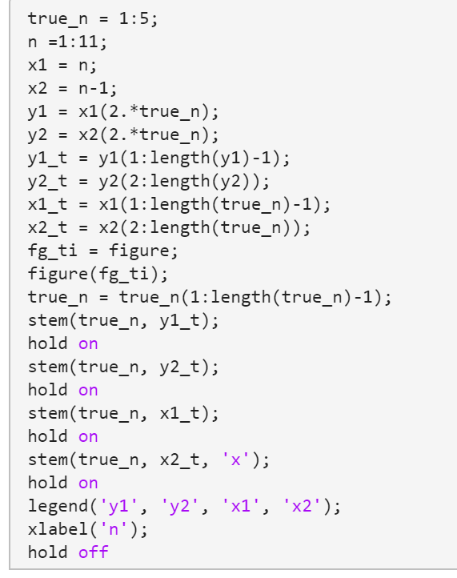

**1.4(g) not causal**

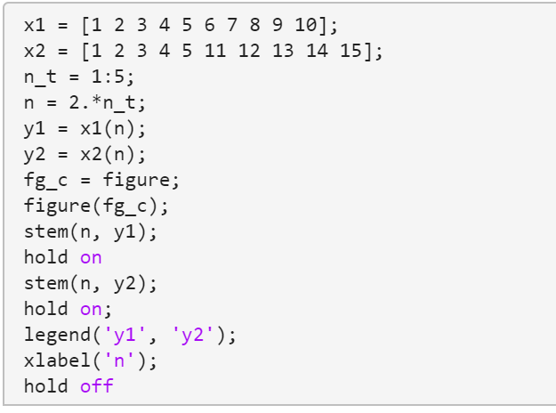

**1.4 function**

