**Lab 1：Introduction**

|  |  |
| --- | --- |
| **Author** | Name：唐心宇lab6 Student ID:11911817  毕云天Lab5 12112501 |
| **Introduction**  In this lab.  3.5 Periodic discrete time signal can be represented in form of sum of DTFS coefficient component. The lab shows transformation of DTFS to original signal and the reversion of it.  The generated signal becomes converge to original signal after more DTFS coefficient component added to the sum.  3.8 DTFS coefficient shows contribution of each frequency. When input signal goes through the system, each coefficient gets a gain. So. the eigen function can show properties of system.  3.10 Use FFT function and DTFS function to compute periodic coefficients and convolution in different way with different operations.  Target of this lab:  3.5 Learn generating signal after knowing DTFS coefficient.  Learn generating ak using fft function.  Learn process of signal synthesis by adding more DTFS coefficient component.  3.8 Learn generating frequency response by using freqz.  Learn use eigen function to show the properties of system.  3.10Learn to computing the DTFS BY dtfs , conv and fft function  Learn to use low operations way to finfish cimpute  **Lab results & Analysis**：  Part 3.5                                                      **3.10**    ***Easy to understand it will have 2N operation in computing***            It could be easy to find in figure that fftcomps increase in low speed in many times. And with large N time of dtfs comes longer and longer.    Easy to find Ny=N for x and h  Just like this    You can see it is just Ny =4=N in this figure.        **Here is nothing to tolk but code ,you can find it in the last part**  **Figure for part(f) and part (h)**      **Here is time for f40c conv40 f40f f80c and f80f**  **f40c=2.1592e-05**  **convtimes =2.0753e-06(40)**  **f80c=4.6216e-05**  **f40f=1.6717e-05**  **f80f=2.7934e-05**  **easy to find that when N became 80 from 40 f80c become nearly 2 times of f40c**  **and f40f became nearly 1.5 times**  **So when N>80 I will use fft and ifft to compute instead of conv or dtfs because of its bad speed.**  **Note**: Please indicate meaning of the symbols in all expressions. Please indicate the coordinate and unit in all figures. | |
| **Experience**   1. **Have learnt to using matlab code to run dtfs computing.** 2. **Learn to use loglog to compare different value.** | |
| **Score** | Score according to targets in introduction.  3.5: 100  3.8: 100  3.10: 95 |

**Code:**

**3.5(a)**

**None**

**3.5(b)**



**3.5(c)**

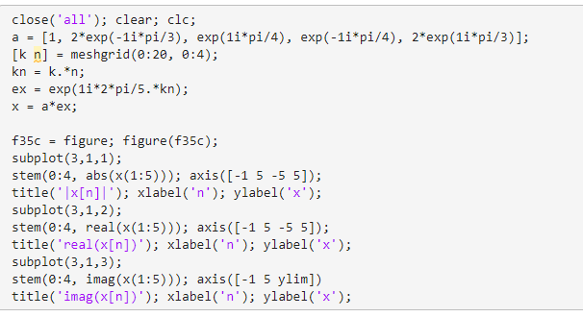

**3.5(d)**

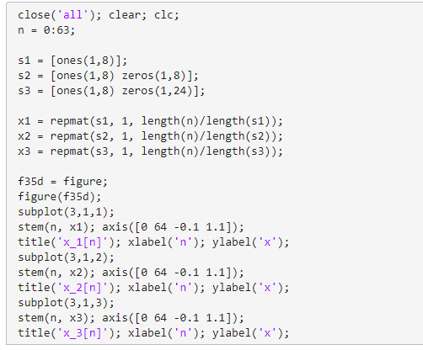

**3.5(e)**

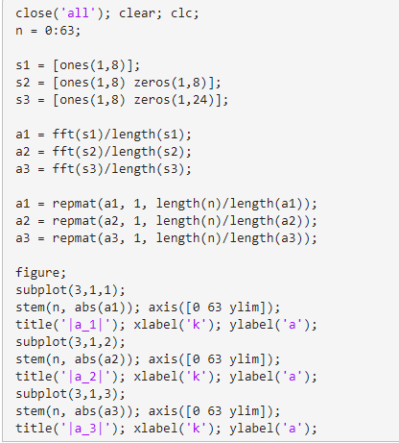

**3.5(f)**

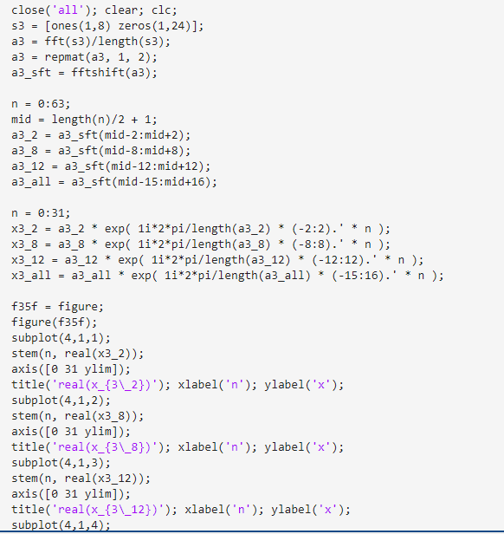

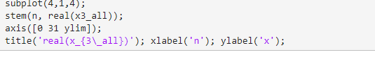

**3.5(g)**

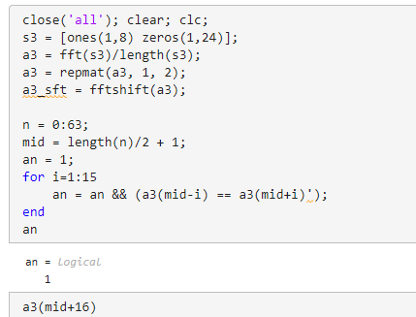

**3.5(h)**

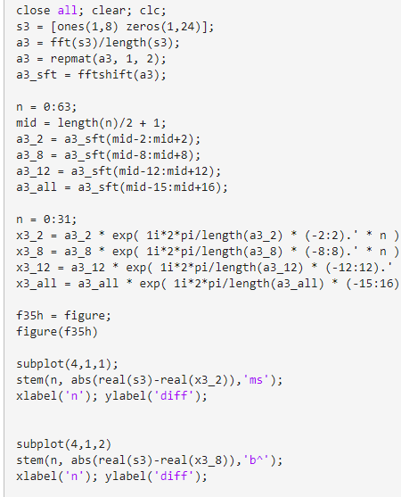

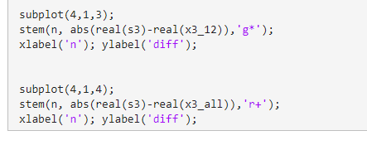

**3.8(a)**

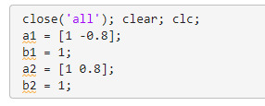

**3.8(b)**

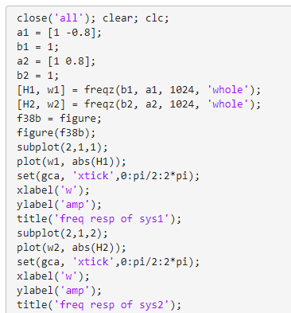

**3.8(c)**

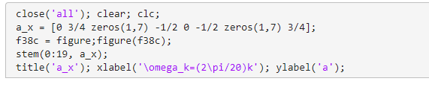

**3.8(d)**

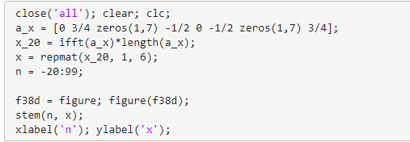

**3.8(e)**

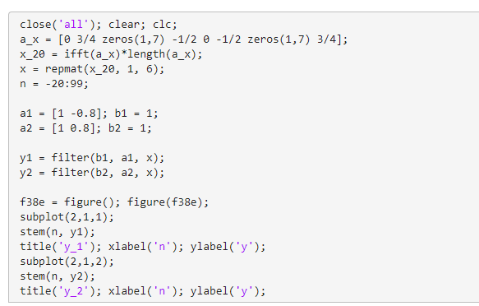

**3.8(f)**

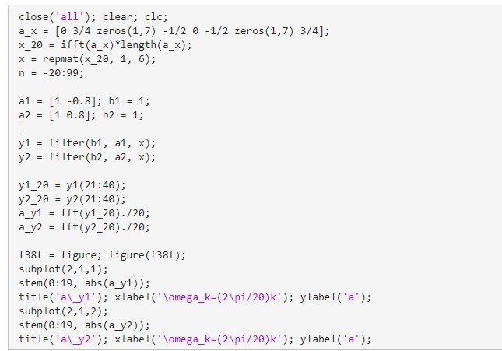

**3.10**

**(b)(c)**

**(d)**

**(e)**

**(f)**

**(g)**

**(h)**

