**Lab 1：Introduction**

|  |  |
| --- | --- |
| **Author** | Name：唐心宇lab6 Student ID:11911817  毕云天Lab5 12112501 |
| **Introduction**  In this lab.  4.6: Use knowledge of CTFT to do amplitude demodulation using LPF. The report will inspect the LPF. Choose multiplication of sin(2*pi*f1t) or cos(2*pi*f2t) etc. with x(t) according to the transform of spectrum after multiplication to get m(t).  Target of this lab:  4.6 complete demodulation and explain correctly.  **Lab results & Analysis**：  Part 4.2  Part 4.6                      Yes, it’s expected. The magnitude of the output of the filter becomes very small. After x(t) multiplied with cos(2pi*f1t). the peek of the spectrum moves to right and left and outside of the range of the filter.            Only multiplication with cos(2pi*ft)^2 and sin(2pi*ft)^2 can make the spectrum split right and left centered and pass the LPF.    x(t)cos(2pi*f_1t) will let and only let m1(t) pass the filter.  So, multiply cos(2pi*f_1t) and x(t) and put the product into LPF.    Dash dot dot: D      Dot dot dot: S  Dot dash dash dot: P  DSP | |
| **Experience**   1. **Have learnt to using matlab code to run dtfs computing.** 2. **Learn to use loglog to compare different value.** | |
| **Score** | Score according to targets in introduction.  4.6 100 |

**Code:**

**4.2**

**4.6**

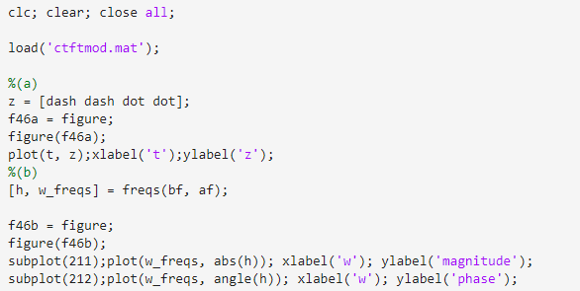

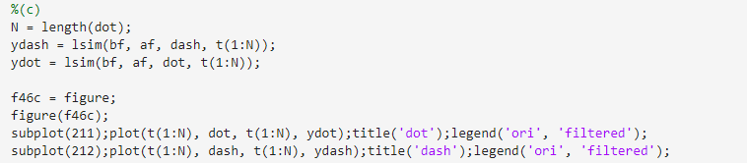

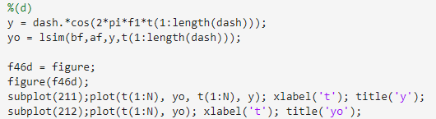

**(e) no need**

