**Lab 1：Introduction**

|  |  |
| --- | --- |
| **Author** | Name：唐心宇lab6 Student ID:11911817  毕云天Lab5 12112501 |
| **Introduction**  This lab report contains:  1. Generate speech-shaped noise and inspect psd of the SSN and original speech.  2. Adjusting the SSN to specific SNR.  3. Compare envelope of the speech generated by filter with different order and cutoff frequency.  **Lab results & Analysis**：    First, Load audio      Generate filter using fir2 after getting psd of original audio.    Generate noise using rand.    Let the noise pass the filter and get SSN.              Let y = ax + b*SSN. Set a=1 first, and get B by condition SNR = -5. Then normalize y to energy of x.       1. Envelop of higher cutoff is thicker.      1. Envelope with lower order is thicker.       High order and low cutoff filter out more frequency. So, correspond to thinner envelop. | |
| **Experience**  1.Learn to design and use different fiter, also find their difference.  2.Learn to use filter analyaze wav file and  3.Learn to adjust SNR of the signal. | |
| **Score** | 100 |

**Code:**

**Q1**

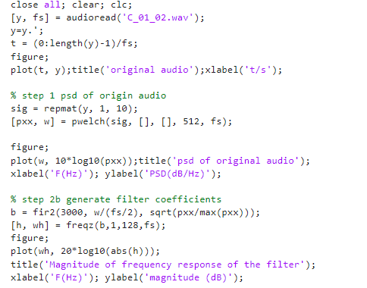

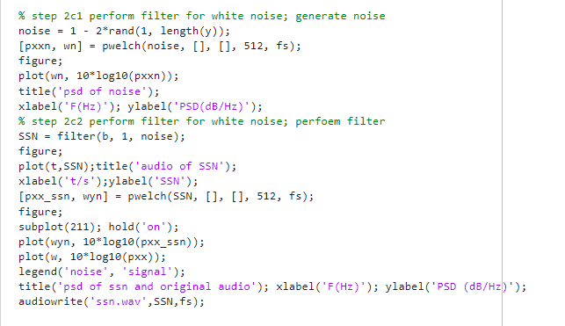

**Q2**

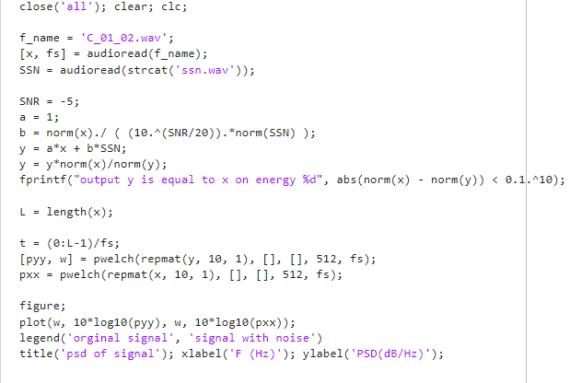

**Q3**

