**Task4**

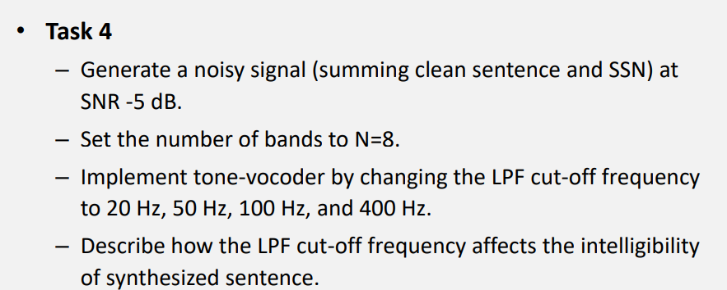

Code:

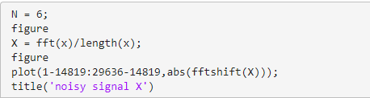

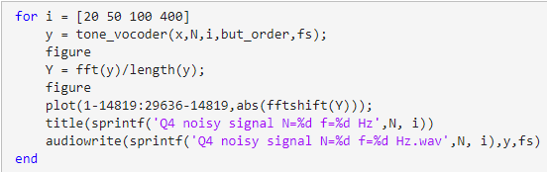

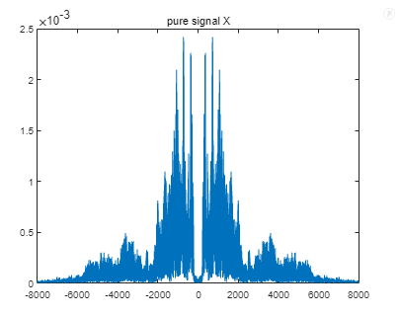 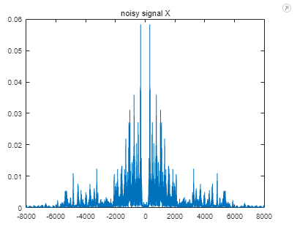

The graph above is spectrum of original signal and noisy signal.

The following graphs is the spectrum of noisy signal generated by the tone-vocoder

With N=6 and cut off frequency = 20 50 100 400Hz.

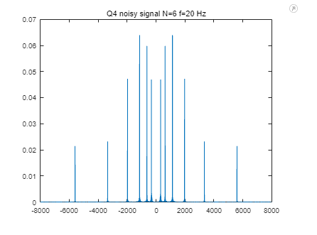

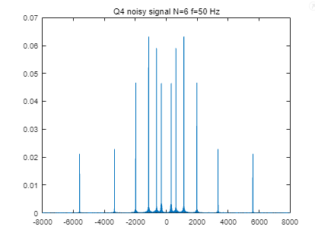

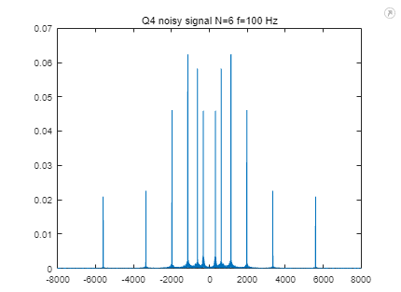

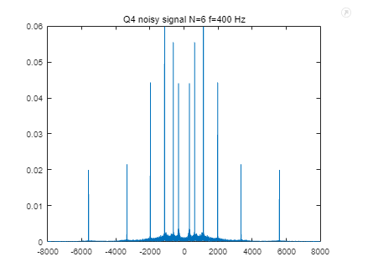

Analysis:

The generated audio is hard to understand. Audio generated with higher cut-off frequency is clearer although there are still not understandable. There are 6 peeks in each side corresponding to N=6. With the cutoff frequency increasing, there appear more and more scattered signals between the peak, which happens in task2.

Conclusion:

Audio generated with more band and higher cutoff frequency sound clearer. Although too much bands can lead to strange sound effect. When the sound has much noise and it’s hard to understand, the generated audio by tone-vocode is hard to understand too.