**Requirement:**

**Menu:**

It has list of categories. As of now we have only **Makeup.**

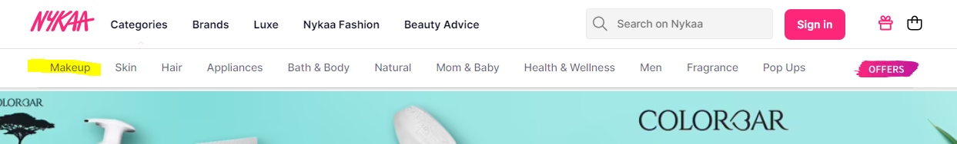

Now next step is when use click on the makeup it will open a **popup** with some list of details called as **level Item.** And these will be distinguished based on their levels.

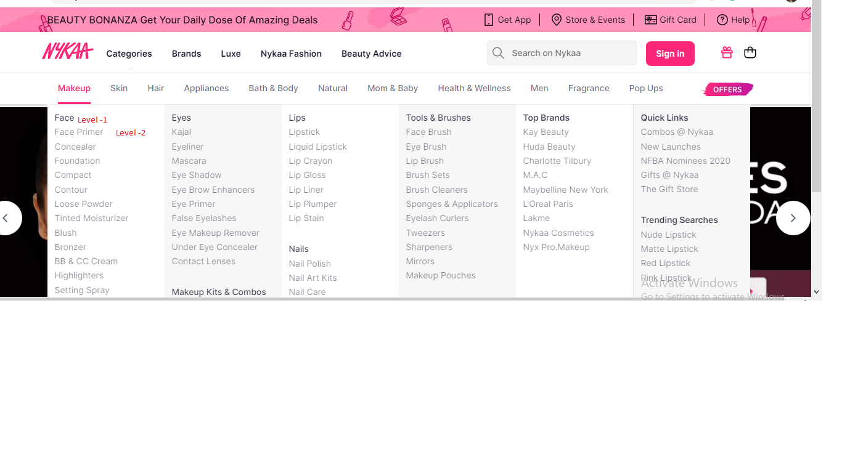

**TBD**

**Solution Design(Db and MS):-**

