**Objective:**

To implement fractal sets, using fragment and vertex shaders.

**A brief write-up about the program:**

**Julia Set:**

* + The Julia set consists of values such that an arbitrarily small perturbation can cause drastic changes in the sequence of iterated function values.
  + Julia set is generated by the special quadratic case form f(z) = z2 + c.
  + z represents a variable of the form a+ib (a and b real numbers) which can take on all values in the complex plane.
  + The quantity c also is defined as a complex number.
  + The simple expression f(z) =  z2 + c has little potential to create anything interesting—it is only by repeatedly iterating it that the Julia set can be defined.  When the output of the expression f(z) is fed back into the expression as a new value of z, this is called **iteration**, a type of feedback process.
  + Thus, for any n:zn+1  = f(z) = zn2 + c  
      
    and each new computed value of f(z) becomes the subsequent input value of z via the feedback loop.

**Mandelbrot Set:**

* Mandelbrot set is the set of all complex numbers *z* for which the sequence defined by the iteration

*z(0) = z, z(n+1) = z(n)*z(n) + z, n=0,1,2, ...*

remains bounded.

* Images of the Mandelbrot set display an elaborate boundary that reveals progressively ever-finer recursive detail at increasing magnifications
* The style of this repeating detail depends on the region of the set being examined.
* The set's boundary also incorporates smaller versions of the main shape, so the fractal property of self-similarity applies to the entire set, and not just to its parts.

**Screenshots:**

**Julia set:**

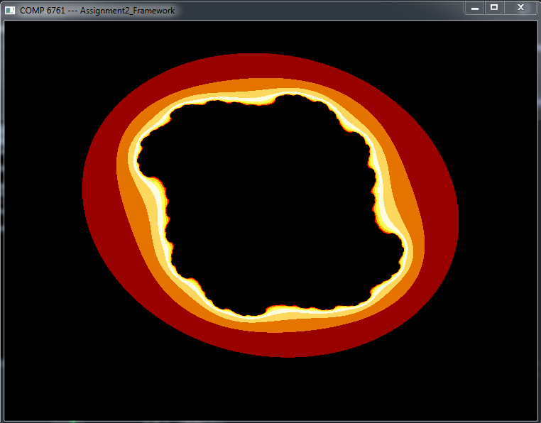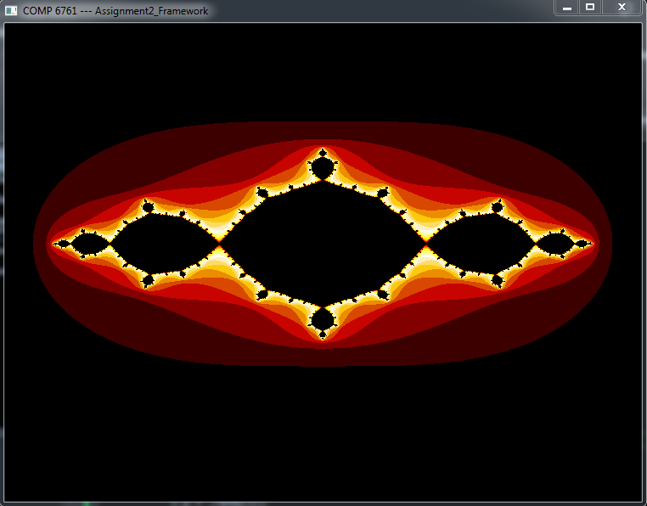

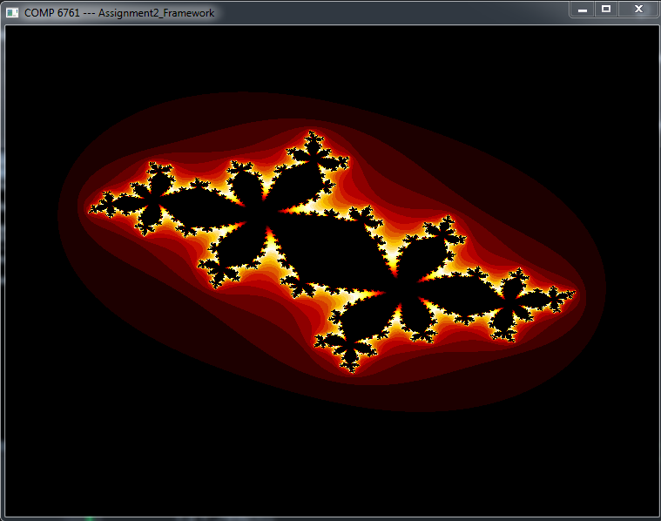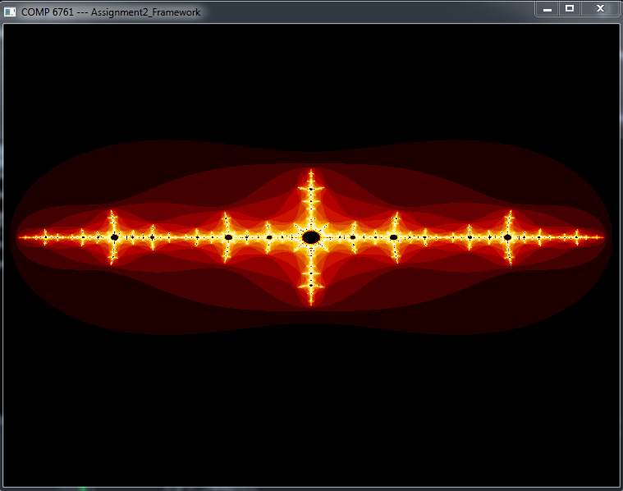

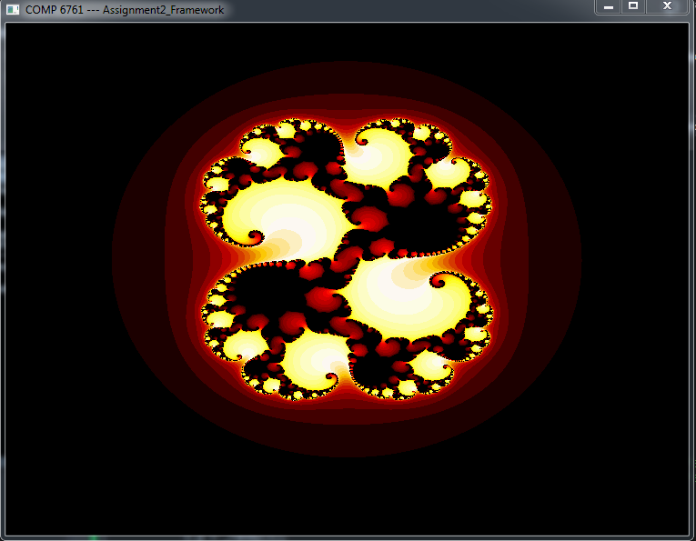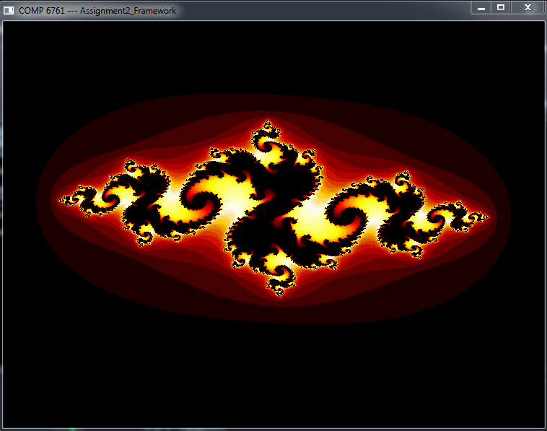

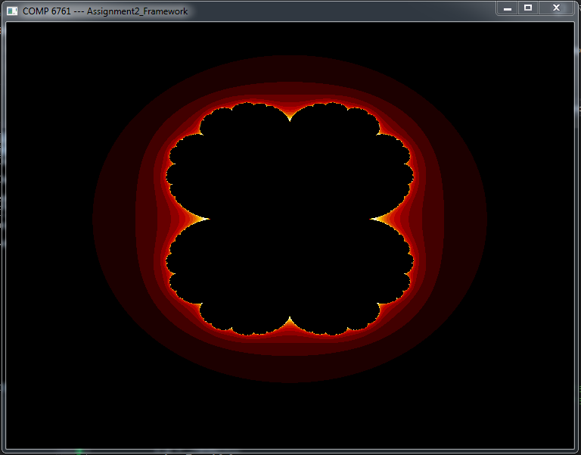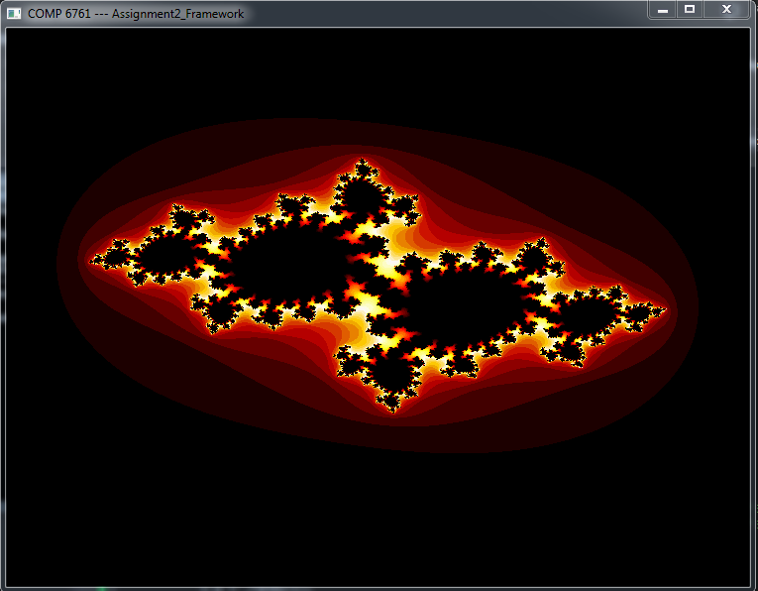

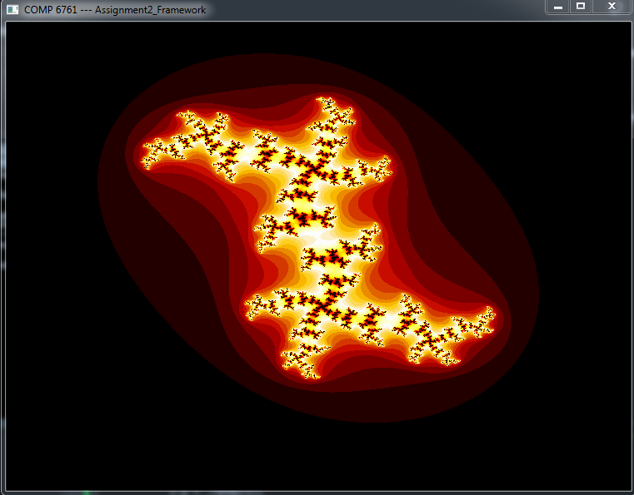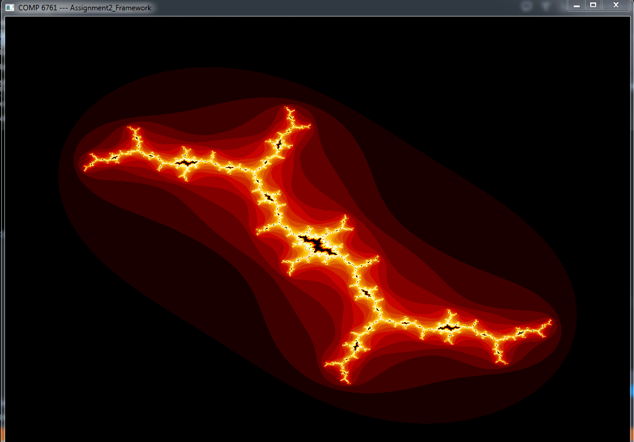

**Mandelbrot Set:**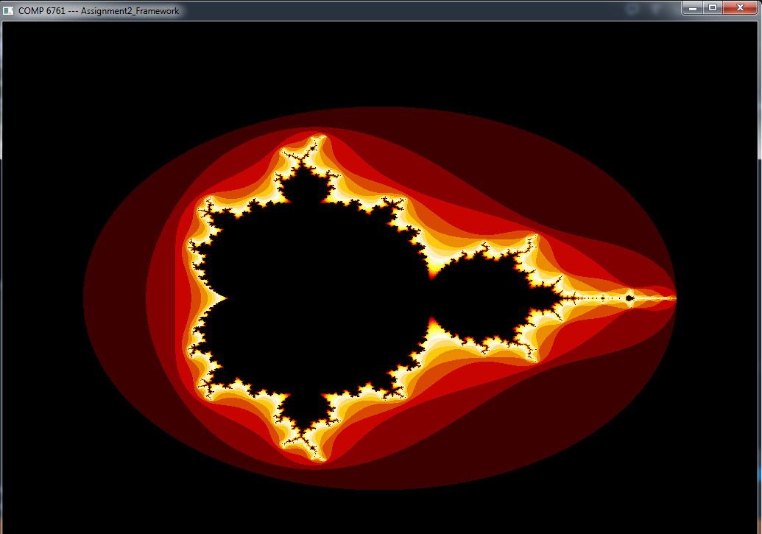

**Usage Instructions:**

* Open the executable file of the assignment from the bin folder.
* By default, Julia set will be displayed.
* Press “2” for Mandelbrot set and Press “1” for Julia Set.
* Press “Z” to zoom in.
* Press “X” to zoom out.
* Press NUM+2 to move up.
* Press NUM+8 to move down.
* Press NUM+4 to move left.
* Press NUM+6 to move right.
* Press “+” to increase iteration value.
* Press “-“ to decrease iteration value.
* Press Esc to quit.

**References:**

1. Julia Set

(http://aleph0.clarku.edu/~djoyce/julia/julia.html)

1. Mandelbrot Set

(http://www.math.utah.edu/~pa/math/mandelbrot/mandelbrot.html)