Practical 4
Part – A

Problem 1:- Password strength (PasswordChecker.java + Driver.java)
(a) In PasswordChecker, check four rules — length ≥ 8, contains an uppercase letter,contains a digit, contains a special character — using regex (e.g. “.*[A-Z].*”) orString methods.
(b) Write strength(String pw) that counts how many rules pass and returns “Weak” (0–1), “Medium” (2–3) or “Strong” (4).
(c) In Driver.main: test several passwords; for each, print which rules passed and thefinal label.
Expected output: “abc” → Weak; “Abcd1234!” → Strong.

Code:-
PasswordChecker.java
public class PasswordChecker {
public static boolean hasLength(String pw) {
return pw.matches(".{8,}");
}
public static boolean hasUpperCase(String pw) {
return pw.matches(".*[A-Z].*");
}
public static boolean hasDigit(String pw) {
return pw.matches(".*\\d.*");
}
public static boolean hasSpecialCharacter(String pw) {
return pw.matches(".*[^a-zA-Z0-9].*");
}
public static String strength(String pw) {
int count = 0;
if (hasLength(pw))
count++;
if (hasUpperCase(pw))
count++;
if (hasDigit(pw))
count++;
if (hasSpecialCharacter(pw))
count++;
if (count <= 1)
return "Weak";
else if (count <= 3)
return "Medium";
else
return "Strong";
}
}
Driver.java
import java.nio.channels.Pipe.SourceChannel;
public class Driver {
public static void main(String[] args) {

String[] passwords = {
"abc",
"Password",
"Password1",
"Abcd1234!"
};
for (String pw : passwords) {
System.out.println("Password: " + pw);
System.out.println("Length >= 8: " + PasswordChecker.hasLength(pw));
System.out.println("Has Uppercase: " + PasswordChecker.hasUpperCase(pw));
System.out.println("Has Digit: " + PasswordChecker.hasDigit(pw));
System.out.println("Has Special Character: " + PasswordChecker.hasSpecialCharacter(pw));
System.out.println("Strength: " + PasswordChecker.strength(pw));
System.out.println("---------------------------------");

}
}
}

OUTPUT:- 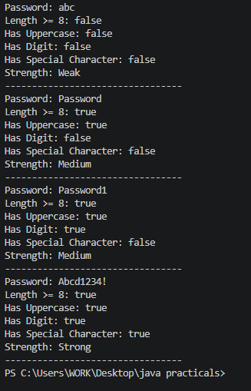
Practical 2:- Chat-log filter (ChatFilter.java + Driver.java)
(a) In Driver.main, define a String[] of log lines like “10:05 alice Hello there” (includeone malformed line with fewer than 3 parts).
(b) Read a keyword from the user.
(c) For each line, split into time/user/message with split(“ ”, 3); skip lines that do nothave 3 parts.
(d) If the message contains the keyword (case-insensitive), increment a counter andappend “time user: message” to a StringBuilder.
(e) Print “Matches: N” and the built report.Expected output: keyword “hello” over 3 lines (1 malformed) → “Matches: 1” and
the matching line.

Code:-
ChatFilter.java
public class ChatFilter {
public static String filter(String logs[], String keyWord){
int count = 0;
StringBuilder report = new StringBuilder();
for (String s : logs){
String[] parts = s.split(" ",3);
if (parts.length < 3){
continue;
}
String time = parts[0];
String name = parts[1];
String msg = parts[2];
if (msg.toLowerCase().contains(keyWord.toLowerCase())){
count++;
report.append(time);
report.append(" ");
report.append(name);
report.append(" ");
report.append(msg);
report.append(" ");
}
}
return "Matches: " + count + "\n" + report.toString();
}
}
Driver2.java
import java.util.Scanner;
public class Driver2{
public static void main(String[] args){
Scanner sc = new Scanner(System.in);
String[] logs =
{
"10:05 alice Hello there",
"10:10 bob How are you?",
"InvalidLine"
};
System.out.println("Enter A Word : ");
String word = sc.next();
String result = ChatFilter.filter(logs, word);
System.out.println(" ");
System.out.println(result);
sc.close();
}
}
OUTPUT:- 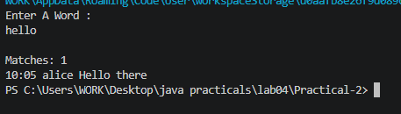
Problem 3:- (For Advanced Learners – home) Template filler (TemplateFiller.java +Driver.java)
(a) In Driver.main, define a template like “Dear {name}, order {id} ships {date}.” andtwo parallel arrays: names {“name”, “id”} and values {“Riya”, “A07”} (note {date} is not supplied).
(b) Compile a Pattern for \{(\w+)\} and get a Matcher on the template.
(c) Walk the matches with a StringBuilder: for each {placeholder}, look up its value inthe names array and replace with the value, or with “[?]” if not found.
(d) Print the filled template.Expected output: the unsupplied {date} becomes [?].
Code:-
TempletFilter.java
import java.util.regex.Matcher;
import java.util.regex.Pattern;
public class TemplateFilter{
public static String FTemplate(String template, String[] names, String[] values) {
Pattern pattern = Pattern.compile("\\{(\\w+)\\}");
Matcher matcher = pattern.matcher(template);
StringBuilder result = new StringBuilder();
int lastIndex = 0;
while (matcher.find()) {
result.append(template.substring(lastIndex, matcher.start()));
String key = matcher.group(1);

String replacement = "[?]";
for (int i = 0; i < names.length; i++) {
if (names[i].equals(key)) {
replacement = values[i];
break;
}
}
result.append(replacement);
lastIndex = matcher.end();
}
result.append(template.substring(lastIndex));
return result.toString();
}
}

Driver3.java
public class Driver3 {
public static void main(String[] args) {
String template = "Dear {name}, order {id} ships {date}.";
String[] names = {
"name",
"id"
};
String[] values = {
"DEEP",
"086"
};
String output = TemplateFilter.FTemplate(template, names, values);
System.out.println(output);
}
}

OUTPUT:- 