PROJECT REPORT
Automated Market and Competitor Research Team
A Multi-Agent System for Consulting-Style Strategic Briefs
Problem Definition | Design | Development | Deployment | Evaluation
Field | Details
Student name | Your full name
SAP ID | Your SAP ID
Roll number | Your roll number
Programme and year | B.Tech Computer Engineering (Honours in Data Science), Final Year
Institute | Institute name
Course | Course name and code
Guide / Faculty | Guide name
Submission date | DD Month YYYY
Source code | GitHub repository URL
Live application | Deployed application URL
Demo video (Google Drive) | Drive link, access: anyone with the link can view

Index
1. Introduction 4
1.1 What is an AI agent 4
1.2 From chatbots to agentic systems 4
1.3 Multi-agent systems 5
1.4 Applications of agent systems 5
1.5 Challenges of agent systems 5
1.6 Related technology 5
1.7 About this project and report 6
2. Problem Definition 8
2.1 Background and motivation 8
2.2 Problem statement 8
2.3 Objectives 8
2.4 Scope 8
2.5 Users and use cases 9
2.6 Why a multi-agent approach 9
2.7 Success criteria 9
2.8 Assumptions and constraints 10
3. System Design 11
3.1 Design principles 11
3.2 System architecture 11
3.3 Agent specifications 11
3.4 Orchestration and control flow 13
3.5 Shared state and data model 14
3.6 Tool design 14
3.7 Prompt design 14
3.8 Grounding and anti-hallucination design 15
3.9 Report structure 15
3.10 Technology stack and rationale 16
3.11 Alternatives considered 16
3.12 Security, privacy and ethics 16
4. Development 18
4.1 Development environment 18
4.2 Development methodology 18
4.3 Implementation highlights 18
4.4 Code size 20
4.5 Testing 20
4.6 Challenges and solutions 20
4.7 Offline smoke test 21
4.8 Source code walkthrough 21
4.9 Execution of the system 23
4.10 Application screenshots 25
4.11 Sample generated output 28
4.12 Live-run evidence to add 29
5. Deployment Architecture 30
5.1 Deployment goals 30
5.2 Deployment architecture 30
5.3 Proof of multiple agents 31
5.4 Deployment options 33
5.5 Containerisation 33
5.6 Configuration and secrets 33
5.7 Continuous integration 34
5.8 Deployment procedure 34
5.9 Operational considerations 34
5.10 Deployment record 35
5.11 Risk register 35
6. Evaluation 36
6.1 Objectives and research questions 36
6.2 Experimental setup 36
6.3 Metrics 37
6.4 Results 38
6.5 Analysis and discussion 39
6.6 Evaluation of non-functional requirements 40
6.7 Threats to validity 40
7. Conclusion and Future Work 41
7.1 Summary 41
7.2 Limitations 41
7.3 Future work 41
8. Demo and Proof of Implementation 42
8.1 Demo link 42
8.2 What the demo shows 42
8.3 Proof-of-implementation artefacts 42
References 43
Appendix A: Prompt excerpts 44
Appendix B: Run summary schema 44
Appendix C: Command reference 45

1. Introduction
Software has traditionally followed instructions written in advance. A new class of systems, built on large language models (LLMs), can instead be given a goal, decide which steps to take, use tools and check their own results. These are called agent systems, and when several of them cooperate they form a multi-agent system. This report presents the design, development and deployment of one such system, an Automated Market and Competitor Research Team, and begins by explaining the concepts it relies on.

1.1 What is an AI agent
An AI agent is a program that perceives its inputs, reasons about what to do, acts through tools and observes the result, repeating this loop until a goal is reached. In an LLM-based agent the language model plays the role of the reasoning engine, while surrounding code supplies instructions, tools, memory and safety checks.
Table 1: Building blocks of an LLM-based agent
Building block | Role in an agent | Example in this project
Model (reasoning) | Interprets the task, plans and writes | Any chat LLM: Groq, Gemini, OpenAI, Anthropic, Ollama
Instructions (prompt) | Defines role, rules and output format | Separate prompt for each agent in prompts.py
Tools | Let the agent act on the world | Web search, Wikipedia, Yahoo Finance data, chart drawing, Word export
State and memory | Carries information between steps and agents | Shared LangGraph state: sources, findings, analysis, strategy
Control flow | Decides what runs next, when to retry or stop | LangGraph graph with a quality gate
Guardrails and evaluation | Keep output safe, grounded and measurable | Citation validation, schema checks, evaluation harness

1.2 From chatbots to agentic systems
Table 2: Chatbot versus agent system
Aspect | Plain chatbot | Agent system
Interaction | One question, one answer | Goal-driven, multiple steps
Knowledge | Only what the model memorised | Retrieves fresh information with tools
Actions | Produces text only | Searches, calculates, creates files, calls APIs
Reliability | Cannot check itself | Validation steps, retries and quality gates
Output | Free text | Structured, auditable results

1.3 Multi-agent systems
A multi-agent system divides a complex task among several agents, each with its own role, tools and instructions. The idea comes from distributed artificial intelligence (Wooldridge, 2009) and has become practical with LLMs through frameworks such as AutoGen (Wu et al., 2023) and MetaGPT (Hong et al., 2023). Benefits include specialisation, easier testing of each part, validation at every hand-off and the ability to recover from partial failure. The costs are more model calls and more coordination logic.
Table 3: Multi-agent coordination patterns
Coordination pattern | How agents cooperate | Typical use | Used here
Sequential pipeline | Each agent passes its output to the next | Report generation, data processing | Yes: Researcher, Analyst, Strategist, Writer
Supervisor (orchestrator) | A controller assigns work and decides next steps | Tasks needing retries or routing | Yes: quality gate decides retry, proceed or abort
Parallel workers | Several agents work at once and results are merged | Large searches, ensembles | Future work
Debate or critique | Agents review and challenge each other | Fact-checking, quality improvement | Future work (Critic agent)

1.4 Applications of agent systems
- Consulting and business research: market scans, competitor benchmarking, due diligence (the focus of this project).
- Finance and banking: document verification, risk summaries, regulatory monitoring and customer-service assistants.
- Software engineering: coding agents that plan, write, test and fix code.
- Customer support: agents that classify requests, retrieve policies and escalate to humans.
- Scientific and academic research: literature review and data analysis assistants.

1.5 Challenges of agent systems
- Hallucination: models can state facts that are not true or cite sources that do not exist.
- Reliability: model output can be malformed, and external tools can fail or be rate limited.
- Cost and latency: every extra model call adds time and expense.
- Evaluation: open-ended text is hard to score objectively.
- Security and governance: keys, prompts and data must be protected; outputs need human review.
The design in Section 3 addresses each of these directly: grounding checks for hallucination, retries and a quality gate for reliability, per-agent token tracking for cost, an evaluation harness for measurement and secrets handling for security.

1.6 Related technology

Retrieval grounding
Retrieval-augmented generation supplies a model with retrieved evidence so that its output is conditioned on documents rather than on its memory alone (Lewis et al., 2020). This project applies a lightweight form of the same principle: the Researcher retrieves snippets, assigns each a numeric identifier, and all later agents may only cite those identifiers. Because the evidence set per run is small (at most 40 snippets), a vector database is unnecessary. Reasoning-and-acting prompting (Yao et al., 2023) motivates giving agents tools rather than relying on model memory.

Orchestration frameworks
Table 4: Orchestration framework comparison
Framework | Strengths | Limitations for this project | Decision
LangGraph | Explicit state graph, conditional edges, loops, typed state, streaming of node updates | Lower-level; more code than role-based frameworks | Selected
CrewAI | Fast role and task prototyping | Less explicit control over loops and quality gates | Not selected
AutoGen | Conversational multi-agent patterns | Free-form chat is harder to make deterministic and testable | Not selected
Plain Python pipeline | Simplest, no dependency | Manual retry and routing logic; less transparent control flow | Not selected

LangGraph was chosen because the workflow needs a conditional retry loop and an abort path, both of which map naturally to graph edges, and because node-level streaming makes progress reporting straightforward (LangChain, 2024).

Consulting frameworks
- SWOT analysis separates internal factors (strengths, weaknesses) from external factors (opportunities, threats).
- Porter's Five Forces assesses industry structure through the threat of new entrants, bargaining power of suppliers and buyers, threat of substitutes and competitive rivalry (Porter, 1979).
- Pyramid principle and MECE structuring guide the writing: lead with the answer; keep points mutually exclusive and collectively exhaustive.

Evaluating LLM output
This project combines deterministic metrics computed from the report itself, such as citation validity, with an LLM-as-judge rubric. Judges correlate reasonably with human preference but have known biases, including favouring their own outputs (Zheng et al., 2023), so the evaluation in Section 6 allows a separate judge model and relies mainly on objective measures.

1.7 About this project and report
The project builds an Automated Market and Competitor Research Team: given a company or industry, four cooperating agents (Researcher, Data Analyst, Strategy Consultant and Report Writer) coordinated by a LangGraph workflow produce a consulting-style brief with market overview, quantitative benchmarking, SWOT, Porter's Five Forces and prioritised recommendations, delivered as Word, Markdown and JSON files.
Table 5: Organisation of this report
Section | Content
2 Problem Definition | Why the problem matters, objectives, scope, users, success criteria
3 System Design | Architecture, agent specifications, orchestration, data model, guardrails
4 Development Details | Environment, code walkthrough, screenshots and execution evidence, testing
5 Deployment Architecture | Deployment diagram, proof of multiple agents, platforms, operations
6 Evaluation | Method, metrics and results against a single-agent baseline
7 Conclusion | Summary, limitations and future work
8 Demo and Proof of Implementation | Demo video link (Google Drive) and verification artefacts

2. Problem Definition

2.1 Background and motivation
Management consulting, corporate strategy, investment research and business development teams all begin new work with a market and competitor scan. A typical scan answers four questions: What is this company or market? Who are the competitors and how do they compare? What are the strengths, weaknesses, opportunities and threats? What should be done next?
Answering these questions manually involves many searches, reading numerous pages, collecting financial data from several places, normalising it into a comparable form and writing everything in a consistent structure. A junior analyst may need one to two days for a single brief. Because the work is repeated for every new client, target or competitor, it is a strong candidate for automation.
Recent large language models (LLMs) can read and write fluently, but using one model in a single prompt for this job is unreliable. Models may fabricate statistics, cite sources that do not exist, silently skip sections or confuse facts about similar companies. A credible solution therefore needs structure, tools and checks around the model.

2.2 Problem statement
Problem statement
Design, develop and deploy an automated multi-agent system that, given a company or an industry, produces a structured consulting-style brief (market overview, competitor benchmarking, SWOT, Porter's Five Forces and prioritised recommendations) in which every factual claim is traceable to a retrieved source and every quantitative figure is computed from data rather than generated from model memory.

2.3 Objectives
- Automate the end-to-end workflow from a one-line request to a formatted report, reducing first-draft effort from hours to minutes.
- Decompose the work across specialised agents with clear responsibilities, tools and interfaces.
- Ground every claim: findings carry source identifiers, and invalid citations or ungrounded numbers are removed automatically.
- Be robust: handle missing data, failed searches and malformed model output without crashing; stop clearly when no evidence exists.
- Be portable: support multiple LLM providers, including free tiers, and run offline for testing.
- Be deployable and measurable: package the system in a container, expose it through a web interface and evaluate it against a baseline using reproducible metrics.

2.4 Scope
Table 6: Project scope
In scope | Out of scope
Company-level and industry-level briefs | Real-time trading signals or investment advice
Public web information and public market data (Yahoo Finance) | Paywalled or proprietary data (Bloomberg, CapIQ, Gartner)
SWOT, Porter's Five Forces, benchmarking and recommendations | Detailed financial modelling (DCF, forecasts)
Word, Markdown and JSON outputs; web UI and CLI | Multi-user accounts, billing, persistent database
English-language sources | Multilingual research

2.5 Users and use cases
Table 7: Primary users and use cases
User | Need | How the system helps
Consulting analyst | Fast first draft of a market scan before a client call | Generates the structured brief with sources in minutes; analyst reviews and refines
Student or researcher | Understand a company or sector with traceable references | Provides reference-linked findings and a transparent audit trail
Business development manager | Compare a target against named competitors | Produces a peer benchmark table, charts and recommendations
Interviewer or candidate (campus consulting) | Practise case preparation | Provides a worked example of frameworks applied to real companies

2.6 Why a multi-agent approach
A single prompt asked to research, calculate, reason and write must do four different jobs at once with no tools and no checks. Splitting the work yields clear benefits and some costs, summarised below.
Table 8: Single-prompt versus multi-agent approach
Aspect | Single prompt | Multi-agent workflow
Tool use | Cannot call search or data APIs by itself | Each agent owns the tools it needs
Specialisation | One long prompt with competing instructions | Short, focused prompts per role
Validation | Hard to validate intermediate steps | Outputs are validated at each hand-off
Failure handling | All-or-nothing | Quality gate can retry or stop; degraded output is flagged
Testability | End-to-end only | Each agent and the orchestrator are unit-testable
Cost and latency | Fewest calls | More calls and more orchestration complexity

2.7 Success criteria
Table 9: Success criteria
# | Criterion | Measure | Target
S1 | Completeness | Required sections present in generated reports | 100%
S2 | Traceability | Share of in-text citations that match a real source | 100%
S3 | Grounding | SWOT items and recommendations with at least one supporting source | At least 90%
S4 | Robustness | Runs that end in a usable report or a clear error (no crash) | 100%
S5 | Efficiency | End-to-end time per brief on a free-tier provider | Under 5 minutes
S6 | Quality versus baseline | Judge rubric and objective metrics against a single-agent baseline | Equal or better
S7 | Reproducibility | Test suite passes offline from a clean checkout | All tests pass

2.8 Assumptions and constraints
- Only publicly available information is used; no personal data is collected or stored.
- Free and unofficial data sources (DuckDuckGo search, Yahoo Finance) may rate-limit or return gaps; the design must tolerate this.
- Free LLM tiers have rate limits; retries with back-off are required.
- The output is decision support for human review, not an autonomous decision.
- Project is developed by an individual student within one academic term, favouring open-source components.

3. System Design

3.1 Design principles
- Deterministic where possible, generative where necessary. Metrics, tables, layouts and reference lists are produced by code. The model writes prose and judgement only.
- Grounding by construction. Every claim carries source identifiers and these are validated against the real source list at three separate stages.
- Narrow agents with explicit contracts. Each agent reads named fields from shared state and writes named fields back, so agents can be tested and replaced independently.
- Fail soft, fail loud. Missing data reduces output and adds a visible limitation. A complete lack of evidence stops the run with a clear error rather than producing a misleading report.
- Provider independence. No agent depends on a particular vendor; one client class hides the differences.
- Observability. Every run records the agent trace, timings, token usage, sources, findings and the final strategy in a JSON file.

3.2 System architecture
The system is a directed graph of five nodes: four agents and one rule-based quality gate. All nodes read from and write to a shared typed state. The gate can send control back to the Researcher, forward to the Data Analyst, or terminate the run.
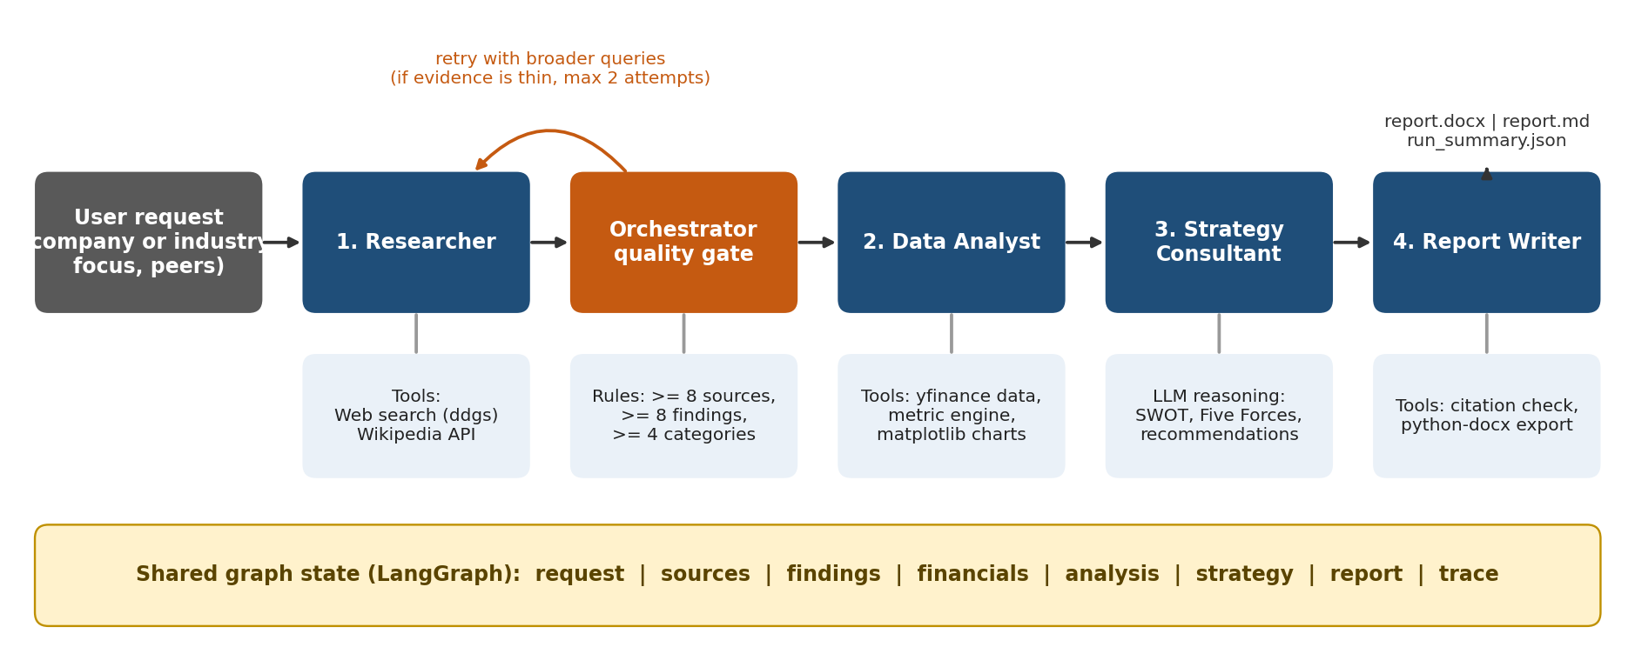
Figure 1: High-level architecture of the multi-agent research team

3.3 Agent specifications
Table 10: Agent specifications
Agent | Role | Inputs (state) | Outputs (state) | Tools
Researcher | Plans queries, retrieves evidence, extracts findings | request | sources, findings | DuckDuckGo search, Wikipedia REST API
Quality gate | Supervises evidence sufficiency | sources, findings, attempts | gate decision, limitations | Rules only (no LLM)
Data Analyst | Computes benchmarks and draws charts; writes grounded insights | request, findings | financials, analysis (table, charts, insights) | yfinance, metric engine, matplotlib
Strategy Consultant | SWOT, Five Forces, recommendations | findings, analysis | strategy | LLM reasoning
Report Writer | Assembles and exports the brief | all of the above | report (Markdown, DOCX) | python-docx, citation sanitiser

3.3.1 Researcher
- Query planning. The LLM proposes 6 to 8 short queries covering overview, market, competitors, customers, trends, financials, risks and regulation. If the call fails or returns fewer than four queries, template queries are used.
- Retrieval. For the first attempt, a Wikipedia summary of the target is added as a stable background source. Each query then calls web search (default five results). Results are de-duplicated by normalised URL, empty snippets are dropped and each source receives a sequential identifier. A cap of 40 sources per run keeps cost and latency bounded.
- Extraction. Sources are processed in batches of ten. The model must return findings of at most about 40 words, each with a category and supporting source identifiers, using only the supplied snippets.
- Guardrail. A finding is discarded if it has no valid source identifier within its batch. The number of discarded findings is recorded in the trace.

3.3.2 Orchestrator quality gate
After each research pass the gate evaluates three conditions and decides what happens next.
Table 11: Quality gate rules
Condition | Default threshold | Meaning
Number of unique sources | 8 or more | Enough independent evidence
Number of grounded findings | 8 or more | Extraction produced usable facts
Distinct finding categories | 4 or more | Coverage across topics, not one angle

Table 12: Quality gate decisions
Situation | Decision | Effect
All thresholds met | Proceed | Hand over to Data Analyst
Not met and attempts remaining (default maximum two passes) | Retry | Researcher plans different, broader queries and avoids earlier ones; new sources are merged
Not met, attempts exhausted, some evidence exists | Proceed with limitation | A limitation note is added to the report
No sources or no findings after all attempts | Abort | Run ends with a clear error; audit file still written

3.3.3 Data Analyst
The analyst separates computation from commentary. Computation is deterministic code; the model only phrases insights from the computed table.
- Data. For companies, market data for the target and any named competitors is fetched through yfinance (two years of daily closes and selected fundamentals). If tickers are not supplied, a best-effort lookup is attempted. For industries, only entities with explicit tickers are used.
- Metrics. Market capitalisation, trailing and forward price-to-earnings, operating and net margin, revenue growth, return on equity, debt-to-equity and beta come from the data provider. One-year return, annualised volatility and maximum drawdown are computed from closing prices (formulas in Section 4.3).
- Charts. An indexed share-price chart (start of window equals 100), an operating-margin bar chart and a one-year-return bar chart.
- Insight guardrail. Any insight containing a decimal or percentage figure that does not match a value in the table (within a small tolerance) is removed, and a note is added to the limitations.
- No-data mode. When no market data exists (for example an industry request), the analyst instead extracts quantitative signals that already appear in the research findings and cites their sources.

3.3.4 Strategy Consultant
This agent receives the numbered findings, the analyst's insights and a compact peer table, and returns a single JSON object that is validated against a Pydantic schema.
- SWOT with 3 to 5 items per quadrant; internal factors for strengths and weaknesses, external for opportunities and threats.
- Porter's Five Forces: exactly five named forces with a Low, Medium or High rating and a one-sentence rationale.
- Four to five recommendations, each with priority, timeframe, expected impact, key risk and supporting sources.
- Executive points that start with the answer.
- Repair loop. If any quadrant has fewer than three items, a force is missing or fewer than three recommendations exist, the agent is asked once more with the specific problems listed. If problems remain, the report states that the assessment is incomplete.

3.3.5 Report Writer
The writer makes four short model calls (executive summary, overview, market landscape and implementation roadmap), each constrained to the facts supplied and to valid source identifiers. Everything else is assembled by code: the benchmark table and charts, SWOT tables, Five Forces table, recommendation table, limitations, methodology and the numbered reference list. A sanitiser removes citation numbers that do not exist in the source list. The Markdown is then converted to a formatted Word document.

3.4 Orchestration and control flow
START -> researcher -> quality_gate
quality_gate --retry---> researcher
quality_gate --proceed-> analyst -> strategist -> writer -> END
quality_gate --abort---> END

The graph is compiled with LangGraph. Each node is wrapped by a common function that times execution, measures LLM token usage attributable to that node, records a trace entry and emits a progress event for the interface. If a node raises an exception, the trace records the error and the run returns a failed result with whatever partial state exists; the audit file is still written.

3.5 Shared state and data model
Table 13: Core data models
Model | Key fields | Purpose
ResearchRequest | target, target_type, focus, geography, competitors, tickers | Validated user input (length and type checks)
Source | id, title, url, snippet, query, origin | A retrieved evidence item; domain derived from URL
Finding | claim, category, source_ids | One grounded fact
EntityFinancials | name, ticker, metrics, dates, closes, synthetic flag | Market data for one company
AnalysisResult | comparison_rows, insights, chart_paths, notes | Analyst output
StrategyResult | swot, five_forces, recommendations, executive_points | Strategy output with per-item source ids
GraphState (TypedDict) | all of the above plus gate decision, limitations, trace | State passed between nodes; nodes return only changed keys

3.6 Tool design
Table 14: Tools and failure handling
Tool | Backend | Failure behaviour | Offline substitute
Web search | ddgs (DuckDuckGo) | Three attempts with back-off; returns an empty list instead of raising | Deterministic fixtures
Encyclopaedic lookup | Wikipedia REST API | Returns nothing on error | Fixture entry
Market data | yfinance | Entity skipped and noted in limitations | Seeded synthetic series, flagged as synthetic
Charts | matplotlib (Agg backend) | Skips a chart when data is missing | Same code path
Export | python-docx | Markdown is kept even if DOCX export fails | Same code path

3.7 Prompt design
All prompts are stored in one module so they can be reviewed and versioned. Each prompt follows the same pattern: role, task, numbered strict rules (use only supplied information, cite valid identifiers, output schema), and an instruction to reply with JSON only where structured output is required. Rules are written as positive constraints with the reason implicit in the task. Examples of the rules appear in Appendix A.

3.8 Grounding and anti-hallucination design
Table 15: Grounding controls by pipeline stage
Stage | Risk | Control
Extraction | Claims with no evidence; invented source ids | Findings need at least one valid id from their own batch, otherwise dropped
Analysis | Invented or miscalculated numbers | Metrics computed in code; insights with numbers not in the table removed
Strategy | Unsupported SWOT items or recommendations | Ids validated against the source list; evidence coverage recorded as a metric
Writing | Fabricated citations in prose | Citation sanitiser removes any number not matching a real source
Output | Misleading demo content | Mock or synthetic runs carry a visible DEMO MODE banner
Model output format | Invalid JSON | Tolerant parser plus up to two repair prompts, then a typed error

3.9 Report structure
Table 16: Structure of the generated brief
Section | Produced by | Content
Title block and demo banner | Code | Scope, geography, focus, date
1 Executive summary | LLM (constrained) | Answer first; market position, key risk, top recommendation
2 Overview | LLM (constrained) | What the target is and who it serves
3 Market and competitive landscape | LLM (constrained) | Market size and growth, competitors, trends, regulation
4 Quantitative benchmarking | Code and LLM | Peer table, three charts and grounded insights
5 Strategic assessment | Strategy agent, code layout | SWOT tables and Five Forces table
6 Recommendations | Strategy agent, writer | Prioritised table, rationale, risks, phased roadmap
7 Risks and limitations | Code | Evidence quality, data gaps, disclaimers
8 Methodology | Code | Agent workflow, evidence base size
References | Code | Numbered list matching in-text citations

3.10 Technology stack and rationale
Table 17: Technology stack
Layer | Choice | Rationale
Language | Python 3.11 | Ecosystem for LLMs, data and documents
Orchestration | LangGraph | Explicit graph, conditional edges, streaming
Data models | Pydantic v2 | Validation of inputs and model output
LLM access | OpenAI SDK (for OpenAI-compatible endpoints) and Anthropic SDK | One thin client covers six providers including free tiers
Search and data | ddgs, Wikipedia API, yfinance | No paid keys required
Analytics and charts | Python statistics, matplotlib | Transparent calculations, headless rendering
Document export | python-docx | Native Word output with tables and figures
Interface | Streamlit | Rapid, shareable web UI with progress streaming
Packaging | Docker | Same image on any host
Quality | pytest, GitHub Actions | Offline tests on every push

3.11 Alternatives considered
Table 18: Design alternatives
Decision | Alternative | Why not chosen
Snippet-based evidence | Fetch and parse full web pages | Slower, heavier, more failure modes; listed as future work
Code computes metrics | Ask the LLM to calculate | Models make arithmetic errors and may recall outdated numbers
Prompt-level JSON with repair | Provider-specific JSON modes | Not uniformly available across free providers
Thin in-house LLM client | Large multi-provider library | Smaller dependency footprint and simpler testing with a mock backend
No vector database | Embed and retrieve snippets | Evidence set is at most 40 short snippets per run

3.12 Security, privacy and ethics
- Secrets. API keys are read from environment variables or a secrets manager. The .env file is excluded from version control and from the Docker image. A key typed into the web interface is held in memory for the session only.
- Abuse and cost control. An optional access code and a per-session run limit protect a publicly hosted instance from consuming the owner's API quota.
- Privacy. Only public information about companies and industries is processed; no personal data is requested or stored.
- Responsible use. Reports include limitations and a disclaimer that they are not investment or legal advice. Sources are listed so that readers can verify claims.
- Terms of service. Search and market data come from free public services; production deployments should use licensed data providers.
- Non-root container. The Docker image runs the application as an unprivileged user.

4. Development

4.1 Development environment
Table 19: Development environment
Item | Detail
Language and runtime | Python 3.11 (tested also on 3.12)
Key libraries | langgraph, pydantic, openai, anthropic, yfinance, ddgs, requests, pandas, matplotlib, python-docx, streamlit, python-dotenv, pytest
Version control | Git; GitHub for hosting and continuous integration
Editor and tooling | Your IDE, for example VS Code
LLM providers used in development | Offline mock backend for all automated tests; provider and model used for real runs for live runs

4.2 Development methodology
The system was built bottom-up in layers, with automated tests written before moving to the next layer. A deliberate decision was to build an offline mock LLM backend early. It returns structurally valid but generic output, which allowed the orchestration, guardrails, report assembly and export code to be developed and tested without network access, API keys or cost. Real models are then plugged in through configuration only.
- Typed data models and configuration.
- LLM client with retries, JSON extraction and repair, usage tracking, plus the mock backend.
- Tools: web search, encyclopaedia lookup, market data, charts (each with an offline substitute).
- Agents, one at a time, each with unit tests for its guardrails.
- LangGraph orchestrator with the quality gate; end-to-end tests for success, retry, limitation and abort paths.
- Markdown-to-Word exporter; visual check by rendering the document to images.
- Command-line interface and Streamlit web interface.
- Evaluation harness with metrics, single-agent baseline and judge.
- Containerisation, continuous integration and deployment configuration.

4.3 Implementation highlights

4.3.1 Provider-agnostic LLM client
A single LLMClient exposes complete() and complete_json(). OpenAI, Groq, Gemini, OpenRouter and Ollama are reached through the OpenAI-compatible SDK by changing only the base URL, key and model; Anthropic uses its own SDK; a mock backend serves tests. Transient failures are retried up to three times with exponential back-off, except authentication errors which are not retried. complete_json() tolerates code fences and surrounding prose and, if parsing fails, re-prompts up to two times before raising a typed error. Every call is logged with agent name, task, tokens and latency so that cost and time can be attributed per agent.

4.3.2 Grounded extraction in the Researcher
ids = clean_ids(f.get("source_ids"), valid) # keep only ids that exist in this batch
if not claim or not ids: # grounding guardrail
dropped += 1 # recorded in the trace
continue

The same clean_ids helper validates identifiers in the strategy output, and sanitize_citations removes invalid numbers such as [3, 99] becoming [3] in prose.

4.3.3 Quantitative metrics in the Data Analyst
Let P_t denote the closing price on trading day t, N the number of available observations and n = min(252, N - 1) the look-back window in trading days.
Table 20: Computed risk and return metrics
Metric | Formula | Notes
One-year return | R = P_T / P_(T-n) - 1 | Reported in percent
Daily return | r_t = P_t / P_(t-1) - 1 | Over the window
Annualised volatility | sigma = stdev(r_t) x sqrt(252) | Population standard deviation of daily returns
Maximum drawdown | MDD = min over t of ( P_t / max(P_s, s <= t) - 1 ) | Worst peak-to-trough decline in the window

These formulas are covered by unit tests with known answers: a series rising from 100 to 130 must give a 30% return and zero drawdown, and a series that doubles then halves must give a drawdown of exactly -50%.

4.3.4 Quality gate as a pure function
The gate's decision logic lives in a pure function evaluate_gate(state, settings) that returns the decision, a reason and any limitation message. Because it has no LLM or network dependency, its three outcomes (retry, proceed with limitation, abort) are unit tested directly.

4.3.5 Strategy validation and repair
The strategist's JSON is parsed by parse_strategy, which normalises ratings and priorities (for example an unknown priority becomes Medium), strips invalid source identifiers and tolerates plain-string SWOT items. adequacy_problems then lists missing pieces; if any exist, the model is called once more with the exact problems appended.

4.3.6 Report assembly and export
The writer builds Markdown with deterministic tables, then a purpose-built converter produces the Word file: title, headings, bullet and numbered lists, shaded table headers with banded rows, embedded charts with captions, a highlighted demo banner and page numbers. Rendering the generated file to images during development was used to verify layout.

4.3.7 Interfaces
- Command line (main.py): target, type, focus, geography, tickers, competitors, provider and model options; prints live progress and output paths.
- Streamlit app (app.py): form input, provider and key selection in the sidebar, live agent progress, tabs for the report, charts and data, sources and agent trace, and download buttons for Word and Markdown. Optional access code and per-session run limit.

4.4 Code size
Table 21: Code size at submission
Component | Files | Non-blank lines
Application source (src/marketresearch) | 20 | 1607
Tests (tests) | 5 | 193
Evaluation harness (evaluation) | 4 | 179
Interfaces (app.py, main.py) | 2 | 165

4.5 Testing
The test suite runs entirely offline in mock mode and takes about three seconds. It exercises both unit behaviour and complete pipeline runs.
Table 22: Automated test suite
Test group | Tests | What is verified
LLM client and guardrails | 7 | JSON extraction with fences and prose, garbage rejection, citation id cleaning and sanitising, repair attempts, usage tracking, request validation
Tools and analytics | 10 | Deterministic mock search, metric formulas against known values, short-series handling, entity selection for company versus industry, comparison table units, ungrounded-number detection, chart files
Agents and orchestration | 13 | Strategy parsing and normalisation, adequacy checks, all quality-gate outcomes, full runs for company and industry, validity of every citation in a generated report, retry loop, clean failure with no evidence, dropping of ungrounded findings
Export | 1 | Word document structure: headings, table content, bullets
Total | 31 | 31 passed, 0 failed

What the offline tests do and do not prove
They prove that the orchestration, guardrails, file generation and error handling behave correctly. They do not measure the quality of real model output; that is the purpose of the evaluation in Section 6.

4.6 Challenges and solutions
Table 23: Development challenges and solutions
Challenge | Impact | Solution
Models return JSON wrapped in prose or code fences, or occasionally invalid JSON | Pipeline failures | Tolerant extraction plus bounded repair prompts; typed error if still invalid
Models cite sources that do not exist | Untrustworthy report | Id validation at extraction, strategy and writing stages
Models invent or recall wrong financial figures | Misleading numbers | Metrics computed in code; insight text checked against the data table
Free search and finance sources can fail or rate-limit | Missing evidence | Retries, graceful degradation, quality gate with broader retry queries
Testing without paying for or depending on an API | Slow, costly, non-reproducible tests | Offline mock LLM, search and finance backends
Industry requests have no tickers | No quantitative section | No-data mode extracts figures from findings with citations
Different providers behave differently | Portability | Thin client, no provider-specific features, configuration by environment
Readable Word output from generated text | Poor formatting | Custom converter and visual verification by rendering to images

4.7 Offline smoke test
An end-to-end run in mock mode for a fictitious company with two fictitious competitors completed successfully. The run produced 11 LLM calls (one planning call, four extraction batches, one insight call, one strategy call and four writing calls), a 40-source evidence set at the configured cap, three charts, a Markdown report of roughly 1,400 words and a Word document of about six pages. This confirms that the mechanics work; the content of mock runs is placeholder text and is labelled as such inside the report.

4.8 Source code walkthrough
The implementation is organised so that each agent, tool and concern lives in its own module. The table lists the main files and their roles; the excerpts that follow show the most important logic, copied directly from the source.
Table 24: Main source files
File | Purpose
src/marketresearch/orchestrator.py | LangGraph workflow, quality gate, node wrapper with tracing, run summary
src/marketresearch/agents/researcher.py | Agent 1: query planning, retrieval, grounded finding extraction
src/marketresearch/agents/analyst.py | Agent 2: metric computation, charts, grounded insights
src/marketresearch/agents/strategist.py | Agent 3: SWOT, Five Forces, recommendations with validation and repair
src/marketresearch/agents/writer.py | Agent 4: report assembly, citation sanitising, DOCX export
src/marketresearch/llm.py, mock_llm.py | Provider-agnostic LLM client with retries, JSON repair, usage tracking; offline stub
src/marketresearch/tools/ | Web search, Wikipedia, market data, charts
src/marketresearch/prompts.py | All agent prompts
app.py, main.py | Streamlit interface and command-line interface
evaluation/ | Test cases, metrics, single-agent baseline, evaluation runner
tests/ | 31 automated tests

The code base has 20 application modules (1607 non-blank lines), 193 lines of tests, 179 lines of evaluation code and 165 lines of interface code.

4.8.1 Orchestration graph (simplified excerpt)
g = StateGraph(GraphState)
g.add_node('researcher', researcher.run)
g.add_node('quality_gate', evaluate_gate)
g.add_node('analyst', analyst.run)
g.add_node('strategist', strategist.run)
g.add_node('writer', writer.run)
g.add_edge(START, 'researcher')
g.add_edge('researcher', 'quality_gate')
g.add_conditional_edges('quality_gate', lambda s: s['gate_decision'],
{'retry': 'researcher', 'proceed': 'analyst', 'abort': END})
g.add_edge('analyst', 'strategist')
g.add_edge('strategist', 'writer')
g.add_edge('writer', END)

4.8.2 Grounding helpers shared by all agents (agents/base.py)
def clean_ids(ids: Any, valid: Iterable[int]) -> List[int]:
"""Keep only integer ids that exist in `valid` (guardrail against invented citations)."""
valid_set = set(valid)
out: List[int] = []
for x in ids or []:
try:
i = int(x)
except (TypeError, ValueError):
continue
if i in valid_set and i not in out:
out.append(i)
return out

def sanitize_citations(text: str, valid: Iterable[int]) -> str:
"""Remove citation numbers that do not match a real source id, e.g. [3, 99] -> [3]."""
valid_set = set(valid)

def repl(m: re.Match) -> str:
keep = [n for n in re.findall(r"\d+", m.group(1)) if int(n) in valid_set]
return f"[{', '.join(keep)}]" if keep else ""

return _CITE.sub(repl, text)

class BaseAgent:
name = "Agent"

4.8.3 Risk and return metrics (agents/analyst.py)
def performance_stats(closes: List[float]) -> Dict[str, Optional[float]]:
"""1-year return, annualised volatility and max drawdown from daily closes (percent values)."""
n = len(closes)
if n < 20:
return {"return_1y": None, "volatility": None, "max_drawdown": None}
window = closes[-(min(252, n - 1) + 1):]
ret = (window[-1] / window[0] - 1) * 100
daily = [window[i] / window[i - 1] - 1 for i in range(1, len(window)) if window[i - 1]]
vol = statistics.pstdev(daily) * math.sqrt(252) * 100 if len(daily) > 1 else None
peak, mdd = window[0], 0.0
for p in window:
peak = max(peak, p)
mdd = min(mdd, (p / peak - 1) * 100)
return {"return_1y": round(ret, 2), "volatility": round(vol, 2) if vol is not None else None, "max_drawdown": round(mdd, 2)}

4.8.4 Validation of the strategy output (agents/strategist.py)
def adequacy_problems(s: StrategyResult) -> List[str]:
probs = []
for q in ("strengths", "weaknesses", "opportunities", "threats"):
if len(getattr(s.swot, q)) < 3:
probs.append(f"SWOT '{q}' has fewer than 3 items")
if len(s.five_forces) < 5:
probs.append("Five Forces needs all 5 forces")
if len(s.recommendations) < 3:
probs.append("at least 3 recommendations are required")
if not s.executive_points:
probs.append("executive_points is empty")
return probs

4.9 Execution of the system

4.9.1 Commands
- Install dependencies: pip install -r requirements.txt.
- Run the automated tests: python -m pytest -v.
- Run an end-to-end research job from the command line: python main.py "Acme Robotics" --provider mock --competitors "Beta Bots,Gamma Mech" (use a real provider and tickers for live analysis).
- Start the web interface: streamlit run app.py and open the local address shown.

4.9.2 Command-line execution
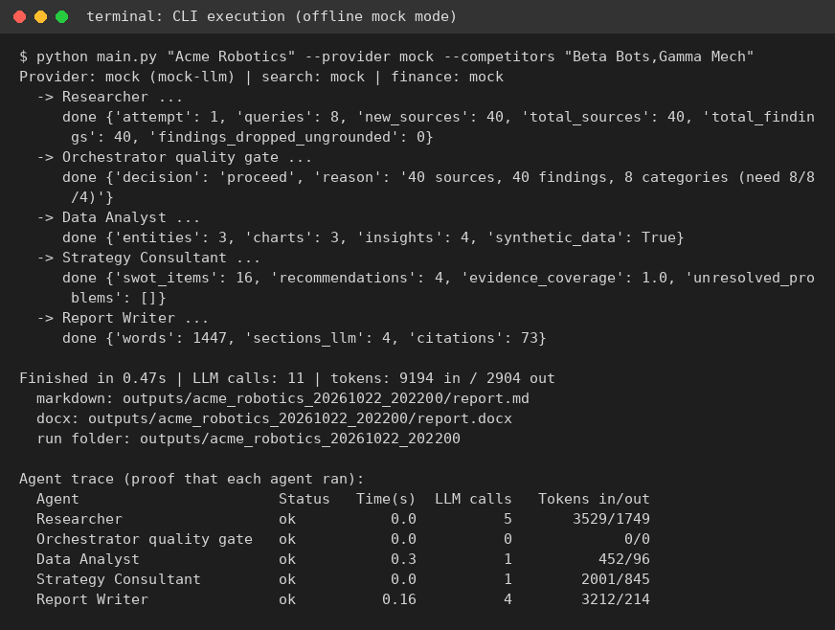
Figure 2: Terminal output of an end-to-end run (offline demo mode)
Reading the output from top to bottom proves each stage ran in order:
Table 25: Interpreting the execution output
Output line | Meaning
Researcher: 8 queries, 40 sources, 40 findings, 0 ungrounded dropped | Evidence gathered and every finding linked to a valid source
Quality gate: proceed (40 sources, 40 findings, 8 categories) | Supervisor checked evidence against thresholds 8, 8 and 4 and let the run continue
Data Analyst: 3 entities, 3 charts, 4 insights | Target and two peers analysed, charts drawn, insights generated
Strategy Consultant: 16 SWOT items, 4 recommendations, coverage 1.0 | Strategy produced; every item carries a source
Report Writer: 1,447 words, 73 citations | Report assembled and exported
11 LLM calls, 9,194 tokens in and 2,904 out | Usage tracked across the run
Agent trace table | Per-agent status, time, calls and tokens

4.9.3 Test execution
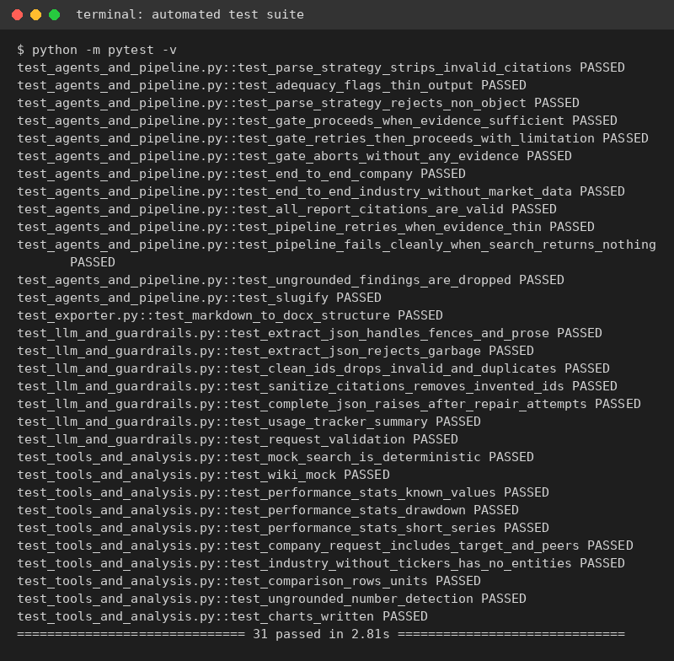
Figure 3: Terminal output of the automated test suite (31 tests passed)

4.10 Application screenshots
The Streamlit interface lets a user enter a target, choose the model provider, watch the agents work and download the result.
Evidence captured in offline demo mode
The screenshots and terminal captures in this report were taken from the real application running in its offline demo mode (mock language model, fixture search results and synthetic market data), so the content shown is placeholder text. They prove that the application, the agents and the pipeline execute. Replace or supplement them with captures from a live run using a real API key (see Section 4.12).

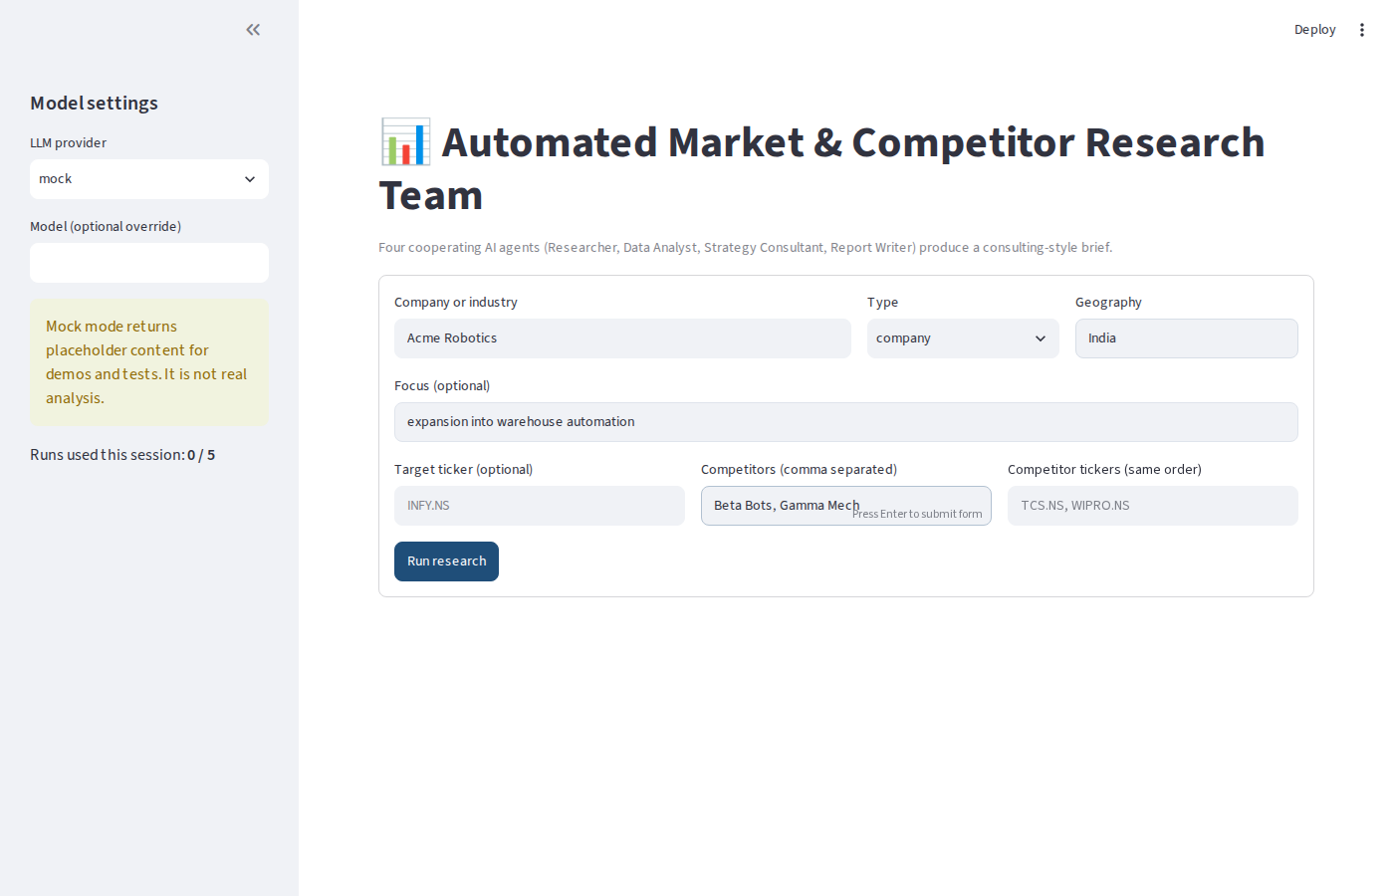
Figure 4: Input screen with request form and model settings
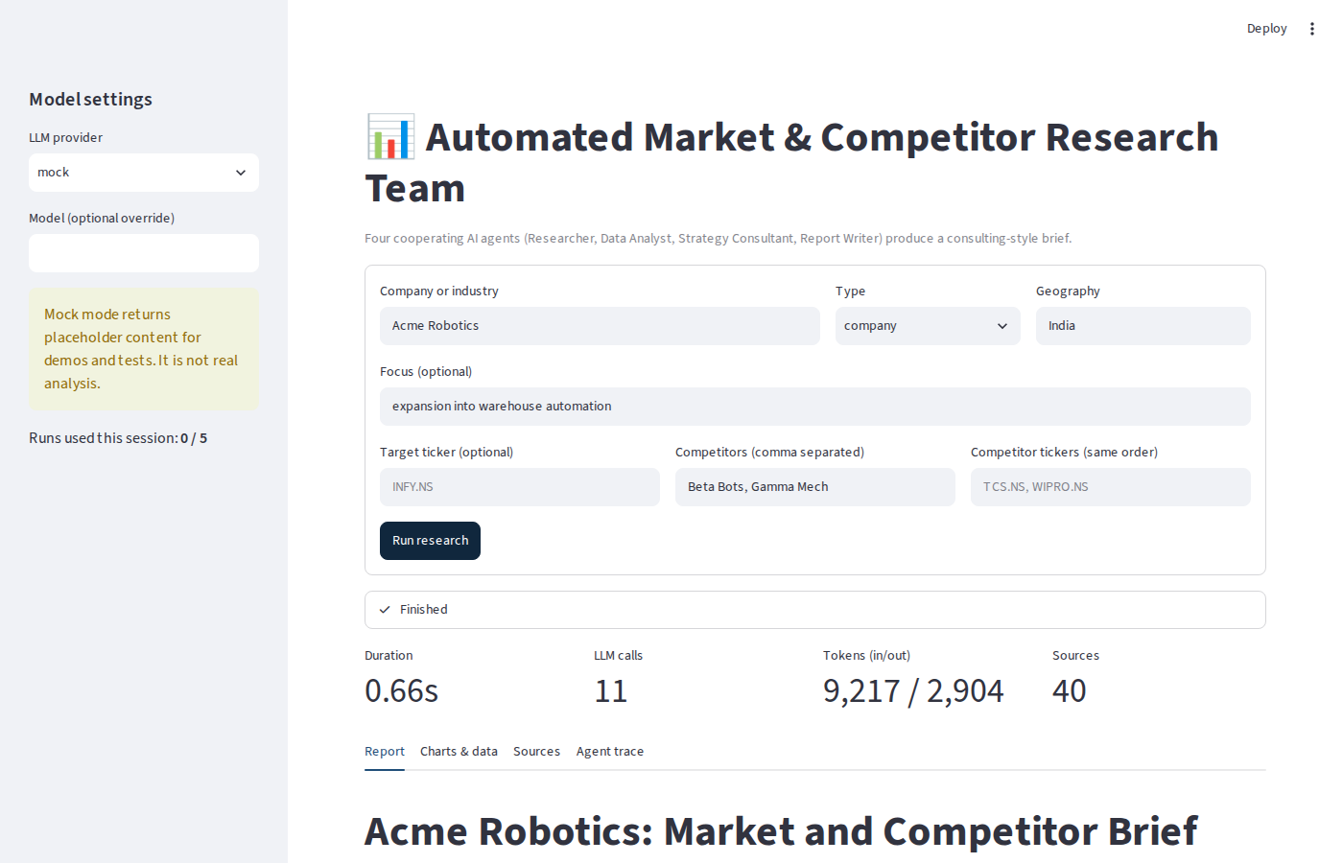
Figure 5: Run completed: status, duration, LLM calls, tokens and sources
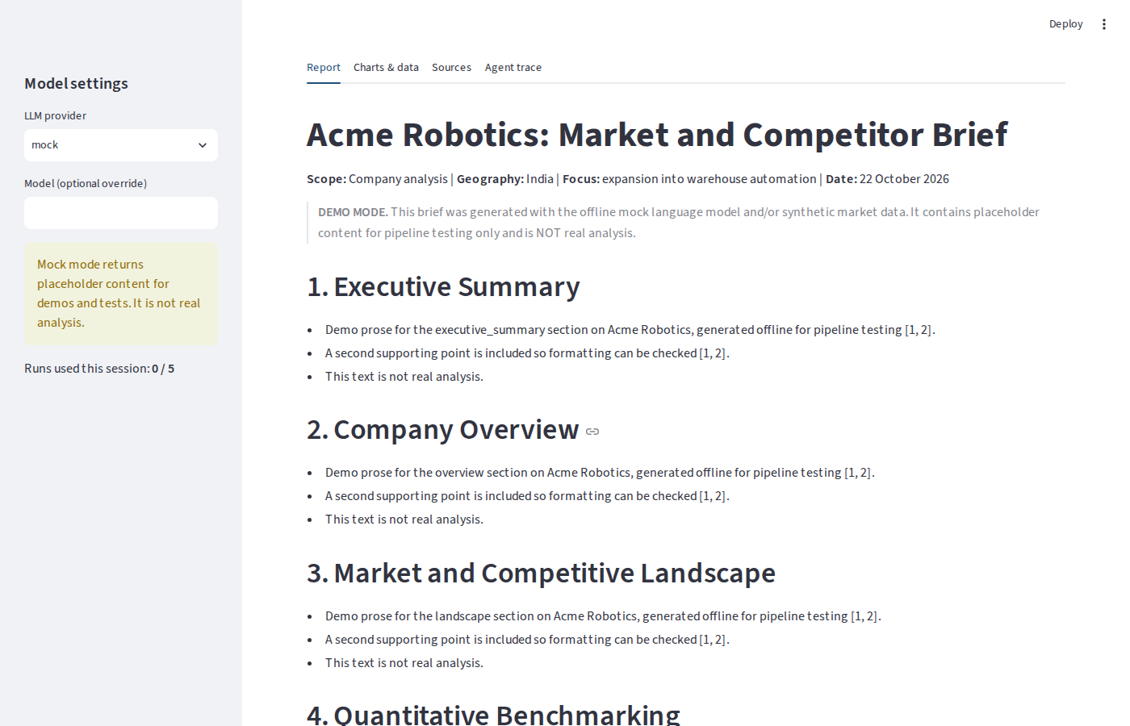
Figure 6: Report tab showing the generated brief
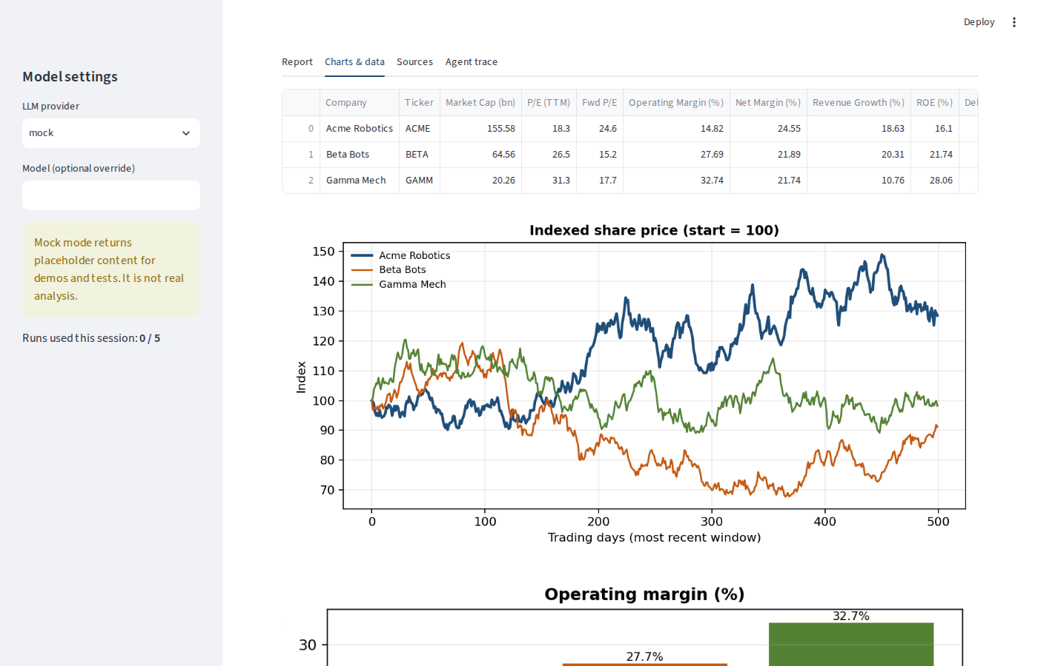
Figure 7: Charts and data tab with the peer benchmark table
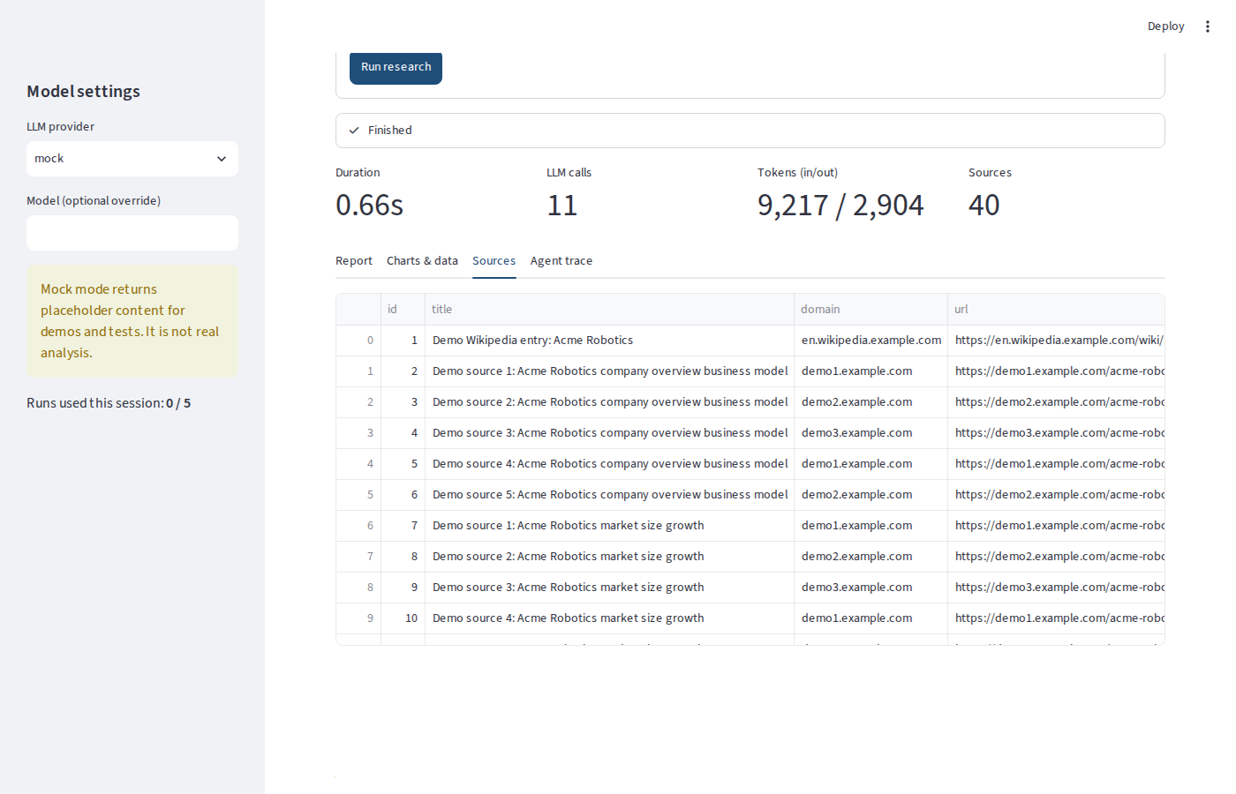
Figure 8: Sources tab listing every cited source with identifier, domain and URL
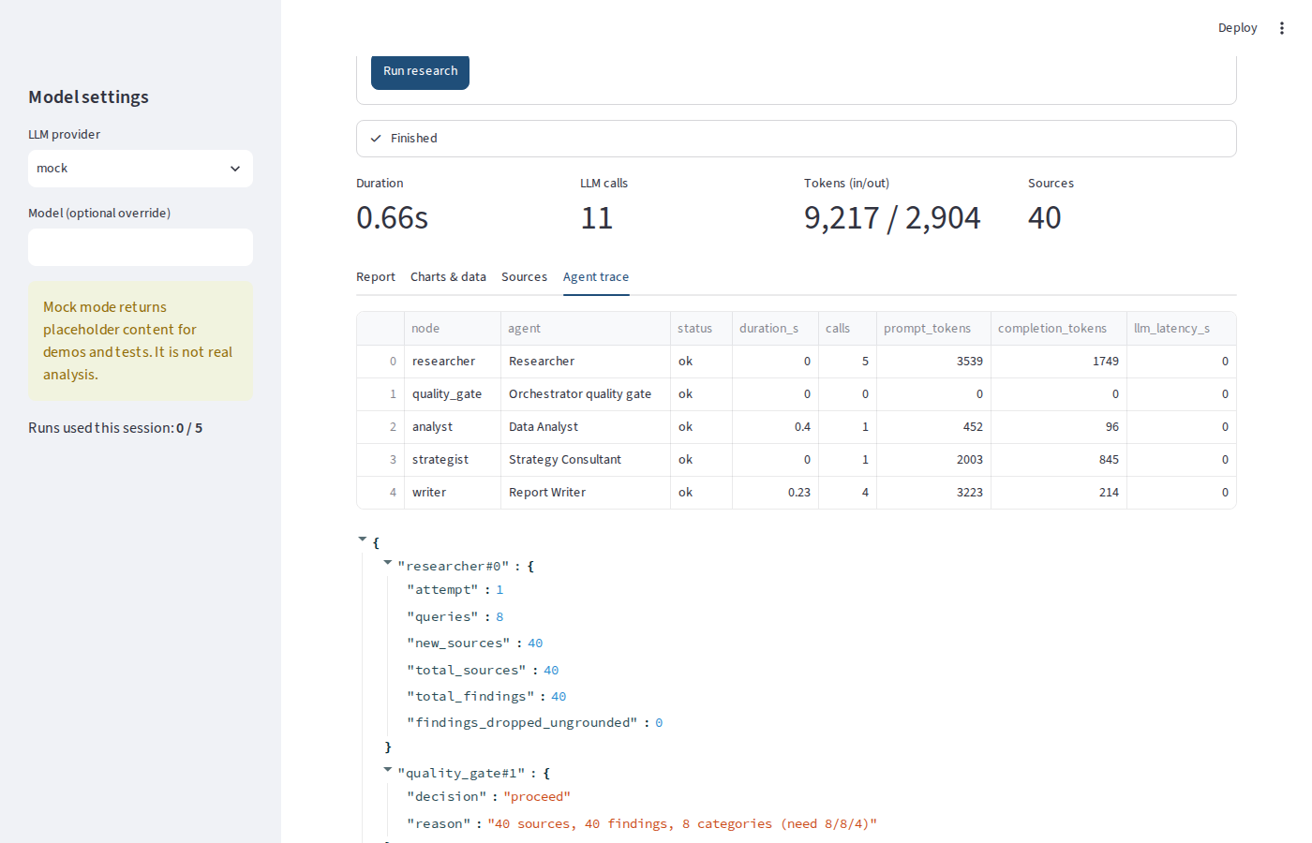
Figure 9: Agent trace tab showing each agent's status, calls and tokens

4.11 Sample generated output
The following figure shows pages 1 and 3 of the Word report generated in the run above: the title block with the demo banner and the executive summary, and the benchmarking charts followed by the start of the strategic assessment.
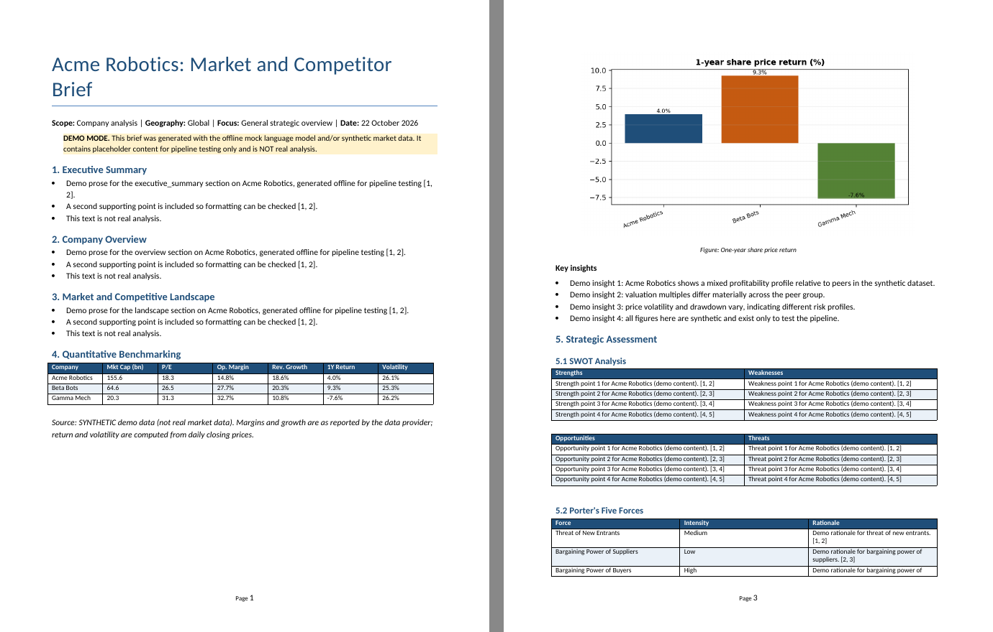
Figure 10: Pages of the generated Word report (offline demo mode)

4.12 Live-run evidence to add
For final submission, add captures from a real run so that the examiner sees real content:
Table 26: Live-run evidence checklist
Evidence | How to capture | Insert here
Live CLI run with real provider | Run the Infosys example from the command reference and screenshot the terminal | Screenshot
Live web interface run | Screenshot the Report, Sources and Agent trace tabs after a real run | Screenshots
Generated Word report from the live run | Open report.docx and screenshot the SWOT and recommendations pages | Screenshot
Run summary file | Open run_summary.json and screenshot the trace and usage sections | Screenshot

5. Deployment Architecture

5.1 Deployment goals
- Anyone with the URL can run a brief without installing Python.
- The same artefact runs locally, in continuous integration and in the cloud (one container image).
- Secrets never enter the repository or the image.
- A public instance cannot exhaust the owner's API quota.

5.2 Deployment architecture
The application is packaged as a single stateless Docker container that runs the Streamlit interface and the LangGraph orchestrator with all four agents. The container reaches external services over HTTPS only when a run is requested. The developer pushes code to GitHub, where continuous integration runs the tests and builds the image; the hosting platform then builds and runs the same image.
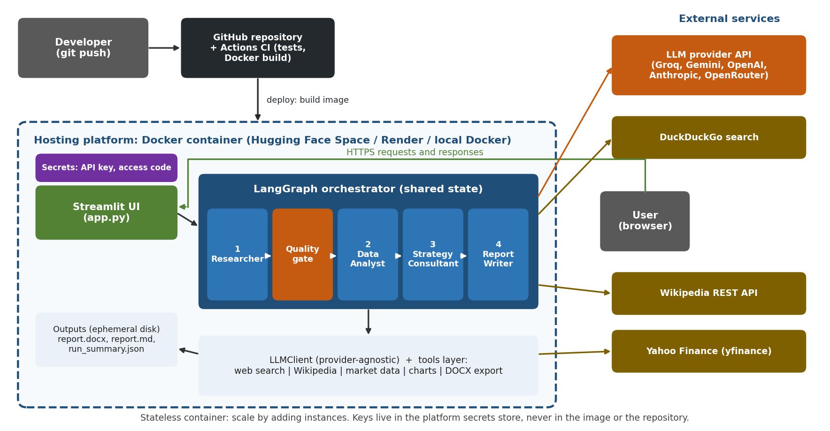
Figure 11: Deployment architecture
Table 27: Deployment components
Component | Technology | Responsibility
Client | Web browser | Submits the request and downloads the report
Interface | Streamlit (app.py) | Form, live progress, tabs, download buttons, access code and run limit
Orchestrator and agents | LangGraph, Python | Runs the four agents and the quality gate over shared state
LLM client and tools | OpenAI and Anthropic SDKs, ddgs, Wikipedia API, yfinance, matplotlib, python-docx | Model calls with retries; evidence and data retrieval; charts and export
Secrets | Platform secrets store | API key and optional access code, injected as environment variables
Storage | Ephemeral container disk | Per-run output folder; reports are downloaded by the user
Source control and CI | GitHub, GitHub Actions | Version history, tests, Docker build
External services | LLM provider, DuckDuckGo, Wikipedia, Yahoo Finance | Reasoning, search, background and market data

5.3 Proof of multiple agents
This section gives evidence that the system really consists of several distinct agents that run in sequence under an orchestrator, rather than one prompt with several headings.

5.3.1 Execution trace of one run
Every node execution is recorded by the orchestrator. The table below is copied from the trace section of run_summary.json produced by the run shown in Section 4.9. Five separate nodes executed, four of them agents that called the language model and one a rule-based supervisor that made no model calls.
Table 28: Agent trace from the execution (offline demo mode)
Graph node | Agent | Status | LLM calls | Tokens in | Tokens out | Time (s)
researcher | Researcher | ok | 5 | 3539 | 1749 | 0
quality_gate | Orchestrator quality gate | ok | 0 | 0 | 0 | 0
analyst | Data Analyst | ok | 1 | 452 | 96 | 0.4
strategist | Strategy Consultant | ok | 1 | 2003 | 845 | 0
writer | Report Writer | ok | 4 | 3223 | 214 | 0.23

Table 29: Per-agent LLM usage from the same run
Agent | LLM calls | Prompt tokens | Completion tokens
Researcher | 5 | 3539 | 1749
Data Analyst | 1 | 452 | 96
Strategy Consultant | 1 | 2003 | 845
Report Writer | 4 | 3223 | 214

Replace with your live run
Token counts above come from the offline stub, which estimates tokens from text length. After a real run, copy the same two tables from your own run_summary.json or from the Agent trace tab: paste live trace here

Figure 12: Agent trace tab of the deployed interface

5.3.2 Evidence that the agents are distinct
Table 30: Evidence of multiple agents
Evidence | Where it can be verified
Four separate agent classes, each in its own file and each subclassing BaseAgent | agents/researcher.py, analyst.py, strategist.py, writer.py
Different system prompts per agent | prompts.py: RESEARCHER_PLAN_SYSTEM, RESEARCHER_EXTRACT_SYSTEM, ANALYST_QUANT_SYSTEM, STRATEGIST_SYSTEM, WRITER_SYSTEM
Different tools per agent | Researcher: search and Wikipedia; Analyst: yfinance and charts; Writer: DOCX export; Strategist: reasoning only
Different state fields written by each agent | Researcher: sources, findings; Analyst: financials, analysis; Strategist: strategy; Writer: report
Five nodes and conditional routing in the LangGraph graph | orchestrator.py and the architecture figure in Section 3.2
Per-agent timing, calls and tokens in the run summary | run_summary.json: trace and usage.by_agent
Live progress per agent in the interface | Streamlit progress panel and Agent trace tab (Section 4.10)
Agent-specific automated tests | tests/test_agents_and_pipeline.py: gate, grounding, strategy parsing, retry path

5.3.3 How an examiner can verify
- Run python main.py "Acme Robotics" --provider mock: the closing agent trace table lists each agent.
- Or open the Streamlit app, run a request and open the Agent trace tab.
- Open the newest outputs/<run>/run_summary.json and inspect trace and usage.by_agent.
- Run python -m pytest -v and confirm the agent and orchestration tests pass.

5.4 Deployment options
Table 31: Deployment platform comparison
Platform | Mechanism | Strengths | Trade-offs | Role in this project
Hugging Face Spaces | Docker Space on port 7860 | Free, simple secrets, public URL | Sleeps when idle | Primary / secondary
Render | Blueprint from render.yaml | Git-based deploys, health checks | Free tier spins down; cold start | Primary / secondary
Streamlit Community Cloud | Directly from the GitHub repository | Easiest for Streamlit apps | Less control over the runtime | Primary / secondary
Local Docker | docker compose up | Identical image, offline use | Not publicly reachable | Verification and demo backup

5.5 Containerisation
The Dockerfile uses a slim Python 3.11 base, installs dependencies in a cached layer, copies the application, creates an unprivileged user and starts Streamlit on the port supplied by the platform. A health check calls Streamlit's built-in health endpoint.
FROM python:3.11-slim
WORKDIR /app
COPY requirements.txt .
RUN pip install -r requirements.txt
COPY . .
RUN useradd -m appuser && chown -R appuser /app
USER appuser
CMD ["sh", "-c", "streamlit run app.py --server.port=${PORT:-7860} --server.address=0.0.0.0"]

5.6 Configuration and secrets
Table 32: Runtime configuration
Variable | Where to set it | Purpose
LLM_PROVIDER, LLM_MODEL | Platform environment variables | Choose provider and model
GROQ_API_KEY (or the key for the chosen provider) | Platform secrets store only | Authenticate to the LLM provider
APP_ACCESS_CODE | Platform secrets store | Optional password for the public interface
RUNS_PER_SESSION | Environment variable | Caps runs per browser session
MIN_SOURCES, MIN_FINDINGS, MAX_RESEARCH_ATTEMPTS | Environment variable | Tune the quality gate

5.7 Continuous integration
A GitHub Actions workflow runs on every push and pull request. It installs the dependencies, runs the full test suite in mock mode with no secrets, and then builds the Docker image to catch packaging errors early.

5.8 Deployment procedure
The repository contains every file required for deployment. The account-specific steps (creating the repository and hosting space, adding secrets, pushing, verifying, recording the demo) are in the separate document Deployment Steps. In summary:
- Verify locally: run the tests, one offline demo and one live run with a real API key.
- Push the code to a GitHub repository (the .env file is ignored).
- Create the hosting target and add the provider key as a secret.
- Deploy, wait for the build and health check to pass, and open the public URL.
- Run a smoke test in the deployed app and the evaluation script against the same provider.
- Record the demo video, upload it to Google Drive and add the link in Section 8.

5.9 Operational considerations
Table 33: Operational considerations
Topic | Approach
Cost control | Roughly 10 to 13 LLM calls per brief (one planning call, one extraction call per ten sources, one insight call, one strategy call, four writing calls, plus retries). Token counts and estimated cost are recorded per run; use a free tier or a low-cost model and set provider-side limits.
Rate limits | Automatic retries with back-off; the quality gate allows a second research pass; users can lower MAX_RESULTS_PER_QUERY.
Observability | Every run writes run_summary.json with the agent trace, per-agent usage, sources, findings, strategy and limitations.
State and storage | Stateless application; outputs on ephemeral disk, so users download reports from the interface.
Scaling | Runs are independent, so scale by adding container instances. Parallel retrieval and caching are the first optimisations.
Availability | Free tiers sleep when idle; the first request after inactivity is slower.
Security | Secrets in the platform store, non-root container, optional access code, per-session run limit, no personal data.

5.10 Deployment record
To be completed by the author after deployment.
Table 34: Deployment record
Item | Value
Platform | Hugging Face Spaces / Render / Streamlit Community Cloud
Public URL | https://...
Date deployed | DD Month YYYY
Provider and model used | for example Groq, llama-3.3-70b-versatile
Build time and image size | from the platform build log
Health check status | Healthy / Running

Deployment screenshots to insert
Figure: deployed app home page with the URL visible
Figure: live agent progress while a run is executing
Figure: Agent trace tab of the deployed app after a live run
Figure: platform dashboard showing a healthy build

5.11 Risk register
Table 35: Risk register
Risk | Likelihood | Impact | Mitigation
Provider rate limit or outage | Medium | Run fails or slows | Retries; switch provider by changing one variable
Search or finance source blocks requests | Medium | Thin evidence | Quality gate retry; limitations in report; licensed APIs for production
Public abuse exhausts API quota | Medium | Cost or lockout | Access code, per-session cap, provider spending limit
Hallucinated content in report | Medium | Misleading brief | Grounding controls; limitations section; human review
Secret leaked in repository | Low | High | .gitignore, platform secrets, rotate keys if exposed

6. Evaluation

6.1 Objectives and research questions
The evaluation checks whether the system meets the success criteria in Section 2.7 and whether the multi-agent design is justified compared with a simpler alternative.
- RQ1 (completeness and traceability). Do generated briefs contain all required sections, and are in-text citations valid?
- RQ2 (quality versus baseline). Does the multi-agent system produce briefs that are better than a single-agent baseline that sees the same evidence?
- RQ3 (robustness). Does the system finish with a usable report or a clear error across company and industry cases?
- RQ4 (efficiency). What is the time, token and cost overhead of the multi-agent design?

6.2 Experimental setup

6.2.1 Test cases
Six cases cover companies with listed peers (where the quantitative path is exercised) and industries without tickers (where the no-data path is exercised).
Table 36: Evaluation test cases
ID | Target | Type | Geography | Peers (tickers) | Focus
C1 | Infosys | company | India | TCS, Wipro, HCLTech | generative AI services opportunity
C2 | HDFC Bank | company | India | ICICI Bank, Kotak Mahindra Bank | digital banking and retail lending
C3 | NVIDIA | company | Global | AMD, Intel | data-centre AI accelerators
I1 | Indian electric two-wheeler market | industry | India | none | market structure and entry barriers
I2 | Indian quick commerce industry | industry | India | none | unit economics and competitive intensity
I3 | Global generative AI enterprise software market | industry | Global | none | adoption drivers and risks

6.2.2 Systems compared
Table 37: Systems under comparison
System | Description
Multi-agent (proposed) | Full LangGraph pipeline: Researcher, quality gate, Data Analyst, Strategy Consultant, Report Writer with all guardrails
Single-agent baseline | One prompt that receives the same retrieved sources and the same market-data table as the multi-agent run and writes the entire brief (Executive Summary, Landscape, SWOT, Recommendations, Risks, References)

Giving the baseline the same evidence and data isolates the effect of the agent decomposition, extraction, validation and structured assembly, rather than the effect of better search or data access.

6.2.3 Environment
Table 38: Evaluation environment
Item | Value
Provider and model (generation) | provider / model
Provider and model (judge) | same, or a different model to reduce self-preference bias
Temperature | 0.2 for generation, 0.0 for judging
Search and data | DuckDuckGo via ddgs; Yahoo Finance via yfinance
Date of evaluation run | DD Month YYYY
Command | python evaluation/run_eval.py --provider <p> --judge [--judge-provider <q>]

6.3 Metrics

6.3.1 Objective metrics (identical for both systems)
Table 39: Objective metrics
Metric | Definition | Why it matters
Section completeness | Share of six required sections found as headings: executive summary, landscape, SWOT, recommendations, risks, references | Structural completeness (S1)
Citation validity | Valid in-text citations divided by all in-text citations, where valid means the number exists in the source list | Traceability (S2)
Citations per 1,000 words | In-text citations divided by body words times 1,000 | Evidence density
Unique sources cited | Count of distinct valid source ids cited | Breadth of evidence use
Numeric facts | Count of percentages, currency amounts and quantities with units in the body | Quantitative content
Latency, LLM calls, tokens, estimated cost | Measured per run from the usage tracker | Efficiency (S5, RQ4)

6.3.2 Metrics specific to the multi-agent system
- Evidence coverage (S3): the share of SWOT items and recommendations that carry at least one valid source id.
- Ungrounded findings dropped: findings removed at extraction because they had no valid source; indicates how often the guardrail fires.
- Run success rate (S4): runs that end with a report, divided by all runs; failures must be clean, with an error message and audit file.

6.3.3 LLM-as-judge rubric
A judge model reads each report and scores it from 1 (poor) to 5 (excellent) on five criteria: relevance, depth, actionability, grounding and clarity. The judge is run at temperature 0. Because judges can favour text produced by the same model family (Zheng et al., 2023), the evaluation script accepts a separate judge provider, and judge scores are treated as supporting evidence next to the objective metrics.

6.4 Results
How to fill this section
1. Run the evaluation script with a real provider (not mock mode).
2. Open the generated evaluation/results/eval_<timestamp>.md file.
3. Copy the mean values into the result tables below and insert the generated PNG chart below. Do not edit values to look better; report what the run produced.

6.4.1 Objective metrics
Table 40: Mean objective metrics across test cases
Metric | Multi-agent | Single-agent
Run success rate
Section completeness (0 to 1)
Citation validity (0 to 1)
Citations per 1,000 words
Unique sources cited
Numeric facts in report
Report length (words)
Latency (seconds)
LLM calls
Total tokens
Estimated cost (USD)
Evidence coverage (multi-agent only) |  | not applicable
Ungrounded findings dropped per run |  | not applicable

6.4.2 LLM-as-judge scores
Table 41: Mean judge scores
Criterion (1 to 5) | Multi-agent | Single-agent
Relevance
Depth
Actionability
Grounding
Clarity

Insert the chart eval_<timestamp>.png here with the caption: Mean quality metrics, multi-agent versus single-agent.

6.4.3 Per-case results
Table 42: Per-case results
Case | Multi-agent OK | Latency (s) | Citation validity (multi) | Citation validity (single)
C1 Infosys
C2 HDFC Bank
C3 NVIDIA
I1 Indian electric two-wheeler market
I2 Indian quick commerce industry
I3 Global generative AI enterprise software market

6.5 Analysis and discussion
Write 3 to 5 paragraphs after the results are in. Suggested structure: (1) answer RQ1 using completeness and citation validity; (2) answer RQ2 using judge scores and objective metrics, noting where the baseline is competitive; (3) answer RQ3 with success rate and any failures and what caused them; (4) answer RQ4 by quantifying the extra calls, tokens and seconds against the quality gain; (5) include one or two concrete examples from the outputs, such as a removed ungrounded insight or a quality-gate retry visible in run_summary.json.

Qualitative review checklist
Read at least two full generated briefs and record observations against this checklist.
Table 43: Manual review checklist
Check | Observation
Spot-check five citations against the cited pages: does the source support the claim?
Are the benchmark figures consistent with the data provider's website?
Are SWOT items specific to the target, not generic?
Are recommendations actionable and prioritised with plausible risks?
Did any section contain content not supported by the sources?

6.6 Evaluation of non-functional requirements
Table 44: Non-functional evaluation
Requirement | Evidence | Status
Reproducible tests | 31 offline tests pass from a clean checkout | Verified
Robustness to missing evidence | Automated tests for retry, limitation and clean abort paths | Verified in tests
Robustness to invalid model output | Tests for JSON repair, invalid ids and malformed strategy | Verified in tests
Portability | Six providers selected by configuration; offline mock | Design verified; live provider tested with ...
Usability | Web interface with live progress, downloads and trace | Short note on user feedback, if collected
Security | Secrets via environment, non-root container, optional access code | Design verified

6.7 Threats to validity
- Small sample. Six cases are enough to compare approaches in a project setting but not to claim statistical significance.
- Judge bias. An LLM judge may prefer longer or more structured text, or text from its own family. Mitigations: objective metrics, an optional different judge model, manual review.
- Non-determinism. Model output varies between runs; results come from a single run per case unless repeated.
- Data volatility. Web search results and market data change over time, so exact numbers differ by date.
- Snippet-based evidence. Both systems see search snippets, not full pages, which limits depth for both.
- Metric limits. Citation validity shows that a cited number exists, not that the source truly supports the claim; manual spot checks are therefore part of the procedure.

7. Conclusion and Future Work

7.1 Summary
This project delivers a complete, working multi-agent system for automated market and competitor research. It decomposes the task into four specialised agents coordinated by a LangGraph workflow with a quality gate, grounds every claim in retrieved sources, computes all quantitative figures in code, and produces a formatted brief with SWOT, Porter's Five Forces and prioritised recommendations. The system is provider-agnostic, covered by 31 offline tests, packaged in a container, wired to continuous integration and equipped with a reproducible evaluation harness that compares it with a single-agent baseline.
After completing the evaluation, add 2 to 3 sentences stating the main measured outcome, for example whether the multi-agent design improved citation validity or judge scores and at what cost in time and tokens.

7.2 Limitations
- Evidence is limited to search snippets and free data sources, which restricts depth and occasionally availability.
- Quality still depends on the underlying language model; guardrails reduce but cannot eliminate subtle errors, so human review remains necessary.
- No persistent memory across runs and no caching, so repeated requests repeat the work.
- English-language sources only; no paywalled research.

7.3 Future work
Table 45: Future work
Idea | Benefit
Fetch and parse full pages for the top sources | Richer, more precise findings
Add a Critic or Fact-Checker agent that re-verifies claims against sources | Higher precision; a measurable reduction in unsupported claims
Parallel retrieval and result caching | Lower latency and cost
Licensed data connectors (news, filings, market research) | Production-grade coverage
Human-in-the-loop review step before export | Analyst control over final conclusions
Structured source-quality scoring (primary versus secondary, recency) | Better weighting of evidence
Persistent store of past briefs with incremental updates | Reuse and trend tracking
Evaluation with human raters and larger test sets | Stronger evidence of quality

8. Demo and Proof of Implementation

8.1 Demo link
Demo video (Google Drive)
Link: Paste the Google Drive link here
Access setting: Anyone with the link can view
Duration: for example 4 minutes Recorded on: DD Month YYYY

The video demonstrates the working system end to end and serves as proof of implementation. It was recorded from the author's own deployment.

8.2 What the demo shows
- The deployed application opened from its public URL.
- A request entered for a real company with named competitors and tickers.
- The four agents working in sequence, visible in the live progress panel.
- The Agent trace tab proving that each agent ran, with calls and tokens.
- The generated report: executive summary, benchmark table and charts, SWOT, Five Forces, recommendations, references.
- Downloading the Word report and opening it.
- The GitHub repository, the passing CI run and the test suite output.

8.3 Proof-of-implementation artefacts
Table 47: Proof-of-implementation artefacts
Artefact | Location | Link or reference
Source code | GitHub repository | GitHub URL
Live application | Hosting platform | Deployed URL
Demo video | Google Drive | Drive URL
Execution evidence | Sections 4.9 to 4.11 of this report | Included
Proof of multiple agents | Section 5.3 of this report | Included
Automated test results | Section 4.5 and CI run | 31 passed; CI run URL
Evaluation results | Section 6 | Completed after live evaluation

References
[1] Hong, S., Zhuge, M., Chen, J., et al. (2023). MetaGPT: Meta programming for a multi-agent collaborative framework. arXiv:2308.00352.
[2] LangChain. (2024). LangGraph documentation. https://langchain-ai.github.io/langgraph/
[3] Lewis, P., Perez, E., Piktus, A., et al. (2020). Retrieval-augmented generation for knowledge-intensive NLP tasks. Advances in Neural Information Processing Systems, 33.
[4] Porter, M. E. (1979). How competitive forces shape strategy. Harvard Business Review, 57(2), 137-145.
[5] Wooldridge, M. (2009). An Introduction to MultiAgent Systems (2nd ed.). John Wiley & Sons.
[6] Wu, Q., Bansal, G., Zhang, J., et al. (2023). AutoGen: Enabling next-gen LLM applications via multi-agent conversation. arXiv:2308.08155.
[7] Yao, S., Zhao, J., Yu, D., et al. (2023). ReAct: Synergizing reasoning and acting in language models. International Conference on Learning Representations (ICLR).
[8] Zheng, L., Chiang, W.-L., Sheng, Y., et al. (2023). Judging LLM-as-a-judge with MT-Bench and Chatbot Arena. Advances in Neural Information Processing Systems, 36 (Datasets and Benchmarks).
Software documentation: Pydantic, OpenAI Python SDK, Anthropic Python SDK, yfinance, ddgs, python-docx, matplotlib and Streamlit official documentation.

Appendix A: Prompt excerpts
Full prompts are in src/marketresearch/prompts.py. Representative rules are shown below.

Researcher: extraction rules
1. Use ONLY information stated in the provided snippets. Never add outside knowledge.
2. Every finding must cite one or more source ids that directly support it.
3. Include numbers only if they appear in the snippet, exactly as stated.
4. Each claim is one self-contained sentence of at most 40 words.
5. Skip marketing fluff, duplicates and anything not relevant to the target.

Data Analyst: insight rules
1. Use ONLY numbers present in the table. Never invent, estimate or recompute figures.
2. If a value is null, say the data is unavailable instead of guessing.
3. Each insight starts with the key takeaway (the 'so what').
4. Do not give investment advice.

Strategy Consultant: key constraints
1. Ground every item in the evidence; only use ids listed in VALID_SOURCE_IDS.
2. SWOT: 3 to 5 items per quadrant; internal = strengths/weaknesses, external = opportunities/threats.
3. Five Forces: exactly 5 named forces, rating Low|Medium|High, one-sentence rationale.
4. 4 to 5 recommendations with priority, timeframe, expected_impact, risks and source_ids.
5. Be honest about evidence gaps; do not overstate.

Appendix B: Run summary schema
Every run writes run_summary.json in its output folder. Top-level keys:
Table 46: Run summary keys
Key | Content
status, error, duration_s | Outcome of the run and total time
usage | Calls, prompt and completion tokens, estimated cost, per-agent breakdown
trace | One entry per node execution: agent, status, duration, tokens, details (for example sources found, charts produced)
request | The validated user request
sources, findings | Evidence base with identifiers and categories
analysis, strategy | Comparison table, insights, SWOT, Five Forces, recommendations
limitations, gate, report_paths | Visible caveats, quality-gate decision and output files

Appendix C: Command reference
# install and test
pip install -r requirements.txt
python -m pytest -q

# offline demo (no API key)
python main.py "Demo Corp" --provider mock

# real company brief with peers
python main.py "Infosys" --ticker INFY.NS --competitors "TCS,Wipro" \
--competitor-tickers "TCS.NS,WIPRO.NS" --geography India

# industry brief
python main.py "Indian electric two-wheeler market" --type industry --geography India

# web interface and evaluation
streamlit run app.py
python evaluation/run_eval.py --provider groq --judge

# container
docker build -t market-research-agents . && docker run --rm -p 8501:7860 --env-file .env market-research-agents

