Supplementary Information

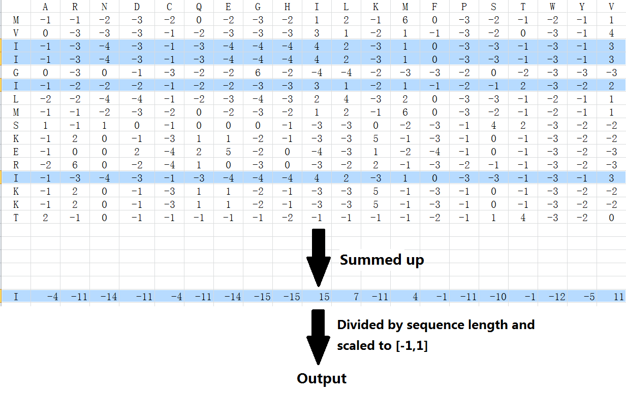

Fig. S1 Method to compute PSSM composition features from original PSSM profiles. (The example sequence showed in this figure is the T4SS effector IPG0285 of Legionella pneumophila).

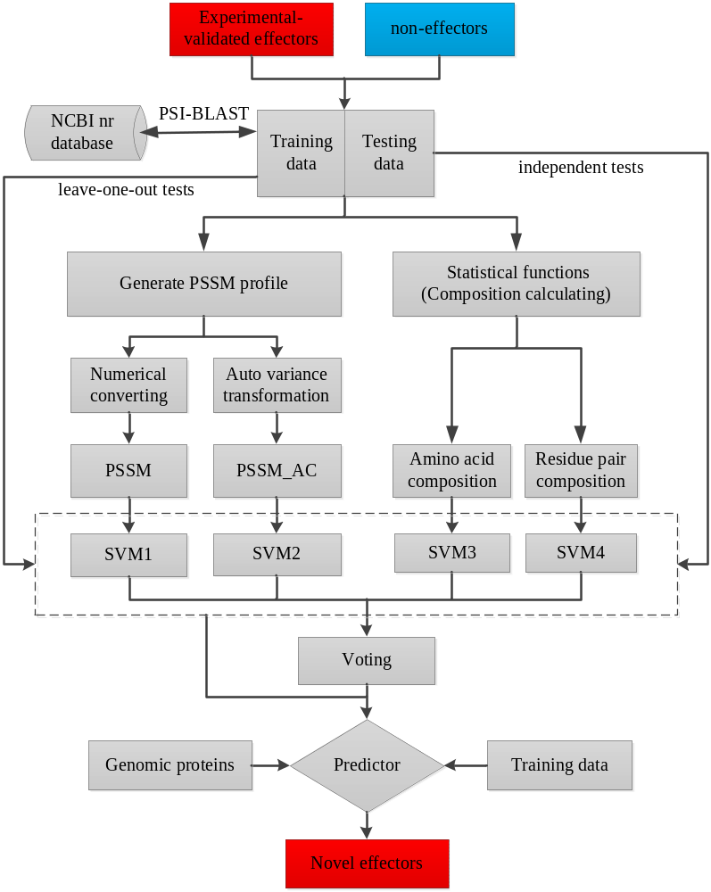

Fig. S2 Schematic representation of the steps for novel effector discovery in this study

Table S1 Compositions of twenty amino acids and their variances in T4_1472
Amino acid | IVA | IVB | Non-effectors | Variance1ª | Variance2^{b}
A | 0.1092 | 0.0621 | 0.0904 | 1.3276 | 2.0006
R | 0.0642 | 0.0398 | 0.0517 | 0.8869 | 0.8379
N | 0.0424 | 0.0569 | 0.0421 | 0.0228 | 1.0421
D | 0.0532 | 0.0535 | 0.0521 | 0.0744 | 0.0944
C | 0.0065 | 0.0105 | 0.0108 | 0.3015 | 0.0184
Q | 0.0507 | 0.0469 | 0.0417 | 0.6322 | 0.3639
E | 0.0749 | 0.0790 | 0.0602 | 1.0456 | 1.3312
G | 0.0668 | 0.0464 | 0.0726 | 0.4062 | 1.8494
H | 0.0212 | 0.0236 | 0.0227 | 0.1075 | 0.0620
I | 0.0447 | 0.0670 | 0.0670 | 1.5765 | 0.0017
L | 0.0775 | 0.1091 | 0.1027 | 1.7847 | 0.4515
K | 0.0605 | 0.0840 | 0.0558 | 0.3319 | 1.9927
M | 0.0181 | 0.0199 | 0.0251 | 0.4963 | 0.3703
F | 0.0251 | 0.0454 | 0.0401 | 1.0546 | 0.3766
P | 0.0542 | 0.0391 | 0.0440 | 0.7223 | 0.3435
S | 0.0829 | 0.0732 | 0.0609 | 1.5527 | 0.8647
T | 0.0617 | 0.0522 | 0.0515 | 0.7255 | 0.0497
W | 0.0053 | 0.0088 | 0.0113 | 0.4241 | 0.1725
Y | 0.0208 | 0.0347 | 0.0302 | 0.6632 | 0.3226
V | 0.0600 | 0.0480 | 0.0672 | 0.5073 | 1.3605
ªthe variances between IVA effectors and non-effectors; ^{b}the variances between IVB effectors and non-effectors

Table S2 Eleven amino acid pairs with the topmost variances (>0.2) between IVA effectors and non-effectors in T4_1472
Amino acid pairs | Composition in IVA effectors | Composition in non-effectors | Variance
SS | 0.0091 | 0.0041 | 0.3572
LL | 0.0051 | 0.0100 | 0.3431
AA | 0.0141 | 0.0092 | 0.3417
SA | 0.0092 | 0.0050 | 0.2991
ER | 0.0071 | 0.0035 | 0.2548
AS | 0.0085 | 0.0051 | 0.2422
LI | 0.0041 | 0.0073 | 0.2247
AE | 0.0084 | 0.0053 | 0.2197
GL | 0.0043 | 0.0074 | 0.2167
PA | 0.0069 | 0.0038 | 0.2163
LF | 0.0013 | 0.0043 | 0.2105

Table S3 Eleven amino acid pairs with the topmost variances (>0.2) between IVB effectors and non-effectors in T4_1472
Amino acid pairs | Composition in IVB effectors | Composition in non-effectors | Variance
KE | 0.0089 | 0.0041 | 0.3404
AA | 0.0046 | 0.0092 | 0.3270
AG | 0.0028 | 0.0071 | 0.3063
EK | 0.0085 | 0.0043 | 0.2946
LK | 0.0096 | 0.0059 | 0.2646
KK | 0.0074 | 0.0037 | 0.2633
GG | 0.0023 | 0.0059 | 0.2565
EE | 0.0073 | 0.0040 | 0.2326
KL | 0.0085 | 0.0052 | 0.2316
VA | 0.0031 | 0.0063 | 0.2246
GA | 0.0030 | 0.0061 | 0.2207

Table S4 Results of 5-fold cross-validation tests for discriminating IVB effectors and non-effectors in T4_1472 using auto covariance transformations of PSSM profiles with different grouped number G
G | Sn | Sp | Acc | MCC | Cª | γ^{b}
1 | 0.784 | 0.936 | 0.904 | 0.716 | 10,2
2 | 0.787 | 0.950 | 0.915 | 0.745 | 10,1
3 | 0.810 | 0.954 | 0.923 | 0.770 | 10,0.5
4 | 0.810 | 0.957 | 0.925 | 0.776 | 10,0.5
5 | 0.816 | 0.956 | 0.926 | 0.778 | 10,0.3
6 | 0.810 | 0.959 | 0.924 | 0.774 | 10,0.3
7 | 0.819 | 0.958 | 0.928 | 0.784 | 10,0.2
8 | 0.826 | 0.951 | 0.924 | 0.776 | 10,0.2
9 | 0.823 | 0.957 | 0.928 | 0.785 | 10,0.2
10 | 0.842 | 0.954 | 0.930 | 0.793 | 10,0.1
11 | 0.836 | 0.947 | 0.923 | 0.774 | 10,0.09
12 | 0.826 | 0.947 | 0.921 | 0.768 | 10,0.09
13 | 0.823 | 0.946 | 0.920 | 0.763 | 10,0.1
14 | 0.819 | 0.946 | 0.919 | 0.761 | 10,0.08
15 | 0.819 | 0.944 | 0.917 | 0.751 | 10,0.08
16 | 0.819 | 0.944 | 0.918 | 0.758 | 10,0.07
17 | 0.819 | 0.940 | 0.914 | 0.749 | 10, 0.05
18 | 0.816 | 0.939 | 0.913 | 0.745 | 10,0.07
19 | 0.816 | 0.936 | 0.911 | 0.740 | 10,0.05
20 | 0.823 | 0.934 | 0.910 | 0.740 | 10,0.06
21 | 0.813 | 0.940 | 0.913 | 0.744 | 10,0.05
22 | 0.813 | 0.947 | 0.918 | 0.758 | 10,0.05
23 | 0.819 | 0.943 | 0.916 | 0.754 | 10,0.05
24 | 0.810 | 0.941 | 0.913 | 0.744 | 10,0.05
25 | 0.816 | 0.932 | 0.910 | 0.733 | 10,0.04
26 | 0.803 | 0.929 | 0.902 | 0.717 | 10,0.04
27 | 0.803 | 0.929 | 0.902 | 0.717 | 10,0.04
28 | 0.800 | 0.934 | 0.905 | 0.723 | 10,0.03
29 | 0.807 | 0.933 | 0.906 | 0.726 | 10,0.03
30 | 0.810 | 0.930 | 0.904 | 0.724 | 10,0.03
ªC: cost, which was optimized based on 10-fold cross-validation grid search. ^{b}γ: gamma, which was optimized based on 10-fold cross-validation grid search.

Table S5 Results of independent dataset tests in T4_1472 using different features
Class | Featureª | IVA vs non-effector^{b} |  |  |  | IVB vs non-effector^{c}
Class | Featureª | Sn | Sp | Acc | MCC | Sn | Sp | Acc | MCC
Single | AAC(20D) | 0.580 | 0.960 | 0.884 | 0.608 | 0.698 | 0.931 | 0.882 | 0.640
Single | DPC(400D) | 0.560 | 0.980 | 0.896 | 0.647 | 0.665 | 0.901 | 0.852 | 0.559
Single | PSSM(400D) | 0.700 | 0.965 | 0.912 | 0.711 | 0.898 | 0.974 | 0.958 | 0.873
Single | PSSM_AC(200D, G=10) | 0.760 | 0.960 | 0.920 | 0.743 | 0.848 | 0.948 | 0.927 | 0.784
Combined | AAC+DPC(420D) | 0.560 | 0.990 | 0.904 | 0.677 | 0.665 | 0.929 | 0.873 | 0.610
Combined | PSSM+AAC(420D) | 0.740 | 0.975 | 0.928 | 0.765 | 0.905 | 0.974 | 0.959 | 0.879
Combined | PSSM_AC+AAC(220D) | 0.700 | 0.975 | 0.920 | 0.736 | 0.858 | 0.968 | 0.945 | 0.832
Combined | PSSM+PSSM_AC(600D) | 0.700 | 0.960 | 0.908 | 0.700 | 0.878 | 0.979 | 0.957 | 0.871
Combined | PSSM+PSSM_AC+AAC(620D) | 0.680 | 0.970 | 0.912 | 0.709 | 0.918 | 0.970 | 0.959 | 0.878
ªAAC: amino acid composition; DPC: residue pair composition; PSSM: PSSM composition; PSSM_AC: auto covariance transformation of PSSM. ^{b}In the LOO test dataset, 20 IVA effectors and 80 non-effectors were randomly selected for training and the other 10 IVA effectors and 40 non-effectors for prediction. ^{c}80 IVB effectors and 300 non-effected were randomly selected from T4-1472 for training and the left sequences for prediction. All SVM parameters were achieved by grid search with 10-fold cross-validation tests (IVB) or leave-one-out tests (IVA).

Table S6 Comparison of the area under the ROC curves of different features by 5-fold cross-validation tests for IVB effector prediction
Class | Feature | AUCª
Single | AAC(20D) | 0.904
Single | DPC(400D) | 0.892
Single | PSSM(400D) | 0.970
Single | PSSM_AC(200D, G=10) | 0.926
Combined | AAC+DPC(420D) | 0.907
Combined | PSSM+AAC(420D) | 0.970
Combined | PSSM_AC+AAC(220D) | 0.950
Combined | PSSM+PSSM_AC(600D) | 0.972
ªAUC: the area under the ROC curve.

Table S7 Results for ensemble prediction of IVA effectors with leave-one-out tests in T4_1472
Classifiers | Modelª | Voting^{b} | Sn | Sp | Acc | MCC
1. AAC  2. DPC  3. PSSM  4. PSSM_AC | 1 | - | 0.633 | 0.967 | 0.900 | 0.667
1. AAC  2. DPC  3. PSSM  4. PSSM_AC | 2 | - | 0.533 | 0.992 | 0.900 | 0.663
1. AAC  2. DPC  3. PSSM  4. PSSM_AC | 3 | - | 0.733 | 0.983 | 0.933 | 0.782
1. AAC  2. DPC  3. PSSM  4. PSSM_AC | 4 | - | 0.667 | 0.967 | 0.907 | 0.691
1. AAC  2. DPC  3. PSSM  4. PSSM_AC | {1,2,3} | 2-in-3 | 0.600 | 1.000 | 0.920 | 0.739
1. AAC  2. DPC  3. PSSM  4. PSSM_AC | {1,2,4} | 2-in-3 | 0.533 | 1.000 | 0.907 | 0.691
1. AAC  2. DPC  3. PSSM  4. PSSM_AC | {1,3,4} | 2-in-3 | 0.767 | 1.000 | 0.953 | 0.851
1. AAC  2. DPC  3. PSSM  4. PSSM_AC | {2,3,4} | 2-in-3 | 0.700 | 0.992 | 0.933 | 0.782
1. AAC  2. DPC  3. PSSM  4. PSSM_AC | {1,2,3,4} | 3-in-4 | 0.600 | 1.000 | 0.920 | 0.739
ªEach term in this column represents the combination form of different classifiers, e.g., {1,2,3} means the ensemble of no. 1, 2 and 3 classifiers in the first column. ^{b}The 2-in-3 voting scheme was adopted for the result voting of three classifiers, and the 3-in-4 voting scheme was adopted for the result voting of four classifiers. The dataset selected for LOO tests was expatiated inTable1.

Table S8 Results of performance comparison with existing methods
Method | Model | Feature | Voting | Sn | Sp | Acc | MCC | AUC
this studyª | SVM | PSSM | no | 0.901 | 0.978 | 0.961 | 0.886 | 0.974
this studyª | SVM | PSSM_AC | no | 0.852 | 0.971 | 0.945 | 0.837 | 0.954
this studyª | SVM | PSSM+AAC | no | 0.914 | 0.984 | 0.968 | 0.908 | 0.977
this studyª | SVM | PSSM_AC+AAC | no | 0.914 | 0.987 | 0.971 | 0.915 | 0.978
this studyª | SVM | {AAC; PSSM; PSSM_AC} | 2-in-3 | 0.933 | 0.993 | 0.981 | 0.945 | 0.988
this study^{b} | SVM | PSSM | no | 0.896 | 0.981 | 0.966 | 0.879 | 0.973
this study^{b} | SVM | PSSM_AC | no | 0.813 | 0.976 | 0.949 | 0.812 | 0.939
this study^{b} | SVM | PSSM+AAC | no | 0.888 | 0.984 | 0.967 | 0.882 | 0.976
this study^{b} | SVM | PSSM_AC+AAC | no | 0.843 | 0.994 | 0.969 | 0.885 | 0.964
this study^{b} | SVM | {AAC; PSSM; PSSM_AC} | 2-in-3 | 0.910 | 1.000 | 0.985 | 0.946 | 0.983
Burstein et al. | ensemble | GC content, C-terminal signal， etc. | voting | - | - | 0.959 | - | 0.980
Lifshitz et al. | HSMM | HMM profile | no | 92.9% | - | - | - | 0.881
ªThese classifiers were tested in Lifshitz et al.’s dataset(283 effectors and 1000 non-effectors);^{b}These classifiers were tested in Burstein et al.’s dataset(134 effectors and 670 non-effectors).

Table S9 Prediction results in the genome of Bartonella henselae using multi classification models in the T_1472 dataset
Featureª | Training data | Model^{c} | Number of  predicted effectors | Number of predicted effectors included in  the seven known effectors^{d}
1. AAC  2. DPC  3. PSSM  4. PSSM_AC | IVA vs non-effector^{b} | 1 | 56 | 5(1993,1194,1195,1196,1997)
1. AAC  2. DPC  3. PSSM  4. PSSM_AC | IVA vs non-effector^{b} | 2 | 34 | 3(1194,1195,1196)
1. AAC  2. DPC  3. PSSM  4. PSSM_AC | IVA vs non-effector^{b} | 3 | 62 | 4(1994,1995,1996,1997)
1. AAC  2. DPC  3. PSSM  4. PSSM_AC | IVA vs non-effector^{b} | 4 | 102 | 3(1194,1195,1196)
1. AAC  2. DPC  3. PSSM  4. PSSM_AC | IVA vs non-effector^{b} | 1+2 | 36 | 3(1194,1195,1196)
1. AAC  2. DPC  3. PSSM  4. PSSM_AC | IVA vs non-effector^{b} | 1+3 | 48 | 4(1994,1995,1996,1997)
1. AAC  2. DPC  3. PSSM  4. PSSM_AC | IVA vs non-effector^{b} | 1+4 | 59 | 3(1194,1195,1196)
1. AAC  2. DPC  3. PSSM  4. PSSM_AC | IVA vs non-effector^{b} | 1+3+4 | 68 | 4(1994,1995,1996,1997)
1. AAC  2. DPC  3. PSSM  4. PSSM_AC | IVA vs non-effector^{b} | {1,3,4}(2-in-3) | 41 | 4(1994,1995,1996,1997)
1. AAC  2. DPC  3. PSSM  4. PSSM_AC | IVB vs non-effector | 1 | 122 | 6(1990,1992,1993,1994,1996,1997)
1. AAC  2. DPC  3. PSSM  4. PSSM_AC | IVB vs non-effector | 2 | 117 | 6(1990,1992,1993,1994,1996,1997)
1. AAC  2. DPC  3. PSSM  4. PSSM_AC | IVB vs non-effector | 3 | 130 | 2(1190,1997)
1. AAC  2. DPC  3. PSSM  4. PSSM_AC | IVB vs non-effector | 4 | 146 | 0
1. AAC  2. DPC  3. PSSM  4. PSSM_AC | IVB vs non-effector | 1+2 | 127 | 6(1990,1992,1993,1994,1996,1997)
1. AAC  2. DPC  3. PSSM  4. PSSM_AC | IVB vs non-effector | 1+3 | 134 | 1(1197)
1. AAC  2. DPC  3. PSSM  4. PSSM_AC | IVB vs non-effector | 1+4 | 143 | 0
1. AAC  2. DPC  3. PSSM  4. PSSM_AC | IVB vs non-effector | 1+3+4 | 139 | 1(1197)
1. AAC  2. DPC  3. PSSM  4. PSSM_AC | IVB vs non-effector | {1,3,4}(2-in-3) | 99 | 2(1990,1997)
1. AAC  2. DPC  3. PSSM  4. PSSM_AC | All effector vs non-effectors | 1 | 132 | 7(1190,1192,1193,1194, 1195,1196,1197)
1. AAC  2. DPC  3. PSSM  4. PSSM_AC | All effector vs non-effectors | 2 | 122 | 7(1190,1192,1193,1194, 1195,1196,1197)
1. AAC  2. DPC  3. PSSM  4. PSSM_AC | All effector vs non-effectors | 3 | 158 | 6 (1190,1193,1194,1195,1196, 1197)
1. AAC  2. DPC  3. PSSM  4. PSSM_AC | All effector vs non-effectors | 4 | 158 | 0
1. AAC  2. DPC  3. PSSM  4. PSSM_AC | All effector vs non-effectors | 1+2 | 122 | 7(1190,1192,1193,1194, 1195,1196,1197)
1. AAC  2. DPC  3. PSSM  4. PSSM_AC | All effector vs non-effectors | 1+3 | 149 | 4(1994,1995,1996,1997)
1. AAC  2. DPC  3. PSSM  4. PSSM_AC | All effector vs non-effectors | 1+4 | 169 | 4(1992,1994,1995,1996,1997)
1. AAC  2. DPC  3. PSSM  4. PSSM_AC | All effector vs non-effectors | {1,2,3}(2-in-3) | 87 | 7 (1190,1192,1193,1194, 1195,1196,1197)
1. AAC  2. DPC  3. PSSM  4. PSSM_AC | All effector vs non-effectors | {1,2,4}(2-in-3) | 79 | 7 (1190,1192,1193,1194, 1195,1196,1197)
1. AAC  2. DPC  3. PSSM  4. PSSM_AC | All effector vs non-effectors | {1,3,4}(2-in-3) | 112 | 6 (1190,1193,1194,1195,1196, 1197)
1. AAC  2. DPC  3. PSSM  4. PSSM_AC | All effector vs non-effectors | {2,3,4}(2-in-3) | 102 | 6 (1190,1193,1194,1195,1196, 1197)
1. AAC  2. DPC  3. PSSM  4. PSSM_AC | All effector vs non-effectors | {1,2,3,4}(3-in-4) | 57 | 7(1190,1192,1193,1194,1195,1196, 1197)
ªAAC: amino acid composition; PSSM: PSSM composition; PSSM_AC: auto covariance transformation of PSSM profiles. ^{b}300 non-effectors were randomly selected in 1132 non-effectors as negative samples. ^{c}Each term in this column represents a classifier or a classifier ensemble using corresponding feature vectors, e.g. {1,2,3}(2-in-3) means the ensemble of classifiers 1, 2 and 3 in the first column, and 2-in-3 denotes the voting scheme. ^{d}Figures in brackets refer to the protein number of known effectors in Bartonella henselae str. Houston-1; the locus tags of protein 1990, 1992, 1993, 1994, 1995, 1996, 1997 are BH13370, BH13390, BH13400, BH13410, BH13420, BH13430, BH13440, respectively.

Table S10 Putative effectors inferred by our classifier ensemble in the genome of Bartonella henselae
No. | GI number | Protein products | Locus tag | Property | Homologs in Gram⁻
1 | 49474930 | YP_032971.1 | BH01120 | hypothetical protein | heme exporter protein D
2 | 49474957 | YP_032998.1 | BH01430 | hypothetical protein | hypothetical protein
3 | 49475083 | YP_033124.1 | BH02730 | hypothetical protein | slyX homolog
4 | 49475092 | YP_033133.1 | BH02870 | hypothetical protein | hypothetical protein
5 | 49475102 | YP_033143.1 | BH02970 | hypothetical protein | transcriptional regulator
6 | 49475163 | YP_033204.1 | BH03620 | hypothetical protein | hypothetical protein
7 | 49475164 | YP_033205.1 | BH03630 | hypothetical protein | hypothetical protein
8 | 49475165 | YP_033206.1 | BH03640 | hypothetical protein | hypothetical protein
9 | 49475172 | YP_033213.1 | BH03710 | hypothetical protein | hypothetical protein
10 | 49475293 | YP_033334.1 | BH04980 | tonB protein | tonB protein
11 | 49475403 | YP_033444.1 | BH06150 | hypothetical protein | hypothetical protein
12 | 49475443 | YP_033484.1 | BH06580 | hypothetical protein | hypothetical protein
13 | 49475471 | YP_033512.1 | BH06880 | hypothetical protein | hypothetical protein
14 | 49475482 | YP_033523.1 | BH07000 | hypothetical protein | hypothetical protein
15 | 49475519 | YP_033560.1 | BH07480 | hypothetical protein | hypothetical protein
16 | 49475542 | YP_033583.1 | BH07720 | hypothetical protein | hypothetical protein
17 | 49475564 | YP_033605.1 | BH07950 | filamentous hemagglutinin | filamentous hemagglutinin
18 | 49475677 | YP_033718.1 | BH09200 | hypothetical protein | transcriptional regulator
19 | 49475687 | YP_033728.1 | BH09300 | hypothetical protein | hypothetical protein
20 | 49475694 | YP_033735.1 | BH09370 | hypothetical protein | hypothetical protein
21 | 49475744 | YP_033785.1 | BH09990 | hypothetical protein | putative membrane protein
22 | 49475817 | YP_033858.1 | BH10820 | hypothetical protein | hypothetical protein
23 | 49475868 | YP_033909.1 | BH11390 | hypothetical protein | putative membrane protein
24 | 49475935 | YP_033976.1 | BH12200 | hypothetical protein | -
25 | 49475942 | YP_033983.1 | BH12280 | hypothetical protein | putative membrane protein
26 | 49475999 | YP_034040.1 | BH13120 | hypothetical protein | probable surface protein
27 | 49476002 | YP_034043.1 | BH13170 | hypothetical protein | -
28 | 49476020 | YP_034061.1 | BH13360 | hypothetical protein | hypothetical protein*
29 | 49476050 | YP_034091.1 | BH13840 | hypothetical protein | hypothetical protein
30 | 49476053 | YP_034094.1 | BH13870 | hypothetical protein | hypothetical protein
31 | 49476064 | YP_034105.1 | BH14000 | hypothetical protein | hypothetical protein
32 | 49476072 | YP_034113.1 | BH14080 | hypothetical protein | -
33 | 49476074 | YP_034115.1 | BH14100 | hypothetical protein | -
34 | 49476081 | YP_034122.1 | BH14170 | hypothetical protein | -
35 | 49476084 | YP_034125.1 | BH14200 | hypothetical protein | -
36 | 49476085 | YP_034126.1 | BH14210 | hypothetical protein | -
37 | 49476093 | YP_034134.1 | BH14310 | hypothetical protein | -
38 | 49476094 | YP_034135.1 | BH14320 | hypothetical protein | hypothetical protein#
39 | 49476095 | YP_034136.1 | BH14330 | hypothetical protein | hypothetical protein#
40 | 49476112 | YP_034153.1 | BH14510 | hypothetical protein | hypothetical protein
41 | 49476114 | YP_034155.1 | BH14530 | hypothetical protein | hypothetical protein
42 | 49476117 | YP_034158.1 | BH14560 | hypothetical protein | -
43 | 49476118 | YP_034159.1 | BH14570 | hypothetical protein | -
44 | 49476120 | YP_034161.1 | BH14590 | hypothetical protein | -
45 | 49476124 | YP_034165.1 | BH14650 | hypothetical protein | -
46 | 49476183 | YP_034224.1 | BH15280 | hypothetical protein | hypothetical protein
47 | 49476209 | YP_034250.1 | BH15540 | hypothetical protein | hypothetical protein
48 | 49476211 | YP_034252.1 | BH15560 | korA protein | korA protein
49 | 49476283 | YP_034324.1 | BH16320 | hypothetical protein | -
50 | 49476300 | YP_034341.1 | BH16510 | hypothetical protein | -
*this protein has lower homology with the putative effector Bep of Bartonella sp. AR 15-3. #these proteins are homologous with each other.
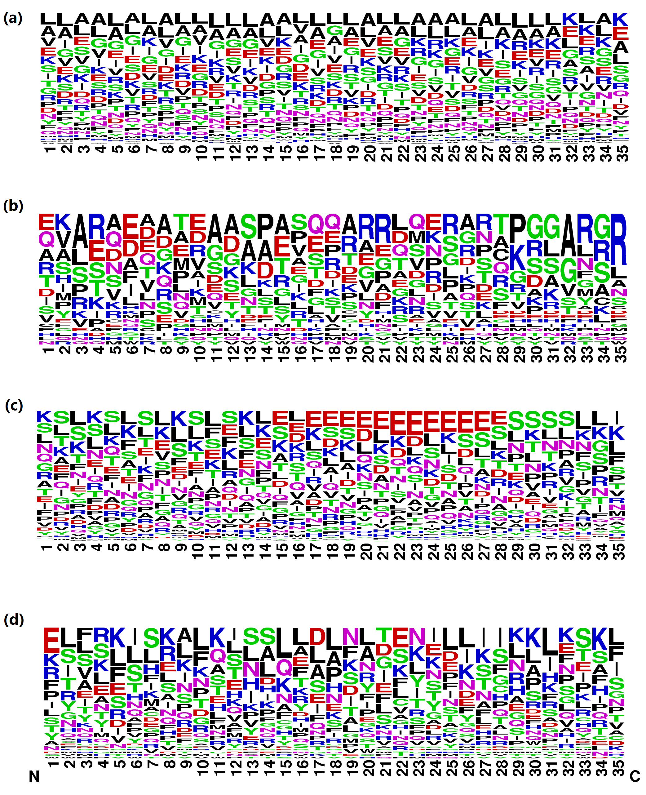

Fig. S3 Probability of occurrence of amino acids at the C-terminus. (a) Sequences of 1132 non-effectors in the T4_1472 dataset. (b) Sequences of 30 IVA effectors in the T4_1472 dataset. (c) Sequences of 310 IVB effectors in the T4_1472 dataset. (d) Sequences of 50 putative effectors predicted in Bartonella henselae. Thirty-five C-terminal residues of sequences were used to generate amino acid profiles by WebLogo.
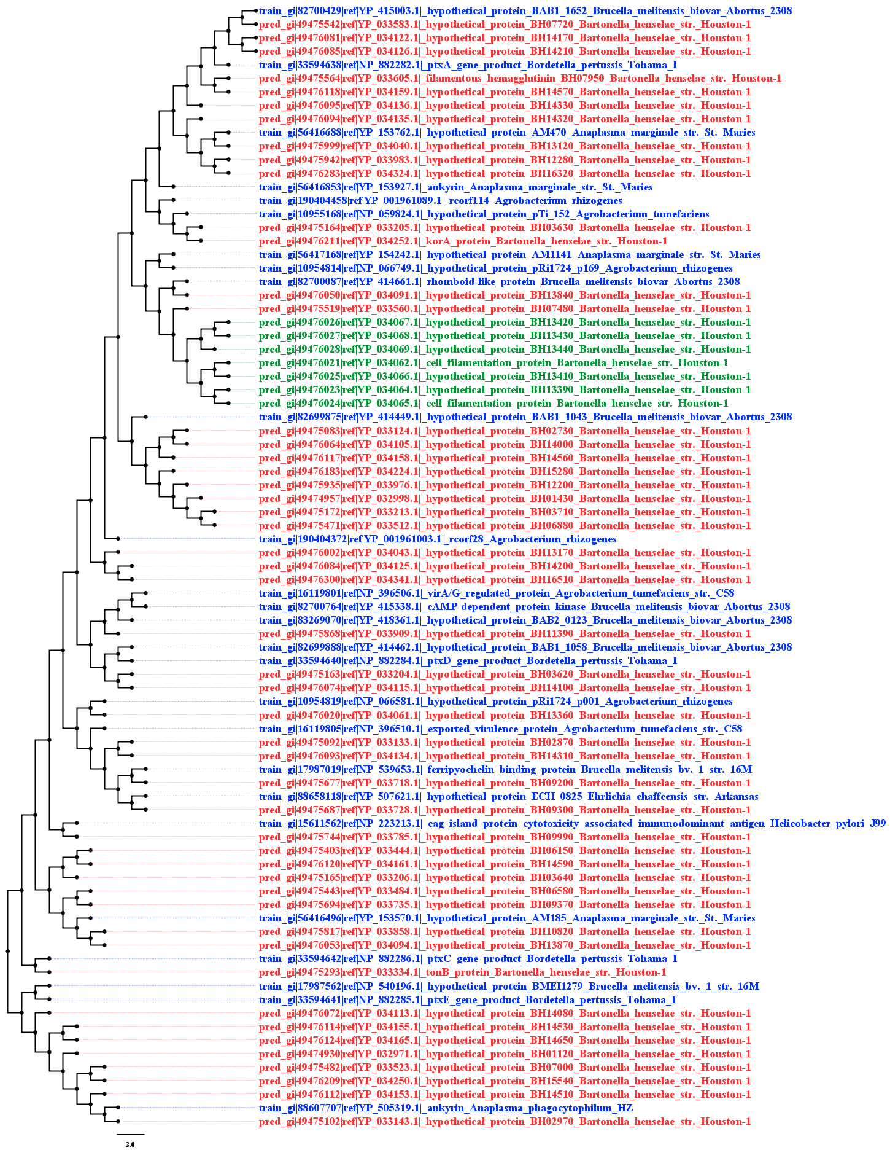

Fig. S4 A maximum likelihood phylogenic tree of 26 known IVA effectors and 57 putative effectors. Blue: 26 IVA effectors in T4_1472 which were used for model training (without the remote protein APH_0859 of Anaplasma phagocytophilum and three known effectors of Bartonella); Red: 50 putative effectors inferred by our model in genomic proteins of Bartonella Henselae. Green: all the seven effectors of Bartonella sp. which were correctly predicted by our model.

