**DETERMINATION OF A PERSON’S HEALTH**

**1). Business requirement of the project**

The main business requirement is to determine what part of the population is healthy. The main benefit from this project will be for the doctors who wish to determine the health of its local patients in terms of basic attributes.

As we know, many people are going towards the category of being over-weight or obese. In order to control it, the project will predict the category in which the person will lie.

Hence, this project can be the starting point for determining the population’s health based on basic factors.

**2). What is the scientific goal?**

The project is made with the help of Data Analysis and Machine Learning using Python. In this project, the machine will analyse the already present data first and then conclude upon a person’s health on his/her given factors.

In this project, gender and either height or weight will be given to the machine. If the height is given then the weight will be predicted and vice-versa. Through these predictions the machine will tell us about the health of a person.

The main goal is to help the society for its betterment as far as health is concerned.

**3). What would you do if you had all the data?**

In our project, the attributes we use are gender, height or age. If we had age as another attribute it would have made the prediction more precise and exact. Hence, our machine would have been more better.

**4). What are the Features or Attributes of data set?**

Dataset comprises of 10000 rows and 4 columns. Each row represents the data of an individual with 4 attributes. The data set includes 4 attributes-

1. Gender

2. Height

3. Weight

4. Index

The machine will be trained in these aspects to determine a person’s health or weight and the category it will lie in.

Index Category

0 Underweight

1 Normal weight

2 Healthy

3 Over weight

4 Obesity

The dataset has following data as shown in bar graphs:-

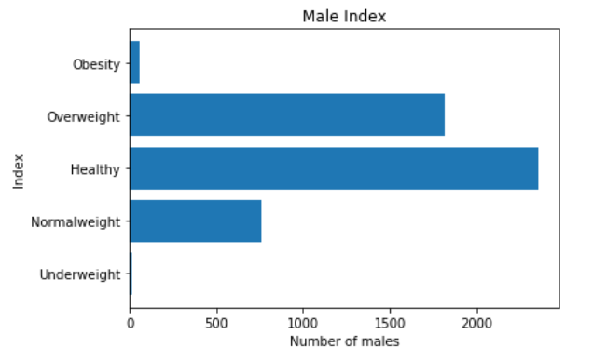

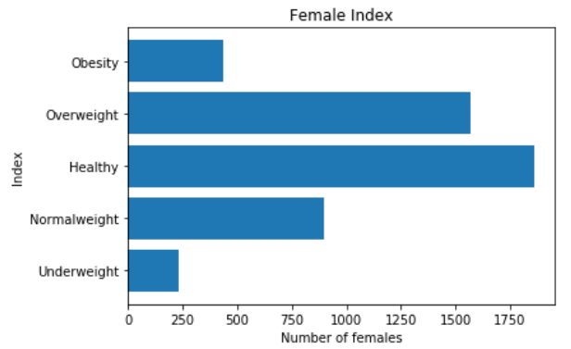

**5). What do you want to predict or estimate?**

The main aim of the project will be to determine whether a person is healthy or not. Also, the machine will predict the person’s health or weight.