**Data Pipeline:**

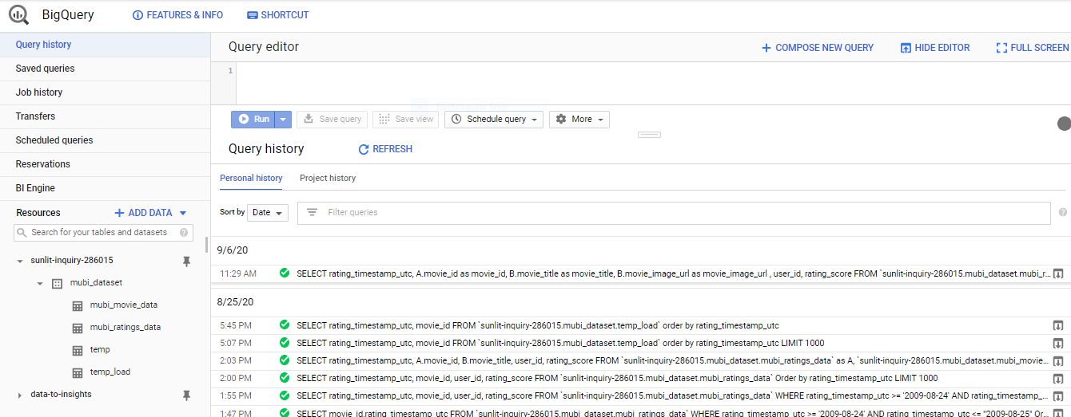

Data loaded to BigQuery

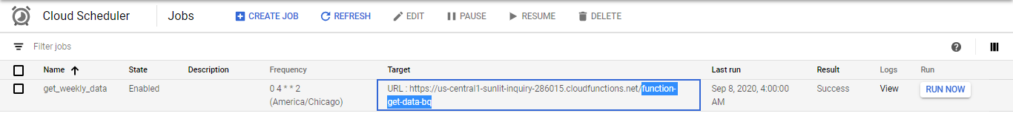

Cloud Schedular to call cloud function get-data-bq() using HTTP request

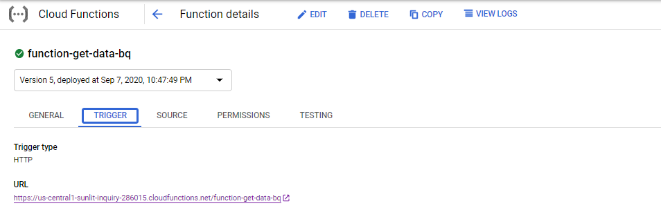

Cloud Function file name: get_data_bq_function.py

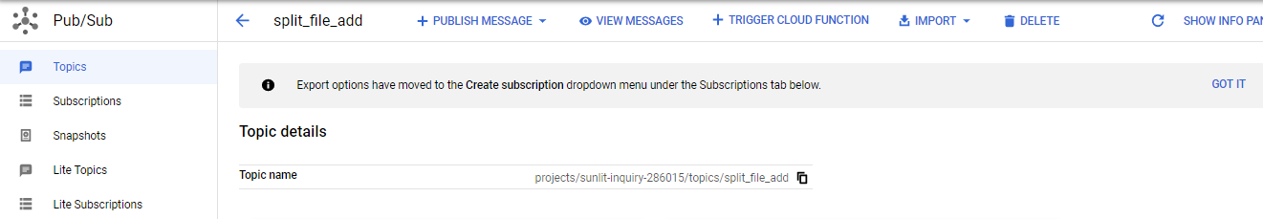

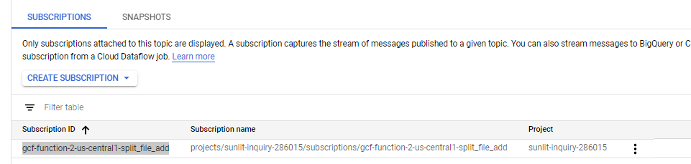

Cloud Pubsub topic trigger cloud function: function-2() when published

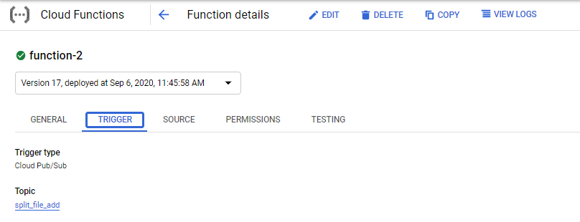

The cloud function trigger function-2 source code in file weekly_data_processor_function.py

**FlaskAPI:**

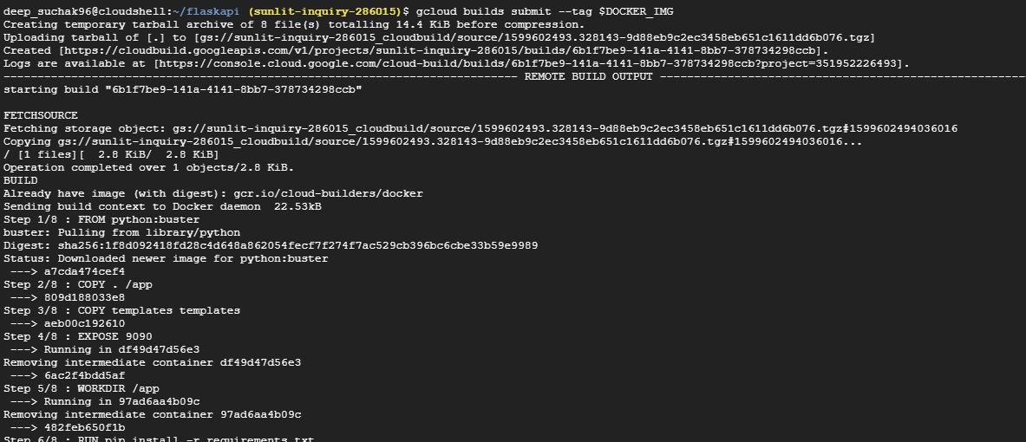

Build Container Image in Cloud Shell

Using commands:

DOCKER_IMG="us.gcr.io/sunlit-inquiry-286015/flaskapp1"

gcloud builds submit --tag $DOCKER_IMG

Flask_app code in folder flaskapp

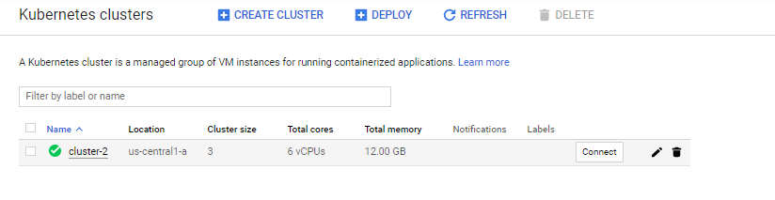

Create GKE cluster

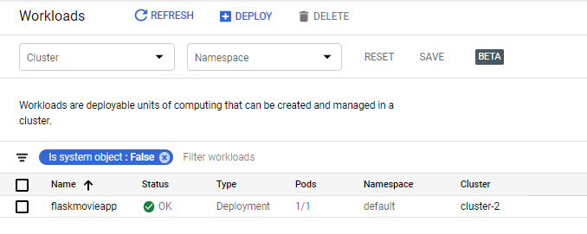

Add workload from image

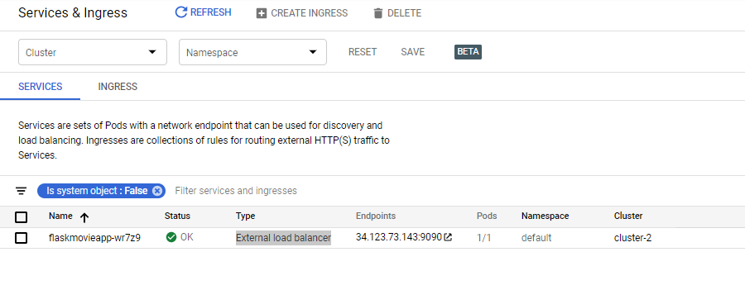

Expose workload using External load balancer