SMARTBRANCH 360
Fault Cards & Troubleshooting Evidence
Cisco Virtual Internship 2026
Five controlled fault scenarios documented using the original Stage 10 Packet Tracer screenshots, diagnostic evidence, corrective actions, and post-fix verification.
F01 | Incorrect Employee Default Gateway
F02 | VLAN 20 Missing From Trunk
F03 | Incorrect Guest DHCP Gateway
F04 | ACL Blocking DNS
F05 | NAT Outside Missing
Fault-lab principle: inject one fault at a time, prove the symptom, diagnose from evidence, repair, and retest.

F01 - Incorrect Employee Default Gateway
Fault ID: F01 | Name: Incorrect Employee Default Gateway
Original State | EMP-PC1 is an Employee VLAN 10 host. Its correct Layer-3 settings use subnet 10.10.10.0/24, default gateway 10.10.10.1, and DNS server 10.10.30.10. With the correct gateway, the employee host can reach SRV1 at 10.10.30.10 and the simulated Internet server at 203.0.113.10.
Injected Configuration | The Employee PC was deliberately given an incorrect default gateway while keeping a valid VLAN 10 address:  IPv4 address: 10.10.10.14  Subnet mask: 255.255.255.0  Default gateway: 10.10.10.254 [FAULT]  DNS server: 10.10.30.10
Observed Symptom | The PC retained a valid local IPv4 address, but all off-subnet traffic failed. Ping to the internal server 10.10.30.10 timed out, and ping to 203.0.113.10 also timed out with 100% packet loss.
Diagnostic Method | Inspect the endpoint IP configuration (or ipconfig) and compare the configured default gateway with the VLAN 10 design gateway. Then test progressively: local addressing, gateway reachability, server reachability, and external reachability. The value 10.10.10.254 immediately identifies the mismatch.
Root Cause | Traffic for destinations outside 10.10.10.0/24 was sent toward 10.10.10.254, which is not the router gateway. The host therefore could not forward packets to R1-BRANCH G0/0.10 at 10.10.10.1.
Corrective Action | Restore the Employee default gateway to 10.10.10.1 (or return the host to the normal DHCP configuration so that it receives the correct gateway). Retest the same destinations after the correction.
Verification | After correction, ping to 10.10.30.10 returned 4/4 replies with 0% loss, and ping to 203.0.113.10 also returned 4/4 replies with 0% loss.
Screenshots | Three Stage 10 screenshots are reproduced on the next page in fault-injection, symptom/diagnosis, and post-fix order.
Learning Outcome | A wrong default gateway can leave local addressing looking correct while breaking all routed traffic. Verifying the endpoint gateway before investigating trunks, ACLs, or NAT avoids unnecessary troubleshooting.

F01 - Screenshot Evidence
Original Stage 10 troubleshooting screenshots
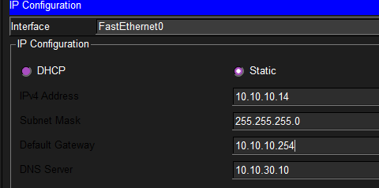 | 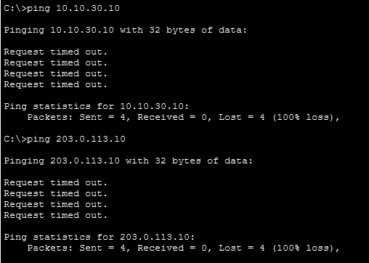
Screenshot 1 - Injected configuration: default gateway changed to 10.10.10.254. | Screenshot 2 - Observed symptom: server and external pings fail with 100% loss.
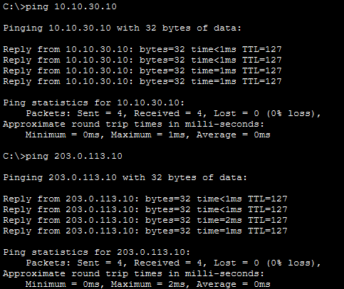
Screenshot 3 - Verification: internal server and external pings succeed after the fix.
Evidence sequence: injected fault -> observed/diagnostic evidence -> restored operation.

F02 - VLAN 20 Missing From Trunk
Fault ID: F02 | Name: VLAN 20 Missing From Trunk
Original State | The SW1-SW2 inter-switch link is an 802.1Q trunk. SW1 Gi0/2 and SW2 Gi0/1 must carry VLANs 10, 20, 30, and 99 so that the Guest VLAN can reach R1-BRANCH through SW1.
Injected Configuration | On SW1 Gi0/2, VLAN 20 was removed from the allowed trunk list:  configure terminal  interface gigabitEthernet0/2  switchport trunk allowed vlan 10,30,99  end
Observed Symptom | Guest connectivity failed while VLANs still present on the trunk could continue to operate. A Guest client could not ping its VLAN gateway 10.10.20.1 and showed 100% packet loss.
Diagnostic Method | Run show interfaces trunk on SW1 and compare the allowed VLAN list on Gi0/2 with the design baseline. The output showed Gi0/2 carrying 10,30,99 instead of 10,20,30,99. The Python checker can also report VLAN 20 missing from SW1 Gi0/2.
Root Cause | VLAN 20 frames from AP-GUEST and the Guest clients on SW2 could not cross the SW1-SW2 trunk. The Guest broadcast domain was therefore logically cut off from R1-BRANCH G0/0.20.
Corrective Action | Restore VLAN 20 to the trunk:  configure terminal  interface gigabitEthernet0/2  switchport trunk allowed vlan 10,20,30,99  end
Verification | Run show interfaces trunk again and confirm Gi0/2 lists 10,20,30,99 under allowed, active, and forwarding VLANs. Retest Guest reachability to 10.10.20.1 and the permitted external destination.
Screenshots | Three Stage 10 screenshots are reproduced on the next page in fault-injection, symptom/diagnosis, and post-fix order.
Learning Outcome | A trunk can remain up while a single VLAN is broken. Interface status alone is not enough; the allowed VLAN list must be checked whenever only one VLAN loses connectivity.

F02 - Screenshot Evidence
Original Stage 10 troubleshooting screenshots
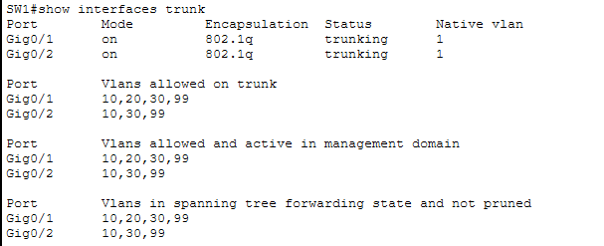 | 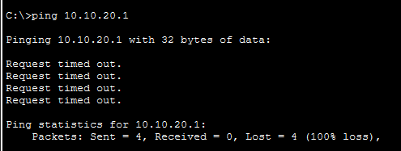
Screenshot 1 - Diagnostic evidence: VLAN 20 is absent from SW1 Gi0/2. | Screenshot 2 - Observed symptom: Guest cannot reach gateway 10.10.20.1.
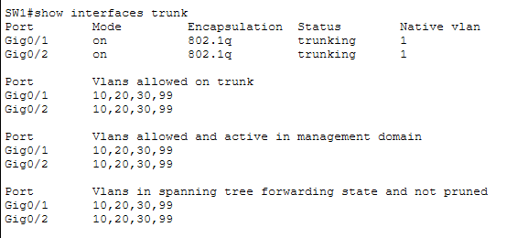
Screenshot 3 - Verification: VLAN 20 is restored to the trunk.
Evidence sequence: injected fault -> observed/diagnostic evidence -> restored operation.

F03 - Incorrect Guest DHCP Gateway
Fault ID: F03 | Name: Incorrect Guest DHCP Gateway
Original State | The Guest DHCP pool must provide default-router 10.10.20.1 for VLAN 20. Guest clients receive addresses from 10.10.20.0/24 and use 203.0.113.10 as the DNS server in the Stage 10 fault-lab configuration.
Injected Configuration | The Guest DHCP pool was deliberately changed to distribute the wrong gateway:  configure terminal  ip dhcp pool GUEST_POOL  no default-router 10.10.20.1  default-router 10.10.20.254  end  The Guest client lease was then renewed so it received the faulty option.
Observed Symptom | The Guest client successfully received an IPv4 lease (10.10.20.13/24) but its default gateway became 10.10.20.254. As a result, ping to 203.0.113.10 timed out with 100% loss.
Diagnostic Method | Inspect the Guest client's DHCP-derived settings and compare the default gateway with the VLAN 20 requirement. On R1-BRANCH, inspect the DHCP pool using show running-config and locate the default-router statement for GUEST_POOL.
Root Cause | DHCP was functioning, but it distributed an invalid default-router option. The client therefore had a valid address yet sent all off-subnet traffic toward the nonexistent gateway 10.10.20.254.
Corrective Action | Restore the correct DHCP option:  configure terminal  ip dhcp pool GUEST_POOL  no default-router 10.10.20.254  default-router 10.10.20.1  end  Renew the Guest client DHCP lease.
Verification | After renewal, the Guest client successfully pinged 203.0.113.10 and its gateway 10.10.20.1, with 4/4 replies and 0% packet loss in both tests.
Screenshots | Three Stage 10 screenshots are reproduced on the next page in fault-injection, symptom/diagnosis, and post-fix order.
Learning Outcome | Receiving a DHCP address does not prove that all DHCP options are correct. Gateway and DNS values must be verified whenever a client has an address but cannot reach remote networks.

F03 - Screenshot Evidence
Original Stage 10 troubleshooting screenshots
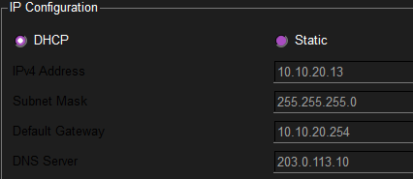 | 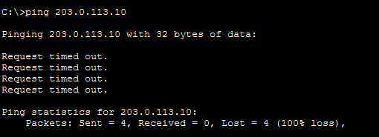
Screenshot 1 - Injected configuration observed at client: DHCP gateway 10.10.20.254. | Screenshot 2 - Observed symptom: external connectivity fails.
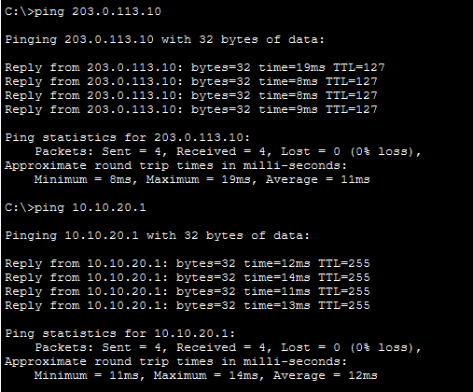
Screenshot 3 - Verification: Guest gateway and external connectivity are restored.
Evidence sequence: injected fault -> observed/diagnostic evidence -> restored operation.

F04 - ACL Blocking DNS
Fault ID: F04 | Name: ACL Blocking DNS
Original State | ACL 100 is applied inbound to R1-BRANCH G0/0.20. Its normal purpose is to deny Guest traffic to the Employee, Server, and Management networks while permitting allowed traffic toward external services. Guest DNS traffic to 203.0.113.10 must remain permitted.
Injected Configuration | ACL 100 was rebuilt with a DNS-specific deny inserted before the final permit:  deny ip 10.10.20.0 0.0.0.255 10.10.10.0 0.0.0.255  deny ip 10.10.20.0 0.0.0.255 10.10.30.0 0.0.0.255  deny ip 10.10.20.0 0.0.0.255 10.10.99.0 0.0.0.255  deny udp 10.10.20.0 0.0.0.255 host 203.0.113.10 eq domain [FAULT]  permit ip any any
Observed Symptom | Direct IP connectivity still worked: ping 203.0.113.10 returned replies. However, ping internet.test failed with 'could not find host', showing that name resolution was broken while general IP reachability remained available.
Diagnostic Method | Compare direct-IP and hostname tests, then run show access-lists. ACL 100 showed a specific deny for UDP/53 from 10.10.20.0/24 to host 203.0.113.10 before the final permit. This isolates the problem to DNS rather than routing or NAT.
Root Cause | The additional ACL rule blocked Guest DNS queries to the configured DNS server. Because ICMP was not blocked, direct ping by address still succeeded, making the failure service-specific.
Corrective Action | Remove the unintended DNS deny and preserve the original Guest isolation rules. ACL 100 must continue denying Guest access to Employee, Server, and Management networks, followed by the intended permit for allowed traffic.
Verification | After the ACL was corrected, ping internet.test successfully resolved to 203.0.113.10 and returned 4/4 replies. Guest isolation rules should also be regression-tested to ensure the security policy remains intact.
Screenshots | Three Stage 10 screenshots are reproduced on the next page in fault-injection, symptom/diagnosis, and post-fix order.
Learning Outcome | ACL faults can affect one protocol while other connectivity tests still pass. Comparing IP-based and name-based tests, then checking ACL order and service ports, is essential for diagnosing application-specific failures.

F04 - Screenshot Evidence
Original Stage 10 troubleshooting screenshots
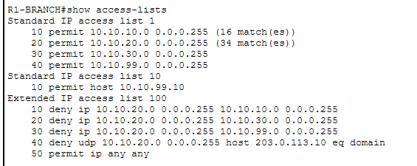 | 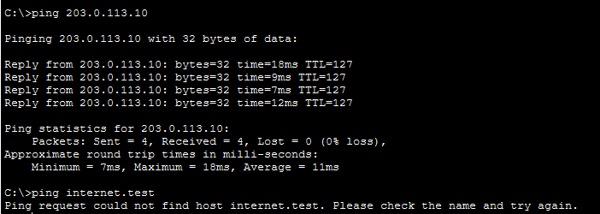
Screenshot 1 - Diagnostic evidence: ACL 100 contains a Guest UDP/53 deny. | Screenshot 2 - Observed symptom: IP ping succeeds but hostname resolution fails.
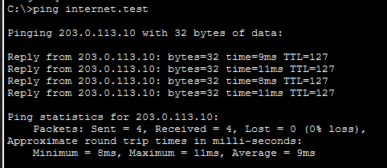
Screenshot 3 - Verification: internet.test resolves and responds after the ACL fix.
Evidence sequence: injected fault -> observed/diagnostic evidence -> restored operation.

F05 - NAT Outside Missing
Fault ID: F05 | Name: NAT Outside Missing
Original State | R1-BRANCH uses G0/0.10, G0/0.20, G0/0.30, and G0/0.99 as ip nat inside interfaces. G0/1 (203.0.113.1/24) is ip nat outside, and PAT is configured with 'ip nat inside source list 1 interface GigabitEthernet0/1 overload'.
Injected Configuration | The external NAT role was removed and existing translations were cleared:  configure terminal  interface gigabitEthernet0/1  no ip nat outside  end  clear ip nat translation *
Observed Symptom | After fresh Employee traffic was generated, no valid new NAT translation appeared. show ip nat statistics reported Total translations: 0 and showed no Outside Interface, while the four internal subinterfaces remained listed as Inside Interfaces.
Diagnostic Method | Use show running-config | include ip nat to confirm the outside statement is missing, then inspect show ip nat statistics and show ip nat translations after generating fresh traffic. A ping to 203.0.113.10 may still succeed in this lab because INTERNET-SRV is directly connected to R1-BRANCH, so ping alone is not definitive NAT evidence.
Root Cause | The PAT rule still referenced G0/1, but G0/1 was no longer classified as an outside NAT interface. Without the inside/outside boundary, the router could not create the expected translations.
Corrective Action | Restore the interface role and regenerate translation state:  configure terminal  interface gigabitEthernet0/1  ip nat outside  end  clear ip nat translation *  Generate fresh Employee traffic to 203.0.113.10.
Verification | show ip nat translations displayed fresh ICMP entries mapping inside local 10.10.10.15 to inside global 203.0.113.1 for traffic toward 203.0.113.10. This translation evidence, rather than ping alone, confirms that NAT/PAT is functioning again.
Screenshots | Three Stage 10 screenshots are reproduced on the next page in fault-injection, symptom/diagnosis, and post-fix order.
Learning Outcome | In a directly connected simulation, successful traffic does not automatically prove that NAT is working. NAT must be verified with interface roles, statistics, and fresh translation entries.

F05 - Screenshot Evidence
Original Stage 10 troubleshooting screenshots
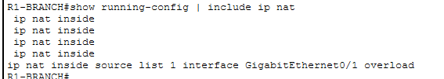 | 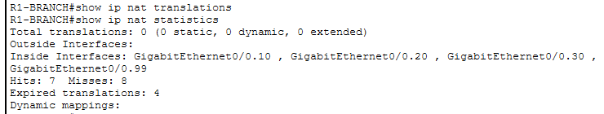
Screenshot 1 - Injected fault: ip nat outside is missing from the configuration. | Screenshot 2 - Diagnostic evidence: no outside interface and zero translations.
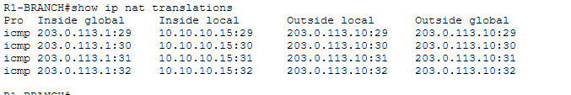
Screenshot 3 - Verification: fresh ICMP PAT translations are present after repair.
Evidence sequence: injected fault -> observed/diagnostic evidence -> restored operation.

