**CUSTOMER-CHURN ANALYSIS**


This document contains SQL queries generated to perform ad-hoc analysis of CUSTOMER CHURNERS.

LinkedIn: www.linkedin.com/in/deepanshi-saini-13a8a830a
Email: dpsaini026@gmail.com

1.Identify the top 5 churn
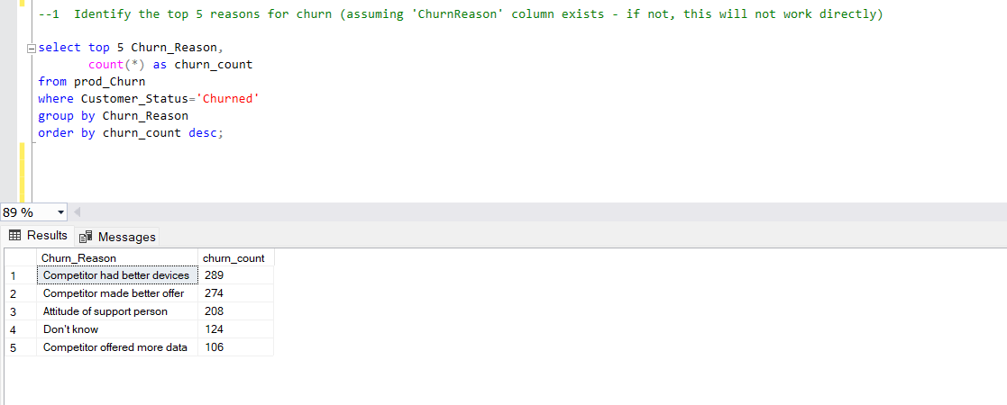

2.Ranking customers based on their total charges within each internet service type,highlighting churners with top 10 total charges.

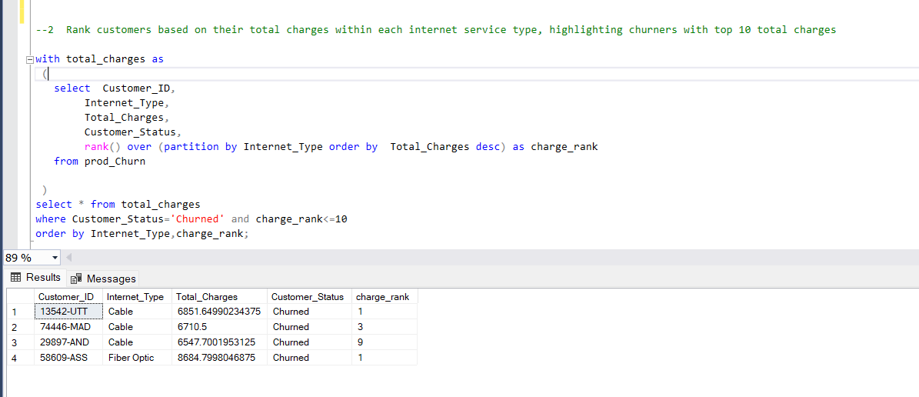

3.Monthly churn rate trend with a 3- month rolling average

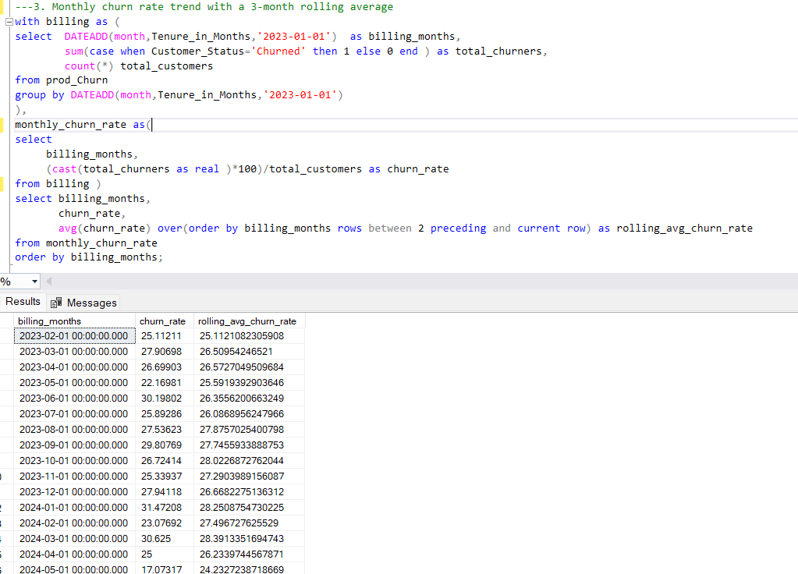

4. Ranking customers within each internet service type based on their tenure (longesr tenure first) and identifying churners.
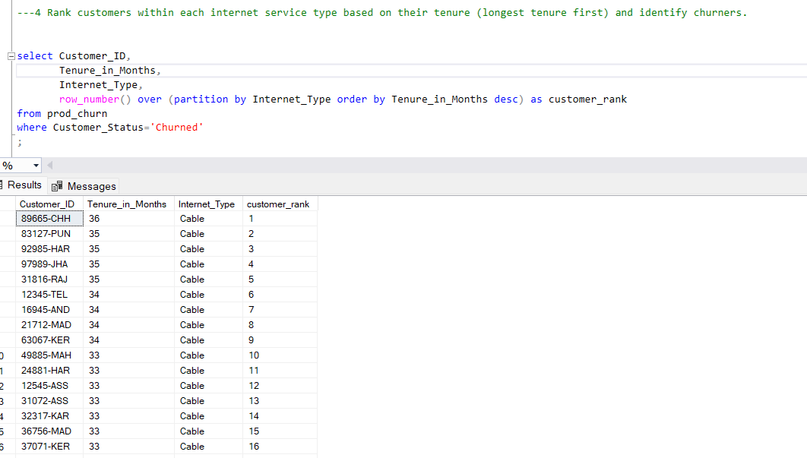

5. Identifying the top 5 most common combination of services among churned customers.

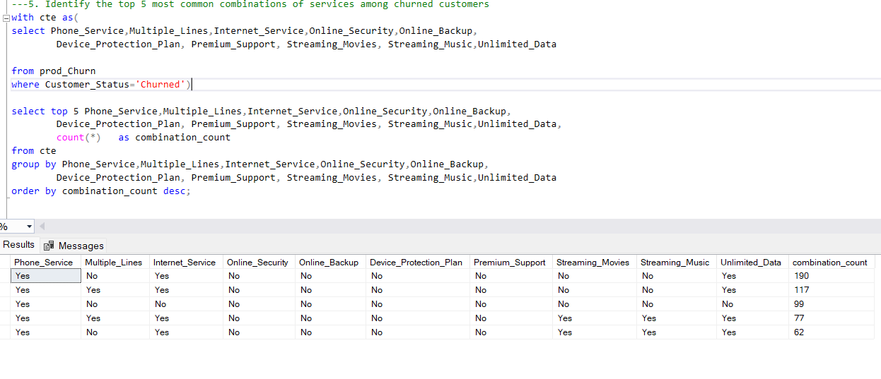

6.Calculate the churn rate for customers who have been with the company for less than 12
months ,between 12 and 24 months, and more than 24 months

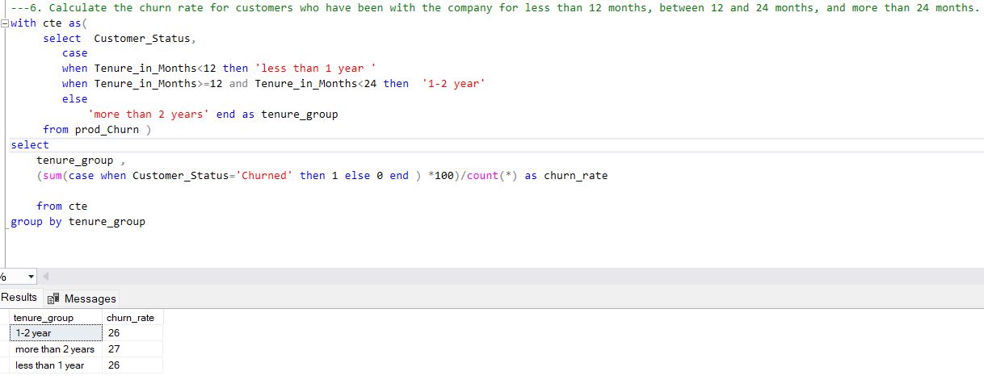
7.Churn rate compared to the average churn rate for customers with the same contact type.

