
Semester | T.E. Semester VI– SPCC
Subject | Software Engineering
Subject Professor In-charge | Prof. Pankaj Vanvari
Assisting Teachers | Prof. Pankaj Vanvari
Laboratory | M310B

Student Name | Deep Salunkhe
Roll Number | 21102A0014
TE Division | A

Title:
Linking different object files
Approach:

Note: I haved Linked C++ with C

- File Creation:
  - Started by creating a C++ source file named cpp.cpp
  - The C++ source file contained a basic function named displayMessage() which printed "Hello, world from cpp!"
- Object File Generation:
  - Compiled the C++ source file cpp.cpp into an object file named cpp.o using the g++ compiler command with the -c option.
  - Command used: g++ -c cpp.cpp -o cpp.o
- C File Creation:
  - Created a C source file named c.c to demonstrate calling the C++ function from C code.
  - In the C source file, declared the displayMessage() function using the extern keyword to inform the C compiler about the function's existence.
- Compilation:
  - Compiled the C source file c.c into an object file named c.o using the gcc compiler command with the -c option.
  - Command used: gcc -c c.c -o c.o
- Linking:
  - Linked the object files c.o and cpp.o together to create an executable named FinalLinked
  - Command used: g++ c.o cpp.o -o FinalLinked
- Execution:
  - Executed the FinalLinked executable to observe the output produced by calling the displayMessage() function defined in the C++ source file from the C code.

Implementation:

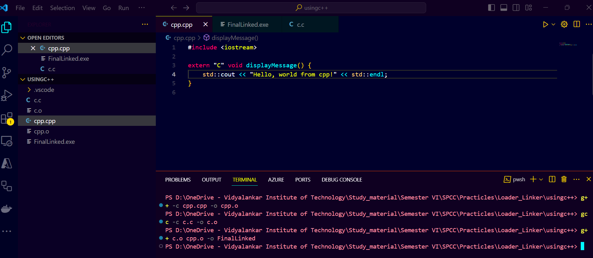

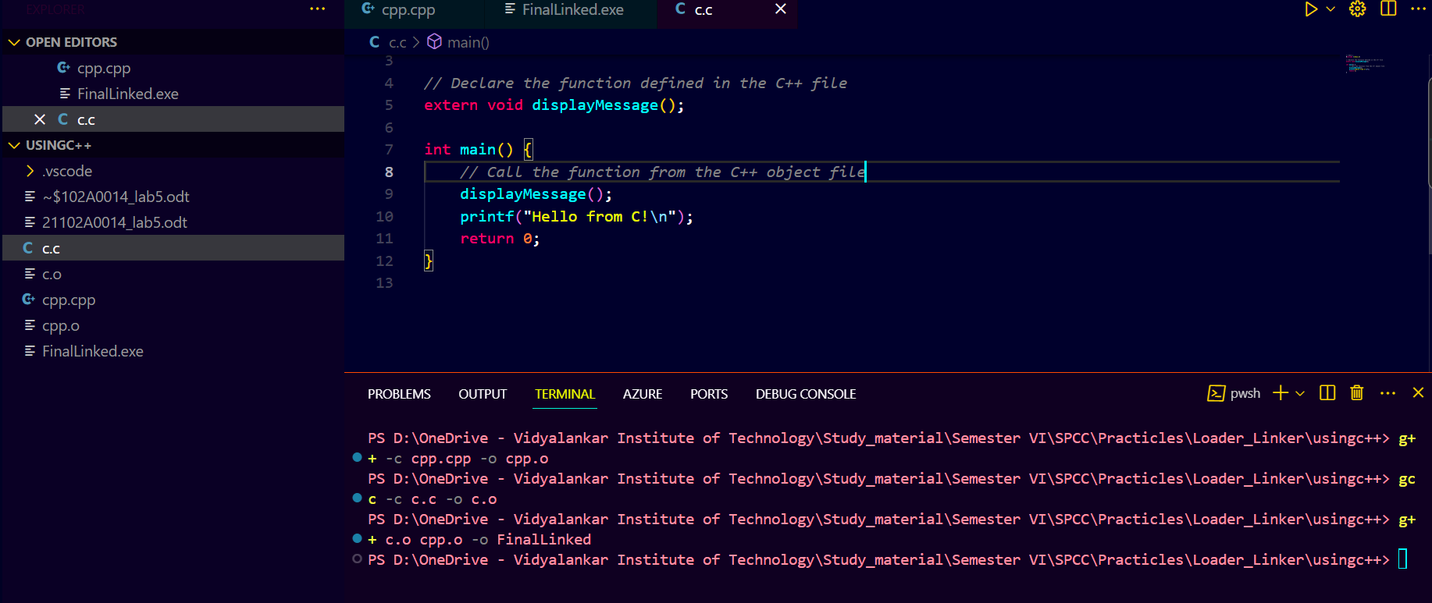
End Result:

