**Oct 12th tweaks:**

1. Timer in background work. (set timer in the navbar)
2. Service provider can make the custom timer (Non-case related timer)
3. Don’t send requests to the server for the table data once already loaded. Use redux.
4. Set the table Filter, sorter
5. Table pagination. Use the sample below:

Use the 3rd one in the picture for reference

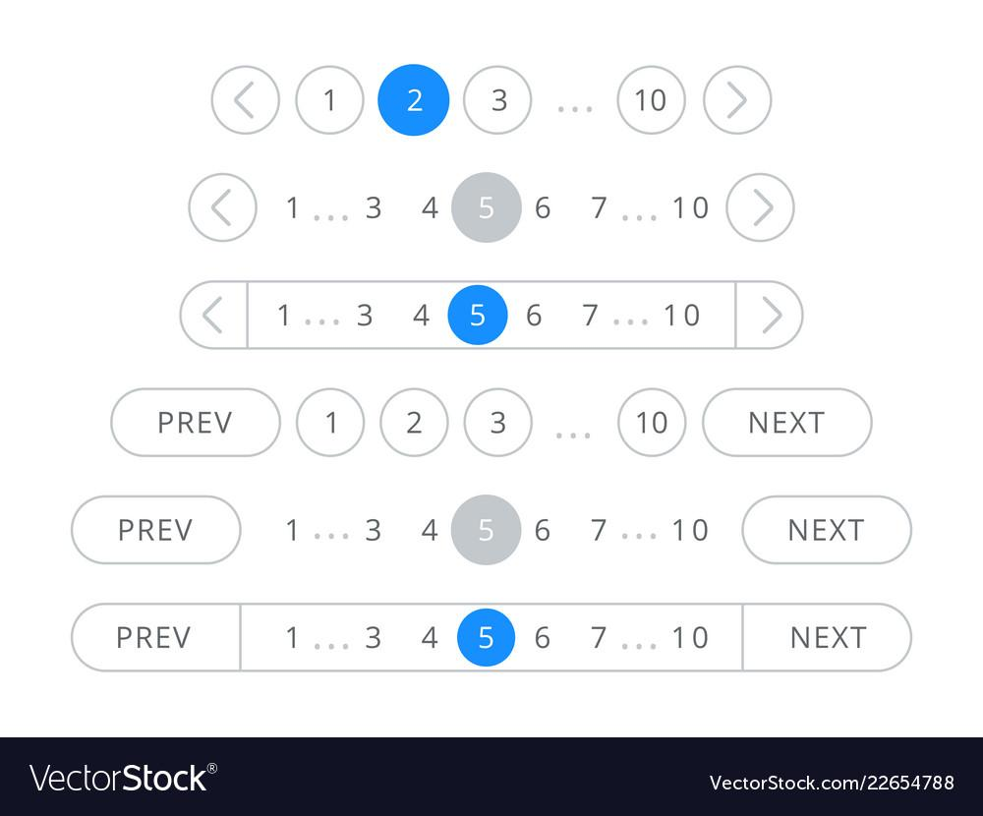

1. Recent data at first in the table list.
2. *Client company admin should upload their profile details either in the profile setup time or later on. Profile details could be either a text document or the video profile. (Needs research)*
3. Use a single component for the button, so that it could be used time and again in other components.
4. *Use the concept of Lazy Loading in imports. (Needs research)*
5. Make the profile page for the users details.
6. Use Toast notifications in for the confirmation.
7. Display the name of the employee, service providers or clients instead of email if it is available.
8. Setup profile picture option for the user registration.
9. *Check the personal number with the algorithm, refer to the reference articles sent by sir in the mail. (Needs research)*
10. Save button in the role management.
11. Setup menu for the default intake form for the clients.
12. Fix the commission rate for the services and the cases by superadmin.
13. *Set the date format according to the location of the client. (Needs research)*
14. Show the total number of cases forwarded by SA to the SP in case forwarding page.
15. Upload Related files for case request and proposal.