# PROJECT SUMMARY

An electronic payment system refers to the payment made from one bank account to another using electronic methods and forgoing the direct intervention of bank employees. It also refers to buying and selling of goods or services over the internet.

Over the past few years, the number of electronic systems in Nepal has grown significantly. Systems like E-sewa, Khalti, IMEpay, Prabhu Pay etc. were all introduced in Nepal in last 4-5 years. These payment systems provide many services of which Top-Up and general bill payment are popular among the users.

There are longer running electronic payment systems who provide the services around the world. Some of the famous ones are PayPal, PayTm, Stripe etc. PayPal has revolutionized online payment system. People no longer need to carry multiple debit/credit cards nor do they need to remember their bank details. In India, you no longer need to carry cash if you have mobile phone with PayTm installed on it.

The scope of online payment system is bigger than the image cast by the current players in Nepal. Taking PayTm as a reference, in a short amount of time PayTm has revolutionized the Indian online market. PayTm has been successful in gaining the trust of users by bringing the retailers to online payment system. PayTm has digitized the transactions and taken a step forward in the field of electronic payment. However, in Nepal, the services provided is not as diversified as it can be, and it doesn’t feel like it will be anytime soon.

Mitra Payment Private Limited’s primary aim is to show Nepalese people the untapped potential of digital payment system. We are a group of young likeminded enthusiasts who have come together to take digital payment system in Nepal to the next step. Mitra Payment Pvt. Ltd. is operated from Jhapa which already makes it different from the existing systems in Nepal.

# SERVICES SYSTEM PLANS TO OFFER

### QR code Payment

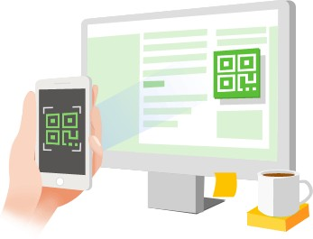

We want to make the process of payment easier and faster. QR codes can securely store data. The data in this includes the bank details, primarily the account number of the merchant. When a customer buys a product from a merchant, they can scan the QR code of the merchant and the money will be transferred from the user’s bank account to the merchant’s bank account.

Our system will allow the users to maintain multiple bank accounts from a single interface and as such, the users can decide which bank they want to pay from.

When a customer goes for shopping in a nearby mart, s/he can scan the QR code of the merchant, type in the amount to be paid, the customer will receive an OTP and s/he can confirm the process. Yes, the transaction is done there and then.

### Control over multiple bank accounts from a single interface

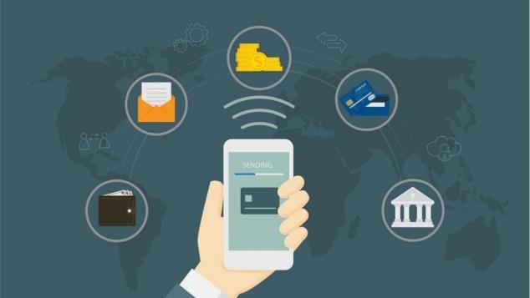

Our users can have account in multiple banks. Right now, it is very tedious for the public to manage their account in multiple banks. We don’t have any system that allows to manage our accounts in multiple banks. Until now, the only possible way is to visit each bank and manage the accounts manually.

With our system, we allow our users to add as many accounts as they want to the system. They can transfer funds from one bank to another, they can do online transactions from any bank they want. The process of managing account in multiple banks will become so much easier with the introduction of our system.

As a result, the customer does not need to travel from one place to another for financial transactions. They can do it with a tap from their mobile phones.

### Automated Business Service

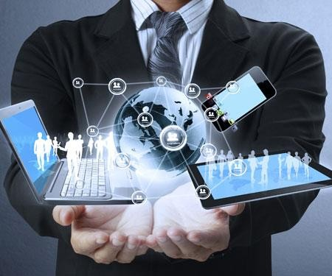

Our system is also designed to act as a reminder to the users. A user may have to pay for a service at a regular interval. For example, paying monthly for insurance, paying bank loans monthly etc. Our system will remind the user that payment must be made for a certain service.

Adding to that, the user can set the system to automatically pay for the services. The system will ask the user to confirm the payment and once confirmed the system will do everything on its own.

### Broader Range in Utility Bill Payment:

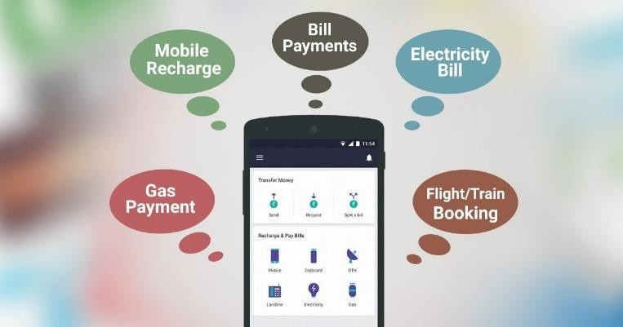

Mitra Payment like its competitors will allow the users to pay for various utilities. You can recharge your mobile phone, pay for electricity, pay for water all from your smartphone.

In addition to the basic utilities bill payment, our system will allow the user to book and pay for flights. Similarly, they can book hotel rooms and pay for the booked rooms in advance.

We want to make doing these simple things easier and quicker. Not all the things have been mentioned here and the system may include wider horizons of bill payments.