**DELIVERABLE 3**

**UML CLASS DIAGRAM**

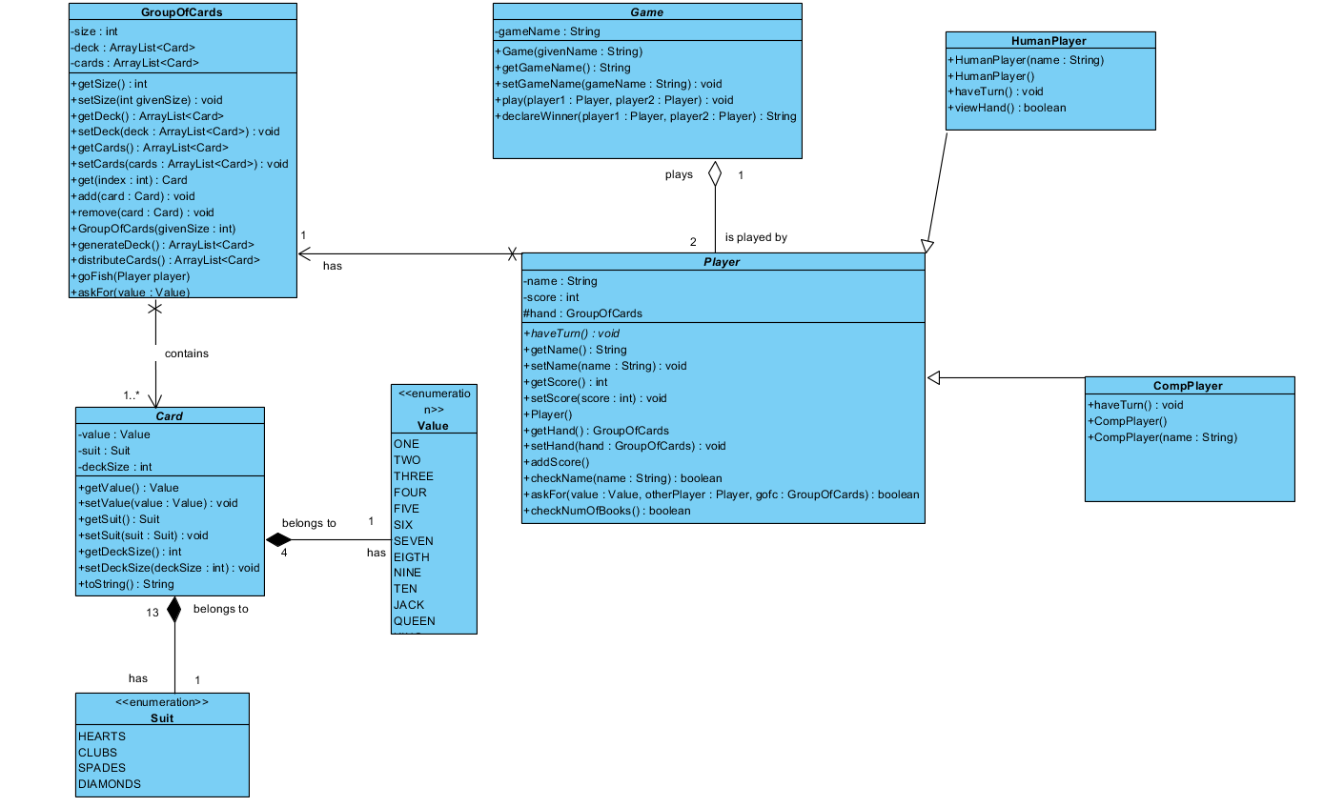

**Source code repository link:**

This links takes to the source code of my repository which has all the classes. The UML and document file of all other deliverable are stored in the main directory of the repository.

<https://github.com/deepsd13/Project/tree/master/src/ca/sheridancollege/project>

**JUnit test code repository link:**

This link takes to the test folder of the repository which includes the JUnit test classes.

<https://github.com/deepsd13/Project/tree/master/test/ca/sheridancollege/project>

Test Results Report:

For my tests I have also done tests for methods which are not use cases so for them I have wrote ‘N/A’ in the test report. Also some of my use cases did not have alternate path so I have not implemented test methods for them.

|  |  |  |  |
| --- | --- | --- | --- |
| REQUIREMENT | USE CASE | TEST METHOD  (CLASSNAME.METHODNAME) | STATUS(DATE) |
| Player could ask for a card | Ask for a card | PlayerTest.testAskForGood() | Pass(August 15,2019) |
| Player could ask for a card | Ask for a card | PlayerTest.testAskForBad() | Pass(August 15,2019) |
| Check number of books | N/A | PlayerTest.testCheckNumBooksGood() | Pass(August 15,2019) |
| Check number of books | N/A | PlayerTest.testCheckNumBooksBad() | Pass(August 15,2019) |
| User Player could register name | Register Name | PlayerTest.testCheckNameGood() | Pass(August 15,2019) |
| User Player could register name | Register Name | PlayerTest.testCheckNameBad() | Pass(August 15,2019) |
| Player could register name | Register Name | PlayerTest.testCheckNameBoundary() | Pass(August 15,2019) |
| Checking if two cards are equal | N/A | CardTest.testEqualsGood() | Pass(August 15,2019) |
| Checking if two cards are equal | N/A | CardTest.testEqualsBad() | Pass(August 15,2019) |
| User Player can see their hand(cards) | View hand | HumanPlayerTest.testViewHandGood() | Pass(August 15,2019) |
| User Player can see their hand(cards) | View hand | HumanPlayerTest.testViewHandBad() | Pass(August 15,2019) |