CUSTOMER LIFETIME VALUE &
CHURN INTELLIGENCE SYSTEM
Architecture • Data/API Documentation • Test Results • Individual Reflection
Submission support pack | Updated 20 October 2026

1. Architecture diagram
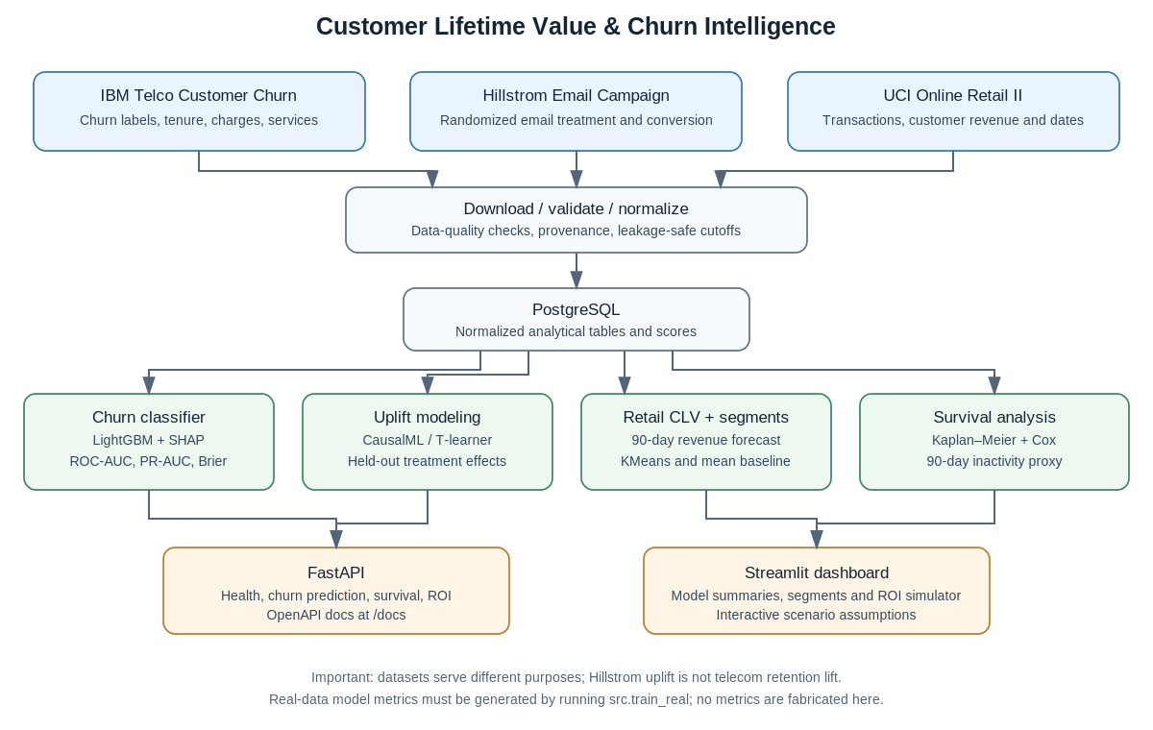
The pipeline keeps three dataset purposes separate: IBM Telco for churn prediction, Hillstrom for randomized email-campaign uplift, and UCI Online Retail II for revenue forecasting and purchase-inactivity survival analysis. Hillstrom email uplift must not be presented as a causal estimate of telecom retention lift.

2. Dataset and data-flow summary
Dataset | Purpose | Main outputs | Limitation
IBM Telco Customer Churn | Churn classification, EDA, telecom segments | Churn probability, held-out metrics, SHAP/fallback importance | Cross-sectional; no complaint log or longitudinal usage history
Hillstrom MineThatData | Randomized email treatment/control uplift | Predicted uplift, held-out uplift summaries, campaign ROI scenarios | Email conversion response is not telecom retention effect
UCI Online Retail II | Customer value, revenue trends, segmentation, survival proxy | 90-day revenue forecast, segments, Kaplan–Meier/Cox outputs | Inactivity is a proxy, not confirmed cancellation; CLV uses an assumed margin
Raw public data is downloaded at runtime rather than redistributed. Check source terms before sharing raw datasets.

3. API documentation
Local Docker base URL: http://localhost:8000 | Interactive OpenAPI: http://localhost:8000/docs
Endpoint | Purpose | Important interpretation
GET /health | API process health check | Does not alone prove database/model readiness
POST /predict/churn | Score a customer from supported customer features | Risk band is a heuristic, not a validated intervention policy
POST /simulate/roi | Calculate scenario cost, incremental saves, value, net benefit and ROI | Incremental lift is an assumption unless validated experimentally
POST /simulate/uplift-roi | Estimate campaign economics for top predicted-uplift customers | Hillstrom response estimates do not transfer automatically to telecom
GET /customers/{customer_id}/survival | Return survival estimates for a trained retail cohort customer | Uses purchase-inactivity proxy and requires sufficient follow-up
Data contract and PostgreSQL table details are documented in docs/API_AND_DATA.md, docs/DATA_DICTIONARY.md, and docs/ARCHITECTURE_AND_DATA_API_SUBMISSION_GUIDE.md.

4. Test results and model performance
Historical preparation-environment test result: 18 passed, 1 skipped, 6 warnings. The survival integration test is now mandatory and must be rerun inside the rebuilt Docker container.
Check | Result | Qualification
Python compilation | Passed | `python -m compileall -q .`
Unit tests | 18 passed | `python -m pytest -q`
Survival integration | Skipped | lifelines unavailable in preparation environment
Compose YAML / presentation / ZIP | Syntax or structure checks passed | Not equivalent to live Docker deployment
Public data download and real-data training | Not verified | External host resolution was unavailable; no measured real-data metrics
PostgreSQL, API and Streamlit end-to-end | Not verified | Must run after Docker startup on a machine with internet access
No real-data accuracy or performance numbers are reported because the datasets were not downloaded and trained in this environment. After a successful run, use artifacts/telco_evaluation.json (ROC-AUC, PR-AUC, precision, recall, F1, Brier and baseline comparison), artifacts/retail_clv_evaluation.json (forecast metrics versus mean baseline), artifacts/hillstrom_uplift_evaluation.json (held-out uplift summaries), and artifacts/retail_km_median_survival.json (survival metrics and diagnostics). Do not substitute synthetic unit-test metrics for public-dataset performance.

5. Individual reflection — complete one copy per intern
Each intern must personalize their own reflection. The following scaffold is intentionally a template; it does not assert that a particular intern completed any task.

Intern name and role
[Name] — [workstream / role] — [dates]

What I owned
I was responsible for [specific module or deliverable]. My individual contributions were [specific files, tests, analyses or documentation]. Work completed collaboratively was [describe].

What I learned
The main concepts I learned were [concepts]. I applied them by [specific activity]. One concrete example was [problem] and the lesson was [lesson].

Challenge and response
The challenge was [issue]. I investigated it by [steps], chose [approach] because [reason], and observed [measured result or honest status].

Evidence
Files/modules: [paths]. Tests/experiment: [command or experiment]. Measured result: [metric and setup, or “not yet measured on real data”].

What I would change
Next time I would [improvement] and verify it using [test or acceptance criterion].

Limitations and responsible use
One limitation was [limitation] and it matters because [impact]. I communicated or addressed it by [action].

Next steps
I would next [actions]. I would consider the work complete when [measurable criterion].

6. Commands to reproduce checks
- cp .env.example .env (then set a strong database password)
- docker compose up --build -d
- docker compose exec app python -m src.datasets --dataset all
- docker compose exec app python -m src.train_real
- docker compose exec app python -m pytest -q
- docker compose exec app python scripts/smoke_test.py
Review docs/TEST_RESULTS.md and docs/IMPLEMENTATION_STATUS.md for detailed acceptance status and limitations.

