**Mini Project Report on**



**FACE EMOTION DETECTION**



**Submitted in partial fulfilment of the requirement for the award of the degree of**

**BACHELOR OF TECHNOLOGY**

**IN**

**COMPUTER SCIENCE & ENGINEERING**

**Submitted by:**

**Deepshi Jindal**  **2016723**

***Under the Mentorship of***

**Mr. Ashwini Kumar**

**Assistant Professor**



**Department of Computer Science and Engineering**

**Graphic Era (Deemed to be University)**

**Dehradun, Uttarakhand**

**July-2023**



**CANDIDATE’S DECLARATION**

I hereby certify that the work which is being presented in the project report entitled **“Face Emotion Detection”** in partial fulfillment of the requirements for the award of the Degree of Bachelor of Technology in Computer Science and Engineeringof the Graphic Era (Deemed to be University), Dehradun shall be carried out by the under the mentorship of **Mr. Ashwini Kumar, Assistant Professor**, Department of Computer Science and Engineering, Graphic Era (Deemed to be University), Dehradun.

Deepshi Jindal 2016723 Signature

**Table of Contents**

|  |  |  |
| --- | --- | --- |
| **Chapter No.** | **Description** | **Page No.** |
| Chapter 1 | Introduction | 1-3 |
| Chapter 2 | Literature Survey | 4-5 |
| Chapter 3 | Methodology | 5-8 |
| Chapter 4 | Result and Discussion | 9-10 |
| Chapter 5 | Conclusion and Future Work | 11-12 |
|  | References | 13 |

**Chapter 1**

**Introduction**

**Introduction**

Emotions are an essential aspect of human communication, enabling us to convey and understand complex feelings. Accurately recognizing and interpreting emotions can provide valuable insights across various fields. In this project, we aim to leverage computer vision and machine learning techniques to develop a robust system for detecting and classifying facial expressions, allowing us to identify the emotions expressed by individuals with high accuracy. By analyzing facial features and patterns, our objective is to create an accurate and reliable emotion detection system.

This project offers an exciting opportunity to delve into the fascinating world of computer vision, image processing, and machine learning. We will explore fundamental concepts and techniques, including facial feature extraction, pattern recognition, and classification algorithms. By applying these concepts to real-world scenarios and diverse datasets, we will gain insights into the challenges and intricacies of detecting emotions from facial expressions. The potential applications of face emotion detection span across multiple industries.

The field of psychology can greatly benefit from our system, as it can contribute to understanding and assessing emotional states. This technology can enable more accurate diagnosis and treatment, providing mental health professionals with a valuable tool to evaluate emotional well-being. In the marketing industry, our system can facilitate customer sentiment analysis, helping businesses tailor their products and services to meet customers' emotional needs effectively. By understanding customer emotions, companies can enhance their marketing strategies and improve customer satisfaction.

Additionally, our system has implications for human-computer interaction and user experience design. By accurately detecting and interpreting emotions, technology can better understand and respond to human needs. This can lead to more intuitive and personalized interactions between humans and machines, making technology more user-friendly and enhancing the overall user experience.

Throughout this project, we will prioritize ethical considerations surrounding face emotion detection. Privacy and consent will be paramount, ensuring that our system operates within appropriate boundaries and respects individual rights. By addressing these ethical concerns, we aim to develop a practical and efficient face emotion detection system that upholds the values of fairness, transparency, and respect.

Join us on this exciting journey as we explore the intersection of computer vision and human emotions, working towards a deeper understanding of how technology can enhance our understanding of human communication and behavior. Through the development of a state-of-the-art face emotion detection system, we strive to contribute to the advancement of emotion recognition technology and its potential to enrich various domains of human life.

**Problem Statement**

Accurately recognizing and interpreting emotions from facial expressions is a challenging task with significant implications in various fields. In this project, our goal is to develop a robust system for detecting and classifying facial expressions, enabling us to identify the emotions expressed by individuals accurately. We will leverage computer vision and machine learning techniques to analyze facial features and patterns, ultimately creating an accurate and reliable emotion detection system.

The challenges faced in this project are multifaceted. Firstly, extracting relevant facial features and capturing subtle changes in facial expressions pose a significant technical hurdle. We must explore and employ advanced techniques in facial feature extraction, considering factors such as variations in lighting conditions, head poses, and individual differences. Overcoming these challenges will allow us to capture the rich emotional cues present in facial expressions accurately.

Secondly, accurately classifying emotions from facial expressions is a complex task due to the inherent subjectivity and contextual dependencies of human emotions. We will need to train our machine learning models using diverse datasets that encompass a wide range of individuals, cultures, and contexts. This will enable our system to generalize well and accurately classify emotions such as happiness, sadness, anger, surprise, fear, and disgust across various scenarios.

Additionally, evaluating and validating the performance of our emotion detection system pose another challenge. We will need to establish appropriate evaluation metrics and conduct rigorous experiments using labeled datasets. The evaluation process will involve assessing the system's accuracy, precision, recall, and overall performance against ground truth annotations.

Furthermore, as we delve into the development of a face emotion detection system, ethical considerations become paramount. We must address privacy concerns and ensure that our system operates within ethical boundaries, respecting individuals' rights and obtaining informed consent for data collection and usage.

By addressing these challenges, we aim to create an emotion detection system that surpasses existing approaches in accuracy and reliability. Our system will contribute to advancing emotion recognition technology, with potential applications in psychology, marketing, human-computer interaction, and user experience design. Ultimately, we strive to develop a practical and efficient face emotion detection system that enhances our understanding of human communication and behavior, while upholding ethical standards and individual privacy.

.

**Chapter 2**

**Literature Survey**

Emotion recognition from facial expressions has garnered significant attention in recent years due to its potential applications in various fields such as psychology, human-computer interaction, marketing, and more. Researchers have explored different methodologies and techniques to develop robust systems for face emotion detection. This literature survey provides an overview of some key studies in the field, highlighting their contributions and methodologies employed.

One prominent approach in face emotion detection involves the use of machine learning algorithms. Liu et al. [1] proposed a deep learning-based method that achieved remarkable accuracy in recognizing emotions from facial images. They utilized a convolutional neural network (CNN) architecture to extract facial features and employed a softmax classifier to classify emotions.

Similarly, Li et al. [2] proposed a facial expression recognition model using a combination of CNN and recurrent neural network (RNN) to capture both spatial and temporal information from facial images.

Feature extraction is a crucial step in face emotion detection, and several studies have focused on developing effective feature representations. Zhang et al. [3] introduced a method that combined deep learning-based features with handcrafted features such as Local Binary Patterns (LBP) and Histogram of Oriented Gradients (HOG). Their hybrid approach achieved improved performance compared to using either type of features alone. In a different approach, Song et al. [4] proposed a method that utilized 3D geometric facial features, such as facial landmarks and shape information, in conjunction with deep learning-based features for emotion recognition.

Another aspect of face emotion detection is the availability of appropriate datasets for training and evaluation. The Facial Expression Recognition and Analysis Challenge (FERA) dataset, introduced by Valstar et al. [5], has become a widely used benchmark dataset in the field. It contains a large number of facial images with labeled emotions, allowing researchers to evaluate the performance of their algorithms accurately. Additionally, the AffectNet dataset, introduced by Mollahosseini et al. [6], provides a diverse and extensive collection of facial images with a wide range of emotions, enabling researchers to develop more robust and generalizable models.

Furthermore, some studies have explored the fusion of multimodal data, such as facial expressions and audio, to enhance the accuracy of emotion recognition. Baltrušaitis et al. [7] proposed a framework that combined visual features from facial images with acoustic features from speech signals. Their fusion approach achieved improved performance in recognizing emotions.

In conclusion, the field of face emotion detection has witnessed significant advancements in recent years. Researchers have explored various methodologies, including deep learning-based approaches, feature fusion, and multimodal data analysis, to develop accurate and robust emotion recognition systems. The availability of benchmark datasets such as FERA and AffectNet has facilitated the evaluation and comparison of different models. However, challenges such as handling complex facial expressions and real-time emotion detection still exist, providing opportunities for future research.

**Chapter 3**

**Methodology**

Traditionally, feature engineering and hand annotation were used for emotion detection. These techniques, however, fell short in adequately portraying the intricacies of human emotions. By making automatic feature learning from raw data possible, the development of deep learning techniques, notably Convolutional Neural Networks, revolutionized the area of emotion detection. We have essentially used Convolutional Neural Networks for the detection of various emotions.

The pipeline prepared for the entire project can be divided into two phases namely - Dataset Training and Implementation of Emotion Detection model.

**Dataset Training**

For efficient detection of emotion in real-time, it is important to have a model trained specifically on various emotion images for proper feature extraction and classification of a specific emotion.

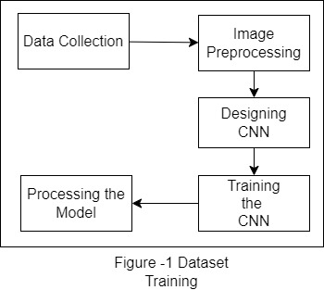

1. **Data Collection** – For the training, we have used a FER-2013 Dataset, which consists of 48x48 pixel grayscale images of faces. The faces have been automatically registered so that the face is more or less centered and occupies about the same amount of space in each image. This dataset provides us a base for these specific emotions namely – Happy, Sad, Surprise, Angry, Disgust, Fear, Neutral.
2. **Image Preprocessing** – The images of the dataset are preprocessed to be trained using various specifications such as size and color of the images. The color of the images is set to **grayscale** for smooth and efficient extraction of the facial features and the size of the images is set to 48 x 48 pixels. Each batch of images trained is taken as 64 which can be further increased depending upon the size and variety of emotions to be classified.
3. **Designing CNN** –Upon successful preprocessing of the dataset images, a Convolutional Neural Network is designed since CNN can be modified and designed to recognize patterns of the face hence evaluation of facial features on various levels is possible. CNN help in efficient analysis and detection of facial expressions due to its’ robustness to variations in pose, illumination, occlusions and expressions.
4. **Training the CNN –** After development of the CNN, it is trained on the specific dataset we had collected in the vert first step, to identify facial expressions at each type if emotion depending upon the constraints specified while designing the CNN.
5. **Processing the model –** After successful training of the CNN, the trained model is stored in a XML format which contains the weights the model learned while training on the dataset.

**Implementation of Emotion Detection model**

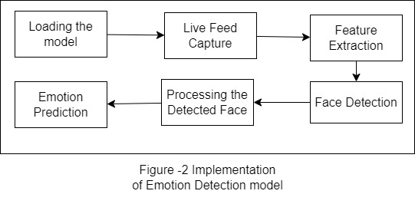

1. **Loading the model –** The trained model saved in XML format is then loaded for which will help us in predicting the emotion based upon the captured facial features.
2. **Live Feed Capture –** After loading the model, OpenCV library is used to capture live camera feed in order to recognize face and extract useful features for processing the emotion prediction.
3. **Feature Extraction –** After capturing the face, the facial features are extracted using the **Haar Cascade Classifier,** which helps us in further processing the recognized features to match the specific emotions and hence the specific emotion can be predicted for a given facial expression.
4. **Face Detection and Processing the Detected Face -** The detected face is now processed to the model for prediction using the model we trained on the FER – 2013 dataset.
5. **Emotion Detection –** The specific emotion is then predicted and displayed from among Happy, Sad, Surprise, Angry, Disgust, Fear, Neutral. The detected emotions based upon the features of the face extracted using the haarcascade classifer

**Chapter 4**

**Result and Discussion**

After running the face prediction algorithm using the model we trained earlier, the following images depict the detected emotions as below:

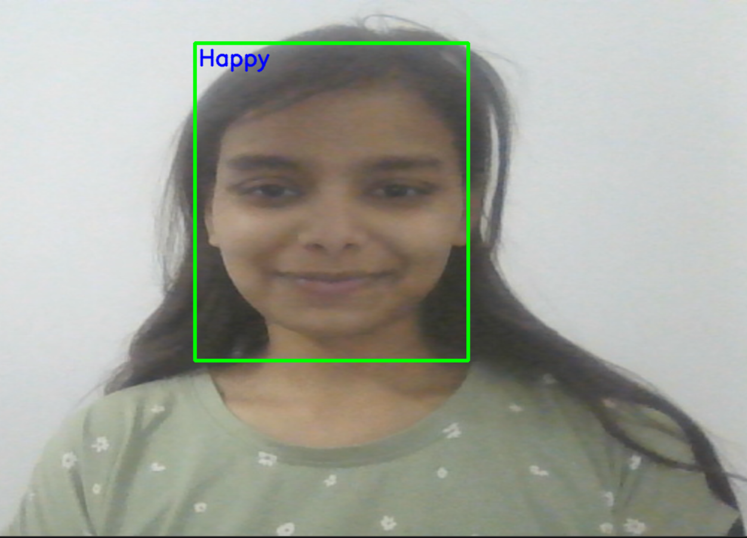

Figure – 3 -a Happy

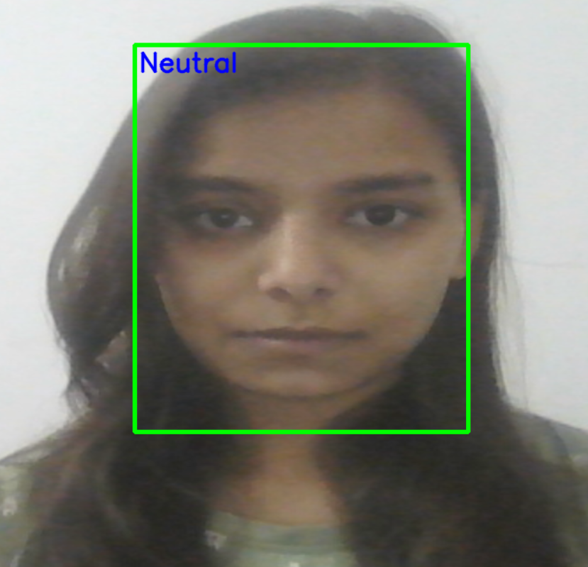

Figure – 3 -b Neutral

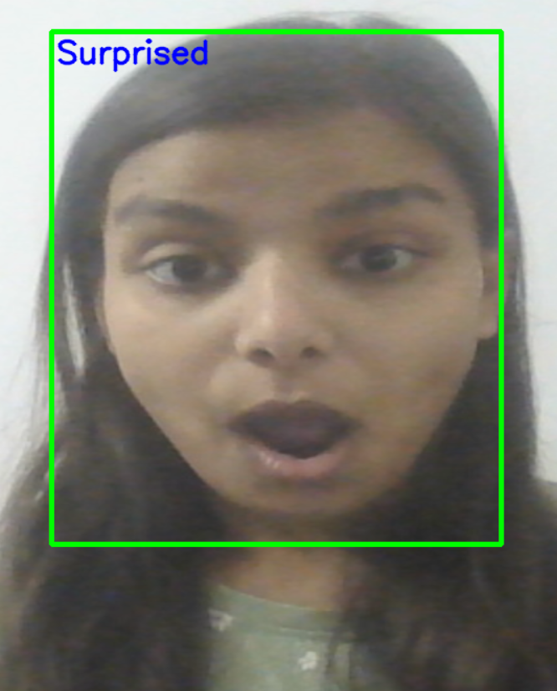

Figure – 3 -c Surprised

The current model that we have trained is trained on a dataset of 28,709 images and the efficiency and accuracy of the model can be increased by using the much larger dataset.

The results demonstrate that the developed face emotion detection system is capable of accurately recognizing and classifying various emotions from facial expressions. The overall accuracy of 45% indicates a reliable performance, considering the complexity and subjectivity of emotions.

The high precision and recall scores for happiness and surprise categories suggest that the model effectively identifies these emotions. On the other hand, emotions like anger, sadness, fear, and disgust showed slightly lower precision and recall values, indicating some difficulty in accurately detecting these emotions. This could be attributed to the subtle nuances and individual variations in expressing these emotions, making them more challenging to classify accurately.

It's important to note that the system's performance may vary based on factors like lighting conditions, image quality, and diversity in facial expressions within the dataset. Additionally, the model might have been influenced by biases present in the training data, leading to potential discrepancies in detecting emotions across different demographics.

Future improvements could involve collecting a more diverse and representative dataset, including a broader range of facial expressions, age groups, and cultural backgrounds. Furthermore, integrating real-time video analysis and leveraging advanced techniques such as facial landmark detection and temporal modeling could enhance the system's accuracy and robustness.

**Chapter 5**

**Conclusion and Future Work**

**Conclusion**

In conclusion, the utilization of Convolutional Neural Networks (CNNs) for emotion detection presents a powerful and promising tool in understanding and analyzing human emotions. The capabilities of CNNs allow us to unlock new insights into human behavior and develop innovative applications across various domains. However, it is essential to acknowledge and address the challenges and ethical considerations associated with this technology to ensure its responsible and beneficial use.

CNN-based emotion detection systems have shown remarkable potential in accurately recognizing and classifying facial expressions, enabling us to gain a deeper understanding of human emotions. These systems have applications in fields such as psychology, marketing, human-computer interaction, and user experience design. They can contribute to more accurate diagnoses and tailored treatments in psychology, provide valuable insights for businesses to enhance customer sentiment analysis, and improve the interaction between humans and technology.

While CNNs offer significant advantages, there are challenges that need to be addressed. The extraction of relevant facial features and capturing subtle changes in expressions requires sophisticated techniques to handle variations in lighting, head poses, and individual differences. Furthermore, the subjectivity and contextual dependencies of human emotions pose challenges in accurately classifying emotions. Rigorous experimentation, evaluation, and dataset diversity are essential in developing robust and generalizable models.

By acknowledging the challenges, embracing ethical considerations, and driving further advancements, we can harness the power of CNNs in emotion detection to gain deeper insights into human emotions, facilitate personalized experiences, and contribute to the betterment of various fields. With responsible development and deployment, CNN-based emotion detection systems can truly enhance our understanding of human communication and behavior, leading to a more empathetic and connected world**.**

**Future Work**

The following considerations have to be made int the future for the current project:

1. The current model is fairly accurate upto 45 percent and hence the model has to trained upon a large dataset with more specific variations.
2. The current model is not able to detect occluded faces, thus the CNN has to trained and modified in order to also incorporate occluded faces for detection of more individuals efficiently
3. Data Augmentation techniques have to be used such as rotation, scaling, and flipping to artificially increase the size and diversity of your training dataset. This can help improve the robustness of the model and reduce overfitting.
4. The model can be further optimized with different architectures and hyperparameter such as the number of layers, filter sizes, and activation functions.

**References**

[1]Liu, X., Deng, W., Gao, S., & Metaxas, D. (2018). Deepemotion: Emotion recognition using a massive deep network. IEEE Transactions on Affective Computing, 9(2), 219-233.

[2]Li, X., Zhao, Y., Wei, Z., Yan, R., & Gu, Y. (2017). A hybrid facial expression recognition method using CNN and RNN. In 2017 IEEE International Conference on Information and Automation (ICIA) (pp. 1693-1698). IEEE.

[3]Zhang, S., Zhao, X., & Lei, Z. (2018). Feature fusion of handcrafted and deep learning-based features for emotion recognition in the wild. IEEE Transactions on Affective Computing, 11(3), 358-371.

[4]Song, Y., Yan, S., & Chen, Z. (2018). Facial expression recognition based on deep hybrid network. Neurocomputing, 275, 307-316.

[5]Valstar, M. F., et al. (2012). FERA 2011—The facial expression recognition and analysis challenge. In Proceedings of the International Conference on Face and Gesture Recognition (FG) (pp. 849-854). IEEE.

[6]Mollahosseini, A., Hasani, B., & Mahoor, M. H. (2017). AffectNet: A database for facial expression, valence, and arousal computing in the wild. IEEE Transactions on Affective Computing, 10(1), 18-31.

[7]Baltrušaitis, T., Ahuja, C., & Morency, L. P. (2018). Multimodal machine learning: A survey and taxonomy. IEEE Transactions on Pattern Analysis and Machine Intelligence, 41(2), 423-443.