Ideation Phase
Define the Problem Statements

Date | 31 January 2025
Team ID:
Project Name | StaffSync - Modern Human Resource Management Solution
Maximum Marks | 2 Marks

Customer Problem Statement Template:
To define the core problems HR personnel, managers, and employees face while handling HR processes manually, and use those insights to guide the development of StaffSync.
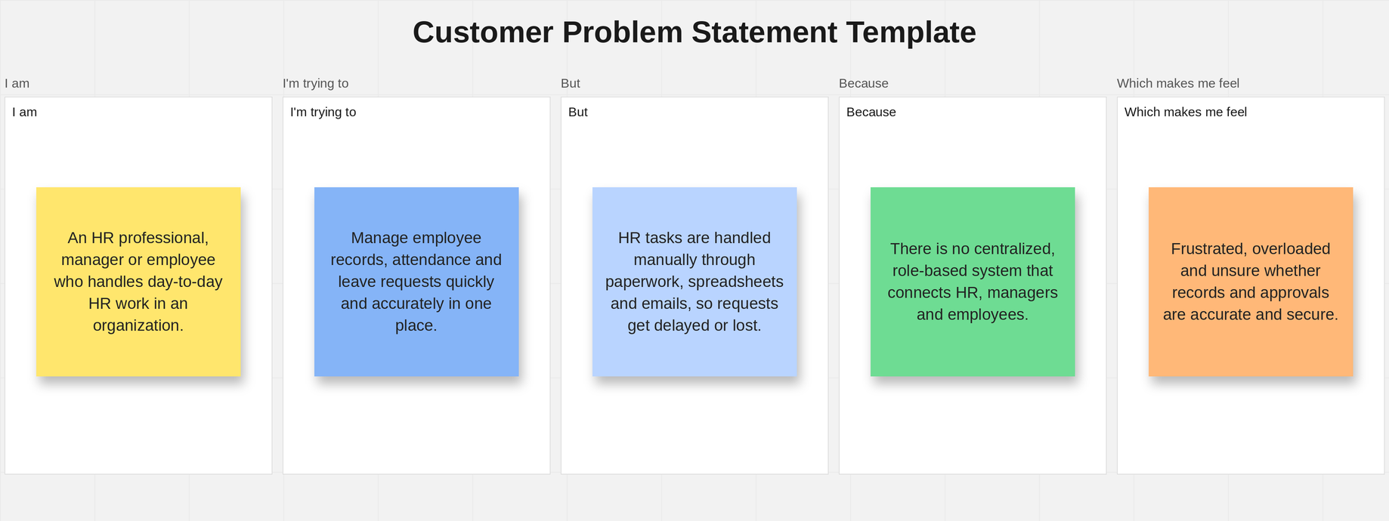
Reference: https://miro.com/templates/customer-problem-statement/

Problem Statement (PS) | I am (Customer) | I’m trying to | But | Because | Which makes me feel
PS-1 | HR personnel | manage employee records, track attendance and post announcements efficiently | employee data and attendance are scattered across spreadsheets and paper files | there is no centralized system to store, update and monitor this information | overwhelmed and worried about errors in records and payroll.
PS-2 | an employee | apply for leave, mark my attendance and check my leave status online | I have to submit requests through emails or paperwork and never know when they are approved | there is no transparent system that shows the status of my requests and updates | frustrated, uninformed and uncertain about my leave.
PS-3 | a manager | review my team’s leave requests and manage training programs | requests reach me late and I lack a clear view of my team’s attendance | there is no role-specific dashboard that brings team leave, attendance and training together | pressured and unable to plan my team’s workload.

