Ideation Phase
Empathize & Discover

Date | 31 January 2025
Team ID
Project Name | StaffSync - Modern Human Resource Management Solution
Maximum Marks | 4 Marks

Empathy Map Canvas:
Understand the needs, frustrations, and behaviors of HR personnel, managers, and employees who need to manage employee records, attendance, leave requests, and announcements efficiently through a platform like StaffSync.
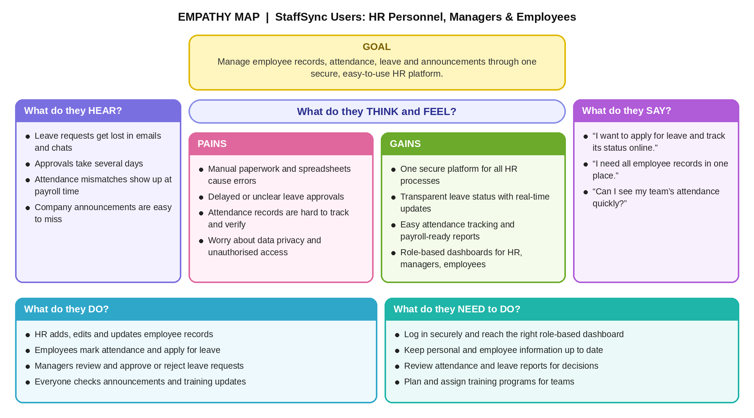

Reference: https://www.mural.co/templates/empathy-map-canvas

