Project Design Phase-II
Data Flow Diagram & User Stories
Date | 26-05-2025
Team ID
Project Name | StaffSync - Modern Human Resource Management Solution
Maximum Marks | 4 Marks
Data Flow Diagrams:
A Data Flow Diagram (DFD) illustrates how data moves within the StaffSync platform. It captures how users (HR personnel, managers and employees) interact with the system, how information flows between different components, and where the data is stored.
The diagram on the next page shows the Level 0 DFD of StaffSync. The three external entities (HR, Manager and Employee) interact with six processes that match the backend modules: User Authentication (1), Employee Management (2), Attendance Management (3), Leave Management (4), Announcement Management (5) and Training Management (6). Each process reads and writes its own MongoDB collection: Users (D1), Employees (D2), Attendance (D3), Leave Requests (D4), Announcements (D5) and Training Programs (D6).
After login, the system issues a JWT token and opens the dashboard for the user's role, so every later flow is limited to what that role is allowed to do (role-based access control).

Example: DFD Level 0 (Industry Standard) - StaffSync
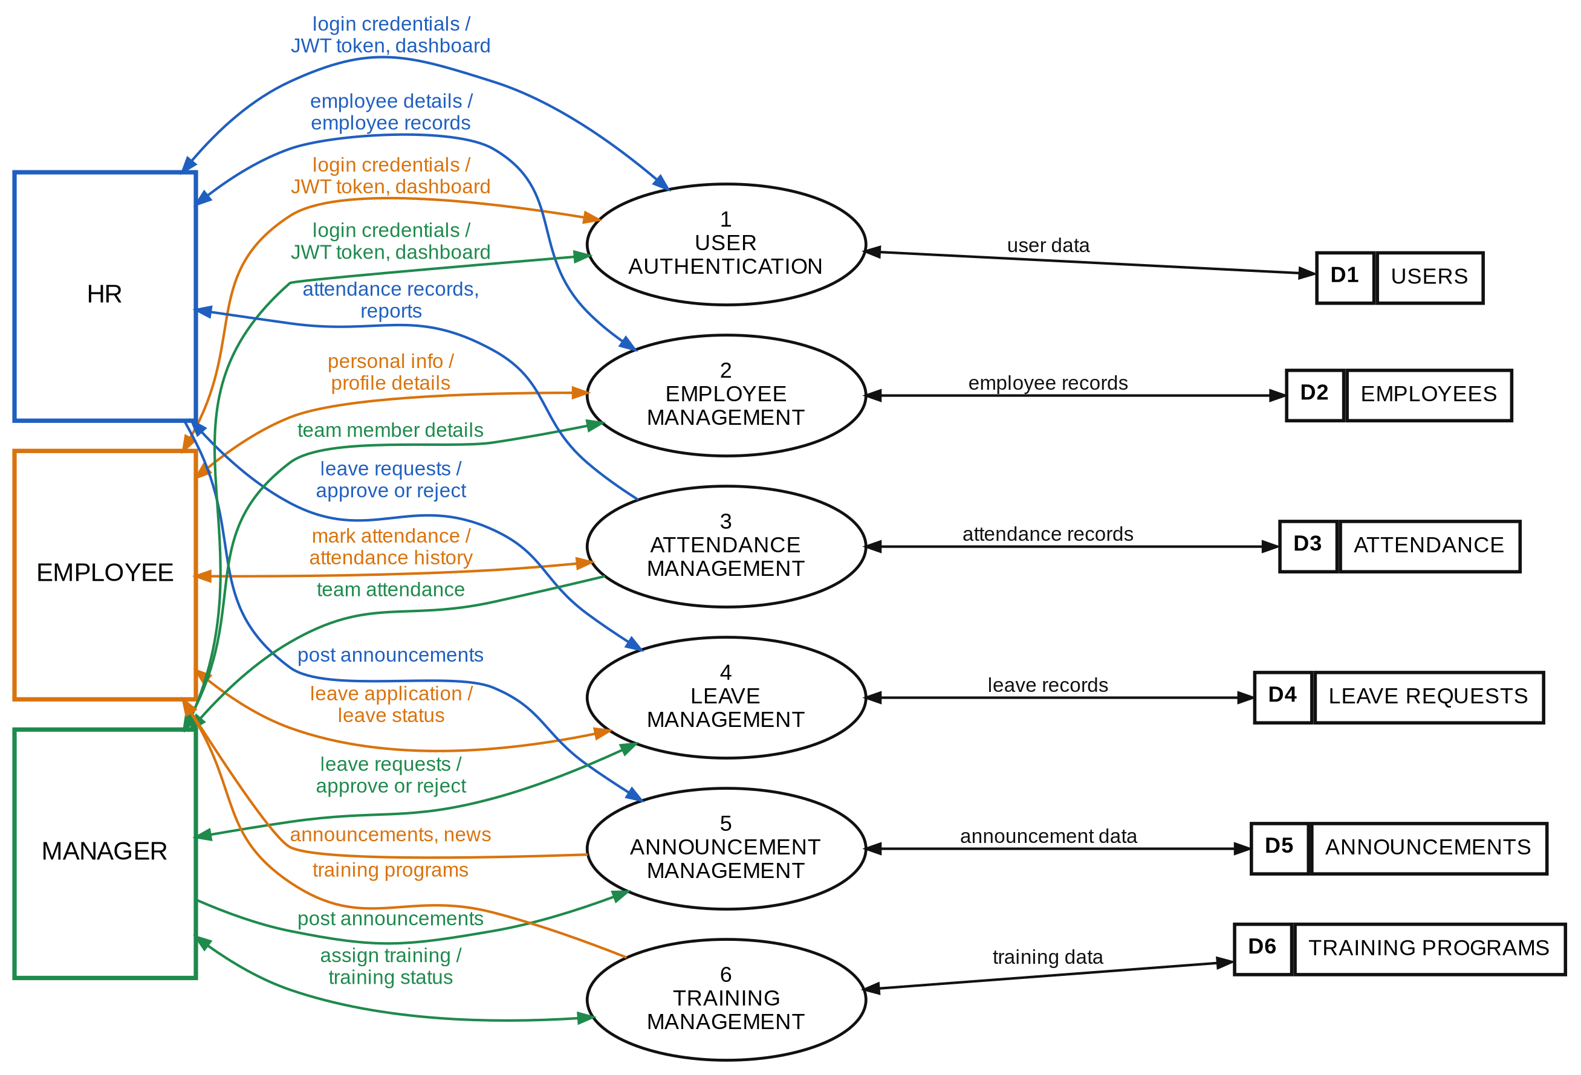
Legend: Blue = HR flows | Orange = Employee flows | Green = Manager flows | Black = process to data store

User Stories
User Story Table - StaffSync
User Type | Functional Requirement (Epic) | User Story / Task | Acceptance Criteria | Priority | Release
User | User Authentication | As a user (HR, Manager or Employee), I can register and log in securely with my credentials. | A JWT token is issued and I am redirected to the dashboard for my role. | High | Sprint-1
User | Role-Based Access | As a user, I can access only the features permitted for my role. | Protected routes and APIs block unauthorized access. | High | Sprint-1
HR | Employee Management | As HR, I can add, view, edit and delete employee records. | Changes are saved and shown in the employee list. | High | Sprint-2
Employee | Profile Management | As an employee, I can view and update my personal information. | Updated details are saved and shown on my profile page. | High | Sprint-2
Employee | Attendance Management | As an employee, I can mark my daily attendance. | Attendance is recorded with the date and appears in my records. | High | Sprint-3
HR | Attendance Tracking | As HR, I can track the attendance of all employees. | Daily attendance records of all employees are displayed. | High | Sprint-3
Employee | Leave Application | As an employee, I can apply for leave and view its status. | The request is saved as pending and status updates are visible to me. | High | Sprint-3
Manager | Leave Approval | As a manager, I can approve or reject the leave requests of my team. | The status changes to approved or rejected and the employee can see it. | High | Sprint-3
HR | Leave Management | As HR, I can view, approve or reject leave requests. | The decision is recorded and reflected in the leave status. | High | Sprint-3
HR | Announcements | As HR, I can post announcements and company news. | The announcement is visible to employees on the announcements page. | High | Sprint-4
Employee | Announcements | As an employee, I can view company announcements and news. | The latest announcements are displayed on my page. | Medium | Sprint-4
Manager | Training Management | As a manager, I can create and assign training programs to my team. | Assigned employees can see the training program. | Medium | Sprint-4
Employee | Training Programs | As an employee, I can access my assigned training programs. | Assigned programs are listed on my dashboard. | Medium | Sprint-4
Manager | Team Attendance | As a manager, I can view the attendance of my team. | Team attendance records are displayed correctly. | Medium | Sprint-4
HR | Reports & Analytics | As HR, I can view reports on attendance, leave and employee data. | Reports are displayed with accurate data. | Medium | Sprint-4
User | Role-Based Dashboards | As a user, I can see a dashboard with the key information for my role. | HR, Manager and Employee dashboards show role-specific content. | Medium | Sprint-4

