A Major Project Final Report on

**DATA SECURITY THROUGH STEGANOGRAPHY AND CRYPTOGRAPHY**Submitted in Partial Fulfillment of the Requirements for   
the Degree of **Bachelor of Engineering in Information Technology**under Pokhara University

Submitted by: **Deep Sharan Shrestha, 14409  
Samishan GC, 14433**

Under the supervision of

**Er. Roshan Kumar Sah**

Date:   
8/2/2023

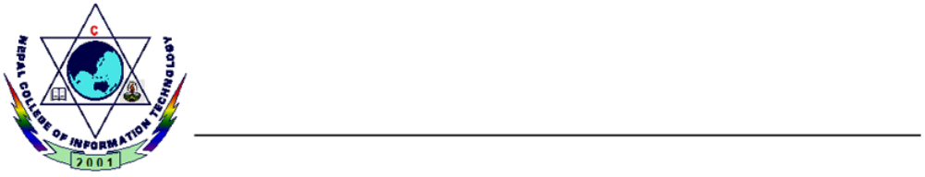

**Department of Information Technology**  
 **NEPAL COLLEGE OF   
 INFORMATION TECHNOLOGY**  
 Balkumari, Lalitpur, Nepal