OSSP SKILL 3
Deepsikha Biswal
ROLL NUMBER : 2520030205
3) HISTORY_SHELL.C
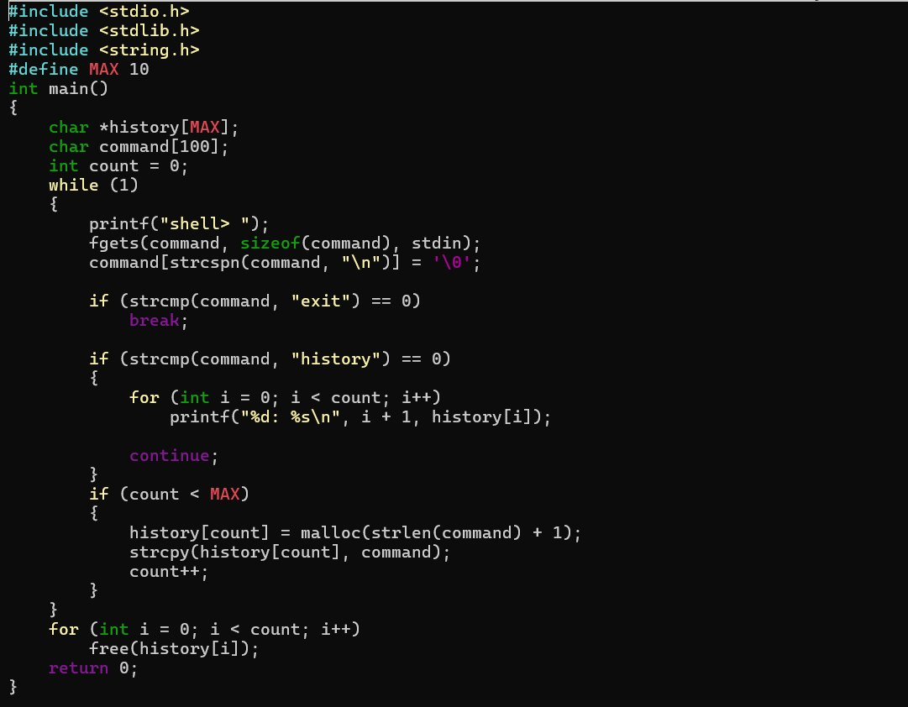
Output:
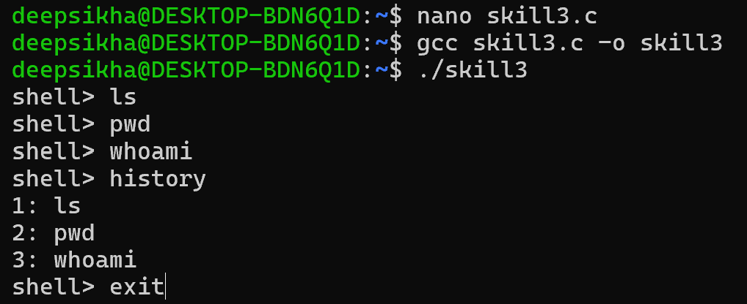

4) TOKENIZATION.C
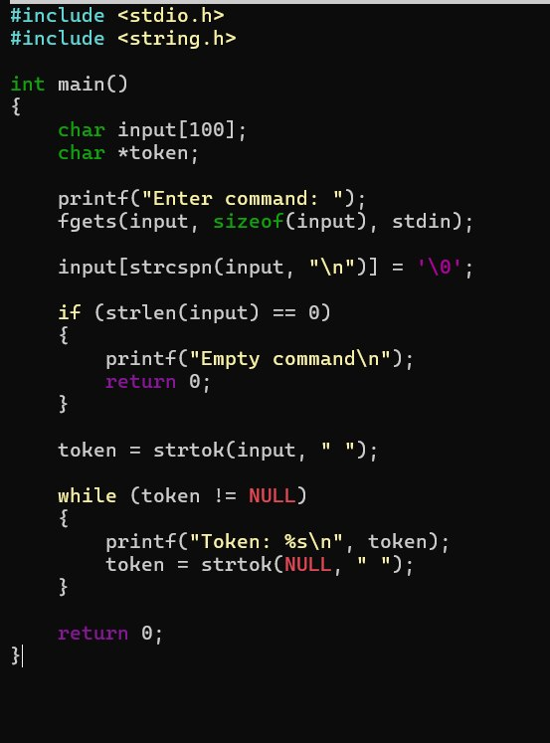
Output:
