Now that Julia and I are saving for retirement, I've taken a greater interest in investments of various of types, their pros and cons, etc. This also leads me to ponder about the larger economy (in which we're now investing) and our place in it.
Last month I was introduced to the concept of investing in an index fund that tracks the stock market. In such a fund, if the stock market grows, then our money grows, and if the stock market shrinks then so does our money. If I understand correctly, then investing in such a fund is like investing in the entire economy: I'm betting/hoping that the economy will grow, so that the stock market will grow, so that our money invested will produce big earnings.
In the several investment brochures/pamphlets that I've read to date I've found a disclaimer like this: “Past performance is no guarantee of future results.” Nevertheless, all the investments that I've studied closely do disclose past performance info, which is intriguing. They want to show how well they've done with investors' money, and I too want to see how well they've done. But, they want to make it clear that there is no guarantee that they'll be able reproduce or improve upon previous outcomes.
In contrast to that, it was suggested to me that the past performance of the stock market can be used as a “reasonably good” predictor of the future performance of an index fund. In fact, it was also suggested to me that

- the stock market can be assumed to grow at a rate of roughly 10% per year – because it has done so historically
- inflation will reduce the effect of that growth, and inflation can be anticipated to be 3% per year
- an index fund will therefore grow at 7% per year

If that were true, then Julia and I could invest in an index fund and expect a return in the 7% ballpark. Some arithmetic with a spreadsheet shows that by investing $150 per month for 30 years, which is a total investment of $53,850 (not accounting for inflation), we'd have a final balance of about $196,000, which is a little less than a four fold increase (a multiple of about 3.65).
That little analysis produced a very mixed emotional response from within me. On the one hand it was so simple, so cut-and-dried. It was refreshing to find any (non-trivial) investment prospect that boasted some form of an expected return rather than just a disclaimer that no particular outcome could be guaranteed. And, a return of 7% sounded pretty good to me, especially if it were steady. However, I was also skeptical that this was an oversimplification, and that the economy might not grow at rate of 10% per year on a 30 year interval.
How could I evaluate this claim? As index funds are based on stock market indexes, such as the S&P 500 index, and as historic index scores are public information and can be downloaded from the Internet, I learned that I could download historic scores and study them to evaluate for myself the claim (steady 7% growth) described above. I decided to do just that. (At this point you're likely pondering: “Why is Doug going to study an index score data set? Doesn't he realize that 'two hours in the library will save two weeks in the lab'?” Well, I've decided it would be more fun to study a data set than read the results of someone else's study this time around.)
I've begun with the Dow Jones Industrial Average, which I retrieved from the Yahoo Finance site. (See dj_hist_sorted.csv. It had recent scores at the top and older ones at the bottom, but I reversed the sort order.) It shows the closing value of the Dow every business day from October 1, 1928 up to the present time. (I performed the download on January 15, 2010, and so that's where data ends for purposes of this discussion.) I created a small computer program called index_fund_models.py (written a programming language called Python, which I love) to help me evaluate this historic data. The program “models” the performance of an imaginary index fund based strictly on the Dow. Here are the assumptions of the model:

- The investment period is 30 years
- $150 per month are invested, and these investments are made on the first business day of each month.
- If the Dow closed at 240.01 yesterday, but it closed at 238.14 today, then the Dow shrank by 1.87 meaning that it lost 0.78% (1.87 / 240.01 = 0.00779...), which is just less than one percent of its value. This would, in turn, mean that I'd have to reduce my investment's balance by 0.78%. A balance at $500 yesterday would become a balance of: $500 - ($500 * 0.0079) = $496.11 today.
- All of the 30 year periods starting from January of 1929 up to 1980 are modeled. (1929-1959, 1930-1960, 1931-1961, … 1979-2009, 1980-2010.)

Please note that there is more than one way to perform a comparable evaluation of this data. Surely the several common spreadsheet applications available today can be made to do what my Python program has done. However, I decided to whip up my Python program rather than grow my spreadsheet know-how for the purpose of making my Dow models.
My program's results are nevertheless structured in spreadsheet form. My spreadsheet is called model_monthly-pay.csv. Row 1 contains column headers/labels, and rows 2 – 53 show the outcomes for each of the 30 year periods. Here are some observations I take from these results:

- The interval from 1952 to 1982 had the worst outcome: 1.38 fold growth, which is comparable to growth that would be achieved at a constant 1.7% per year.
- The interval from 1970 to 2000 had the best outcome: 8.34 fold growth, which is comparable to a constant 11% per year.
- 31 out of the 51 outcomes showed less than the (approx.) 3.65 fold growth that denotes an steady 7% return.
- The economy grew over each of these intervals – there was not one era of net atrophy.

In addition, I took the opportunity to use a spreadsheet function to compute a “simple arithmetic average” of my 'end balance' and 'growth factor' columns in model_monthly-pay.csv. The average of the ending balances was roughly $195,900 and that of the growth factor values was 3.64. These two averages persuade me that there is a pretty good dose of merit to the claim I'm investigating: they seem to show an average of 7% growth in the economy as measured by the Dow.
I'm glad, however, to see for myself the variance in the outcomes. To see that growth during the last century ranged from 1.7% up to 11%, to see the historic extremes, helps me feel a little more grounded. And, to feel like I'm even more comfortable with the odds with which Julia and I will be dealing (since almost all investment vehicles I've considered so far keep a portion of their holdings in the stock market), I made a histogram of the outcomes:
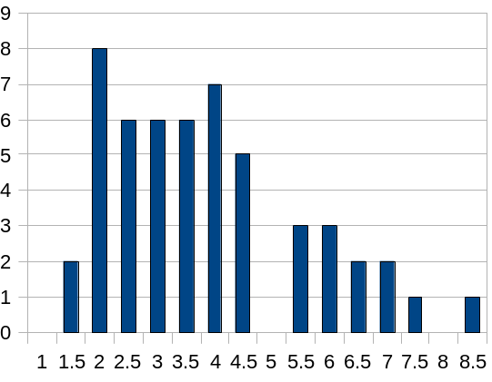
(The X-axis shows groups of growth factors listed in 0.5 increments. The y-axis is the number of growth factor outcomes within those increments.) It looks to me like the data is centered around growth factor of 3, which is fairly close 3.65. I'm no statistician, and so I could be way off in left field, but I think that the histogram and item 3 from the numbered list above both suggest that an average growth factor of 3.65 (or 3.64) is skewed a little on the high side. I think – based upon this Dow data – a likely outcome for our retirement savings (whatever portion ends up in the stock market) is for a growth factor ranging from 2 to 4, or what will look after the fact like 5% to 7.5% returns. But, who knows?! Not me.
Well, that was a fun exercise. I feel better informed and more comfortable with the risks associated with index fund investing with retirement in view. As for my new thoughts and feelings on putting my savings boat afloat in the sea of the larger economy, that will have to wait for another essay.

