**Capstone Project: Sentimental analysis and cuisine based recommendation system based on yelp ratings, reviews and tip data on restaurants within the US**

Data source: <https://www.yelp.com/dataset_challenge>

Yelp.com is a website/mobile application with the capabilities of submitting reviews by users for various businesses across the world. In particular, it's a popular application for users who are interested in finding if a particular restaurant/cuisine offer the best quality of food and service. This project proposes to do a sentimental analysis of the reviews, ratings, and tip data tied with the demographic information within the interested US cities.

Clients: Generic user of the yelp.com site.

Fields within the four json files within the yelp dataset:

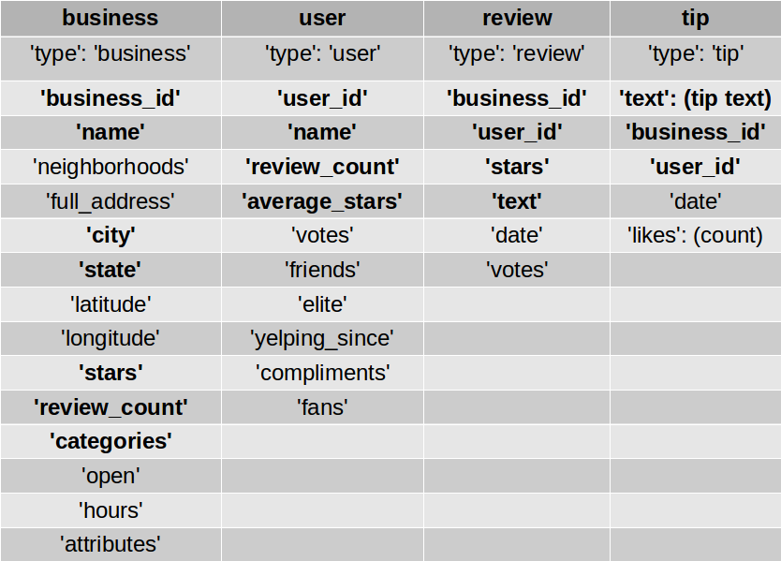

Interesting questions to be looked into:

1. User demographics (Male/Female)

2. Gender differences in the reviews and tip text within cities with most reviews

3. Correlation between tip text and reviews.

4. Recommendation system, Yelp ratings and (user data)

Additional datasets/libraries to be looked at:

1. Gender determination from US names

2. demographic/population data within the interested cities (yelp data) in US