**Question 1:**

Tools: Pure Python and python utility, no processing engine and Physical servers.

In a non-cloud environment, design an approach to move big structural data from any source (flat file, SQLSQL, Oracle, MySQL to target source SQL Server/Oracle). Data volume can dynamically grow from 1 million to 50 million.

Answer :

High Level Design Diagram :

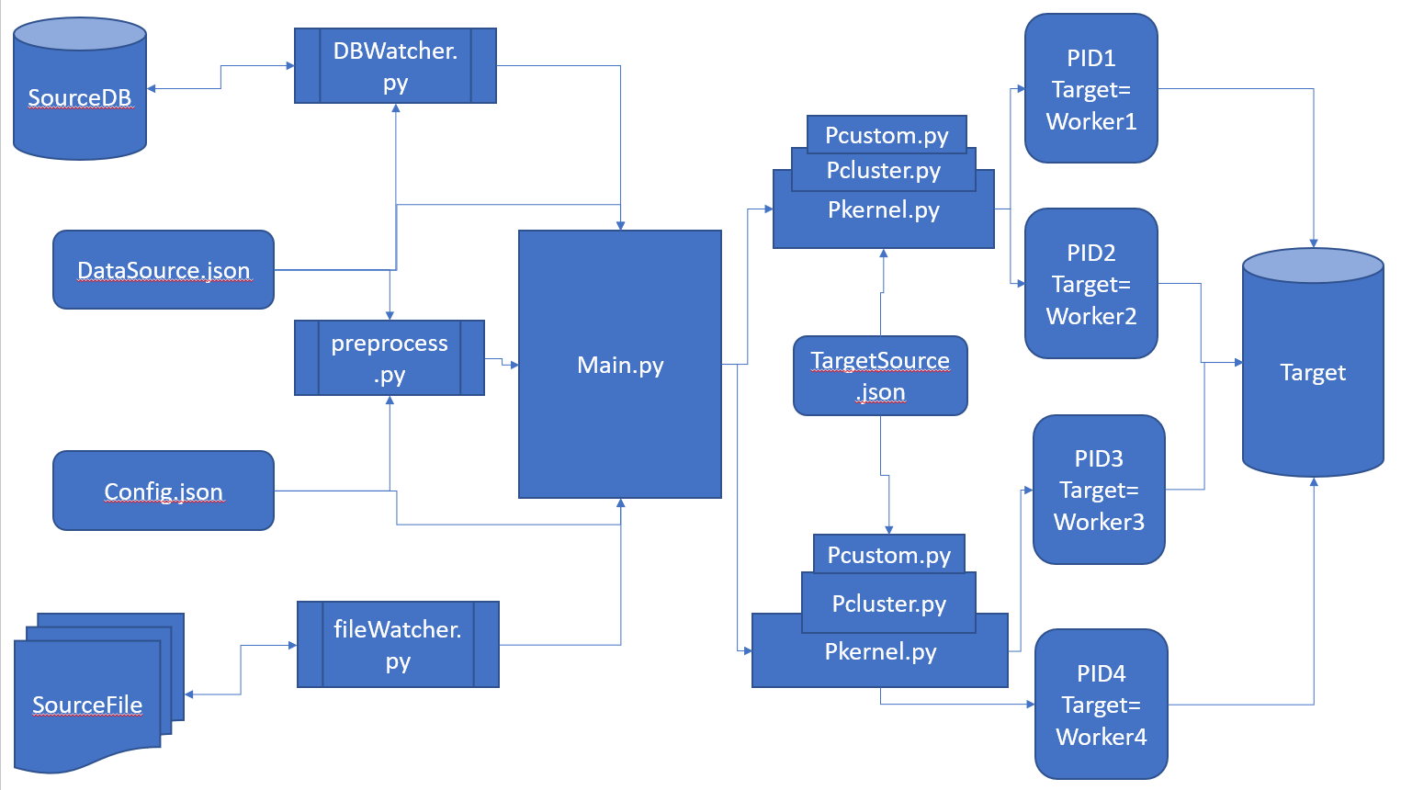

Sample code:

https://github.com/deepstartup/q1/tree/main/q1



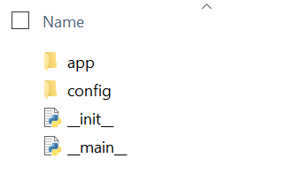

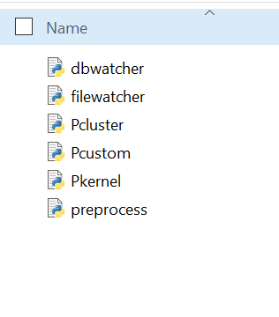

Config:

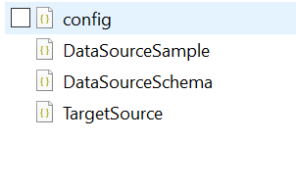

**Question 2:**

Create package to demonstrate object oriented test-driven design using Python.

Sales Data (Monthly feed) – Every Sales record has associated Region & Customer

Region Data -- Region has other attributes that provides detail on region

Customer Data -- Detail Customer information

Create main.py class to pull historical sales data for multiple months.

Define class hierarchies to manage

* Above data
* Test module

Answer :

I have attached the sample package here for demonstration :



Public github link : https://github.com/deepstartup/q2-TDD

The file hierarchies as :

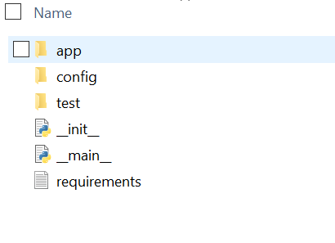

Inside App:

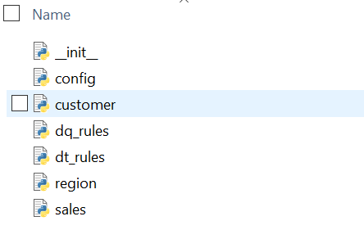

Inside Test:

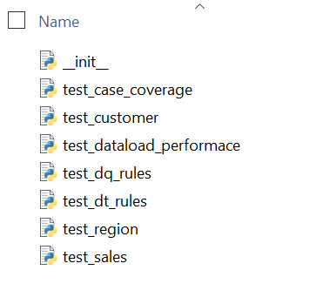

Class hierarchies :

Region 🡪 Customer(Region) 🡪 Sales(Region,Customer)

For the above level of inheritance also stands same. (explained in sample package)