EX:No.4 221501025

**04/03/25**

**IMPLEMENT AN PYTHON PROGRAM TO CHECK STATIONARY OF TIME SERIES DATA**

**AIM:**

IMPLEMENT AN PYTHON PROGRAM TO CHECK STATIONARY OF TIME SERIES DATA

**PROCESS:**

import pandas as pd

import numpy as np

import matplotlib.pyplot as plt

from statsmodels.tsa.stattools import adfuller

**PROCEDURE**:

* Load the dataset
* Check the columns to see what data is available
* Check the columns to see what data is available
* Ensure there are no leading/trailing spaces in column names
* Reverse the order of the data to maintain chronological order
* Plot the Time Series to visually inspect
* Perform Augmented Dickey-Fuller (ADF) Test for Stationarity

**CODE:**

import pandas as pd

import numpy as np

import matplotlib.pyplot as plt

from statsmodels.tsa.stattools import adfuller

file_path = "C:\\Users\\Lenovo\\Downloads\\apple_stock_prices.csv"

data = pd.read_csv(file_path)

# Convert 'Date' column to datetime

data['Date'] = pd.to_datetime(data['Date'])

data.sort_values('Date', inplace=True)

# Use 'Adj Close' for analysis

price_data = data['Adj Close'].copy()

price_data.fillna(price_data.mean(), inplace=True)

Q1 = price_data.quantile(0.25)

Q3 = price_data.quantile(0.75)

IQR = Q3 - Q1

lower_bound = Q1 - 1.5 * IQR

upper_bound = Q3 + 1.5 * IQR

price_data = price_data[(price_data >= lower_bound) & (price_data <= upper_bound)]

# Plot the Adjusted Close Price Time Series

plt.figure(figsize=(10, 6))

plt.plot(data['Date'], data['Adj Close'], label='Adj Close')

plt.title('Apple Stock Adjusted Close Price Over Time')

plt.xlabel('Date')

plt.ylabel('Adjusted Close Price')

plt.grid(True)

plt.legend()

plt.show()

# Perform Augmented Dickey-Fuller (ADF) Test for Stationarity

result = adfuller(price_data.dropna())

# Print ADF Test Results

print("ADF Test Results:")

print(f"ADF Statistic: {result[0]}")

print(f"p-value: {result[1]}")

print(f"Critical Values: {result[4]}")

# Interpretation

if result[1] <= 0.05:

print("The series is likely stationary (p-value <= 0.05).")

else:

print("The series is likely non-stationary (p-value > 0.05).")

**OUTPUT:**

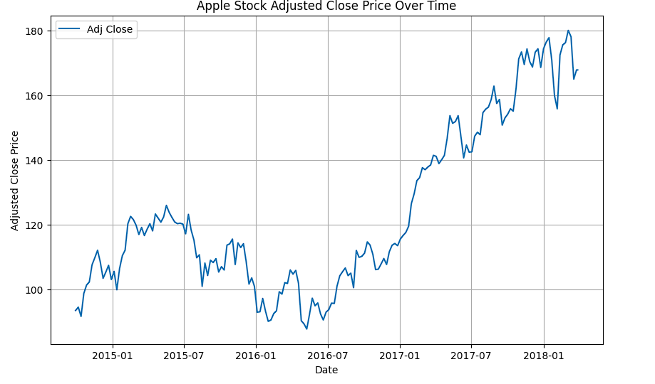

**RESULT:**

The program to implement of program to check stationary or not is created and executed successfully.