Data Mining Project Report

Deepti Agrawal

Submission Date: 11th April, 2021
TABLE OF CONTENTS

Problem 1: Clustering
Executive Summary
Introduction
Data Description
1.1 Read the data, do the necessary initial steps, and exploratory data analysis (Univariate, Bi-variate, and multivariate analysis).
1.2 Do you think scaling is necessary for clustering in this case? Justify
1.3 Apply hierarchical clustering to scaled data. Identify the number of optimum clusters using Dendrogram and briefly describe them
1.4 Apply K-Means clustering on scaled data and determine optimum clusters. Apply elbow curve and silhouette score. Explain the results properly. Interpret and write inferences on the finalized clusters.
1.5 Describe cluster profiles for the clusters defined. Recommend different promotional strategies for different clusters.

Problem 2: CART-RF-ANN
Executive Summary
Introduction
Data Description
2.1 Read the data, do the necessary initial steps, and exploratory data analysis (Univariate, Bi-variate, and multivariate analysis).
2.2 Data Split: Split the data into test and train, build classification model CART, Random Forest, Artificial Neural Network
2.3 Performance Metrics: Comment and Check the performance of Predictions on Train and Test sets using Accuracy, Confusion Matrix, Plot ROC curve and get ROC_AUC score, classification reports for each model.
2.4 Final Model: Compare all the models and write an inference which model is best/optimized.
2.5 Inference: Based on the whole Analysis, what are the business insights and recommendations.

Problem 1: Clustering

Executive Summary
A leading bank wants to develop a customer segmentation to give promotional offers to its customers. They collected a sample that summarizes the activities of users during the past few months. You are given the task to identify the segments based on credit card usage.

INTRODUCTION
The purpose of this whole exercise is to explore the dataset. Do the Exploratory Data Analysis. The data consists of credit card activities of 210 users based on their monthly spending, advance payments, current balance, credit limit, minimum payment amount, etc. We will be applying clustering techniques to form segments of users in order to send them promotional offers based on their activity patterns.

Data Description
Credit Card Usage Attributes:
- spending: Amount spent by the customer per month(in 1000s)
- advance_payments: amount paid by the customer in advance by cash (in 100s)
- probability_of_full_payment: probability of payment done in full by the customer to the bank
- current_balance: balance amount left in the account to make purchases (in 1000s)
- credit_limit: limit of the amount in credit card (10000s)
- min_payment_amt: minimum paid by the customer while making payments for purchases made monthly (in 100s)
- max_spent_in_single_shopping: maximum amount spent in one purchase ( in 1000s)

Q 1.1 Read the data, do the necessary initial steps, and exploratory data analysis (Univariate, Bi-variate, and multivariate analysis).
The data has been loaded correctly to a dataframe.
Sample of the Dataset:
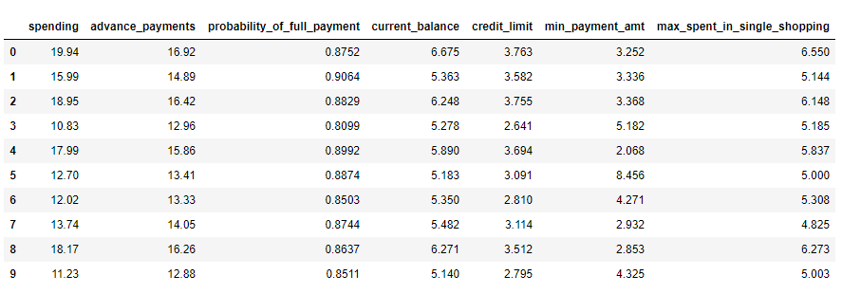Table 1: Dataset Sample
Dataset has 210 observations of credit card user activities over 7 attributes.

EXPLORATORY DATA ANALYSIS
We will be performing initial investigations on data so as to discover patterns, to spot anomalies and to check assumptions with the help of summary statistics and graphical representations.
Basic Info
Let us check the types of variables in the dataframe.
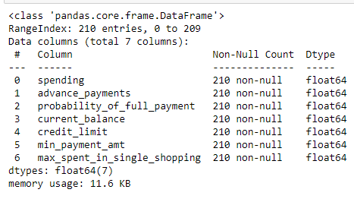
All the 7 attributes are of type float and contain continuous data. There are no null values in any of the 210 observations.
Check for missing values
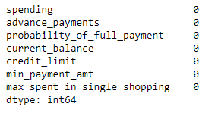
From the above result, we can see that there are no missing values present in the dataset. Also, upon checking we found that there are no duplicate records.
Descriptive statistics
We will proceed with checking the descriptive statistics of the data which helps understand its features by giving short summaries about the sample and measures of data.
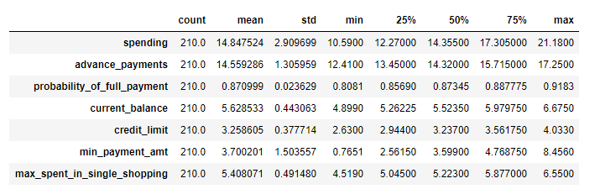
Table 2: Descriptive Statistics Table

From the descriptive statistics, we can see that
- Most customers have at least 4000 to 6000 current balance in their cards.
- The dataset have customers with credit limits ranging from approx. 26,000 to 40,000
- The maximum amount spent in single purchase is 5000 on an average
- The minimum advance payment done by the customers in cash is approx. 1200
- The probability of customers doing full payment is 88% for 75% of users.
- The average spending is approx. 14000
UNIVARIATE ANALYSIS
Checking the Skewness of the data
Skewness is a measure of the symmetry of a distribution. The highest point of a distribution is its mode. The mode marks the response value on the x-axis that occurs with the highest probability. A distribution is skewed if the tail on one side of the mode is fatter or longer than on the other: it is asymmetrical.
We will see the graphical representation of what skewness is, in the next step where we will frequency plots of all the continuous variables.
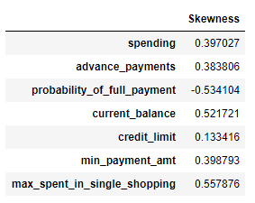
Here, we are checking the skewness quotient. Positive value means right skewed distribution and negative value means that the distribution is skewed to the left.

Here, we can see that most of the data is right skewed except probability of full payment.
Data Visualization
- Frequency Plot for spending 2. Frequency Plot for advance_payments
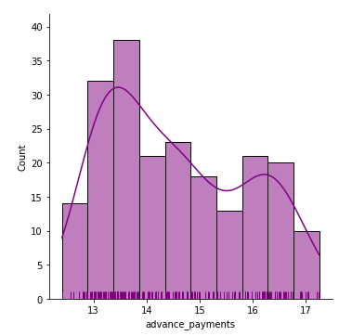
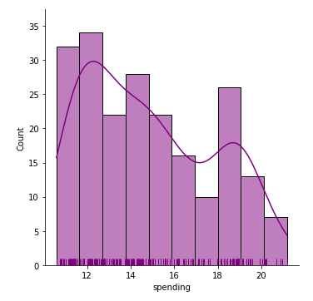

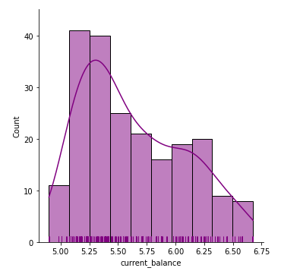
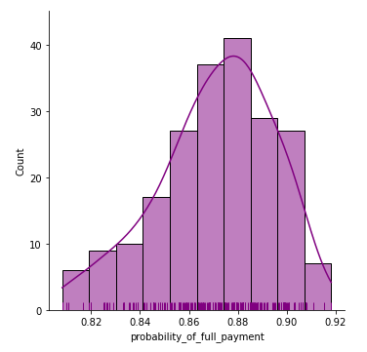
3. Frequency Plot for probability_of_full_payment 4. Frequency Plot for current_balance

5. Frequency Plot for credit_limit 6. Frequency Plot for min_payment_amt
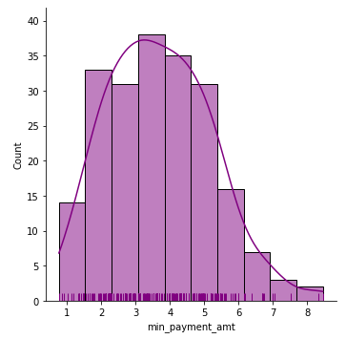
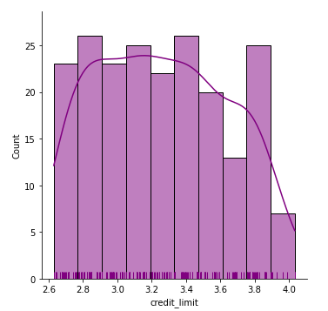

7. Frequency Plot for max_spent_in_single_shopping
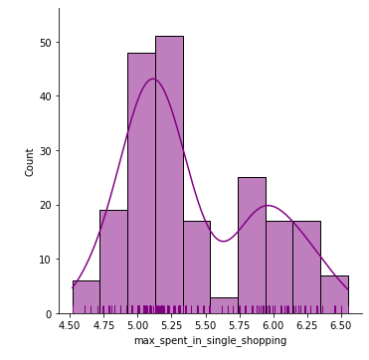
Checking for Outliers in the Data
An outlier is an observation that lies at an abnormal distance from other values in a random sample from a population.
Outliers are often bad data points but they should be investigated properly. Often they contain valuable information about the process under investigation or the data gathering and recording process.
Box Plots have lines extending from the boxes (whiskers) indicating variability outside the upper and lower quartiles.
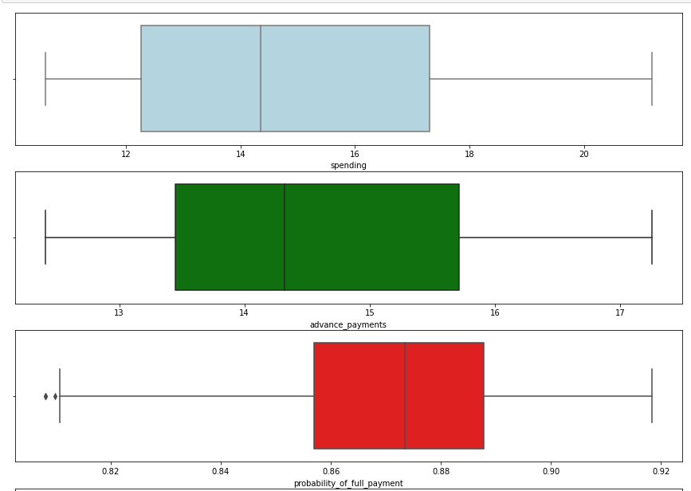
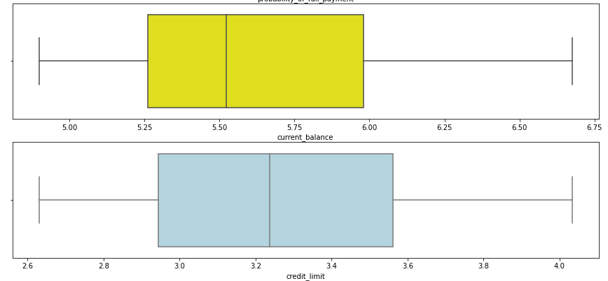
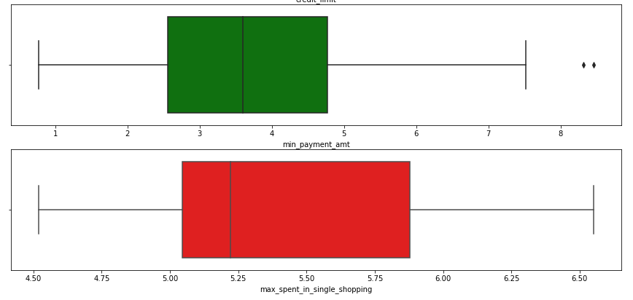
From the above boxplots of all continuous variables, we can observe that,
- probability_of_full_payment has two outliers present below the lower whisker.
- min_payment_amount has two outliers present outside the upper whisker but otherwise the distribution of data looks normal.
- Credit_limit has the lowest right skewness quotient among all others. It looks almost normally distributed.

MULTI-VARIATE ANALYSIS
Correlation Matrix
We will be creating a correlation matrix (table) showing correlation coefficients between variables. Each cell in the table shows the correlation between two variables.
T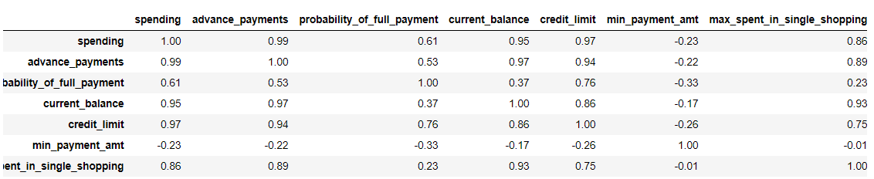Table 3: Correlation Matrix
Here, as we observe
- spending, advance_payments , current_balance and credit_limit are highly correlated to each other.
- Min_payment_amt is negatively correlated with almost all variables
- max_spent_in_single_shopping is highly related to current_balance.
Now, we will observe the same correlations through individual correlation graphs and also a heat map of the same correlation matrix.

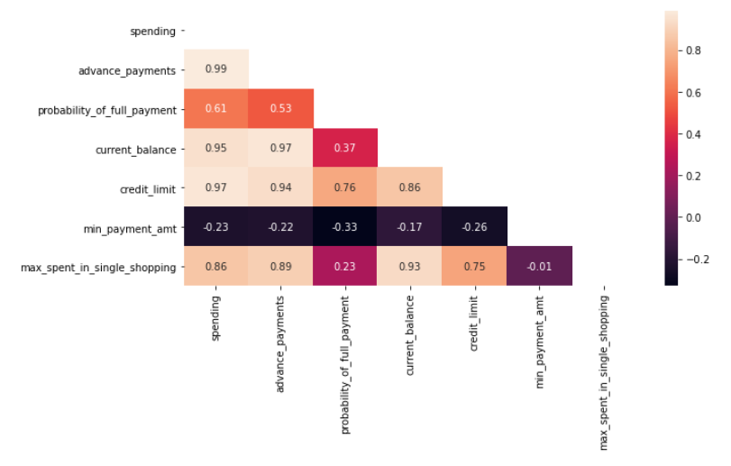
As the scale shows, lighter the color shade, higher the correlation and vice-versa.
It is visible that, spending, advance_payments, current_balance and credit_limit are highly correlated to each other.
Pair-plot
We use pairplot to plot multiple pairwise bivariate distributions in a dataset. It creates a grid of Axes such that each numeric variable in data will be shared across the y-axes across a single row and the x-axes across a single column. The diagonal plots are treated differently: a univariate distribution plot is drawn to show the marginal distribution of the data in each column.
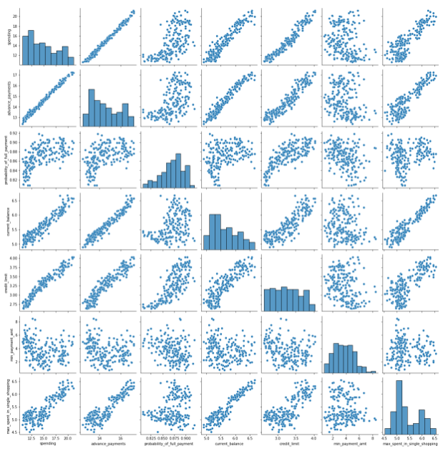
From the pairplot, we can clearly see that there is a linear relationship between many variables which shows that they are highly correlated.
And the diagonal graphs shows the univariate relationship graphs which we have already discussed before.
Insights from Exploratory Data Analysis
- The dataset was loaded correctly with 210 observation across 7 columns.
- All the attributes contains numerical data and are of type float.
- There are no missing values present however and also zero duplicate entries.
- We found that the probability of customers doing full payment is high
- The max amount spent in single purchase is 5000 on an average.
- As observed, most customers have at least 4000 to 6000 balance in their card.
- The minimum advance payment done by the customers in cash is approx. 1200
- The probability of customers doing full payment is 88% for 75% of users.
- The average spending is approx. 14000
- spending, advance_payments, current_balance and credit_limit are highly correlated to each other.
- max_spent_in_single_shopping is highly related to current_balance.
- We have observed that most of the data is right tailed except for probability of full payment.
- We have no categorical data present in the dataset.

Q 1.2 Do you think scaling is necessary for clustering in this case? Justify
Yes, scaling is necessary for clustering in this case, because all of the attributes are numerical with few of them having different meaning. (e.g.: spending and probability have different scales)
Like in our data set spending and advance payments is having values in 2 digits whereas probability of full payment has value in just decimals. Since the data in these variables are of different scales, it is tough to compare these variables.
Feature scaling (also known as data normalization) is the method used to standardize the range of features of data. Since, the range of values of data may vary widely, it becomes a necessary step in data preprocessing while using machine learning algorithms. Standardization helps to make the relative weight of each variable equal by converting each variable to a unit less measure or relative distance.
Standardization prevents variables with larger scales from dominating how clusters are defined. It allows all variables to be considered by the algorithm with equal importance.
There are a few different options for standardization, but two of the most frequently used are z-score and unit interval:
- Z-score transforms data by subtracting the mean value for each field from the values of the file and then dividing by the standard deviation of the field, resulting in data with a mean of zero and a standard deviation of one.
- Unit interval is calculated by subtracting the minimum value of the field and then dividing by the range of the field (maximum minus minimum) which results in a field with values ranging from 0 to 1.
We will be using a StandardScaler which normalizes the data using the formula (x-mean)/standard deviation. Essentially returns the z-scores of every attribute. We will be doing this only for the numerical variables.
Original Dataset
Scaled Dataset (after applying z-score scaling)
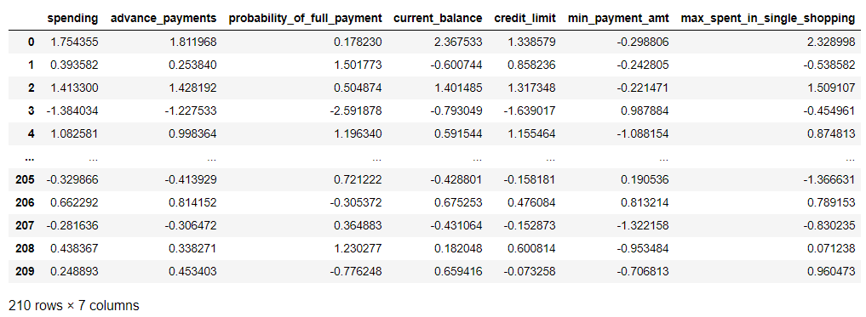Table 4: Scaled dataset sample

Q 1.3 Apply hierarchical clustering to scaled data. Identify the number of optimum clusters using Dendrogram and briefly describe them
We will be performing clustering on our data. Clustering is basically a technique that groups similar data points such that the points in the same group are more similar to each other than the points in the other groups. The group of similar data points is called a Cluster.
We will be performing Hierarchical Clustering on our dataset here. In this technique, the closest points are combined in a pairwise manner to form the clusters. It is an iterative procedure, where at every step of the iteration, two points or two clusters are combined to form a bigger cluster. At the end of the process all points are combined into a single cluster. The number of clusters is not predetermined.
Strategies for hierarchical clustering generally fall into two types:
- Agglomerative: This is a "bottom-up" approach: each observation starts in its own cluster, and pairs of clusters are merged as one moves up the hierarchy.
- Divisive: This is a "top-down" approach: all observations start in one cluster, and splits are performed recursively as one moves down the hierarchy.
In general, the merges and splits are determined in a greedy manner.
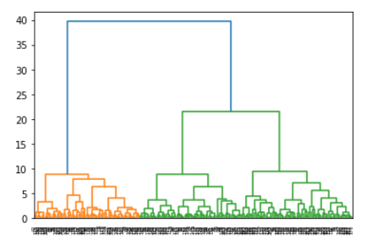
We have first used ward linkage method to form a dendrogram.
A dendrogram is a treelike diagram that summarizes the process of clustering. On the x-axis are the records, similar records are joined by lines whose vertical length reflects the distance between the records. The greater the difference in height, the more dissimilarity. By choosing a cutoff distance on the y-axis, a set of clusters is created.
Ward’s Linkage method looks at cluster analysis as an analysis of variance problem, instead of using distance metrics or measures of association. This method involves an agglomerative clustering algorithm. It will start out at the leaves and work its way to the trunk, so to speak. It looks for groups of leaves that form into branches, the branches into limbs and eventually into the trunk. Ward's method starts out with n clusters of size 1 and continues until all the observations are included into one cluster.
To understand better, we have remodeled dendrogram to show only 10 nodes
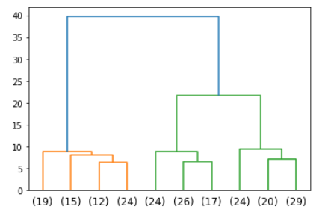
Now, we want to form a maximum of 2 cluster. We can do so by using fcluster and applying maxclust criteria or by cutting the dendrogram at a distance wherein it forms 2 clusters. Here, we will cut it at 25.
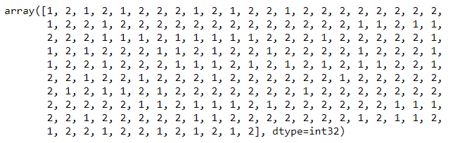
Given above are the cluster code for all the 210 users.
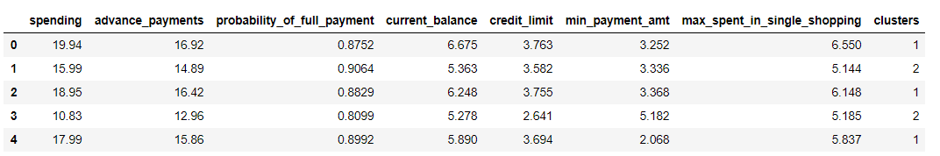
Here, we have added the cluster codes to our original dataset.
Below is the number of observations in each cluster.
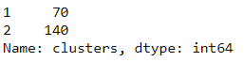
However, the problem of interest here is to determine the optimum number of clusters. Each cluster is a representative of a different population. To some extent this is a subjective choice. After considering the dendrogram, one may decide the level where the resultant tree needs to be cut. This is another way to say that how close-knit or dispersed the clusters should be. If the number of clusters is large, the cluster size is small and the clusters homogeneous. If the number of clusters is small, each contains more items and hence clusters are more heterogeneous.
Here, as our observations size is small i.e. 210, we may proceed with 2 clusters.
We have also performed agglomerative hierarchical clustering wherein we have used average linkage method and calculated through Euclidean distance for 2 clusters.
In average linkage method, distance between two clusters is defined as the average distance between each point in one cluster to every point in the other cluster.
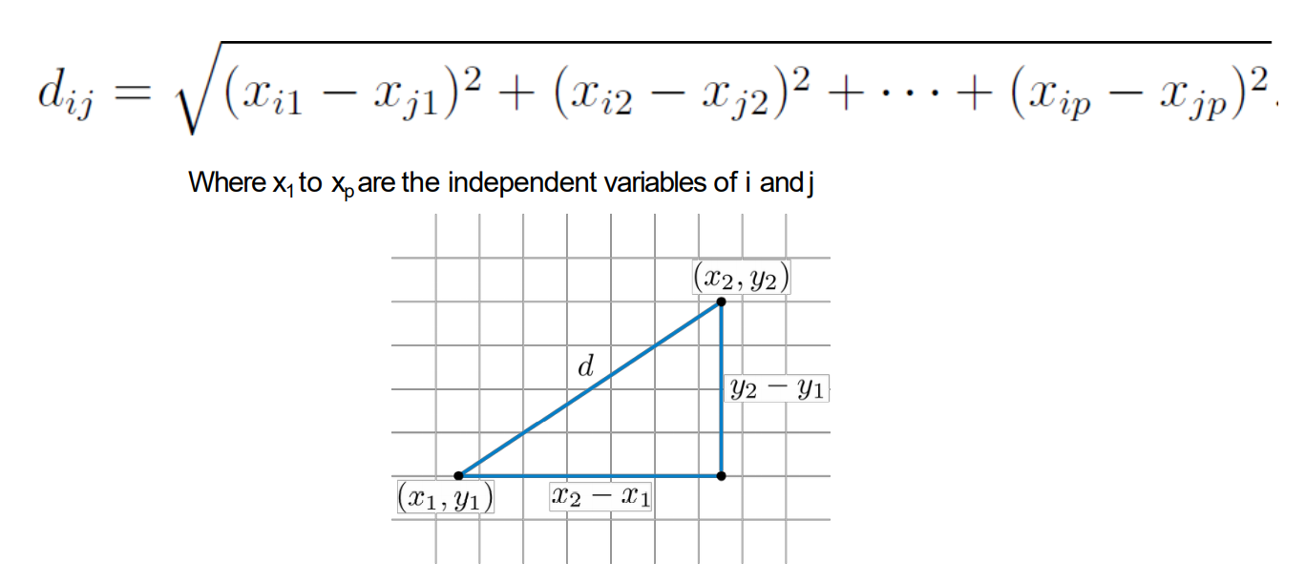
The distance between two clusters is calculated through Euclidean distance formula shown above.
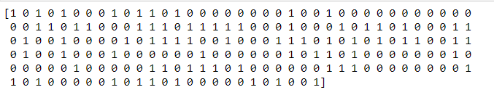
Given above are the agglomerative cluster codes for all the 210 users.
This is how the agglomerative clusters represent our original dataset.
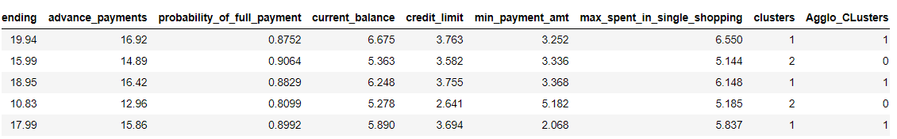
We will be showing detailed profiling of all the clusters in Q 1.5

Q 1.4 Apply K-Means clustering on scaled data and determine optimum clusters. Apply elbow curve and silhouette score. Explain the results properly. Interpret and write inferences on the finalized clusters.
We have already seen how hierarchical clustering is performed. Now, we will perform another clustering technique which is known as K-Means clustering.
In the k-means clustering process, k denotes the number of clusters, which has to be pre-determined. Once k is fixed, the observations are allocated to one and only one cluster so that the closest points belong to one cluster. The cluster size is not controlled.
A non-hierarchical approach to forming good clusters is to pre-specify a desired number of clusters, k. Assign each record to one of the k clusters, according to their distance from each cluster so as to minimize a measure of dispersion within the clusters. The ‘means’ in the K-means refers to averaging of the data; that is, finding the centroid.
We will start with taking number of cluster to be 2 i.e. k=2 and then finding out the inertia.
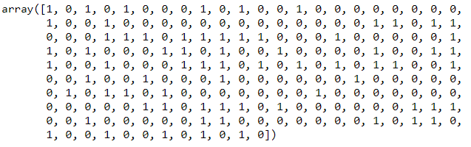
These are the cluster labels for all the 210 observations.
The K-Means algorithm clusters data by trying to separate samples in n groups of equal variance, minimizing a criterion known as the inertia or within-cluster sum-of-squares. Inertia can be recognized as a measure of how internally coherent clusters are.
We have calculated the inertia (within cluster sum of squares) for k= 1,2,3,4 and 5
Given below are the values of inertia, as the value of k increases
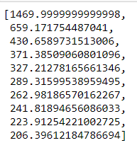
We can see that, as k is increasing the value of inertia is decreasing.
Now, to choose the value of k, we will be using Elbow Method which says that, that value of k is chosen to be optimum, where addition of one more cluster does not lower the value of total inertia or WCSS(within cluster sum of squares) appreciably.
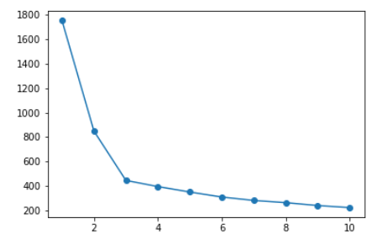
This WSS plot does not indicate any clear break in the elbow after k=2. Hence one option for optimum number of clusters is 2.
We will further use Silhouette method which measures how tightly the observations are clustered and the average distance between clusters. For each observation a silhouette score is constructed which is a function of the average distance between the point and all other points in the cluster to which it belongs, and the distance between the point and all other points in all other clusters, that it does not belong to. The maximum value of the statistic indicates the optimum value of k.
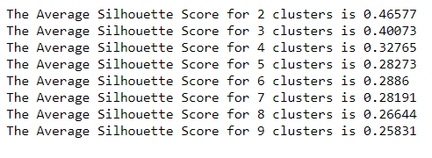
Here, we can see that the maximum silhouette score is for k=2.
Therefore, optimum clusters will be 2.
Following are the cluster labels for 210 observations.
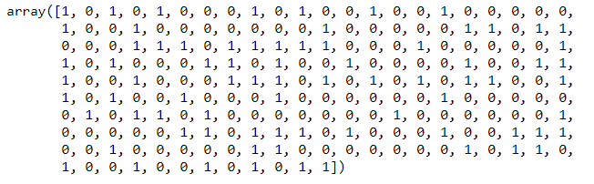

We have appended the cluster labels to our original dataset.
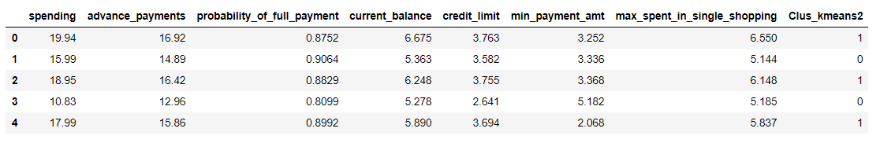
We will be showing detailed profiling of all the clusters in next question.

Q 1.5 Describe cluster profiles for the clusters defined. Recommend different promotional strategies for different clusters.
We have formed 2 clusters for our data in the previous steps. Now, we will generate descriptions of the clusters with reference to the input variables we used for the cluster analysis.
- Hierarchical clustering
This clustering process has divided our data into two clusters of 70 and 140 observations respectively.
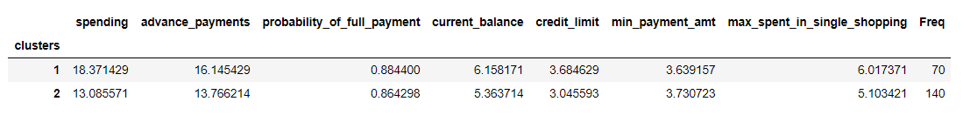
- Cluster 1: Users with high spending and a good track record in terms of advance payments and probability of full payment.
- Cluster 2: Users with less spending and slightly lower credit limit but the minimum payment done by them is better than the user in other clusters.

- Agglomerative Clustering
This clustering process has divided our data into two clusters of 135 and 75 observations respectively.
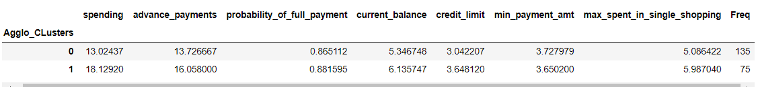
- Cluster 0: Users with low spending and lower credit limit
- Cluster 1: Users with high spending, higher credit limit and they do good amount of advance payments.

- K-Means Clustering
This clustering process has divided our data into two clusters of 133 and 77 observations respectively.
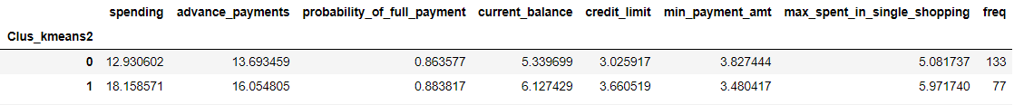
- Cluster 0: Users with low spending and lower credit limit
- Cluster 1: Users with high spending, higher credit limit and they do good amount of advance payments.
Conclusions based on Cluster Profiles
- Our dataset of 210 observations has been divided by all the algorithms into 2 optimal clusters.
- One cluster have approx. 77 users and other has 133 users.
- These are clustered on the basis of their credit card usage on certain parameters.
- Cluster 1 which has 133 users, consists of users who spend less, and have a lesser credit limit.
- Cluster 2 which has 77 users, consists of people who spend more and have a good credit card track record.
We have graphically represented the two clusters based on certain parameters below.
Here, Cluster 1 = Red dots and Cluster 2 = Green dots
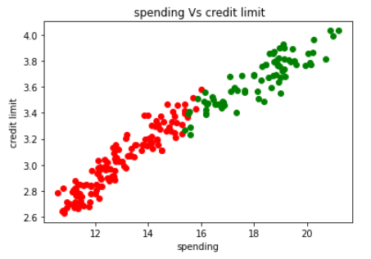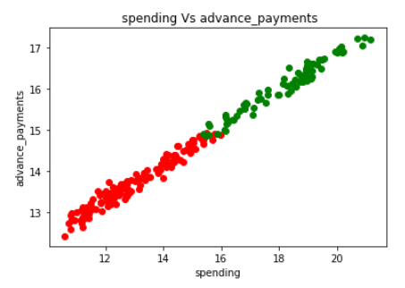
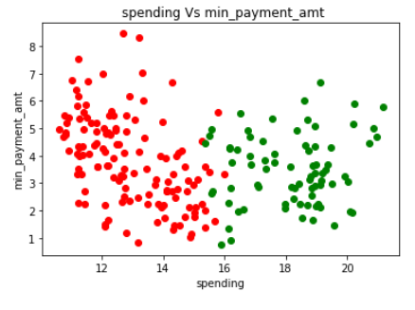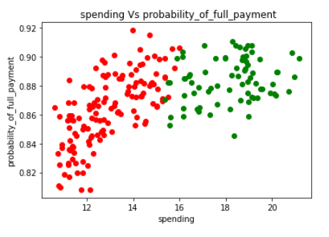
Recommendations for Both Clusters
- Cluster 1
This segment is characterised by customers who have the lowest spending and have a fairly high percentage of full payments. They are paying higher minimum payment amount on their credit card and maintaining a good track record. These users can be who pay low interest rate or use their card to pay utility bills or loan. Increasing the credit limit might be risky but the bank can give reward points which can encourage them to make more purchases.

- Cluster 2
This segment is characterized by customers with the highest credit limit and the highest percentage of full payments.They are potential target customers who are paying dues and doing purchases and having a good record. These are prime customers that the credit card provider can entice to increase their spending habits by raising their credit limits even more limit or can lower down interest rate. Can be given premium card /loyalty cards to increase transactions.

_______________________________________________________________________________________

Problem 2: CART-RF-ANN

Executive Summary
An Insurance firm providing tour insurance is facing higher claim frequency. The management decides to collect data from the past few years. You are assigned the task to make a model which predicts the claim status and provide recommendations to management. Use CART, RF & ANN and compare the models' performances in train and test sets.

INTRODUCTION
The purpose of this whole exercise is to explore the dataset. Do the Exploratory Data Analysis. The data consists of tour insurance claim status of 3000 customers based on agency they used to book the tour, product chosen, duration and destination of the tour, amount of sales done and commission earned by the insurance firm, etc. We will be making a model which predicts the claim status using CART, RF & ANN.

Data Description
Tour Insurance Data Attributes:
- Target: Claim Status (Claimed)
- Code of tour firm (Agency_Code)
- Type of tour insurance firms (Type)
- Distribution channel of tour insurance agencies (Channel)
- Name of the tour insurance products (Product)
- Duration of the tour (Duration)
- Destination of the tour (Destination)
- Amount of sales of tour insurance policies (Sales)
- The commission received for tour insurance firm (Commission)
- Age of insured (Age)

Q 2.1 Read the data, do the necessary initial steps, and exploratory data analysis (Univariate, Bi-variate, and multivariate analysis).

The data has been loaded correctly to a dataframe. It consists of tour insurance claim status of customers based on agency they used to book the tour, product chosen, duration and destination of the tour, amount of sales done and commission earned by the insurance firm, etc.

Sample of the Dataset:
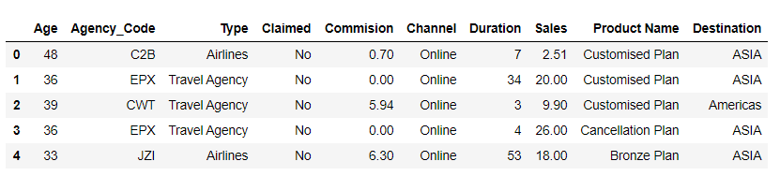
Dataset has 3000 observations of tour insurance details over 7 attributes.
EXPLORATORY DATA ANALYSIS
We will be performing initial investigations on data so as to discover patterns, to spot anomalies and to check assumptions with the help of summary statistics and graphical representations.
Basic Info
Let us check the types of variables in the dataframe.
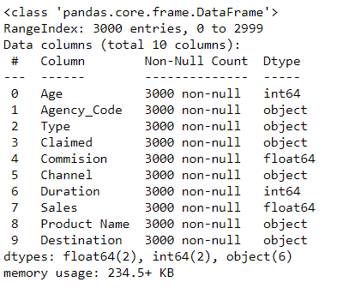
In the above data, 2 attributes (Age, Duration) are of type integer, 2 attributes (Commision, Sales) are of type float and all the other 6 attributes (Agency_Code, Type, Claimed, Channel, Product Name and Destination) are of object category. There are no null values in any of the 3000 observations.
Check for missing values
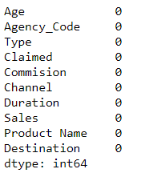
From the above result, we can see that there are no missing values present in the dataset.
Checking for Duplicate Records
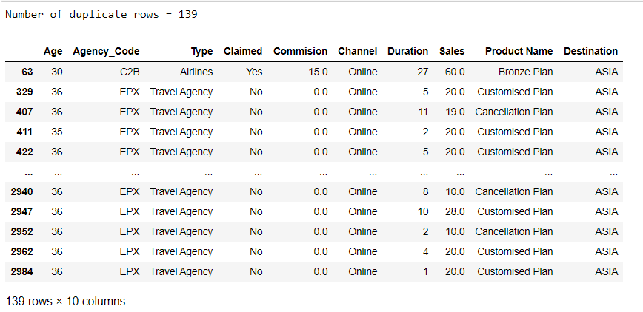
We have found out 139 duplicate rows which are present in our data. We have decided to move forward by dropping the duplicates assuming that the travel company cannot sell the same kind of tour package to similar demography.
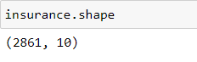
Therefore, now we are left with 2861 record of our data over the same 10 attributes.
Checking Channel column
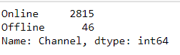
Here, we can see that the attribute Channel has only 46 values of offline channel and rest all through online. Therefore, we can go ahead with dropping this column for further analysis as dropping it won't affect our prediction.
After dropping Channel column, our dataset looks like this:
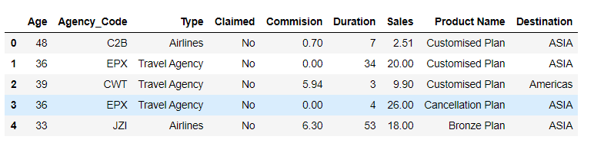

Descriptive statistics
We will proceed with checking the descriptive statistics of the data which helps understand its features by giving short summaries about the sample and measures of data.
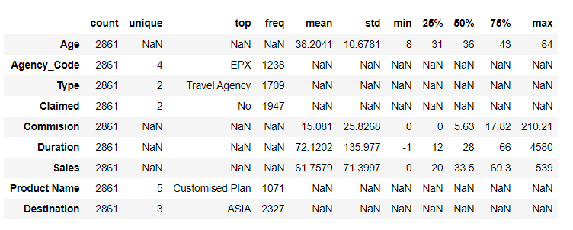
- There are 4 insurance agencies which are divided into two types.
- These agencies are selling 5 types of tour plans for 3 unique destinations.
- Out of 2861 observations 1947 corresponds to tours that have not been claimed.
Descriptive statistics of only the continuous variables.
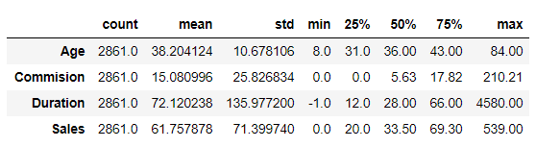
From the descriptive statistics we can see that,
- We can see that the duration of tour has a minimum value of -1.0 which seems to be a problem.
- The age column has individual as young as an 8 years old and also with individual of 84 years age.
- The mean sales by the insurance firms has a value of approx. 62.
- On 75% of tours that have been taken in the past, the commission earned for tour insurance firm is as low as 17.2, whereas on one of the tour they have earned 210 as commission.
- There have been tours where the sales were zero.

UNIVARIATE ANALYSIS
Checking the Skewness of the data
Here, we are checking the skewness quotient. Positive value means right skewed distribution and negative value means that the distribution is skewed to the left.
We will see the graphical representation of what skewness is, in the next step where we will frequency plots of all the continuous variables.

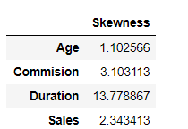
Here, we can see that most of the data is right skewed (positive value) and duration being highly skewed to the right.
Data Visualization
- Frequency Plot for Age 2. Frequency Plot for Commision
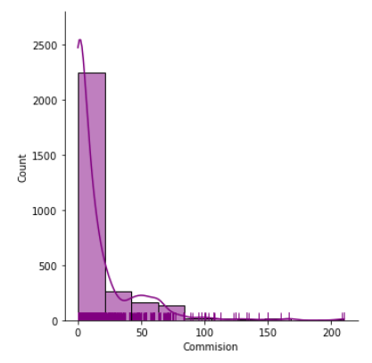
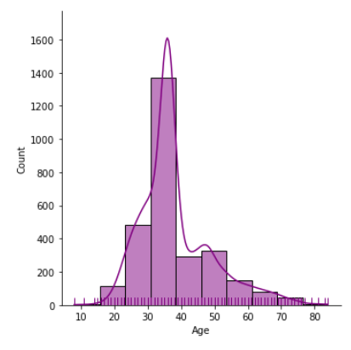

3. Frequency Plot for Sales 4. Frequency Plot for Duration
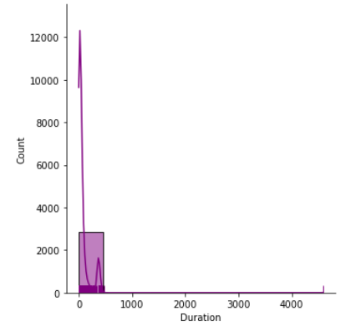
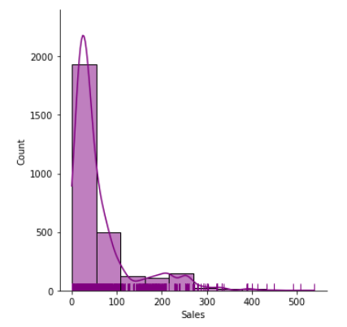
Checking for Outliers in the Data
An outlier is an observation that lies at an abnormal distance from other values in a random sample from a population.
Outliers are often bad data points but they should be investigated properly. Often they contain valuable information about the process under investigation or the data gathering and recording process.
Box Plots have lines extending from the boxes (whiskers) indicating variability outside the upper and lower quartiles.
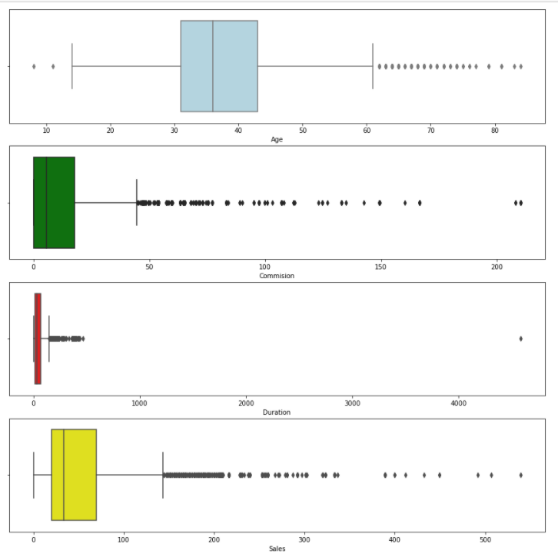
From the above boxplots of all continuous variables, we can observe that,
- All the variables have high number of outliers present in them.
- Age variable still looks quite normally distributed.
- Duration has the minimum spread of data and is highly right skewed.
- We will not be treating outliers over here. Treating outliers sometimes results in the models having better performance but the models lose out on the generalization.

Individual Count plots for Categorical Variables
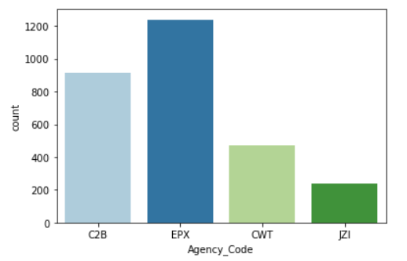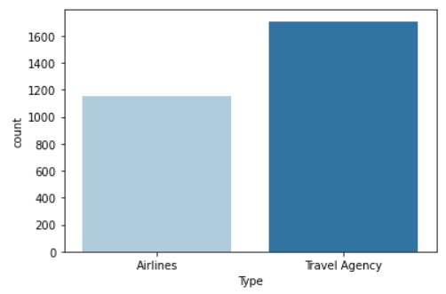
- There are 4 types of agencies with EPX having the highest frequency across two types: airlines and travel agency.

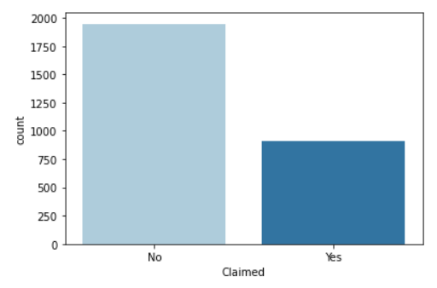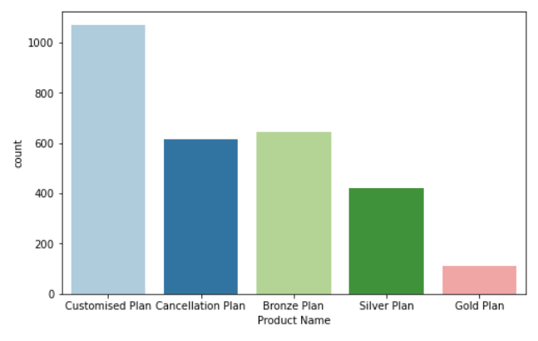
- The data has almost 1900 observations of tours that were not claimed.
- These agencies sold 5 types of plans with customized plan being sold most of the times.

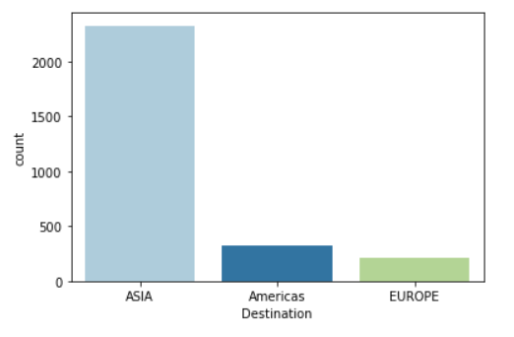
- The tours were mostly for ASIA as a destination.

BI-VARIATE ANALYSIS
- Viewing Sales for different agencies
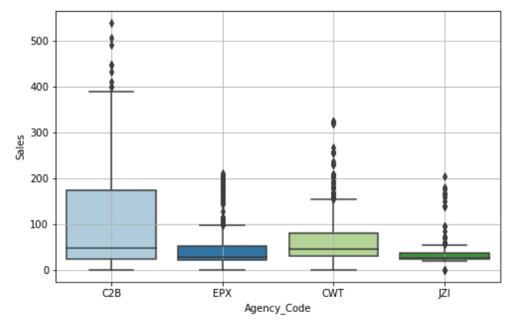
- Agency C2B has made the highest Sales.

- Viewing Sales for different agencies
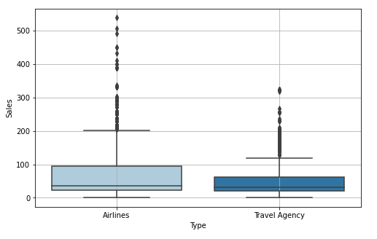
- Most sales have happened through Airlines.

MULTI-VARIATE ANALYSIS
- Viewing the range of sales which has been done by various agencies for different destinations.
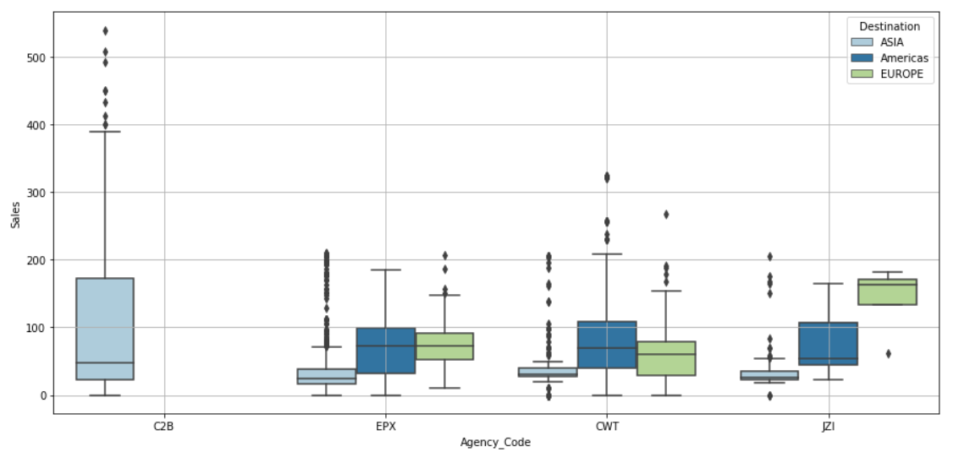
- We have seen that agency C2B has done highest sales by selling tour plans only for ASIA.
- Whereas, other agencies have sold across all the regions.

- Viewing the range of sales of different packages which has been done by various agencies.
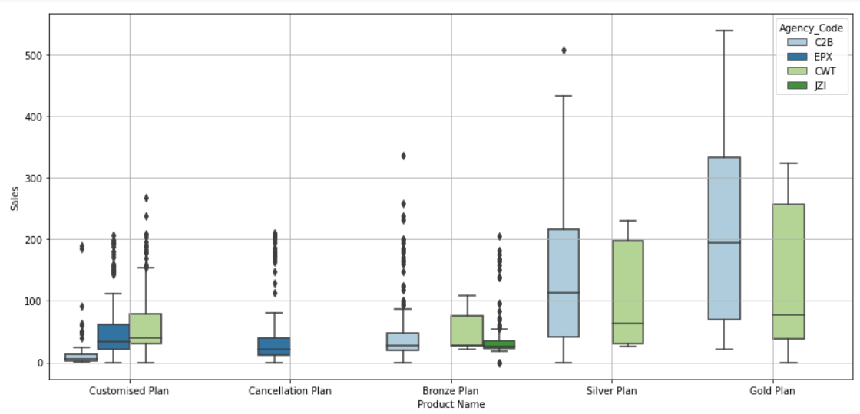
- We can see that Cancellation plan has been sold by only EPX agency.
- Also, Gold and Silver plan has been sold only by C2B and CWT
- Agency JZI sells only bronze plans.
- C2b corresponds to highest sales as it has been successful in selling Good number of Gold Plans.
We can also see below, that most claims were made for airlines and that C2B has sold only airlines insurance.
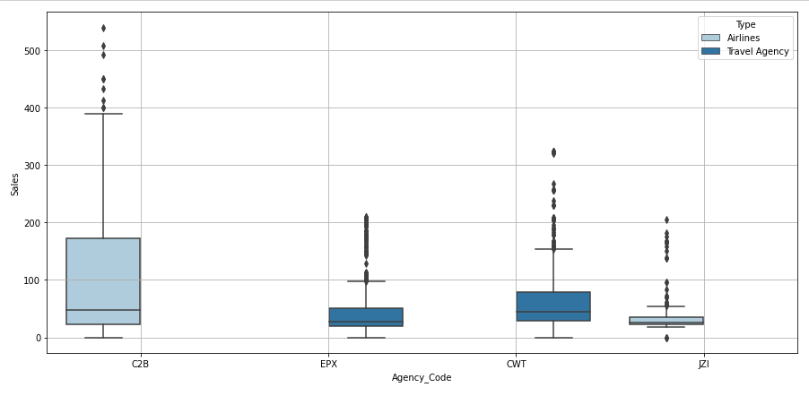
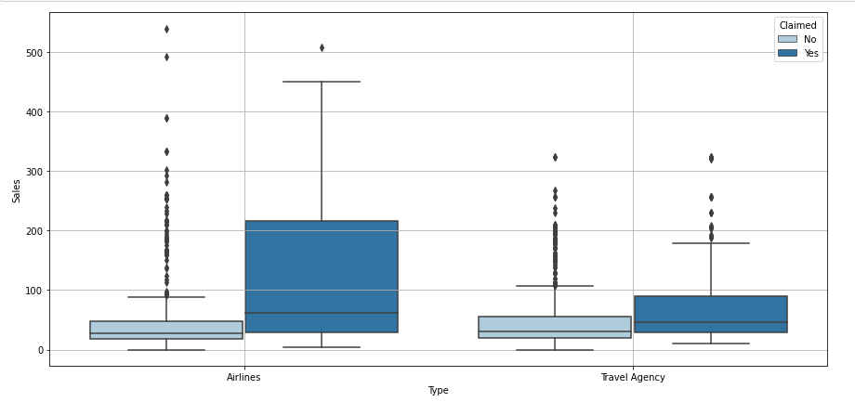
Pair-plot
We use pairplot to plot multiple pairwise bivariate distributions in a dataset. It creates a grid of Axes such that each numeric variable in data will be shared across the y-axes across a single row and the x-axes across a single column. The diagonal plots are treated differently: a univariate distribution plot is drawn to show the marginal distribution of the data in each column.
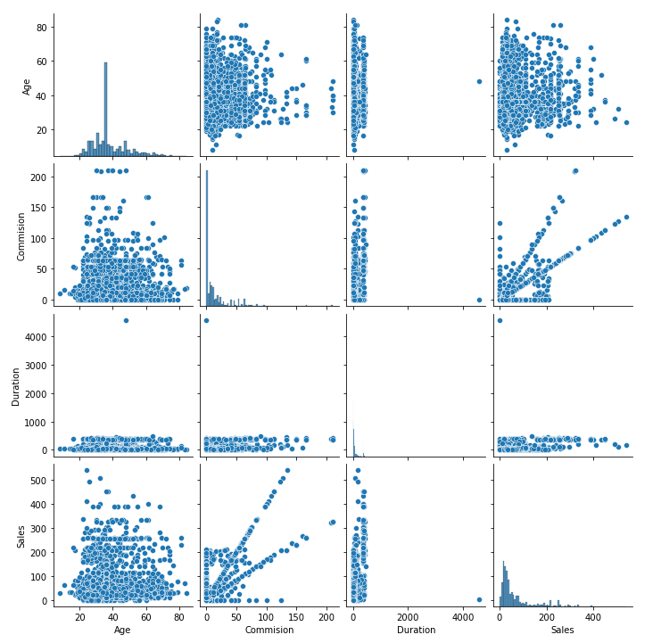
- Sales and commision depict a linear related graph
Correlation Matrix
We will be creating a correlation matrix (table) showing correlation coefficients between variables. Each cell in the table shows the correlation between two variables.
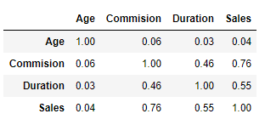
- Sales is related to Commision and duration. Other than that no other variables show correlations.
Correlation Heat Map
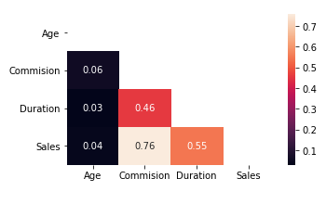
As the scale shows, lighter the color shade, higher the correlation and vice-versa.
It is visible that, Commision and Sales are highly correlated with a coefficient of 0.76

Insights from Exploratory Data Analysis

- The dataset was loaded correctly with 3000 observation across 10 columns.
- There were 2 columns (Age, Duration) of integer type, 2 columns (Commision, Sales) of float type and 6 columns (Agency_Code, Type, Channel, Claimed, Product Name and Destination) of type object (categorical).
- There are no missing values present however we found 139 duplicate entries which we have dropped for further analysis, as the travel company cannot sell the same kind of tour package to similar demography.
- After dropping the duplicates we are left with 2861 entries.
- We found that Sales is related to Commision and duration. Other than that no other variables show correlations.
- Agency C2B has made the highest sales mostly by selling Gold and Silver Plans
- Agency EPX did not sell Gold and Silver Plans and had the most number of insurance taken through other plans.
- Agency CWT is average in selling all plans other than cancellation plan.
- Agency JZI has sold only Bronze plans for all the three continents as destinations.
- We have dropped Channel attribute for our further analysis as there were only 46 entries of offline claims which would not affect our prediction.
- The highest sales recorded (212) was for Gold Plan by C2B and the second highest (139) was for Silver Plan again by C2B. Both were done for ASIA as a destination.
- All the variables have high number of outliers present in them.
- Age variable still looks quite normally distributed.
- Duration has the minimum spread of data and is highly right skewed.
- On 75% of tours that have been taken in the past, the commission earned for tour insurance firm is as low as 17.2, whereas on one of the tour they have earned 210 as commission.
- There have been tours where the sales were zero.
- The age column has individual as young as an 8 years old and also with individual of 84 years age.
- The mean sales by the insurance firms has a value of approx. 62.

Q 2.2 Data Split: Split the data into test and train, build classification model CART, Random Forest, Artificial Neural Network
Decision tree in Python can take only numerical / categorical columns. It cannot take string / object types.
We have 5 object type columns in our data which we need to convert to categorical data.
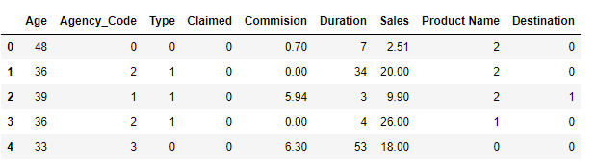
This is how our dataset looks after converting object columns to categorical data.
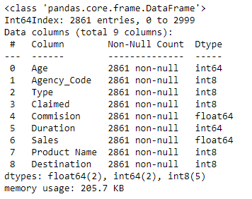
Here, we can see that all the columns are either integer or float type.

Data Splitting
The train-test split is a technique for evaluating the performance of a machine learning algorithm. It can be used for classification or regression problems and can be used for any supervised learning algorithm.
The procedure involves taking a dataset and dividing it into two subsets. The first subset is used to fit the model and is referred to as the training dataset. The second subset is not used to train the model; instead, the input element of the dataset is provided to the model, then predictions are made and compared to the expected values. This second dataset is referred to as the test dataset.
Train Dataset: Used to fit the machine learning model.
Test Dataset: Used to evaluate the fit machine learning model.
The objective is to estimate the performance of the machine learning model on new data: data not used to train the model.
Here, we have Claimed as our target variable i.e. which is to be predicted.
Therefore, we will separate this column from our dataset before splitting it into train and test data.

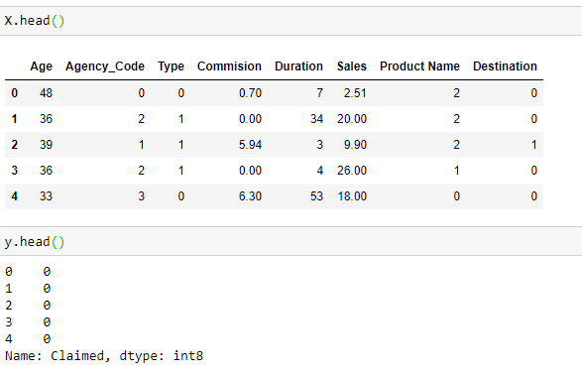
Now, we will perform our splitting process on these data frames.
Here, we are splitting the data into 70% training and 30% testing data.
Training data (contains 2002 observations)
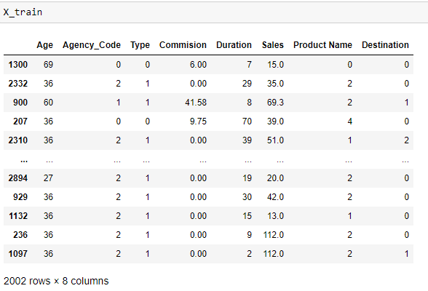
Testing data (contains 859 observations)
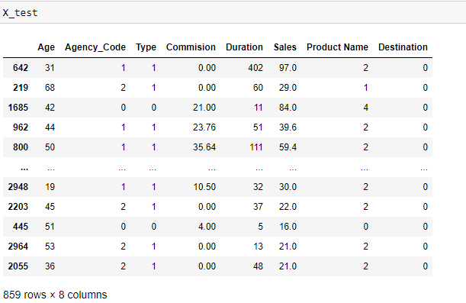
Now, on this training and testing data we will be building different classifications models like CART, Random Forest and Artificial Neural Network.
- CART Model
CART (Classification and Regression Trees) can be used for both classification and regression problems.
The difference lies in the target variable:
- With classification, we attempt to predict a class label. In other words, classification is used for problems where the output (target variable) takes a finite set of values, e.g., whether it will rain tomorrow or not.
- Meanwhile, regression is used to predict a numerical label. This means your output can take an infinite set of values, e.g., a house price.
Here, we will be building it for classification.
We will start by building a Decision Tree Classifier using Gini index as the criteria
Gini Index: It is calculated by subtracting the sum of squared probabilities of each class from one. It favours larger partitions and easy to implement. A feature with a lower Gini index is chosen for a split while building the tree.
The tree is huge in size with root node having Gini index of 0.309
The tree is first classified on the basis of Sales<= 83.5 or greater.
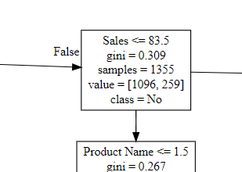
We need to limit the tree, by applying Grid search with some parameters on our classifier.
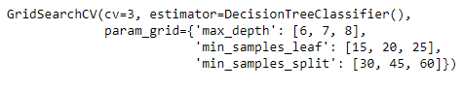
max_depth represents the maximum depth of the tree.
min_samples_leaf represents the minimum number of samples required to be at a leaf node. A split point at any depth will only be considered if it leaves at least ``min_samples_leaf`` training samples in each of the left and right branches.
Min_samples_split represents the minimum number of samples required to split an internal node.

After fitting these parameters into our model, the best parameters came out to be as below:
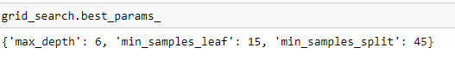
Now, as we have fit these parameters to our Decision Tree classifier, the model has been successfully built.
We will now be checking their feature importance which refers to techniques that assign a score to input features based on how useful they are at predicting a target variable.
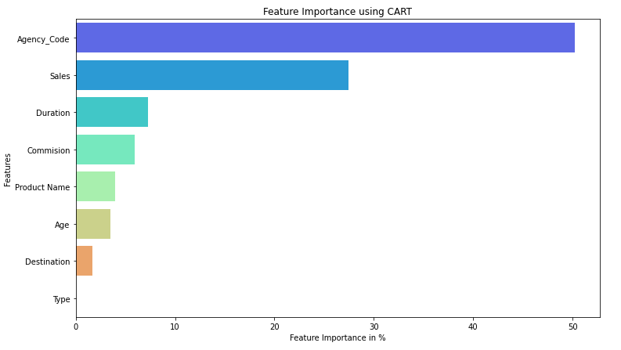
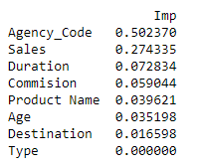
This shows, Agency_Code is the most useful feature for building a model and that Type is not used at all.
We have successfully built our CART model and we will be performing predictions and evaluating the model performance in further steps.
- Random Forest Model
Random forests is a supervised learning algorithm. It can be used both for classification and regression. It is also the most flexible and easy to use algorithm. A forest is comprised of trees. It is said that the more trees it has, the more robust a forest is. Random forests creates decision trees on randomly selected data samples, gets prediction from each tree and selects the best solution by means of voting. It also provides a pretty good indicator of the feature importance.
It technically is an ensemble method (based on the divide-and-conquer approach) of decision trees generated on a randomly split dataset. This collection of decision tree classifiers is also known as the forest. The individual decision trees are generated using an attribute selection indicator such as information gain, gain ratio, and Gini index for each attribute. Each tree depends on an independent random sample. In classification, each tree votes and the most popular class is chosen as the final result.
Here, also we will be using the same grid search which we have used while building the CART model with some added parameters.
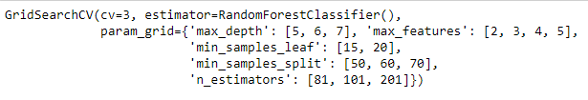
Here we have 2 added parameters which are max_features (the number of features to consider when looking for the best split) and n_estimators (the number of trees in the forest.)
After fitting these parameters into our model, the best parameters came out to be as below:
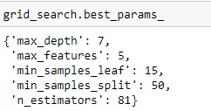
Now, as we have fit these parameters to our Random Forest classifier, the model has been successfully built.
We will now be checking their feature importance.
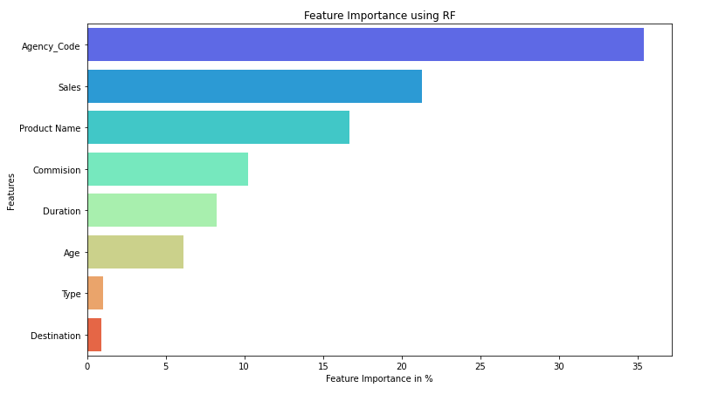
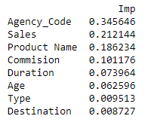
In this model, Agency_Code is still the most useful feature but its percentage has been decreased as compared to CART model. Here, the least useful feature is Destination.
We have successfully built our Random Forest model and we will be performing predictions and evaluating the model performance in further steps.
- MLP Classifier (Artificial Neural Network)
Neural networks are loosely representative of the human brain learning. An Artificial Neural Network consists of Neurons which in turn are responsible for creating layers. These Neurons are also known as tuned parameters.
The output from each layer is passed on to the next layer. There are different nonlinear activation functions to each layer, which helps in the learning process and the output of each layer. The output layer is also known as terminal neurons.
Each Neural Network is provided with a cost function which is minimised as the learning continues. The best weights are then used on which the cost function is giving the best results.
Before, building the model we need to first scale our train and test data.
Here, also we will be using the same grid search which we have used while building other models with some added parameters.
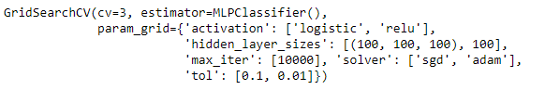
hidden_layer_sizes: The ith element represents the number of neurons in the ith hidden layer.
activation: {'logistic', 'relu'}, default='relu'. Activation function for the hidden layer.
- 'logistic', the logistic sigmoid function, returns f(x) = 1 / (1 + exp(-x)).
- 'relu', the rectified linear unit function, returns f(x) = max(0, x)
solver : {'sgd', 'adam'}, default='adam'. The solver for weight optimization.
- 'sgd' refers to stochastic gradient descent.
- 'adam' refers to a stochastic gradient-based optimizer
max_iter: Maximum number of iterations. The solver iterates until convergence (determined by 'tol') or this number of iterations.
tol : Tolerance for the optimization.
After fitting these parameters into our model, the best parameters came out to be as below:
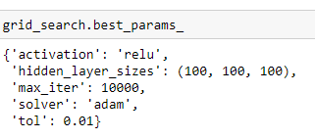
We cannot perform Feature importance for an MLPClassifier.
We have successfully built our Artificial Neural Network model and we will be performing predictions and evaluating the model performance in further steps.

Q 2.3 Performance Metrics: Comment and Check the performance of Predictions on Train and Test sets using Accuracy, Confusion Matrix, Plot ROC curve and get ROC_AUC score, classification reports for each model.
When building and optimizing a classification model, measuring how accurately it predicts our expected outcome is crucial. Therefore, we make use of Performance metrics like Confusion matrix, classification report, roc curve and roc_auc score.
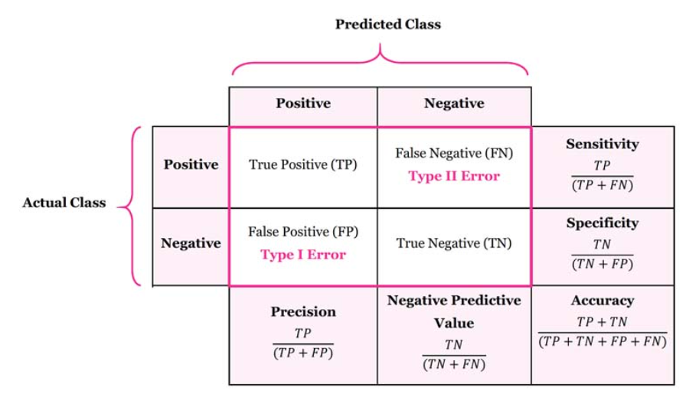
Confusion Matrix is a table depicting actual values and predicted values. The rows depict actual value and columns corresponds to predicted value.
- True Positive (TP): Observation is positive and is predicted to be positive.
- False Negative (FN): Observation is positive but is predicted negative
- True Negative (TN): Observation is negative and is predicted to be negative.
- False Positive (FP): Observation is negative but is predicted positive.
Accuracy is the most intuitive performance measure and it is simply a ratio of correctly predicted observation to the total observations.
Precision tell us what proportion of positive identifications was actually correct? It is defined as follows: TP/(TP+FP)
Sensitivity or Recall tells us what proportion of actual positives was identified correctly? It is defined as follows: TP/(TP+FN)
F1 Score is the weighted average of Precision and Recall. Therefore, this score takes both false positives and false negatives into account.
ROC is a probability curve and AUC represents the degree or measure of separability. It tells how much the model is capable of distinguishing between classes. Higher the AUC, the better the model is at predicting 0s as 0s and 1s as 1s.
Now, we will use these performance metrics and evaluate all the 3 models which we have built.
- Evaluation of CART model
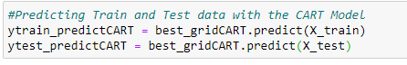
We have predicted our training and test data with our CART model and now we will evaluate its performance.
Checking the Performance of our training data
- Confusion Matrix and Classification Report
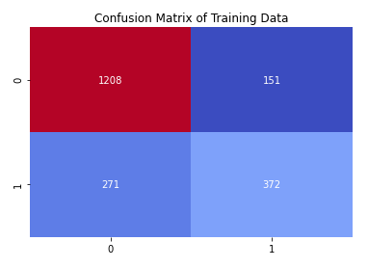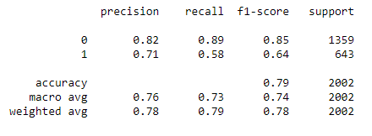
- Roc Curve and ROC_AUC score
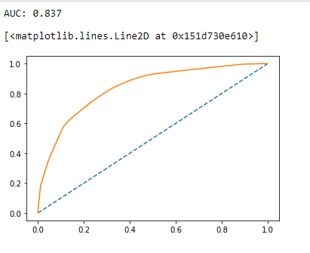
Training Data
- Accuracy: 79 %
- Precision: 71 %
- Recall: 58%
- F1-score: 64 %
- AUC: 83.7 %
Checking the Performance of our testing data
- Confusion Matrix and Classification Report
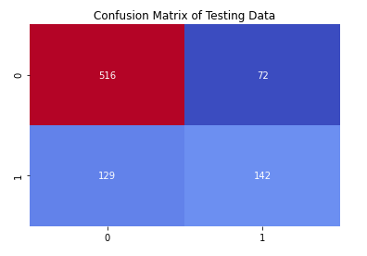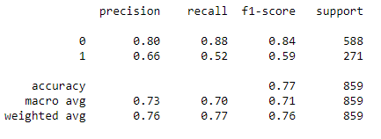
- Roc Curve and ROC_AUC score
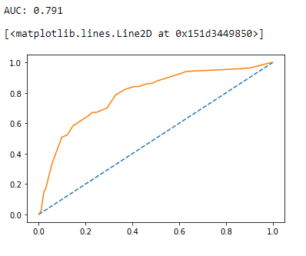
Test Data
- Accuracy: 77 %
- Precision: 66 %
- Recall: 52 %
- F1-score: 59 %
- AUC: 79.1 %

Conclusions on CART model
- Training and test set results are almost similar.
- However, the recall rate is very low as it is able to detect only 52 % of actual positives correctly.

- Evaluation of Random Forest model
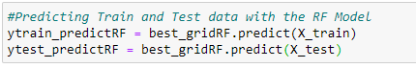
We have predicted our training and test data with our Random Forest model and now we will evaluate its performance.
Checking the Performance of our training data
- Confusion Matrix and Classification Report
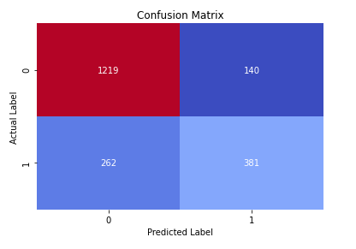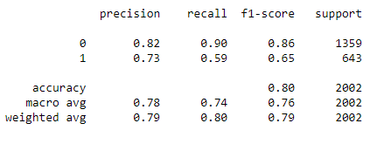
- Roc Curve and ROC_AUC score
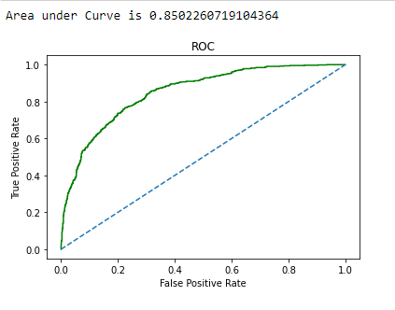
Training Data
- Accuracy: 80 %
- Precision: 73 %
- Recall: 59%
- F1-score: 65 %
- AUC: 85.06 %
Checking the Performance of our testing data
- Confusion Matrix and Classification Report
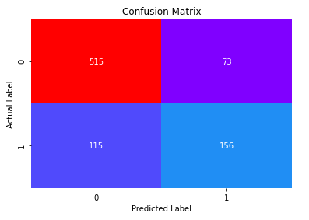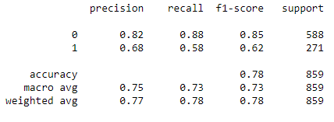
- Roc Curve and ROC_AUC score
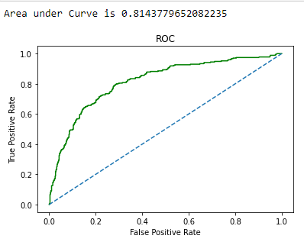
Test Data
- Accuracy: 78 %
- Precision: 68 %
- Recall: 58 %
- F1-score: 62 %
- AUC: 81.45 %

Conclusions on Random Forest model
- Training and test set results are almost similar.
- With the overall measures high, the model has performed good.

- Evaluation of Artificial Neural Network model
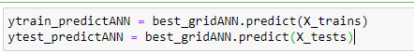
We have predicted our training and test data with our Artificial Neural Network model and now we will evaluate its performance.
Checking the Performance of our training data
- Confusion Matrix and Classification Report
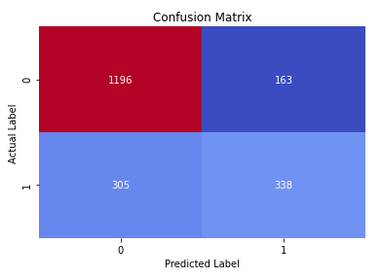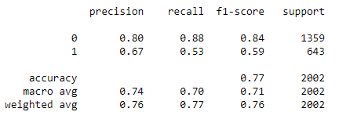
- Roc Curve and ROC_AUC score
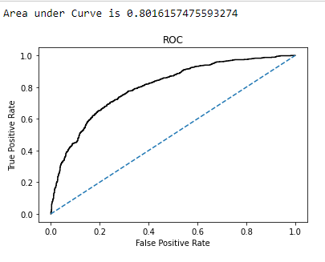
Training Data
- Accuracy: 77 %
- Precision: 67 %
- Recall: 53 %
- F1-score: 59 %
- AUC: 80.3 %

Checking the Performance of our testing data
- Confusion Matrix and Classification Report
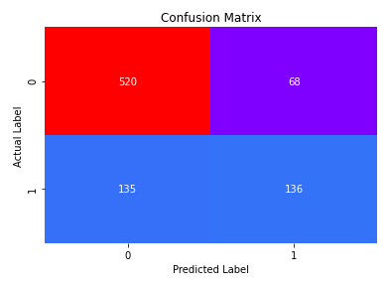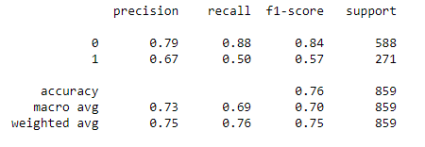
- Roc Curve and ROC_AUC score
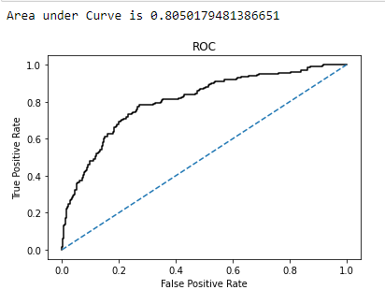
Test Data
- Accuracy: 76 %
- Precision: 67 %
- Recall: 50 %
- F1-score: 57 %
- AUC: 80.4 %
Conclusions on ANN model
- Training and Test set results are almost similar, and with the overall measures high, the model is a good model.
- Recall is still low

Q 2.4 Final Model: Compare all the models and write an inference which model is best/optimized.

- Comparison of the performance metrics from the 3 models
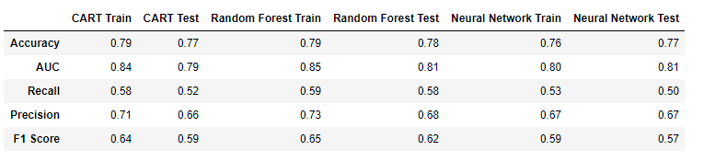
- The highest accuracy on train and test data is shown by Random Forest Model. However, other models have also performed closely well.
- Random forest shows the best recall rate i.e. 58% on test data.
- All the models have performed almost similarly over precision on test data with Random forest being the best.
- The recall is around 50% for all models which should have been improved. This might also mean that our data has insufficient proportions of our target variable.

- ROC Curve for the 3 models on the Training data
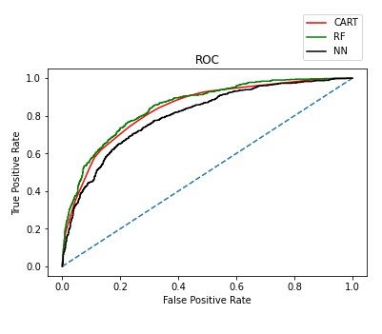
- Both the CART and Random forest model are performing well on the training data. However, Random forest has the best performance.
- Random forest has shown the highest AUC for the training data.
- On the training data, Ann model shows the least precision i.e. 67%

- ROC Curve for the 3 models on the Test data
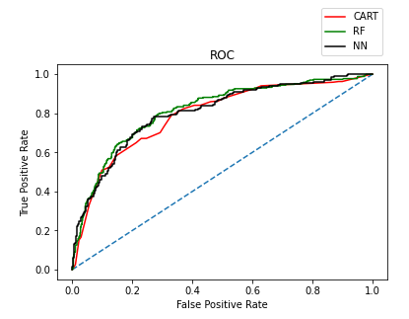
- However, on test data CART model seems to have the lowest performance and ANN has performed better.
- Random forest has performed the best on test data also with 78% accuracy.
- Also, random forest shows the highest F1 score i.e. 62 %

Final Conclusion
We have decided to go with the Random Forest Classifier as it has better f1 score, precision, accuracy and recall than the CART and ANN model.

Q 2.5 Inference: Based on the whole Analysis, what are the business insights and recommendations

- Agency JZI has sold only Bronze plans and all were of airlines type. We should consider providing training to its employees for better sales or upselling higher plans. They can also run some marketing promotions to increase their sales. It can also consider tying up with any of the other agencies.
- Agency C2B has highly performed in terms of sales of Gold and Silver plans but have only chosen Asia as a destination. Also, all the Sales is of type Airlines and which has the most claim frequency.
- Highest number of claims have happened for Gold and Silver plans.
- I think that more data should be required to better understand why the claim frequency has increased.
- For now, the insurance firm should check why claims are more for airlines.
- Our model is giving 78 % accuracy in predicting the claims. So, the firm can upsell the insurance as per the claim predicted by the model. The airlines and travel packages should be booked by customer itself and insurance can be upsell after checking the claim status.
- Most of the sales happened through online channel that means customer finds this experience is easy and it should be promoted more rather than offline.
- Agency Code and Sales are found to be the most important features for predicting claims through Random Forest Model.

