Machine Learning Project Business Report

DEEPTI AGRAWAL

Submission Date:

20th June 2021

TABLE OF CONTENTS

Problem 1:
Executive Summary…………………………………………………………………………………………….3
Introduction……………………………………………………………………………………………………..3
Data Description………………………………………………………………………………………………...3

- Data Ingestion:
  - Read the dataset. Do the descriptive statistics and do the null value condition check.
Write an inference on it…………………………………………………………………………………….3
1.2 Perform Univariate and Bivariate Analysis. Do exploratory data analysis. Check for Outliers…..7
- Data Preparation:
1.3 Encode the data (having string values) for Modelling. Is Scaling necessary here or not? Data Split: Split the data into train and test (70:30). …………………………………………………………………………………16
- Modelling:
1.4 Apply Logistic Regression and LDA (linear discriminant analysis)…………………………………………21
1.5 Apply KNN Model and Naïve Bayes Model. Interpret the results. …………………………………….24
1.6 Model Tuning, Bagging (Random Forest should be applied for Bagging), and Boosting……………………27
1.7 Performance Metrics: Check the performance of Predictions on Train and Test sets using Accuracy, Confusion Matrix, Plot ROC curve and get ROC_AUC score for each model. Final Model: Compare the models and write inference which model is best/optimized…………………………………………………………………………31
- Inference:
1.4 Based on these predictions, what are the insights? ...........................................................................................49

Problem 2:
Executive Summary.....................................................................................................................................51
Introduction.................................................................................................................................................51
Data Description..........................................................................................................................................51
2.1 Find the number of characters, words, and sentences for the mentioned documents………………………..51
2.2 Remove all the stopwords from all three speeches. ........................................................................................53
2.3 Which word occurs the most number of times in his inaugural address for each president? Mention the top three words. (After removing the stopwords)........................................................................................................59
2.4 Plot the word cloud of each of the speeches of the variable. (After removing the stop words)………………62
THE END! .............................................................................................................................................................64

Problem 1:

Executive Summary
You are hired by one of the leading news channels CNBE who wants to analyze recent elections. This survey was conducted on 1525 voters with 9 variables. You have to build a model, to predict which party a voter will vote for on the basis of the given information, to create an exit poll that will help in predicting overall win and seats covered by a particular party.

INTRODUCTION
The purpose of this whole exercise is to explore the dataset. Do the Exploratory Data Analysis. The data consists of survey of 1525 voters based on their age, economic national condition, political knowledge, Blair, Hague, etc. We will be making and analyzing multiple machine learning models and predict which party a voter will vote and to create an exit poll that will help in predicting overall win and seats covered by a particular party.

Data Description
Voter Survey Parameters:
- vote: Party choice: Conservative or Labour
- age: in years
- economic.cond.national: Assessment of current national economic conditions, 1 to 5.
- economic.cond.household: Assessment of current household economic conditions, 1 to 5.
- Blair: Assessment of the Labour leader, 1 to 5.
- Hague: Assessment of the Conservative leader, 1 to 5.
- Europe: an 11-point scale that measures respondents' attitudes toward European integration. High scores represent ‘Eurosceptic’ sentiment.
- political.knowledge: Knowledge of parties' positions on European integration, 0 to 3.
- Gender: female or male.

DATA INGESTION
Q 1.1 Read the dataset. Do the descriptive statistics and do the null value condition check.Write an inference on it.
The data has been loaded correctly to a data frame. It consists of survey of 1525 voters based on their age, economic national condition, political knowledge, Blair, Hague, etc.
Sample of the Dataset:
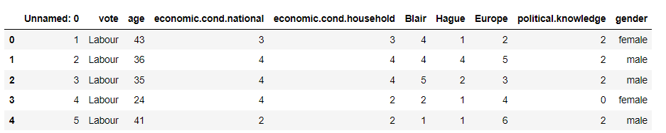
Dataset has survey of voters over 10 different attributes.

EXPLORATORY DATA ANALYSIS

We will be performing initial investigations on data so as to discover patterns, to spot anomalies and to check assumptions with the help of summary statistics and graphical representations.

Basic Info
Let us check the types of variables in the data frame.

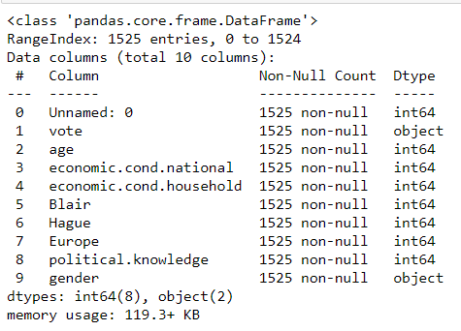

The data has 1525 instances with 10 attributes with 2 of type object and rest 8 are integer type.

Check for missing values

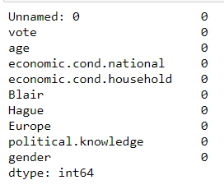
From the above result, we can see that there are no missing values present in our dataset.

We have dropped the column Unnamed: 0 as it is irrelevant for our modelling. Therefore our dataset now looks like below
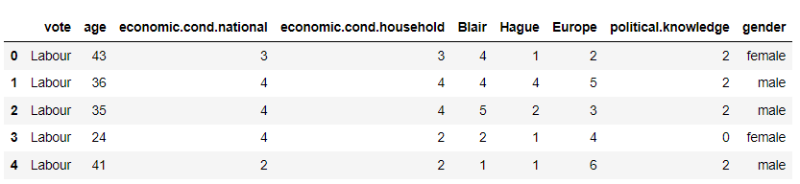
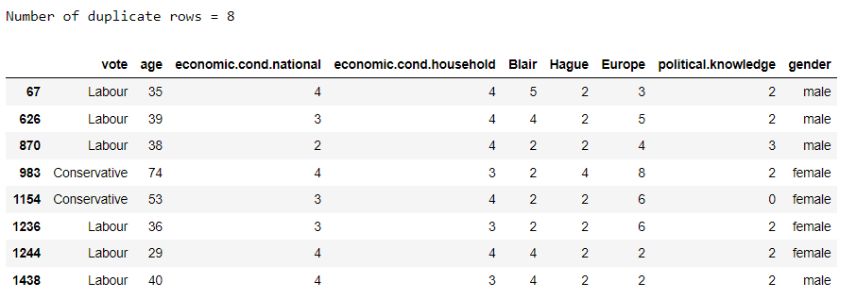

Also, upon checking we found that there are 8 duplicate records which are of no use for our analysis. Therefore, we will delete these 8 records.
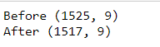
Our dataset now have 1517 observations left after deleting the duplicate records.

Check for zero values
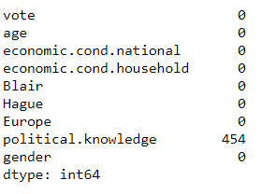
We only have zero values in column named political.knowledge which is okay because this column can have values 0, 1, 2 and 3 in it.

Descriptive statistics

We will proceed with checking the descriptive statistics of the data which helps understand its features by giving short summaries about the sample and measures of data.

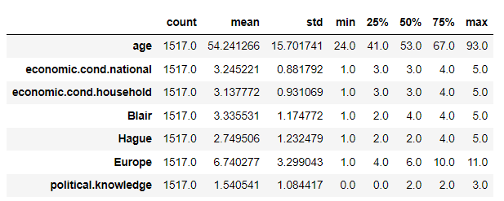
Table 2: Descriptive Statistics Table

From the descriptive statistics, we can see that

- The mean age of the voters is 54 years and minimum being 24 years.
- 25 % of voters have economic condition national less than or equal to 3
- The economic national condition and economic household condition is almost same on an average.
- 50 % of the voters accessed labour leader Blair as 4 or 5 but the average rating is 3.33
- 25 % of the voters accessed conservative leader Hague as a 4 or 5 but the average rating is 2.74
- 50% voters have a Europe score of 6 or less than 6. This means that we have equal percentage of supporters and oppositions.
- 25% people have no political knowledge
There are 2 categorical columns in our data namely vote and gender. Below are the various categories and counts of these columns.
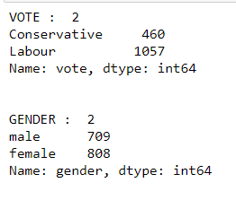
From this we can observe that we have an imbalanced data with 469 voters who have conservative as their party choice and 1057 who have labor as the choice. Number of females and males are almost equally distributed.
Inference from basic data analysis

- The data provided was in an excel format which we converted into a pandas data frame to ease our analysis.
- The data originally had 1525 instances with 10 attributes with 2 of type object and rest 8 are integer type. After which, we have dropped column named Unnamed: 0 as it was irrelevant. Also, we found 8 duplicate records which we have removed from our dataset as they will not add any value to our analysis. Finally, we are left with 1517 observations over 9 attributes.
- We do not have any null values or zero values in our dataset.
- The mean age of the voters is 54 years and minimum being 24 years.
- 25 % of voters have economic condition national less than or equal to 3
- The economic national condition and economic household condition is almost same on an average.
- 50 % of the voters accessed labour leader Blair as 4 or 5 but the average rating is 3.33
- 25 % of the voters accessed conservative leader Hague as a 4 or 5 but the average rating is 2.74
- 50% voters have a Europe score of 6 or less than 6. This means that we have equal percentage of supporters and oppositions.
- 25% people have no political knowledge.
- The two categorical columns are Vote and Gender. There are only 460 voters who prefer conservative and 1057 who have Labor as their party choice. Also, there are 709 male and 808 female voters in our dataset.

Q 1.2 Perform Univariate and Bivariate Analysis. Do exploratory data analysis. Check for Outliers.

UNIVARIATE ANALYSIS
Checking the Skewness of the data
Skewness is a measure of the symmetry of a distribution. The highest point of a distribution is its mode. The mode marks the response value on the x-axis that occurs with the highest probability. A distribution is skewed if the tail on one side of the mode is fatter or longer than on the other: it is asymmetrical.
We will see the graphical representation of what skewness is, in the next step where we will frequency plots of all the continuous variables.
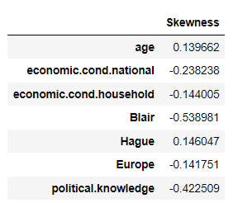
Here, we are checking the skewness quotient. Positive value means right skewed distribution and negative value means that the distribution is skewed to the left.
Here, we can see that only age and Hague have positive skewness quotient i.e. they are right skewed. Blair has the highest negative skewness.
Data Visualization

Frequency Plot for age Frequency Plot for economic.cond.national
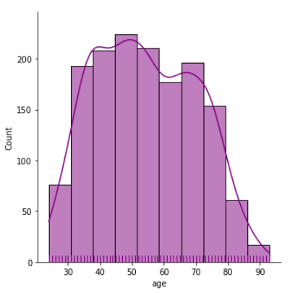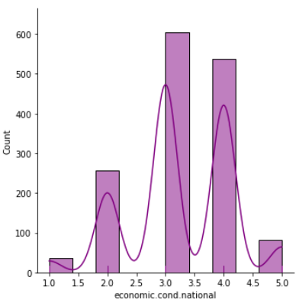

Frequency Plot for economic.cond.household Frequency Plot for Blair
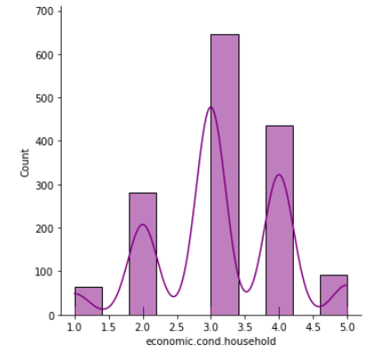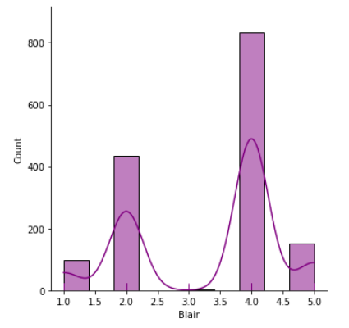
Frequency Plot for Hague Frequency Plot for Europe
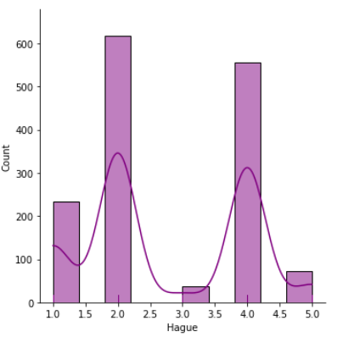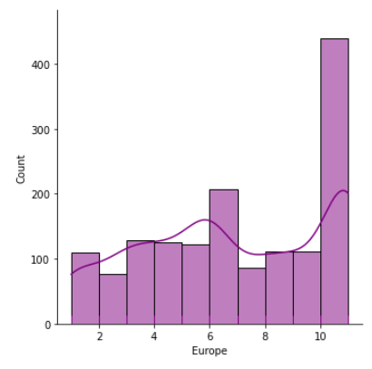
Frequency Plot for political.knowledge
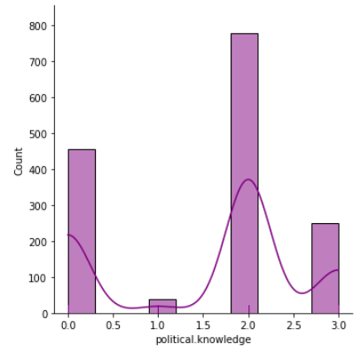
Observations from individual frequency plots:
- Age looks normally distributed with a little right skewness.
- Maximum voters have economic national condition between 3 and 4
- Maximum voters have economic household condition accessed as 3
- The labor leader Blair is accessed as 4 by most of the voters.
- The conservative leader Hague is accessed as 2 by most of the leaders
- Maximum people are highly Eurosceptic with a score of 10 and above. That means, these are people who criticize the European Union (EU) and European integration.
- Most of the people have a fair political knowledge accessed as 2. But, it is strange to see that there are still many people who vote and have zero political knowledge.

Checking for Outliers in the Data
An outlier is an observation that lies at an abnormal distance from other values in a random sample from a population.
Outliers are often bad data points but they should be investigated properly. Often they contain valuable information about the process under investigation or the data gathering and recording process.
Box Plots have lines extending from the boxes (whiskers) indicating variability outside the upper and lower quartiles.
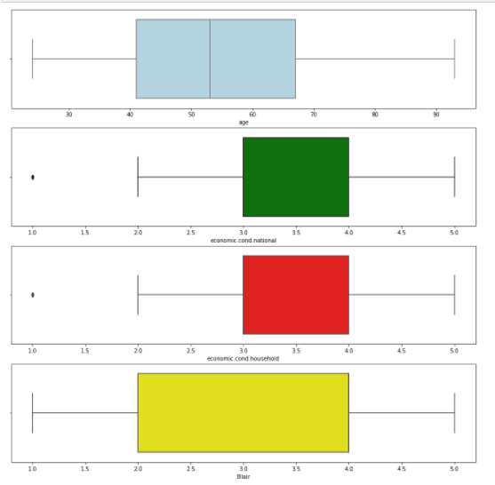
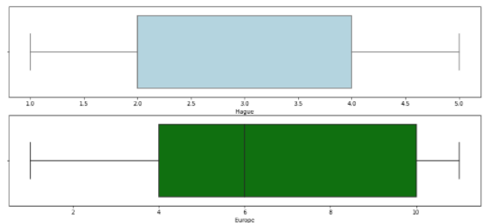
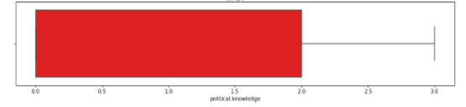
From the above boxplots of all continuous variables, we can observe that,
- We can see that only two columns i.e. economic.cond.national and economic.cond.household have outlier in them. Also, both these columns show similar boxplots i.e. similar distribution. This shows that there are few people who have extreme household and national conditions, either they are too rich or too poor. Here, an outlier on the lower side suggests that it indicates some poor people.
- Age looks almost normally distributed.
- Blair and Hague has a wide spread of data in between 2 and 4. Both these columns shows similar distribution in box plot.
- Maximum people have political knowledge graded as equal to or less than 2.
We have performed outlier removal on the columns economic.cond.national and economic.cond.household and rechecked their boxplots.
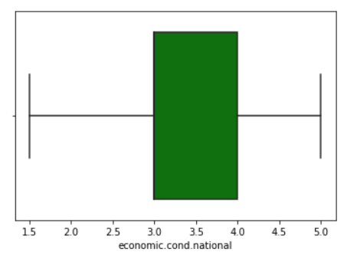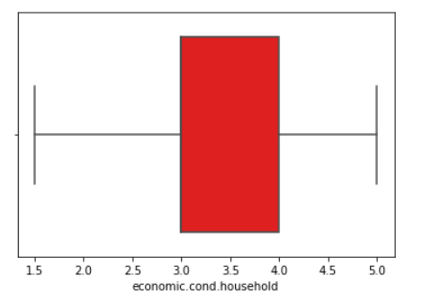

Individual Count plots for Categorical Variables
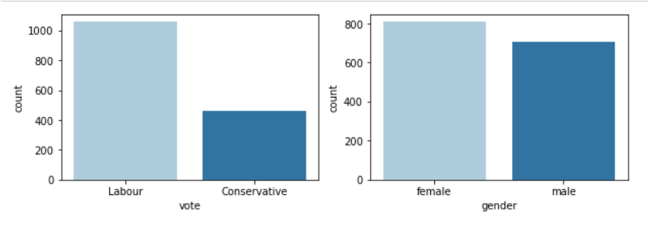
More voters have Labor party choice than Conservative party. There are almost equal number of men and women voters in our dataset.
BI-VARIATE ANALYSIS
- Viewing vote against age
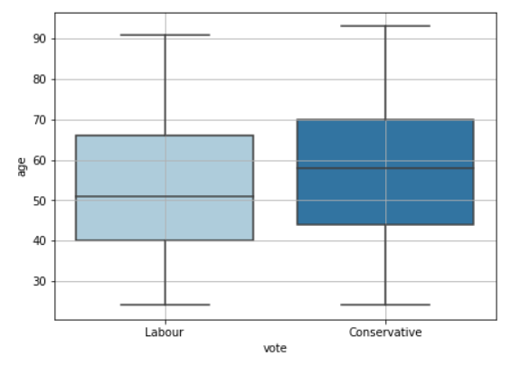
- Viewing vote against economic.cond.national and economic.cond.household individually
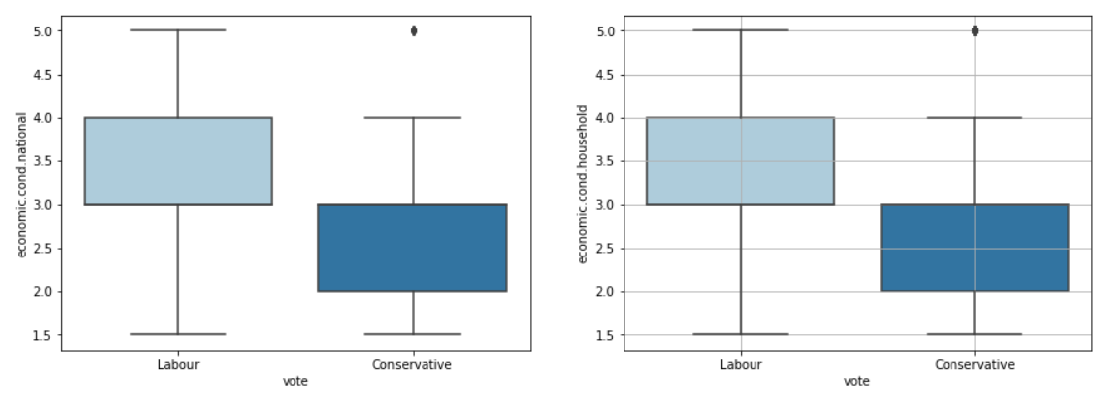
Here we observe that people with lower economic national condition and lower economic household condition have voted for conservative party.
- Viewing vote against Blair and Hague individually
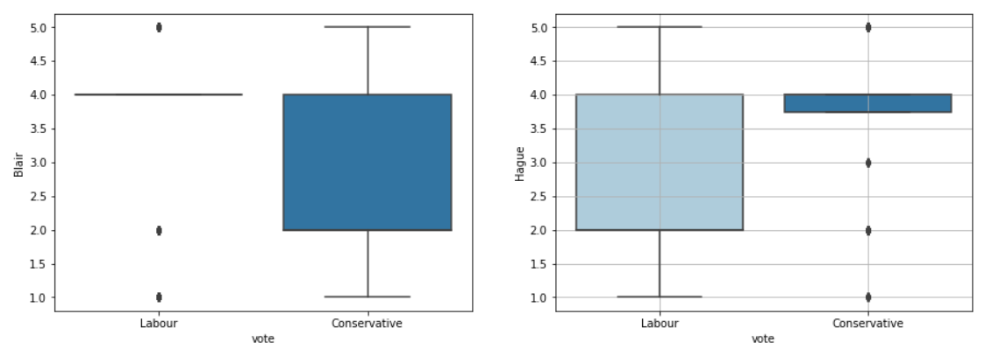
Where, Blair (labor leader) is accessed at less than 4, people have voted for conservative party and where Hague (conservative leader) is accessed at less than 4, people have voted for labor party. These are opposite of each other.
- Viewing vote against Europe and political.knowledge individually
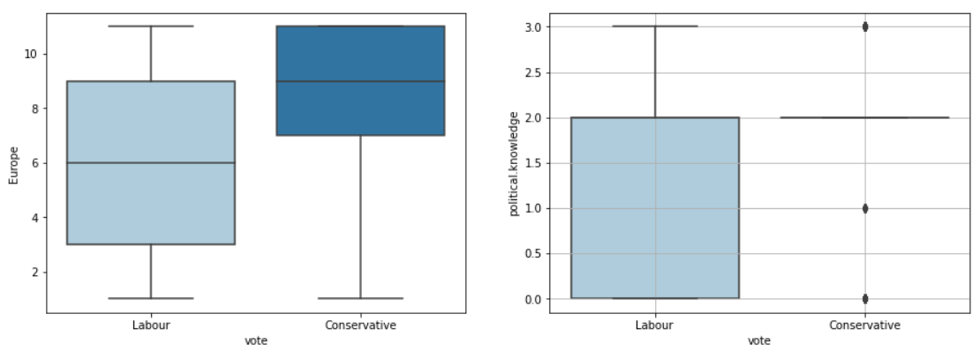
People who are less Eurosceptic (in support of European integration) i.e., they have a Europe score of less than 7 have mostly voted for labor party.
People who have zero political knowledge or between 0 and 2 have voted mostly for labor party.
MULTI-VARIATE ANALYSIS
- Viewing vote against age for both genders
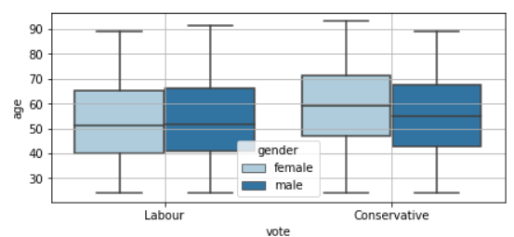
- Viewing vote against Hague for each Blair score and vice-versa
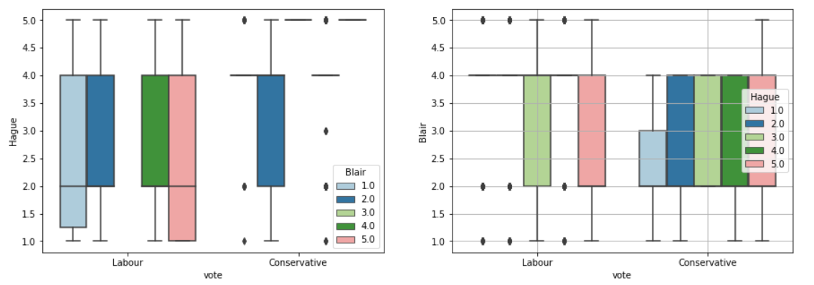
Voters who have accessed Blair at 2 have equal proportions of labor party and conservative party supporters. Also, there are voters who have accessed Hague at 5 and 3 but have still voted for labor party.

- Viewing vote against political.knowledge for each Europe score and vice-versa
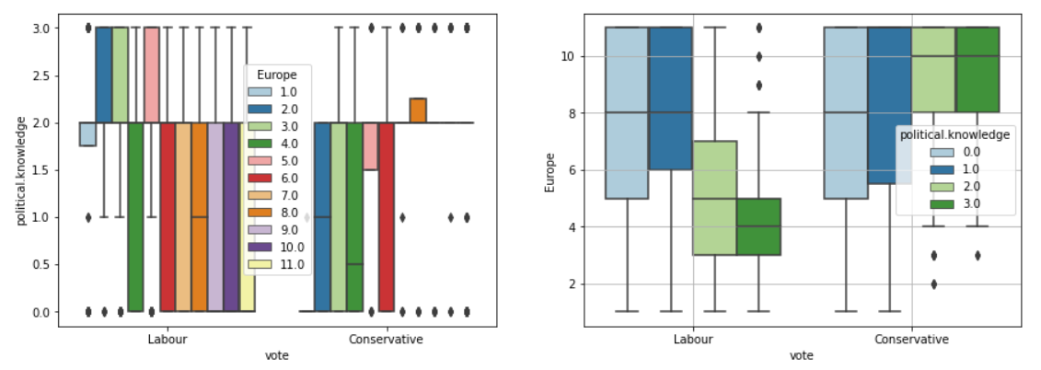
People who have high political knowledge have almost equal number of supporters and critics of European Union.

Pair-plot
We use pair plot to plot multiple pairwise bivariate distributions in a dataset. It creates a grid of Axes such that each numeric variable in data will be shared across the y-axes across a single row and the x-axes across a single column. The diagonal plots are treated differently: a univariate distribution plot is drawn to show the marginal distribution of the data in each column.
We are viewing the pair plot with Vote as a separator.
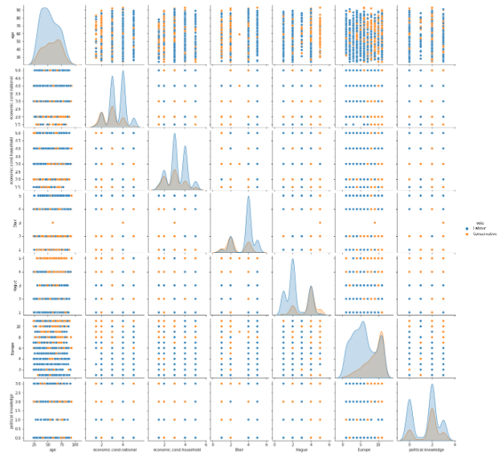
- As observed by the pair plot, Europe seems to be a very good predictor of vote.
- Other than that all variables seem to be a good predictor to some extent.

Correlation Matrix
We will be creating a correlation matrix (table) showing correlation coefficients between variables. Each cell in the table shows the correlation between two variables.
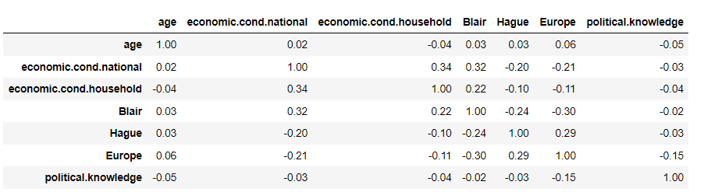
Now, we will observe the same correlations through individual correlation graphs and also a heat map of the same correlation matrix.

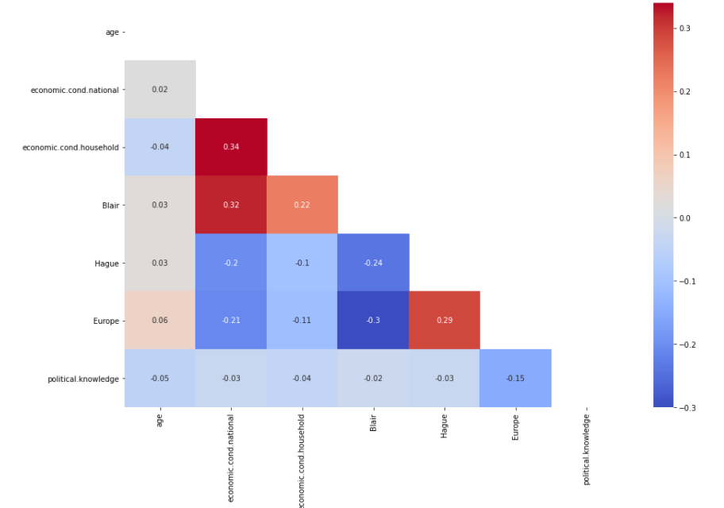

We have observed the following insights from correlation matrix and heat map.
- Europe and Blair are highly negatively correlated. Whereas, Europe and Hague are highly positively correlated.
- Hague and Blair are negatively correlated.
- Political knowledge and Europe also seems negatively correlated.
- Economic national condition is highly negatively correlated to Blair and Economic household condition.
- Blair is highly positively correlated to economic condition household.

Insights from Univariate, Bivariate and Multivariate Data Analysis

- Age looks normally distributed with a little right skewness.
- Maximum voters have economic national condition between 3 and 4
- Maximum voters have economic household condition accessed as 3
- The labor leader Blair is accessed as 4 by most of the voters.
- The conservative leader Hague is accessed as 2 by most of the leaders
- Maximum people are highly Eurosceptic with a score of 10 and above. That means, these are people who criticize the European Union (EU) and European integration.
- Most of the people have a fair political knowledge accessed as 2. But, it is strange to see that there are still many people who vote with zero political knowledge. Age looks normally distributed with a little right skewness.
- We can see that only two columns i.e. economic.cond.national and economic.cond.household have outlier in them. Also, both these columns show similar boxplots i.e. similar distribution. This shows that there are few people who have extreme household and national conditions, either they are too rich or too poor. Here, an outlier on the lower side suggests that it indicates some poor people. We have treated these outliers.
- Where, Blair (labor leader) is accessed at less than 4, people have voted for conservative party and where Hague (conservative leader) is accessed at less than 4, people have voted for labor party. These are opposite of each other.
- Blair is highly positively correlated to economic condition household.
- We have changed few column names for further easy modelling

DATA PREPARATION

Q 1.3 Encode the data (having string values) for Modelling. Is Scaling necessary here or not? Data Split: Split the data into train and test (70:30).
We know that most of the Machine Learning libraries accept only the data in the numerical form so it is essential to convert the Categorical variables present in our dataset into numbers. This means that if your data contains categorical data, you must encode it to numbers before you can fit and evaluate a model. We simply cannot drop them from our dataset as they are known to hide a lot of interesting information and it’s crucial to learn the methods of dealing with such variables.
We have 02 columns of object datatype in our data frame containing ordinal data. We need to encode them before modelling our data into various models.
Here we have 2 columns vote and gender.
For vote column, we have given number 1 to Conservative and 0 to Labour
For gender column, we have given number 1 to Male and 0 to Female
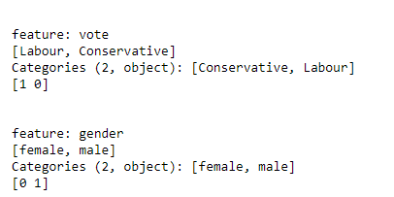
After Encoding, our dataset looks like this,
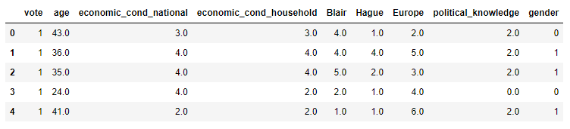
We have again checked the data info where we can clearly see that our object columns have now been converted to integer.
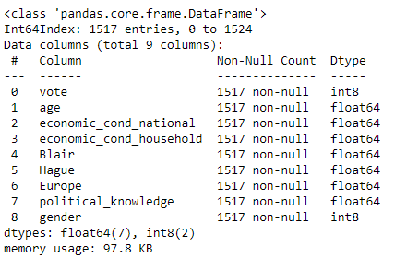

Is scaling necessary?



The descriptive statistics of our data suggests that, most of our data is ordinal.

No, scaling is not necessary for this case, although all of the attributes are numerical with few of them having different meaning. (e.g.: age and Europe have different scales). But, we can choose whether or not to scale our data depending on what kind of model are we building.
We can use various scaling techniques like feature scaling (also known as data normalization) which is a method used to standardize the range of features of data. Since, the range of values of data may vary widely, it becomes a necessary step in data preprocessing while using machine learning algorithms. Standardization helps to make the relative weight of each variable equal by converting each variable to a unit less measure or relative distance. Standardization prevents variables with larger scales from dominating how clusters are defined. It allows all variables to be considered by the algorithm with equal importance.
We can use a Standard Scaler which normalizes the data using the formula (x-mean)/standard deviation. Essentially returns the z-scores of every attribute. We will be doing this only for the numerical variables.
Machine learning algorithms like linear regression, logistic regression, neural network, etc. that use gradient descent as an optimization technique require data to be scaled. Take a look at the formula for gradient descent below:
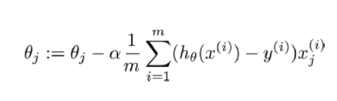
The presence of feature value X in the formula will affect the step size of the gradient descent. The difference in ranges of features will cause different step sizes for each feature. To ensure that the gradient descent moves smoothly towards the minima and that the steps for gradient descent are updated at the same rate for all the features, we scale the data before feeding it to the model.
We still have an option whether we need to scale a data or not. We will be building our model without scaling.

Checking for Multicollinearity

Multicollinearity occurs when two or more independent variables are highly correlated with one another in a regression model.
It can be a problem in a regression model because we would not be able to distinguish between the individual effects of the independent variables on the dependent variable.
It may not affect the accuracy of the model as much. But we might lose reliability in determining the effects of individual features in your model – and that can be a problem when it comes to interpretability.
We will detect multicollinearity in our data by using VIF (Variation Inflation Factor).
VIF determines the strength of the correlation between the independent variables. It is predicted by taking a variable and regressing it against every other variable. VIF score of an independent variable represents how well the variable is explained by other independent variables.
R^2 value is determined to find out how well an independent variable is described by the other independent variables. A high value of R^2 means that the variable is highly correlated with the other variables. This is captured by the VIF which is denoted below:
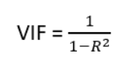
So, the closer the R^2 value to 1, the higher the value of VIF and the higher the multicollinearity with the particular independent variable.
The VIF of our data comes to be:
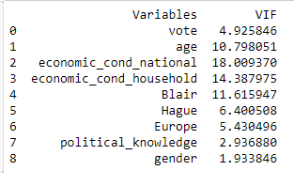
- Here we can observe the vif score for all columns except vote, political.knowledge and gender is higher than 5 and but they do not have very high value.
- This shows that our dataset does not have very high amount of multicollinearity between its datatypes.

Data Splitting

The train-test split is a technique for evaluating the performance of a machine learning algorithm. It can be used for classification or regression problems and can be used for any supervised learning algorithm.
The procedure involves taking a dataset and dividing it into two subsets. The first subset is used to fit the model and is referred to as the training dataset. The second subset is not used to train the model; instead, the input element of the dataset is provided to the model, then predictions are made and compared to the expected values. This second dataset is referred to as the test dataset.
Train Dataset: Used to fit the machine learning model.
Test Dataset: Used to evaluate the fit machine learning model.
The objective is to estimate the performance of the machine learning model on new data: data not used to train the model.
Here, we have vote as our target variable i.e. which is to be predicted.
Therefore, we will separate this column from our dataset before splitting it into train and test data.

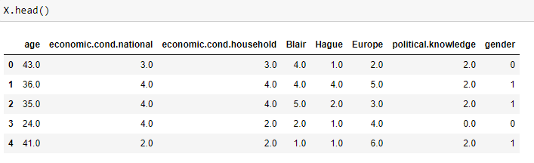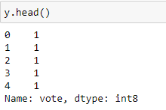
Now, we will perform our splitting process on these data frames. Here, we are splitting the data into 70% training and 30% testing data.
Training data (contains 1061 observations)
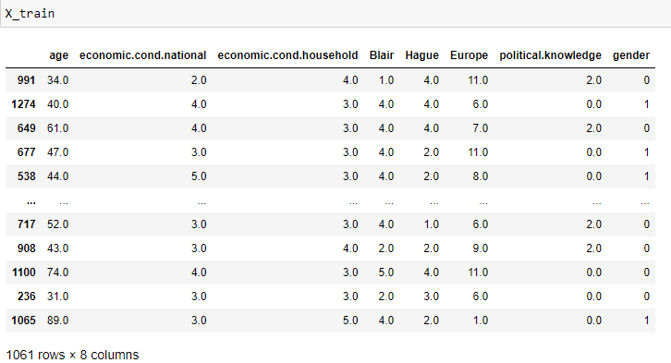

Testing data (contains 456 observations)
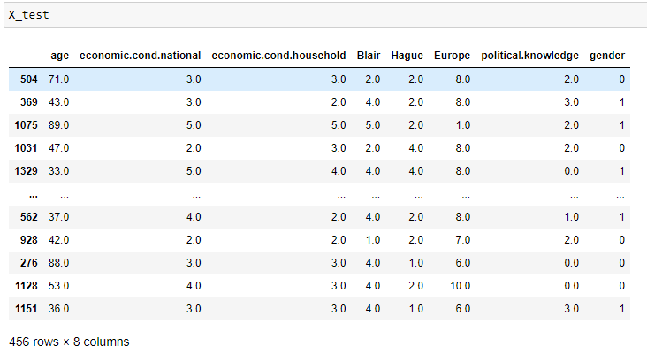

MODELLING
Q 1.4 Apply Logistic Regression and LDA (linear discriminant analysis).
Now, on the previously splitted training and testing data we will be used in building different classifications models like Logistic Regression and Linear Discriminant Analysis.

M1. BUILDING Logistic Regression MODEL
Logistic regression is a statistical model that in its basic form uses a logistic function to model a binary dependent variable, although many more complex extensions exist in regression analysis.
It is a supervised learning method for classification. It establishes relation between dependent class variable and independent variables using regression.
The dependent variable is categorical i.e. it can take only integral values representing different classes. The probabilities describing the possible outcomes of a query point are modelled using a logistic function.
Here, the dependent variable is vote.

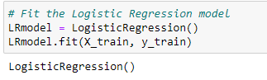
Here, we have instantiated the Logistic Regression Model.
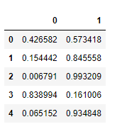
These are the predicted probabilities on our test set.
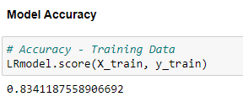
Our model accuracy comes out to be 83.41 %. Now, we will apply grid search and find out the best parameters for building the model on given data.

Model Tuning

Tuning is the process of maximizing a model's performance without overfitting or creating too high of a variance. In machine learning, this is accomplished by selecting appropriate “hyper parameters.”

- Penalty: Used to specify the norm used in the penalization. The ‘newton-cg’, ‘sag’ and ‘lbfgs’ solvers support only l2 penalties. This is why we are checking for either l2 penalty or none.
- Solver: For small datasets, ‘liblinear’ is a good choice. For multiclass problems, only ‘newton-cg’,‘lbfgs’ handle multinomial loss; ‘liblinear’ is limited to one-versus-rest schemes.
- Tol: Tolerance for stopping criteria.
- Max-iter: maximum number of iterations taken for the solvers to converge.
- N_jobs: Number of CPU cores used when parallelizing over classes. This parameter is ignored when the solver is set to ‘liblinear’ regardless of whether ‘multi_class’ is specified or not.

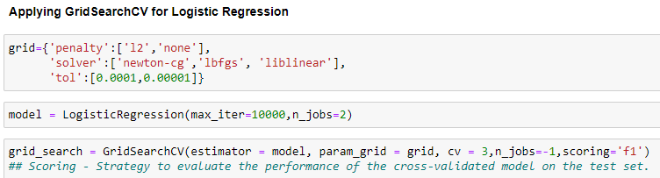

Given below, are the best parameters and best estimator model which we will be using for further analysis.

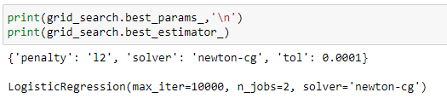
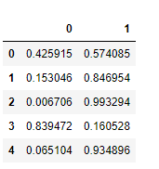
We can see that probabilities on our test data looks almost same as previous.

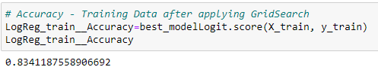

Our model has the same accuracy with and without applying grid search parameters. We will be evaluating the performance matrix of our Logistic Regression model later. Also, we will do hypothesis testing on our model and form the equation.

M2. BUILDING LDA model

Discriminant Analysis is used for classifying observations to a class or category based on predictor (independent) variables of the data. It creates a model to predict future observations where the classes are known.
LDA uses linear combinations of independent variables to predict the class in the response variable of a given observation. LDA assumes that the independent variables (p) are normally distributed and there is equal variance / covariance for the classes. LDA is popular, because it can be used for both classification and dimensionality reduction.
LDA is based upon the concept of searching for a linear combination of predictor variables that best separates the classes of the target variable.
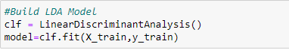
Here, we have instantiated the LDA Model.
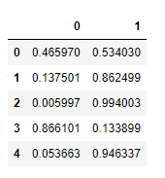

These are the predicted probabilities on our test set.
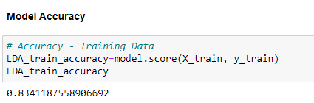

Model Tuning

We will try changing the cut-off value and evaluate our model on accuracy, recall, precision and f1 score.
We see that 0.4 and 0.5 gives better accuracy than the rest of the custom cut-off values. We can choose any of them because both shows a good recall, precision and F1 score. Here, we will take the cut-off as 0.5 to get the optimum 'f1' score which is the default only.

Let us evaluate the predictions of the test data using these cut-off values.
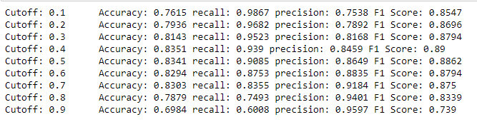
We can see that cut-off value 0.5 and 0.4 gives almost same scores. Therefore, we will go forward with or original model only.
We will be evaluating the performance matrix of our LDA model later.
Q 1.5 Apply KNN Model and Naïve Bayes Model. Interpret the results.

M3. BUILDING KNN MODEL

KNN algorithm also known as K-Nearest Neighbors Algorithm is used to solve the both problems of classification as well as regression. This working principle of algorithm is mainly based on feature similarity in both classification and regression problem. KNN classifier is different from other probabilistic classifiers where the model comprises a learning step of computing probabilities from a training sample and use them for future prediction of a test sample. In probability based model once the model is trained the training sample could be thrown away and classification is done using the computed probabilities.
In KNN there is no learning step involved instead the dataset is stored in memory and is used to classify the test query on the fly. KNN is also known as lazy learner as it does not create a model using training set in advance. It is one of the simplest methods of classification. In KNN, the term `k’ is a parameter which refers to the number of nearest neighbors.
The classification procedure for a query point q works in two steps as:
1. Find the K neighbors in the dataset which are closet to q based on the similarity measure.
2. Use these K neighbors to determine the class of q using majority voting.
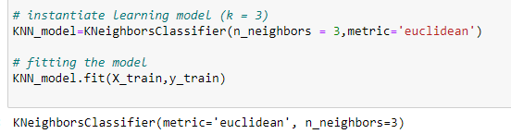
Here, we have instantiated the KNN Model using k value=3 and distance measure as Euclidean distance.
We will run the KNN with no of neighbors to be 1,3,5..19 and will find the optimal number of neighbors from this list using the Misclassification error.
Misclassification error (MCE) = 1 - Test accuracy score. We will calculate MCE for each model with neighbors = 1,3,5...19 and will find out the model with lowest MCE.
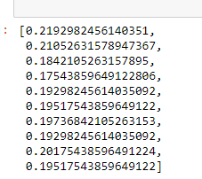
These are the Misclassification scores out of which we will find the minimum.
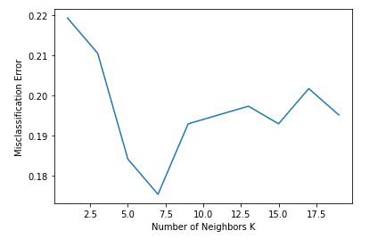
We find that the minimum is for K=7
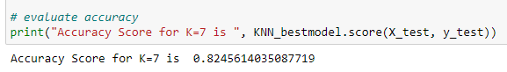
We can see that accuracy on test score is 82.45 %

M4. BUILDING naïve BAYES MODEL

Naïve Baye’s Classifier works on the principle of baye’s theorem with a naïve assumption of that a presence of a particular feature in a class is completely unrelated to the presence of other features (Input features are independent from each other). The naïve baye’s classifier is expressed as:
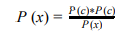
Where, P (c|x) is the posterior probability of class c for given predictor feature x.
P(c) is the prior probability of class c.
P(x) is the prior probability of predictor.
And P (x|c) is the likelihood of the probability of predictor x for given class c.
The above equation is interpreted as
Gaussian Naïve Bayes
It is easy to compute probabilities for categorical variable x, but what if the variable x is continuous? If we assume that the variable x follows a specific distribution then we can use the probability density function to compute the probability of given value. Gaussian Naïve Baye’s Classifier assumes that the continuous values associated with each feature are normally distributed or follow normal distribution.
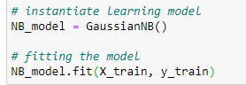
Here, we have instantiated the Gaussian Naive Bayes Model.

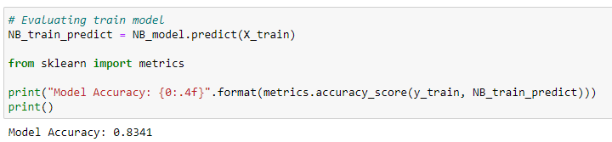
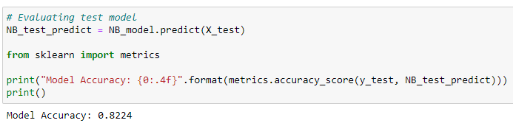
Hyper parameters
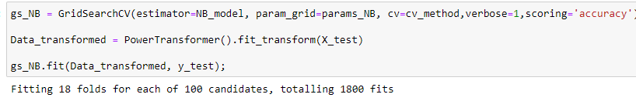
After using hyper parameters the accuracy on test set has improved from 82.24% to 83.11 %
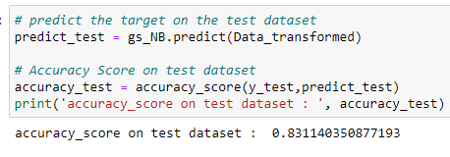
We will be evaluating the performance matrix of our Naïve Bayes model later.

Q 1.6 Model Tuning, Bagging (Random Forest should be applied for Bagging), and Boosting.

M5. BUILDING BAGGING MODEL USING RANDOM FOREST

Bagging is an ensemble algorithm that fits multiple models on different subsets of a training dataset, then combines the predictions from all models. Random forest is an extension of bagging that also randomly selects subsets of features used in each data sample.
Bootstrap Aggregation (Bagging) is a general procedure that can be used to reduce the variance for those algorithm that have high variance. An algorithm that has high variance are decision trees, like classification and regression trees (CART).
A problem with decision trees like CART is that they are greedy. They choose which variable to split on using a greedy algorithm that minimizes error. As such, even with Bagging, the decision trees can have a lot of structural similarities and in turn have high correlation in their predictions.
Combining predictions from multiple models in ensembles works better if the predictions from the sub-models are uncorrelated or at best weakly correlated.
Random forest changes the algorithm for the way that the sub-trees are learned so that the resulting predictions from all of the subtrees have less correlation.

First we will be building our base model which is Random Forest.
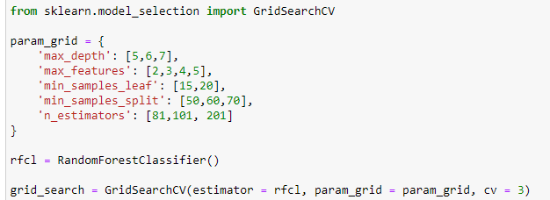
Here, we have instantiated Random forest model.
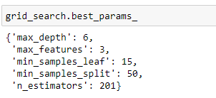
These are the best parameters for our model.
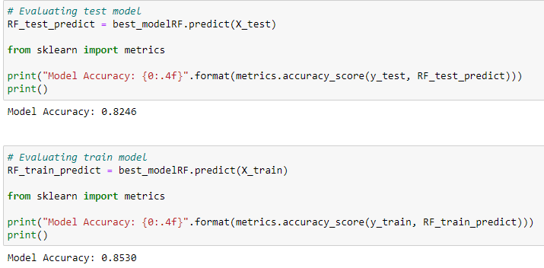
The train accuracy is 85.30 % and test accuracy is 82.46 % for our base model upon which we will build bagging model.
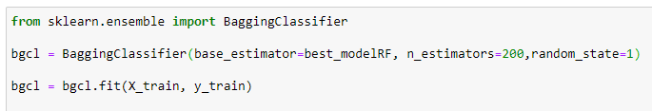
Here, we have instantiated the bagging classifier and fit it into our data.
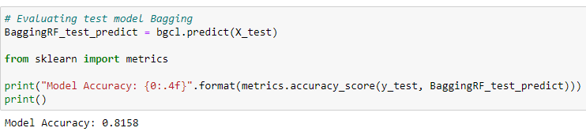
We can see that bagging model has further decreased our test accuracy to 81.58 %
We will evaluate the performance matrix later.

No, we will build boosting models i.e. Adaptive Boosting and Gradient Boosting.
Boosting is loosely-defined as a strategy that combines multiple simple models into a single composite model. With the introduction of more simple models, the overall model becomes a stronger predictor. In boosting terminology, the simple models are called weak models or weak learners.

M6. BUILDING AdaBOOSTING MODEL

AdaBoost algorithm, short for Adaptive Boosting, is a Boosting technique that is used as an Ensemble Method in Machine Learning. It is called Adaptive Boosting as the weights are re-assigned to each instance, with higher weights to incorrectly classified instances. Boosting is used to reduce bias as well as the variance for supervised learning. It works on the principle where learners are grown sequentially. Except for the first, each subsequent learner is grown from previously grown learners. In simple words, weak learners are converted into strong ones.
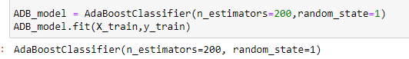
Here, we have instantiated the AdaBoost Model.

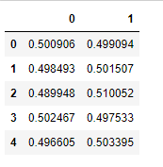
These are the predicted probabilities on our test set.
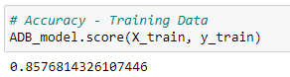
Our model accuracy comes out to be 85.71 % which is already the best accuracy score achieved so far.

M7. BUILDING GRADIENT BOOSTING MODEL

Gradient boosting is one of the most powerful techniques for building predictive models gradient boosting re-defines boosting as a numerical optimization problem where the objective is to minimize the loss function of the model by adding weak learners using gradient descent. Gradient descent is a first-order iterative optimization algorithm for finding a local minimum of a differentiable function. As gradient boosting is based on minimizing a loss function, different types of loss functions can be used resulting in a flexible technique that can be applied to regression, multi-class classification, etc.
It is a stage-wise additive model that generates learners during the learning process (i.e., trees are added one at a time, and existing trees in the model are not changed). The contribution of the weak learner to the ensemble is based on the gradient descent optimization process. The calculated contribution of each tree is based on minimizing the overall error of the strong learner.

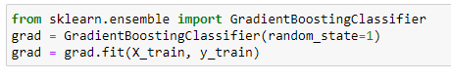
Here, we have instantiated the Gradient Boost Model.
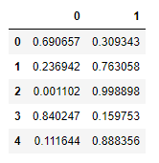
These are the predicted probabilities on our test set.
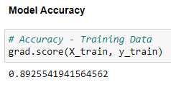
Our model accuracy comes out to be 89.25% which is the best accuracy score achieved so far beating the previous one achieved by adaboost model.

Q 1.7 Performance Metrics: Check the performance of Predictions on Train and Test sets using Accuracy, Confusion Matrix, Plot ROC curve and get ROC_AUC score for each model. Final Model: Compare the models and write inference which model is best/optimized.
When building and optimizing a regression model, measuring how accurately it predicts our expected outcome is crucial. Therefore, we make use of Performance metrics like Confusion matrix, classification report, roc curve and roc_auc score.
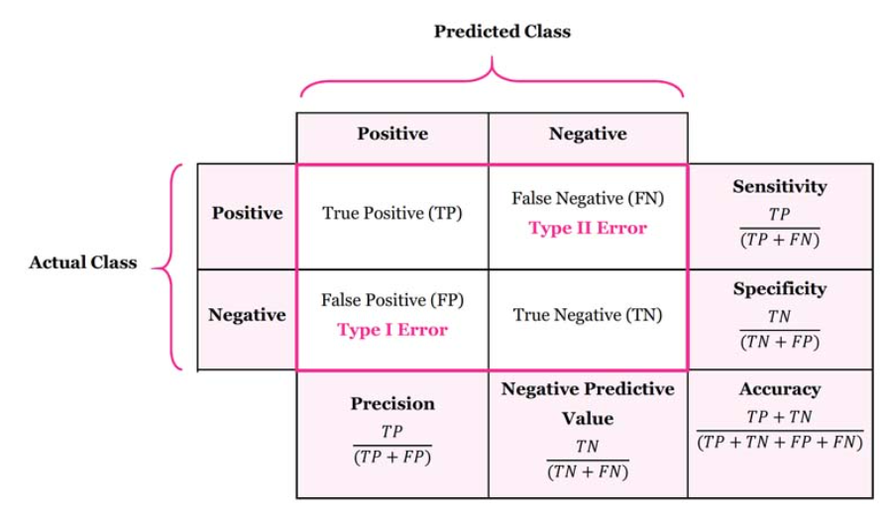
Confusion Matrix is a table depicting actual values and predicted values. The rows depict actual value and columns corresponds to predicted value.
- True Positive (TP): Observation is positive and is predicted to be positive.
- False Negative (FN): Observation is positive but is predicted negative
- True Negative (TN): Observation is negative and is predicted to be negative.
- False Positive (FP): Observation is negative but is predicted positive.
Accuracy is the most intuitive performance measure and it is simply a ratio of correctly predicted observation to the total observations.
Precision tell us what proportion of positive identifications was actually correct? It is defined as follows: TP/ (TP+FP)
Sensitivity or Recall tells us what proportion of actual positives was identified correctly? It is defined as follows: TP/ (TP+FN)
F1 Score is the weighted average of Precision and Recall. Therefore, this score takes both false positives and false negatives into account.
ROC is a probability curve and AUC represents the degree or measure of separability. It tells how much the model is capable of distinguishing between classes. Higher the AUC, the better the model is at predicting 0s as 0s and 1s as 1s.
Now, we will use these performance metrics and evaluate all the models which we have built.

P1. Evaluation of Logistic Regression model
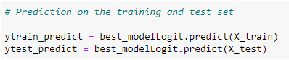
We have predicted our training and test data with our Logit model and now we will evaluate its performance.
Checking the Performance of our training data
- Confusion Matrix and Classification Report

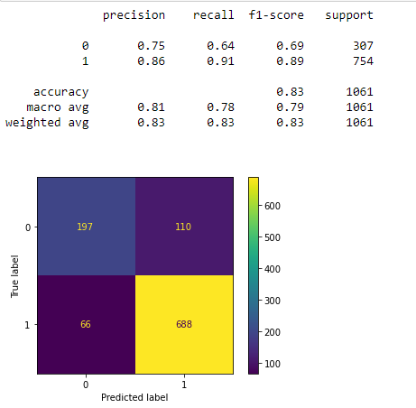
- Roc Curve and ROC_AUC score
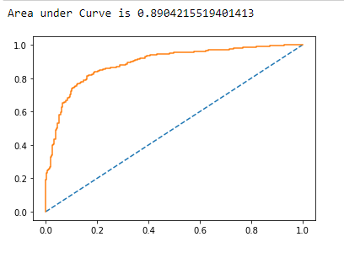
Checking the Performance of our testing data
- Confusion Matrix and Classification Report
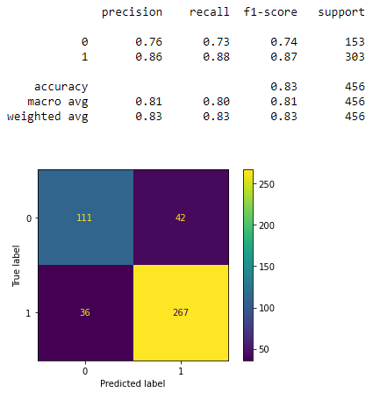
- Roc Curve and ROC_AUC score
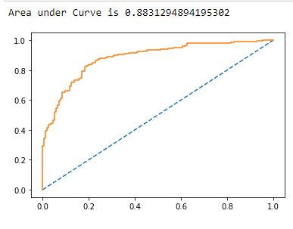
Hypothesis testing on our model
To establish the reliability of the coefficients, we need hypothesis testing.
The Null hypothesis (H0) claims there is no relation between price and any of the variables. That means the coefficient is 0 in the universe. Assuming H0 to be true, what is the probability of finding the coefficients found in the sample if the sample is drawn from that universe in which H0 is true.
At 95% confidence level if the p value is < .05, we reject the H0 i.e. probability of finding these coefficients in sample if they are 0 in the universe is very low. If p value is >=.05, we do not have sufficient evidence in the data to reject the H0 and hence we do not reject H0. We believe H0 is likely to be true in the universe.
The summary, looks like below:
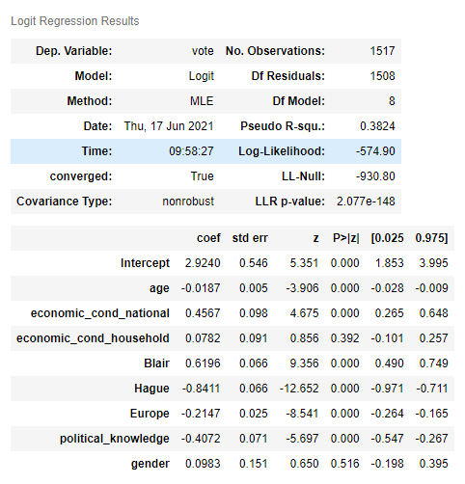
- Attributes such as gender and economic_cond_household have P value > 0.05 and hence statistically their coefficients are not reliable.
- Overall, model P value is lower than 0.05 which means model is reliable and has no useless attributes.
So, finally we have got our Logistic Regression Equation is
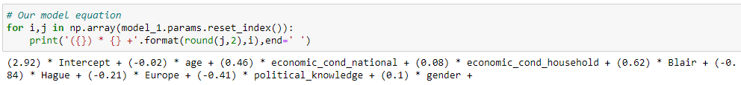
Conclusions from our Logistic Regression Model
TRAINING DATA  - Accuracy : 83.41%  - AUC : 89.04%  - Precision : 86%  - Recall : 91%  - F1 score : 89% | TEST DATA  - Accuracy : 82.89%  - AUC : 88.31%  - Precision : 86%  - Recall : 88%  - F1 score : 87%

Overall Summary
- Our test model is very close to the training model.
- Overall the model has a good recall, precision and f1 score

P2. Evaluation of LDA model
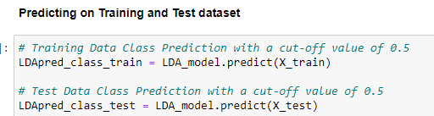
We have predicted our training and test data with our LDA model and now we will evaluate its performance.
Checking the Performance of our training data
- Confusion Matrix and Classification Report
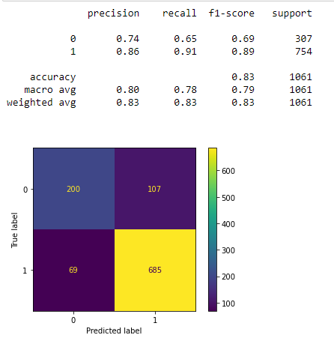
- Roc Curve and ROC_AUC score
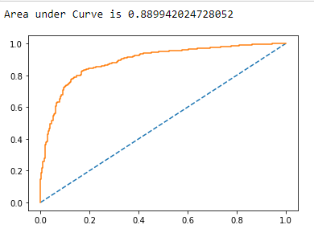

Checking the Performance of our testing data
- Confusion Matrix and Classification Report
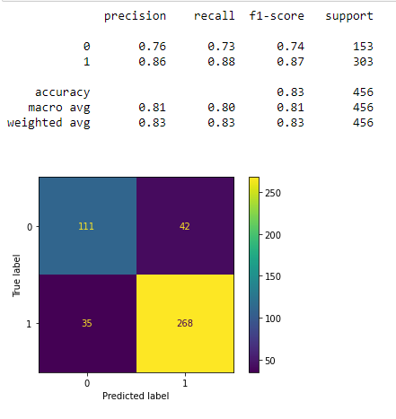
- Roc Curve and ROC_AUC score
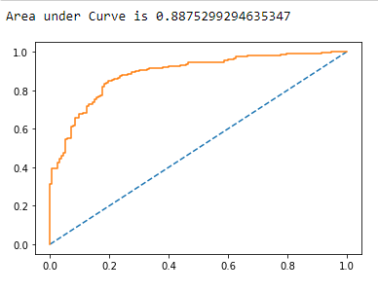
Conclusions on LDA model
TRAINING DATA  - Accuracy : 83.41%  - AUC : 88.89%  - Precision : 86%  - Recall : 91%  - F1 score : 89% | TEST DATA  - Accuracy : 83.11%  - AUC : 88.75%  - Precision : 86%  - Recall : 88%  - F1 score : 87%

OVERALL SUMMARY
- Our test model is very close to the training model.
- Overall the model has a good recall, precision and f1 score

P3. Evaluation of KNN model
Predicting on the training and test set
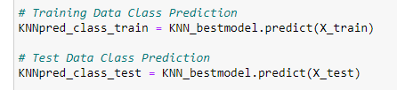
We have predicted our training and test data with our KNN model and now we will evaluate its performance.
Checking the Performance of our training data
- Confusion Matrix and Classification Report

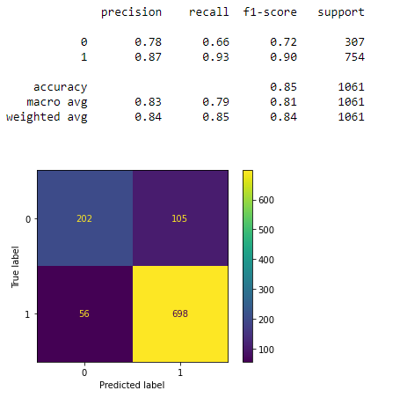
- Roc Curve and ROC_AUC score
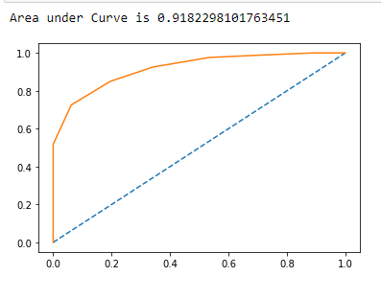

Checking the Performance of our testing data
- Confusion Matrix and Classification Report
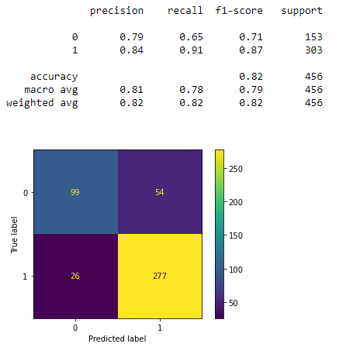
- Roc Curve and ROC_AUC score
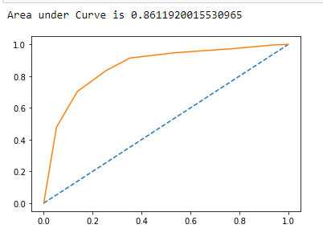
Conclusions on KNN model
TRAINING DATA.  - Accuracy : 84.82%  - AUC : 91.82%  - Precision : 87%  - Recall : 93%  - F1 score : 90% | TEST DATA  - Accuracy : 82.45%  - AUC : 86.11%  - Precision : 84%  - Recall : 91%  - F1 score : 87%
OVERALL SUMMARY
- Our test model is very close to the training model. The train accuracy is the best achieved so far.
- Overall the model has a good recall, precision and f1 score

P4. Evaluation of naïve Bayes model
We have predicted our training and test data with our Gaussian Naïve Bayes model and now we will evaluate its performance.
Checking the Performance of our training data
- Confusion Matrix and Classification Report

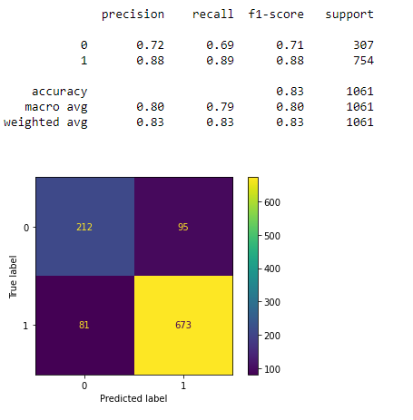
- Roc Curve and ROC_AUC score
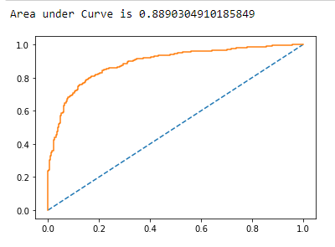

Checking the Performance of our testing data
- Confusion Matrix and Classification Report
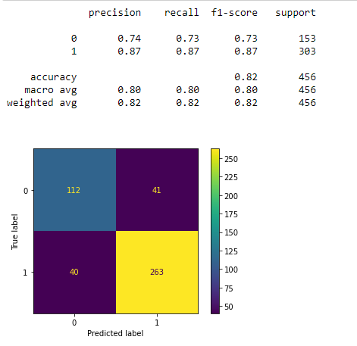
- Roc Curve and ROC_AUC score
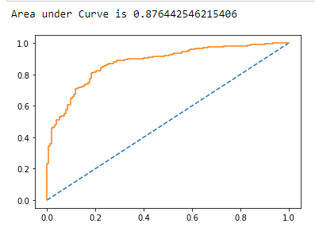
We tuned our model and predicted the test set.
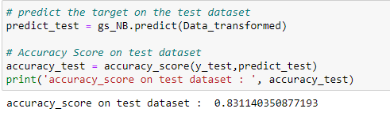

Performance Matrix after Hyper parameters on test set
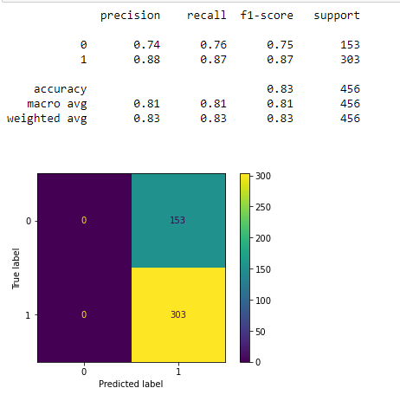
The accuracy on test set has improved from 82.23 % to 83 %
Conclusions on Naïve Bayes model
TRAINING DATA.  - Accuracy : 83.41%  - AUC : 88.9%  - Precision : 88%  - Recall : 89%  - F1 score : 88% | TEST DATA  - Accuracy : 82.23%  - AUC : 87.64%  - Precision : 87%  - Recall : 87%  - F1 score : 87%

OVERALL SUMMARY
- Our test model is very close to the training model.
- Overall the model has a good recall, precision and f1 score
- The test accuracy has improved a bit after applying hyper parameters to our model.

P5. Evaluation of Bagging model using random forest
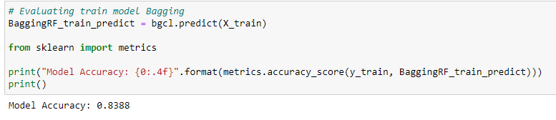
We have predicted our training and test data with our Bagging model and now we will evaluate its performance.
Checking the Performance of our training data
- Confusion Matrix and Classification Report
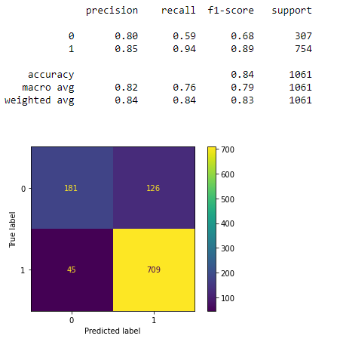
- Roc Curve and ROC_AUC score
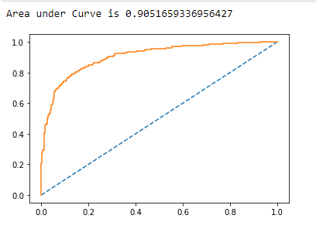
Checking the Performance of our testing data
- Confusion Matrix and Classification Report

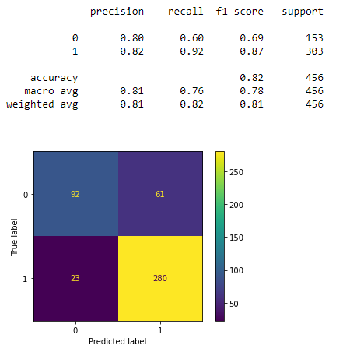
- Roc Curve and ROC_AUC score
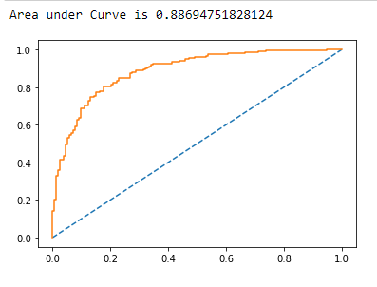
Conclusions on Bagging (RF) model
TRAINING DATA.  - Accuracy : 83.88%  - AUC : 90.51%  - Precision : 85%  - Recall : 94%  - F1 score : 89% | TEST DATA  - Accuracy : 81.57%  - AUC : 88.69%  - Precision : 82%  - Recall : 92%  - F1 score : 87%

OVERALL SUMMARY
- Our test accuracy has dropped down to 81.58 % which is the least so far.
- Overall the model has a good recall, precision and f1 score
- This model has performed slightly lesser than the other models.

P6. Evaluation of ADABOOST model
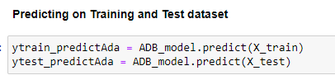
We have predicted our training and test data with ourAdaBoost model and now we will evaluate its performance.
Checking the Performance of our training data
- Confusion Matrix and Classification Report
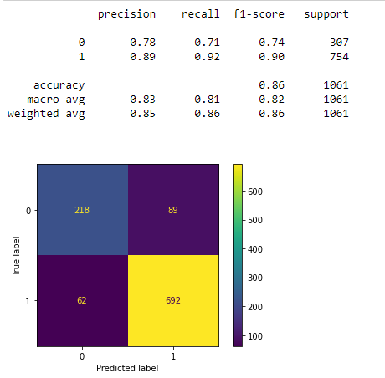
- Roc Curve and ROC_AUC score
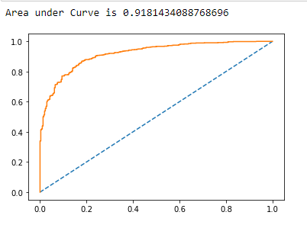
Checking the Performance of our testing data
- Confusion Matrix and Classification Report

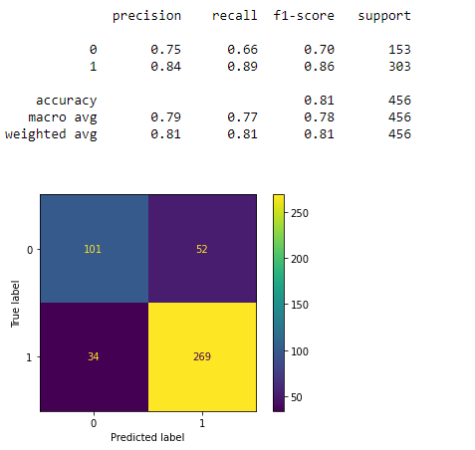
- Roc Curve and ROC_AUC score
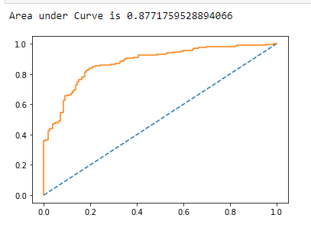
Conclusions on Adaptive Boosting model
TRAINING DATA.  - Accuracy : 85.76%  - AUC : 91.81%  - Precision : 89%  - Recall : 92%  - F1 score : 90% | TEST DATA  - Accuracy : 81.14%  - AUC : 87.71%  - Precision : 84%  - Recall : 89%  - F1 score : 96%
OVERALL SUMMARY
- Our test accuracy has dropped down to 81.14 % which is the least so far.
- The train accuracy has improved which is 85.76 %
- Overall the model has a good recall, precision and f1 score
- This model has performed slightly lesser than the other models on the test data.

P7. Evaluation of GRADIENT BOOST model
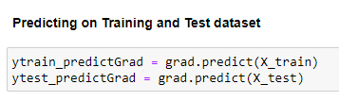
We have predicted our training and test data with our Gradient Boost model and now we will evaluate its performance.
Checking the Performance of our training data
- Confusion Matrix and Classification Report
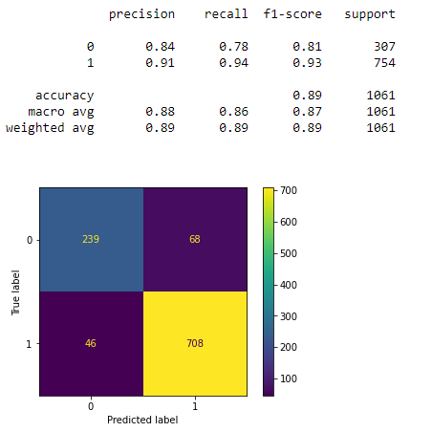
- Roc Curve and ROC_AUC score
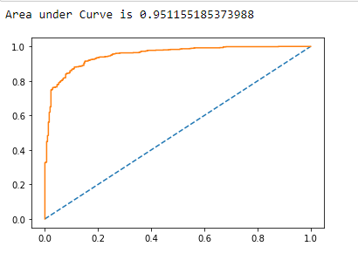
Checking the Performance of our testing data
- Confusion Matrix and Classification Report
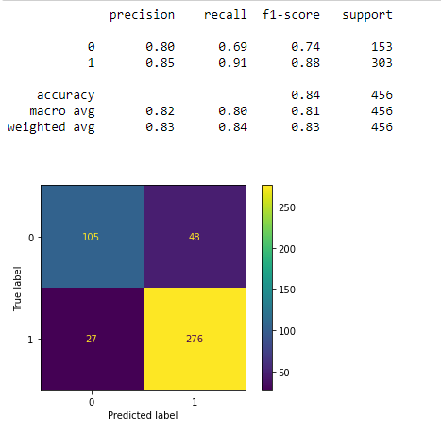
- Roc Curve and ROC_AUC score

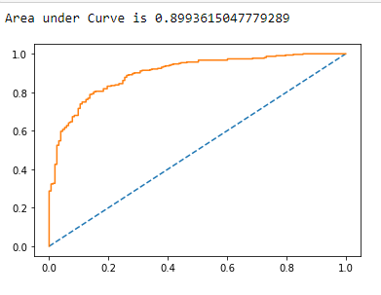
Conclusions on Gradient Boost model
TRAINING DATA.  - Accuracy : 89.25%  - AUC : 95.11%  - Precision : 91%  - Recall : 94%  - F1 score : 93% | TEST DATA  - Accuracy : 83.5%  - AUC : 89.93%  - Precision : 85%  - Recall : 91%  - F1 score : 98%

OVERALL SUMMARY
- Our test accuracy has increased to 83.5 % which is the best so far.
- The train accuracy has improved drastically which is 89.25 %
- Overall the model has a very high recall, precision and f1 score
- This model has performed the best out of all the models.
FINAL MODEL COMPARISON
- Comparison of the performance metrics from both models
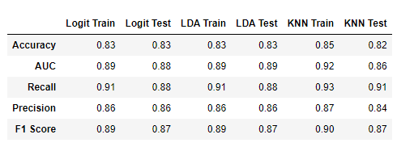
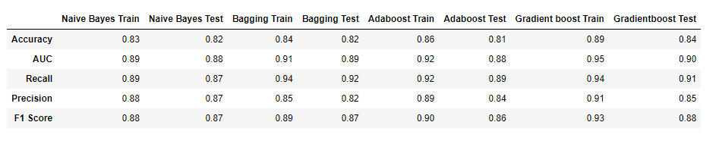

- ROC Curve for the 3 models on the Training data

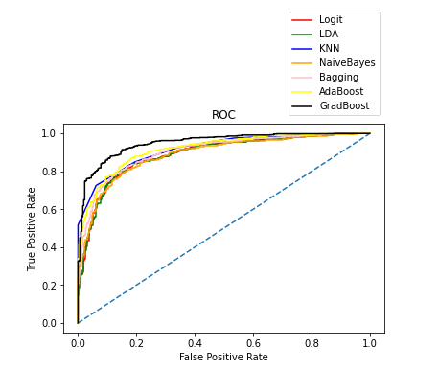
- ROC Curve for the 3 models on the Test data

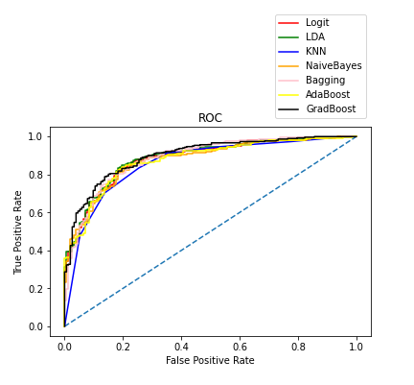
Conclusion:

- The test accuracy of all the models is around 82-84 %
- Gradient Boost model gives the best accuracy i.e. 84% on the test data with adaptive boosting performing the least.
- All models are giving very good recall, precision and accuracy score.
- Logistic Regression and LDA model shows overfitting of data with exactly same training and test results.

Final Model:
We have decided to go with the Gradient Boost Model as it has better f1 score, precision, accuracy and recall than all the other models.

INFERENCE
Q 1.8 Based on these predictions, what are the insights?

Inference:
- The gradient boost model gives us a 84% accuracy whereas adaptive boost model gives a 81 % accuracy.
- There is very minimal difference in the performance metrics of all the models with gradient boost on the higher side.
- Logistic regression and LDA model shows overfitting of data with exactly same train and test results.
- Overall recall value, precision and f1 score are very good for all the models.

The steps performed:
- We stored the data in a data frame and performed an Exploratory Data Analysis after which we could analyze the shape, size, statistics and basic info of our data.
- After EDA, we checked the data visually by generating univariate, bi and multivariate graphs and recognized patterns and anomalies.
- We dropped the Unnamed: 0 column as it was irrelevant.
- Checked the data for correlations of which we found that our data is not correlated.
- We had 2 object type data columns (vote and gender) which we have encoded through feature encoding for further modelling our data.
- Splitting of the data was performed into 70% train and 30% test.
- We have built 7 models: Logistic Regression, Linear Discriminant Analysis, K-nearest neighbors, Naïve Bayes (Gaussian), Bagging using Random Forest, Adaptive Boosting and Gradient Boosting Model.
- For model building, first we initialized them, predicted on train and test, predicted the probabilities, did model tuning using hyper parameters and then generated the performance metrics.
- Evaluated all models on their performance metrics and then drew a comparison for final conclusion.

Insights and recommendations:
- Hague score and Blair score seems to hold good value in predicting the votes. People who have given higher rating to Blair seem to have voted mostly for labor party.
- Other than this, economic national condition and Europe also has a good role in predicting votes.
- People with good economic national and household conditions have voted for labor party and the lower ones have voted for conservative party.
- People who are highly Eurosceptic have voted for conservative party.
- The parties should focus on the economic conditions of the voters in order to gain their confidence for votes.

Problem 2:

Executive Summary
In this particular project, we are going to work on the inaugural corpora from the nltk in Python. We will be looking at the following speeches of the Presidents of the United States of America:
- President Franklin D. Roosevelt in 1941
- President John F. Kennedy in 1961
- President Richard Nixon in 1973

INTRODUCTION
The purpose of this whole exercise is to analyze the text given to us i.e. the presidential speech of 3 presidents. We will be cleaning the text and taking out relevant data out of it. Further, we will find out the basic attributes of these speeches and find out the most occurring words to understand what they have talked about in their speeches.

Data Description

Here, we have the text document of speeches of the three presidents.

ANALYSIS

Q 2.1 Find the number of characters, words, and sentences for the mentioned documents.
We have imported inaugural speeches of all the US presidents using the Natural Language Toolkit Corpus. We can see that we’ve got the data of all the US presidents starting from Washington in 1789 to Trump in 2017.
First, we will be reading the Speech taken in 1941 by President Franklin D. Roosevelt by using <inaugural.raw> command which gives a raw format of the data.
- President Franklin D. Roosevelt Speech of 1941
His speech is stored in a file name “1941-Roosevelt.txt” from which we have extracted the raw text and then extracted the words out of it.
The first 5 sentences of his speech looks like this.
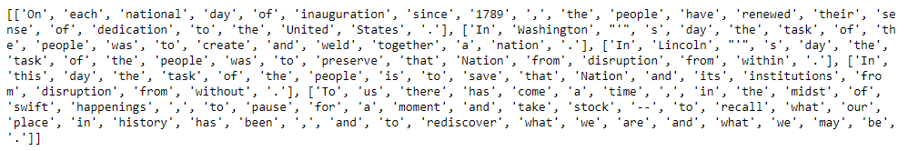
Checking the number of characters, words and sentences in Roosevelt’s Speech
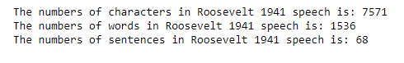
- President John F. Kennedy Speech of 1961
His speech is stored in a file name “1961-Kennedy.txt” from which we have extracted the raw text and then extracted the words out of it.
The first 5 sentences of his speech looks like this.
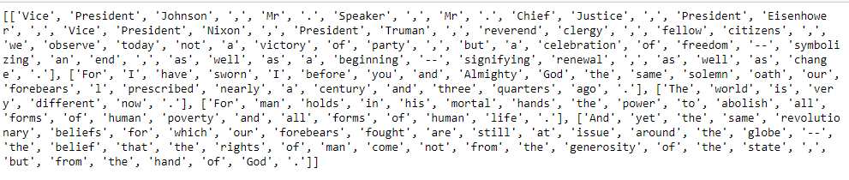
Checking the number of characters, words and sentences in Kennedy’s Speech
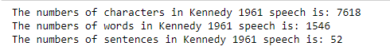
- President Richard Nixon Speech of 1973
His speech is stored in a file name “1973-Nixon.txt” from which we have extracted the raw text and then extracted the words out of it.
The first 5 sentences of his speech looks like this.
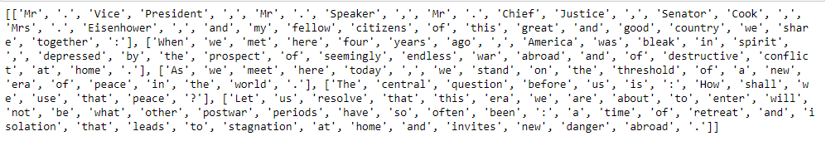
Checking the number of characters, words and sentences in Nixon’s Speech
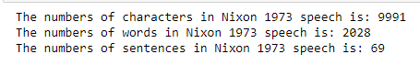

Q 2.2 Remove all the stopwords from all three speeches.
Now, we’ve got our speech broken down into words, we can start doing some basic pre-processing and cleaning on it.
We will be applying the following steps on all the three speeches one by one.
Step 1: Convert our document into lower case.
Step 2: Removing the special characters (/@$: etc.)
Step 3: Performing Tokenization
Tokenizing involves splitting sentences and words from the body of the text.
Step 4: Removing Stop Words
Often there are words and punctuation that are repeated more often than others and they don’t usually give us more information about the data. Nltk already has a small list of words like this, and they are called stopwords.eg. to, of, how, let, etc.
Step 5: Stemming using Lemmatizer
Stemming is the process of producing morphological variants of a root/base word. A stemming algorithm reduces the words “chocolates”, “chocolatey”, “choco” to the root word, “chocolate” and “retrieval”, “retrieved”, “retrieves” reduce to the stem “retrieve”. We will be using Lemmatizer which is an algorithm for stemming.
Step 6: Check Frequency Distribution
PRE-PROCESSING/CLEANING ALL THE THREE SPEECHES:
- President Franklin D. Roosevelt Speech of 1941
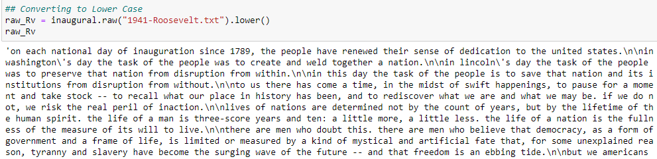
Here, we have converted our text to lower case first. It is visible that we have not yet extracted words out of our text.
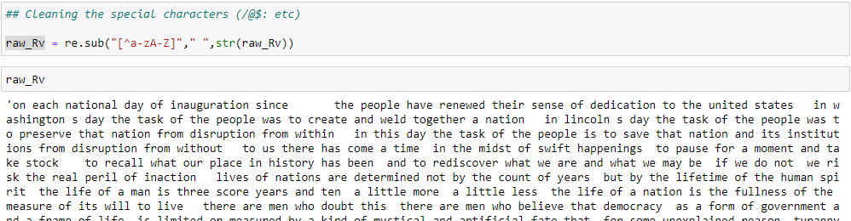
As compared to the previous image, we can see here that only words are left and rest all special characters or numbers have been removed.
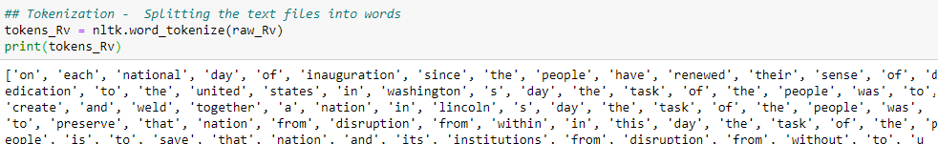
Now we have tokenized the complete text document and converted them into tokens. Each word is a token when a sentence is “tokenized” into words. Each sentence can also be a token, if you tokenized the sentences out of a paragraph.
Here, we have tokenized our document into words.
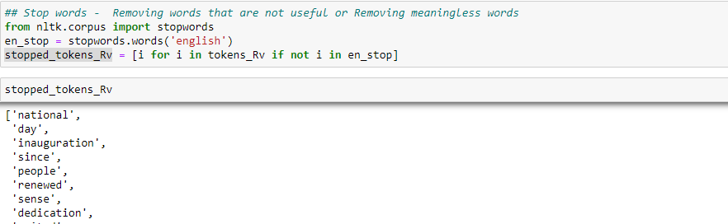
Now, we have removed the stopwords from these tokens.
It can be seen that words like (on, each, of, the, have and their) have been removed from the first sentence of our speech and similarly from other sentences as well. These words carry least importance in our speech and are just helping in forming the sentences.
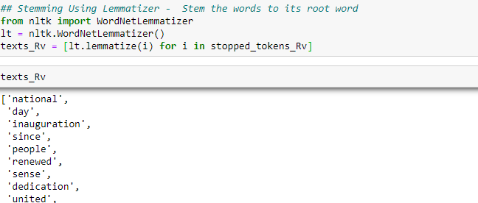
We have used lemmatizer because it reduces or links the words to its root but represents it using the original word only.
On checking the top 15 frequently occurring words we could figure out that words like (know, u) have occurred multiple times but hold no importance.
Therefore, we will add them to stop words list and remove them.
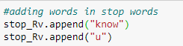
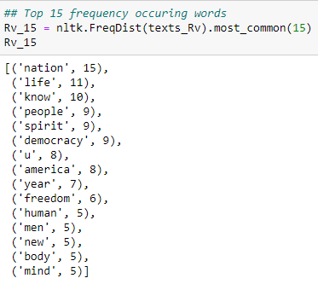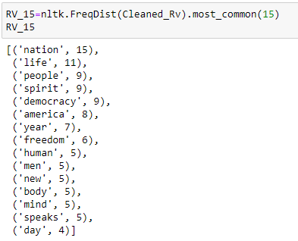
Right image shows the top 15 frequently occurring words after removing know and u.
Therefore, we have successfully cleaned our data and removed the stopwords.
- President John F. Kennedy Speech of 1961
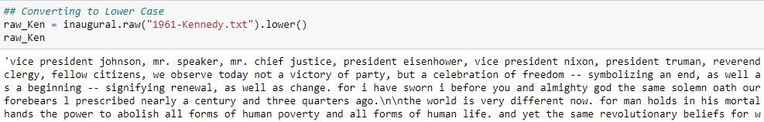
Here, we have converted our text to lower case first. It is visible that we have not yet extracted words out of our text.
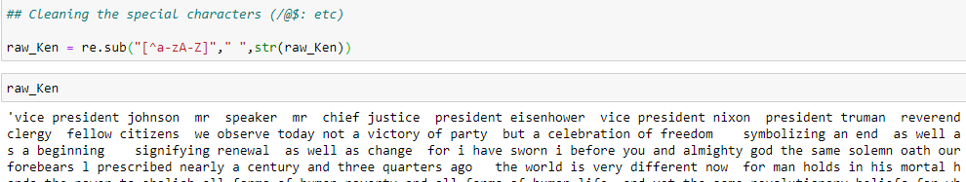
As compared to the previous image, we can see here that only words are left and rest all special characters or numbers have been removed.
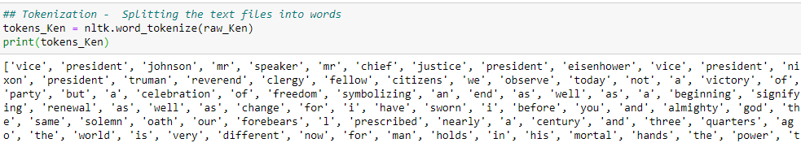
Now we have tokenized the complete text document and converted them into tokens using words.
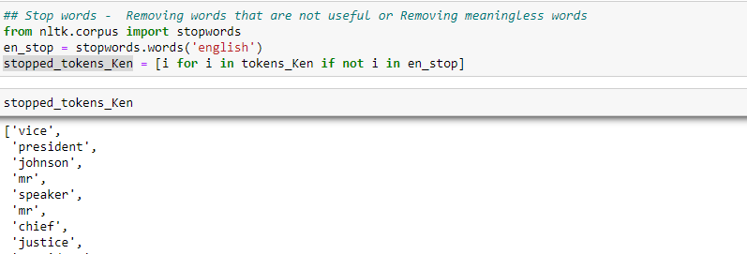
Now, we have removed the stopwords from these tokens.
It can be seen that words like (not, a) have been removed from the second sentence of our speech and similarly from other sentences as well. These words carry least importance in our speech and are just helping in forming the sentences.
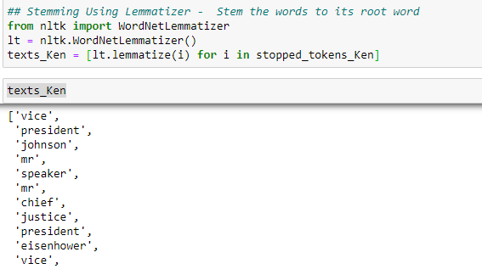
We have used lemmatizer because it reduces or links the words to its root but represents it using the original word only.
On checking the top 15 frequently occurring words we could figure out that words like (let, u) have occurred multiple times but hold no importance.
Therefore, we will add them to stop words list and remove them.
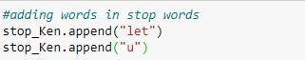
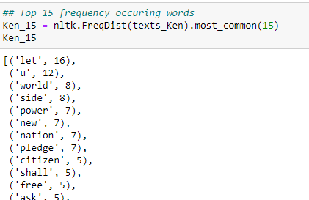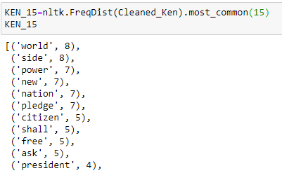
Right image shows the top 15 frequently occurring words after removing let and u.
Therefore, we have successfully cleaned our data and removed the stopwords.
- President Richard Nixon Speech of 1973
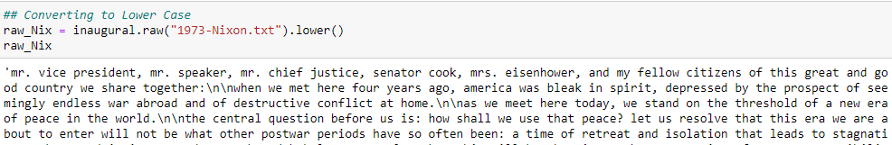
Here, we have converted our text to lower case first. It is visible that we have not yet extracted words out of our text.
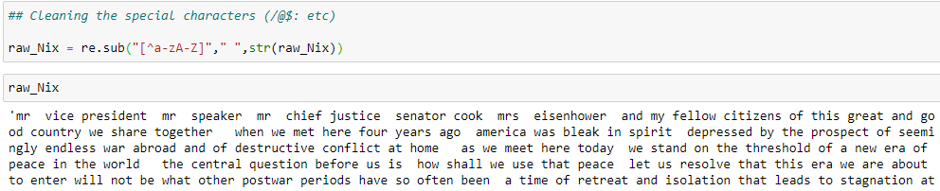
As compared to the previous image, we can see here that only words are left and rest all special characters or numbers have been removed.
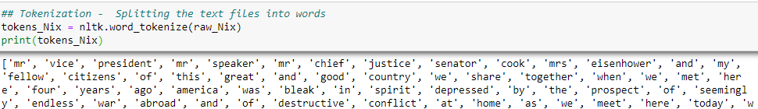
Now we have tokenized the complete text document and converted them into tokens using words.
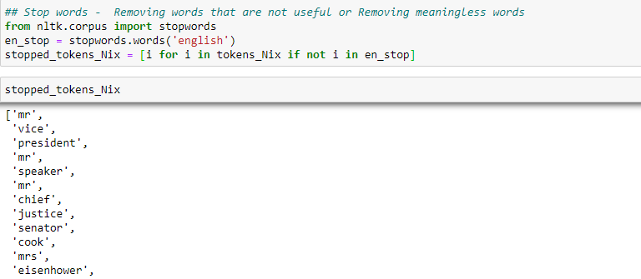
Now, we have removed the stopwords from these tokens.
It can be seen that words like (and, my) have been removed from the first sentence of our speech and similarly from other sentences as well. These words carry least importance in our speech and are just helping in forming the sentences.
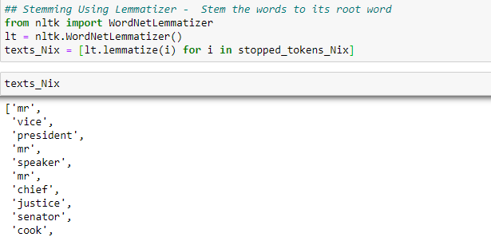
On checking the top 15 frequently occurring words we could figure out that words like (let, u) have occurred multiple times but hold no importance.
Therefore, we will add them to stop words list and remove them.

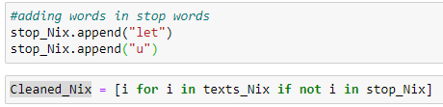
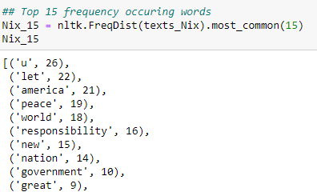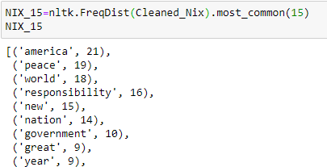
Right image shows the top 15 frequently occurring words after removing let and u.
Therefore, we have successfully cleaned our data and removed the stopwords.

Q 2.3 Which word occurs the most number of times in his inaugural address for each president? Mention the top three words. (After removing the stopwords)
In order to check the words that occurs the most time in the inaugural address of all the three President’s, we need to check the Frequency distribution of the text. This will tell us how many times does a particular word comes up. Plus it’s already arranged in the decreasing order.
- President Franklin D. Roosevelt Speech of 1941
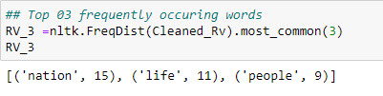
These are the top 3 words in President Roosevelt’s 1941 Speech.
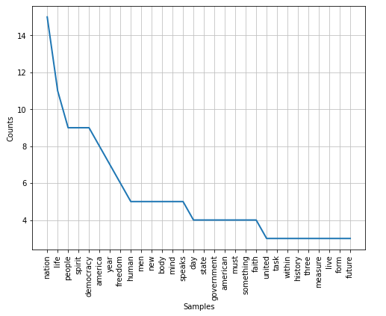
The previous graph displays the frequency distribution of top 30 words occurring frequently.
Now, we will be plotting a Lexical Dispersion of words nation, life and people in the Speech document. Lexical dispersion is a measure of how frequently a word appears across the parts of a corpus.
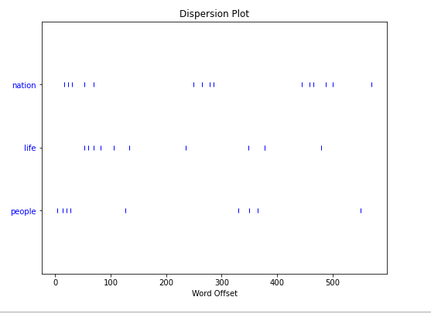
This dispersion shows that all the 3 words have been used throughout the speech and not in only a particular part of his speech.
- President John F. Kennedy Speech of 1961
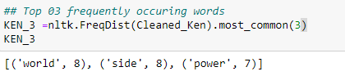
These are the top 3 words in President Kennedy’s 1961 Speech.
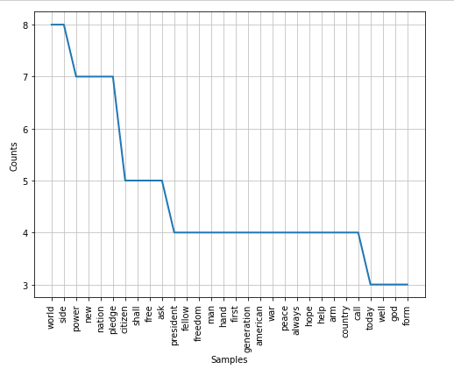
The previous graph displays the frequency distribution of top 30 words occurring frequently.
Now, we will be plotting a Lexical Dispersion of words world, side and power in the Speech document.
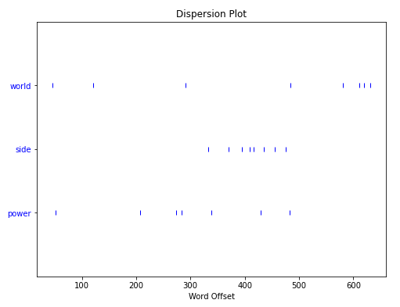
This dispersion shows that President Kennedy has talked about side in the middle part of his speech and world and power have been used throughout.
- President Richard Nixon Speech of 1973
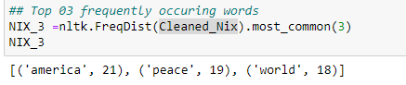
These are the top 3 words in President Nixon’s 1973 Speech.
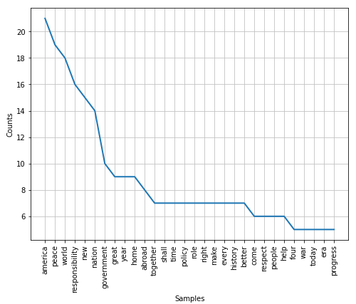
The previous graph displays the frequency distribution of top 30 words occurring frequently.
Now, we will be plotting a Lexical Dispersion of words America, peace and world in the Speech document.
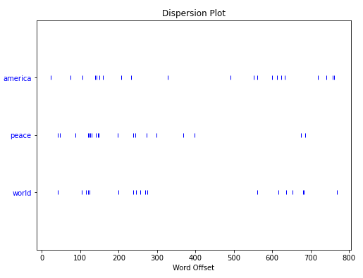
This dispersion shows that President Kennedy has talked about peace in the first part of his speech and world and America have been used throughout.

Q 2.4 Plot the word cloud of each of the speeches of the variable. (After removing the stopwords)

Word clouds (also known as text clouds or tag clouds) work in a simple way: the more a specific word appears in a source of textual data (such as a speech, blog post, or database), the bigger and bolder it appears in the word cloud.
A word cloud is a collection, or cluster, of words depicted in different sizes. The bigger and bolder the word appears, the more often it’s mentioned within a given text and the more important it is.
Tags are usually single words, and the importance of each tag is shown with font size or color.

We have already cleaned our data by removing stopwords, stemming, removing special characters, removing numbers and converting our text to lowercase.
Hence, now we will form a word cloud of the three President’s Speeches in order to visually represent the weightage and importance of each word in the speech.

- President Franklin D. Roosevelt Speech of 1941
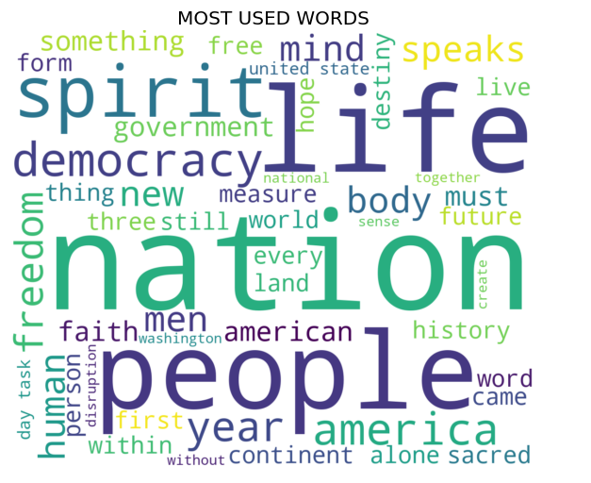
We can see the top 3 words which were nation, life and people are boldly visible to carry the most importance.
- President John F. Kennedy Speech of 1961
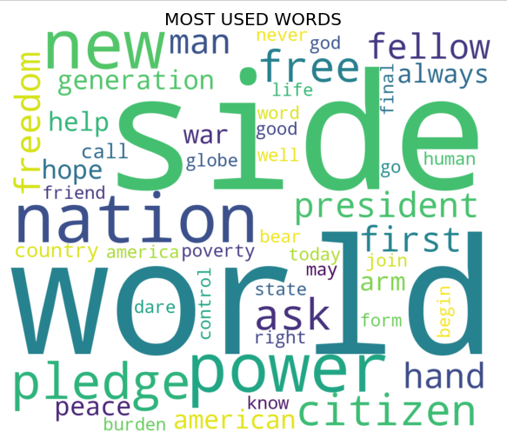
We can see the top 3 words which were world, side and power are boldly visible to carry the most importance.
- President Richard Nixon Speech of 1973


We can see the top 3 words which were America, peace and world are boldly visible to carry the most importance.

THE END

