Data Mining Analysis
(breast-cancer data)
Deepta B S ^{i},Harshitha Shreeka ^{i},Harshitha S S ^{i}

i) Department of Information Science
PES Institute of Technology
Bangalore, India

- Abstract— The aim of the project is to get the best attribute set to mine association rules. Weka learning tool is used for this purpose. The paper will concentrate on how to select the most effective feature from the feature vector. Subset evaluator is being used to find the most effective subset of attributes.
- Keywords – Data Mining, Classification, Feature set, Naive Bayesian, Decision Trees, Apriori.

Introduction
Data mining is a process of analyzing data from different perspectives and summarizing it into useful information. This paper illustrates comparative study of different data mining techniques like Apriori, Naïve Bayes classifier, this study helps us to decide the best subset for data analysis. Subsets are generated both in wrapper method and by ranking algorithm. Data set is divided into test and training sets thus comparing the results of both cases.
This can be achieved by using WEKA (Waikato Environment for Knowledge Analysis) which is a workbench that contains a collection of visualization tools and algorithms for data analysis and predictive modeling on a data set.

II. DATA SET DESCRIPTION

In the project, Weka is used to diagnose cancer Wisconsin dataset. To be consistent , 16 instances with missing values are removed from the dataset to construct a new dataset with 683 instances.
Brief information from the UC Irvine machine learning repository:
Located in breast-cancer-Wisconsin sub-directory, filenames root: breast-cancer-Wisconsin.
- Currently contains 699 instances.
- 2 classes (malignant and benign).
- 9 integer-valued attributes.

PREPROCESSING DATA
- Missing attribute values: 16
- There are 16 instances in Groups 1 to 6 that contain a single missing (i.e., unavailable) attribute value, now denoted by "?".
Class distribution:
- Benign: 458 (65.5%)
- Malignant: 241 (34.5%)
Now, to perform all the algorithms, the attributes should be converted to nominal. Hence, NumericToNominal filter is applied.

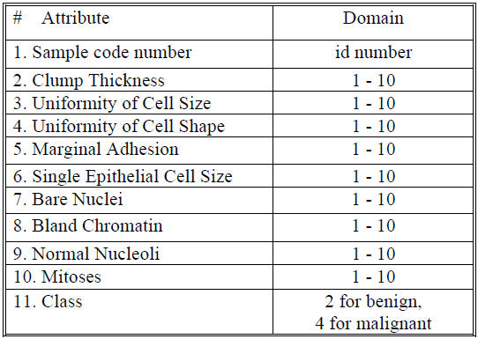
Fig 3.1-Attribute information

IV. Literature Survey

Classification

Classiﬁcation is a form of data analysis that extracts models describing important data classes. Such models, called classiﬁers, are used to predict categorical class labels. For example, we can build a classiﬁcation model to categorize the attribute sets into being acc(acceptable), unacc(unacceptable), good or vgood(very good). Such analysis can help provide us with a better understanding of the data at large.

- Decision trees:
Decision tree builds classification models in the form of a tree structure. It breaks down a dataset into smaller and smaller subsets while at the same time an associated decision tree is incrementally developed. The final result is a tree with decision nodes and leaf nodes. A decision node has two or more branches. Leaf node represents a classification or decision. The topmost decision node in a tree which corresponds to the best predictor called root node. Decision trees can handle both categorical and numerical data.
These trees can be used to predict the ‘class’ label for the attribute sets based on the training model that is built. A portion of the decision tree built using the buying and maintenance is shown below.

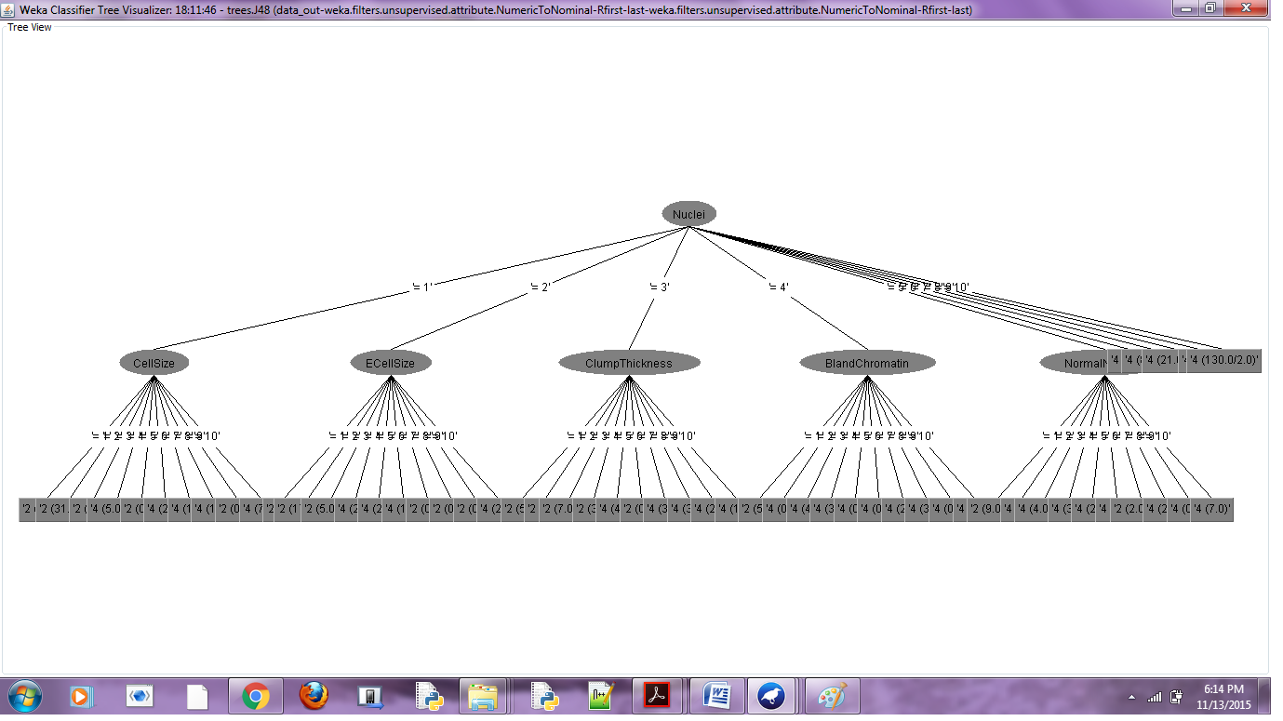
Fig 4.1-Decision tree

- Naïve Bayes classification
Bayesian classiﬁers are used to predict class membership probabilities such as the probability that a given tuple belongs to a particular class. Bayesian classiﬁcation is based on Bayes’ theorem. Naïve Bayesian classiﬁers assume that the effect of an attribute value on a given class is independent of the values of the other attributes. This assumption is called class conditional independence.

Let X be a data tuple. In Bayesian terms, X is considered “evidence.” Let H be some hypothesis such as that the data tuple X belongs to a speciﬁed class C. For classiﬁcation problems, we want to determine P(H|X), the probability that the hypothesis H holds given the “evidence” or observed data tuple X. Bayes’ theorem is useful in that it provides a way of calculating the posterior probability, P(H|X), from P(H), P(X|H), and P(X).
Bayes’ theorem is
P(H|X)= P(X|H)P(H)
P(X)
The naïve Bayesian classifier works as follows: Let D be a training set of tuples and their associated class labels. Each tuple is represented by a n dimensional attribute vector, X = (x1,x2,…,xn), depicting n measurements made on the tuple from n attributes, respectively, A1, A2, … , An. Suppose that there are m classes, C1, C2,.…, Cm. Given a tuple, X, the classifier will predict that X belongs to the class having the highest posterior probability, conditioned on X. That is, the Naïve Bayesian classifier predicts that tuple X belongs to the class Ci if and only if
P(Ci|X) > P(Cj|X) for 1 ≤ j ≤ m; j ≠ i

There are two methods for feature selection
- Filter method
- Wrapper method

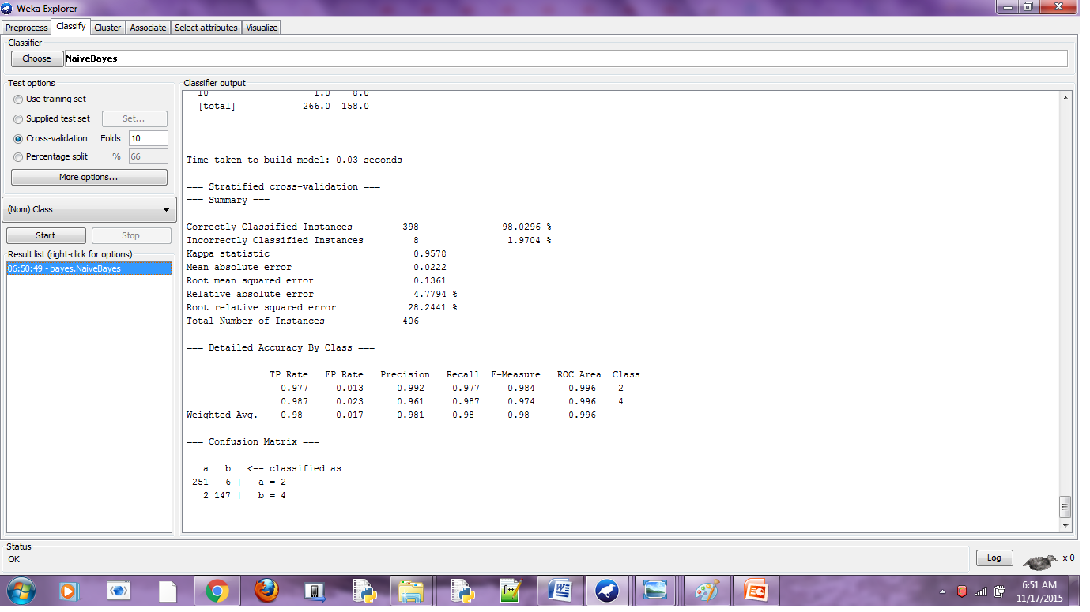
Fig 4.2-Naïve bayes result – training set

Wrapper Method
- This will create all possible subsets from the feature vector available.
- Then it will use classification algorithm to induce classifier from features in each subset
- It will consider the subset of features with which the classification algorithm performs the best.
To find subset the evaluator will use
A search technique (random search, breadth first search, depth first search or a hybrid search)

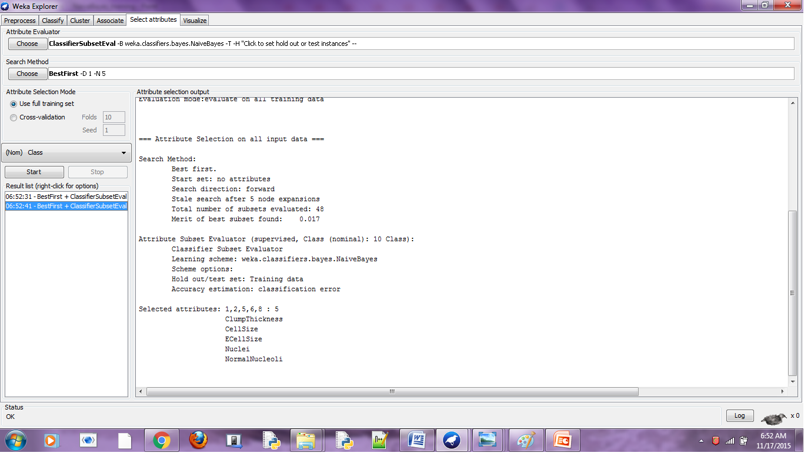
Fig 4.2.1-Classifier Subset evaluation-Training

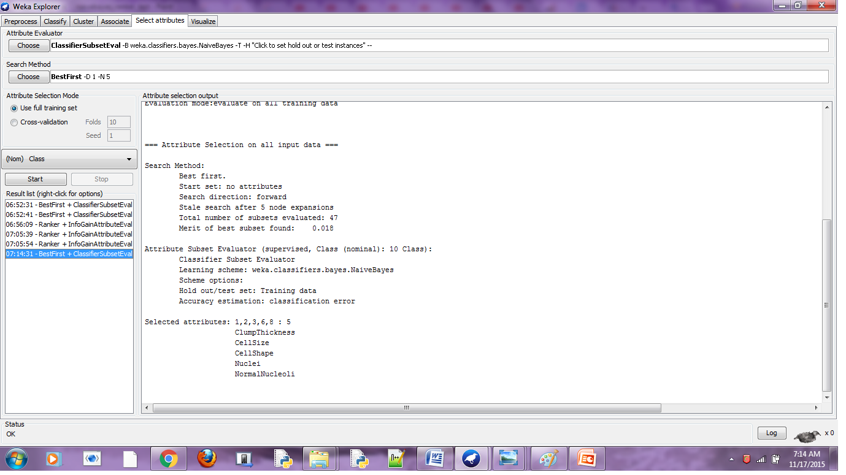
Fig 4.2.2-Classifier Subset evaluation-Test

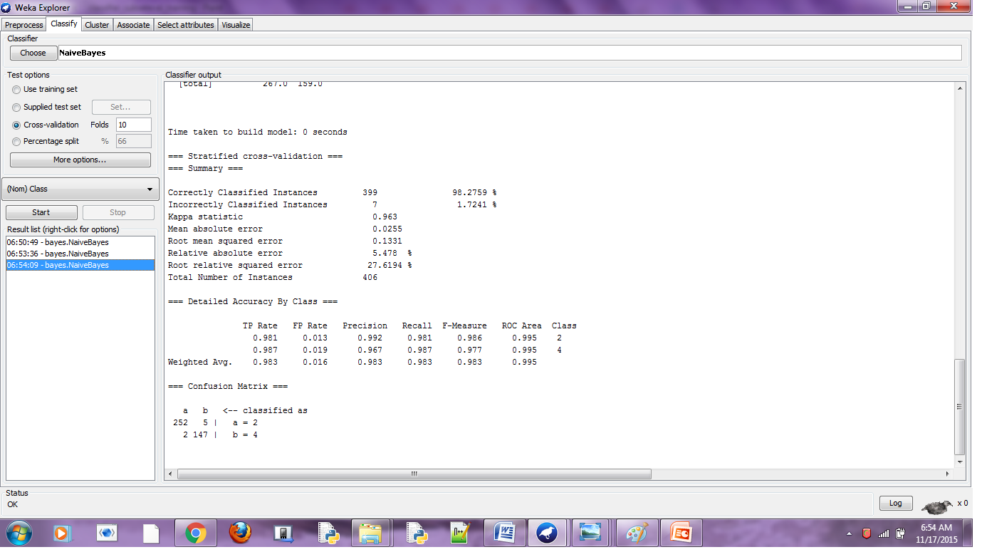
Fig 4.2.3-Naïve Bayes Best attribute-training

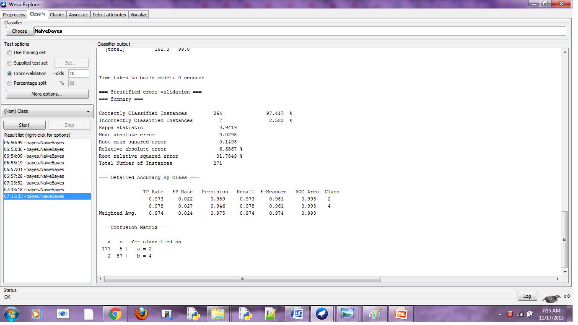
Fig 4.2.4-Naïve Bayes Best attribute-test

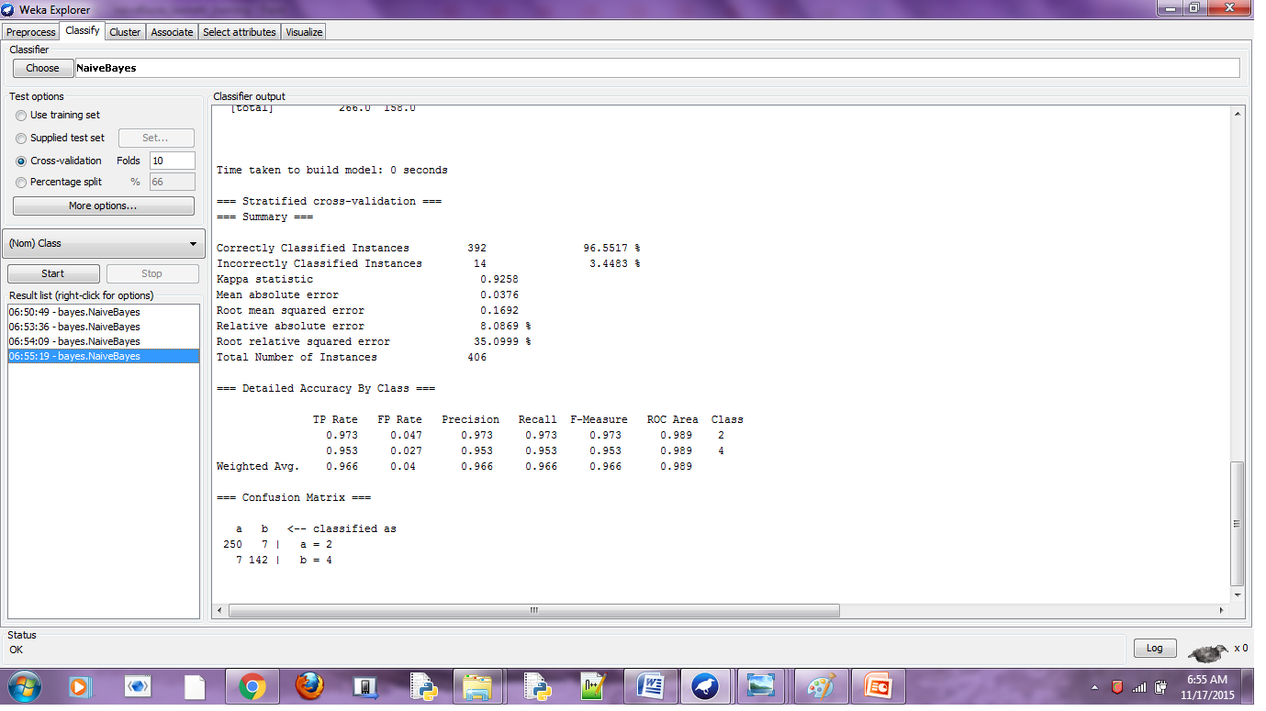
Fig 4.2.5-Naïve Bayes Random attributes-training

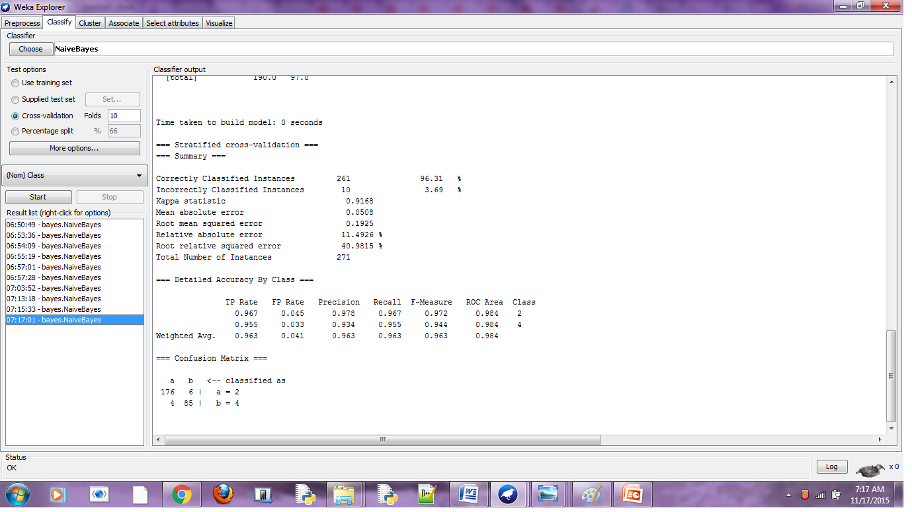
Fig 4.2.6-Naïve Bayes Random attributes-Test

Observation:
On observing the performance measures like F-measure, precision and recall, we can see that for the feature vector containing the best suited attributes for classification give better performance measures than those with random attributes in the feature vector. We can also see that this is the case in both the sets, training and test.

Filter Method
- Use an attribute evaluator and a ranker to rank all the features in your dataset
- The number of features to be selected from the feature set can always be defined
- Omit the feature one at a time that have lower ranks and see the predictive accuracy of the classification algorithm.
- Weights put by the ranker algorithms are different than those by the classification algorithm

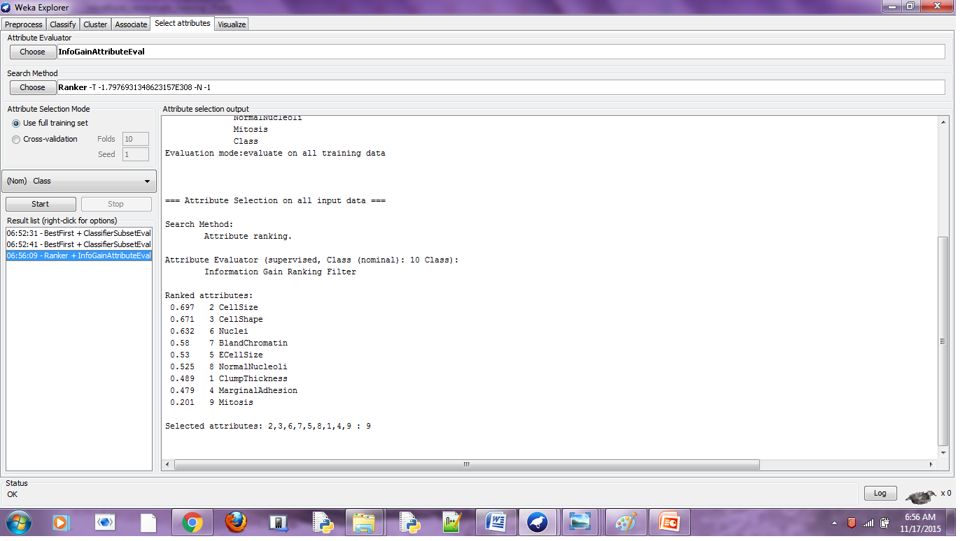
Fig 4.2.7- Classifier Subset Using Ranking method-Training

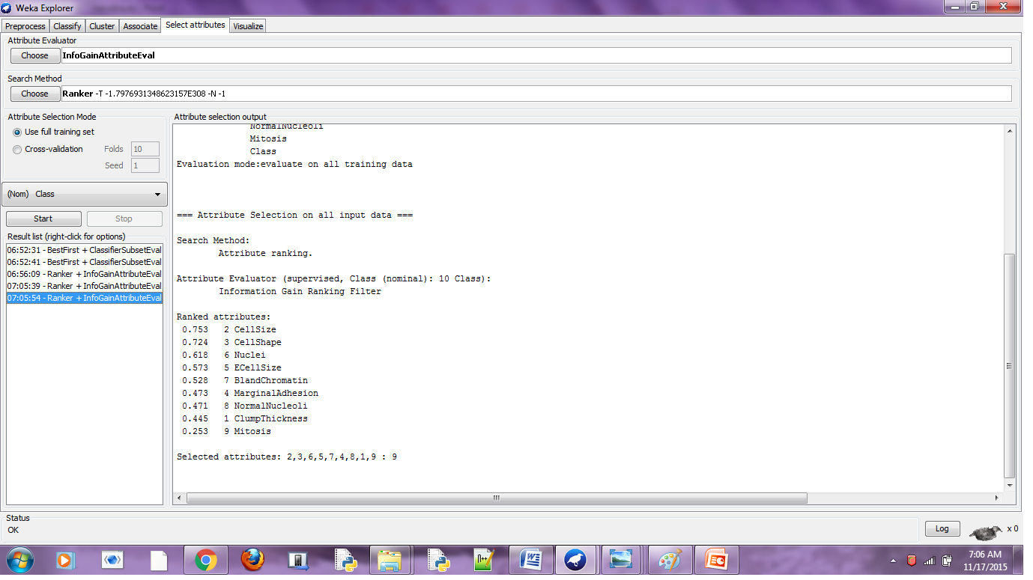
Fig 4.2.8-Classifier subset using ranking method-Test

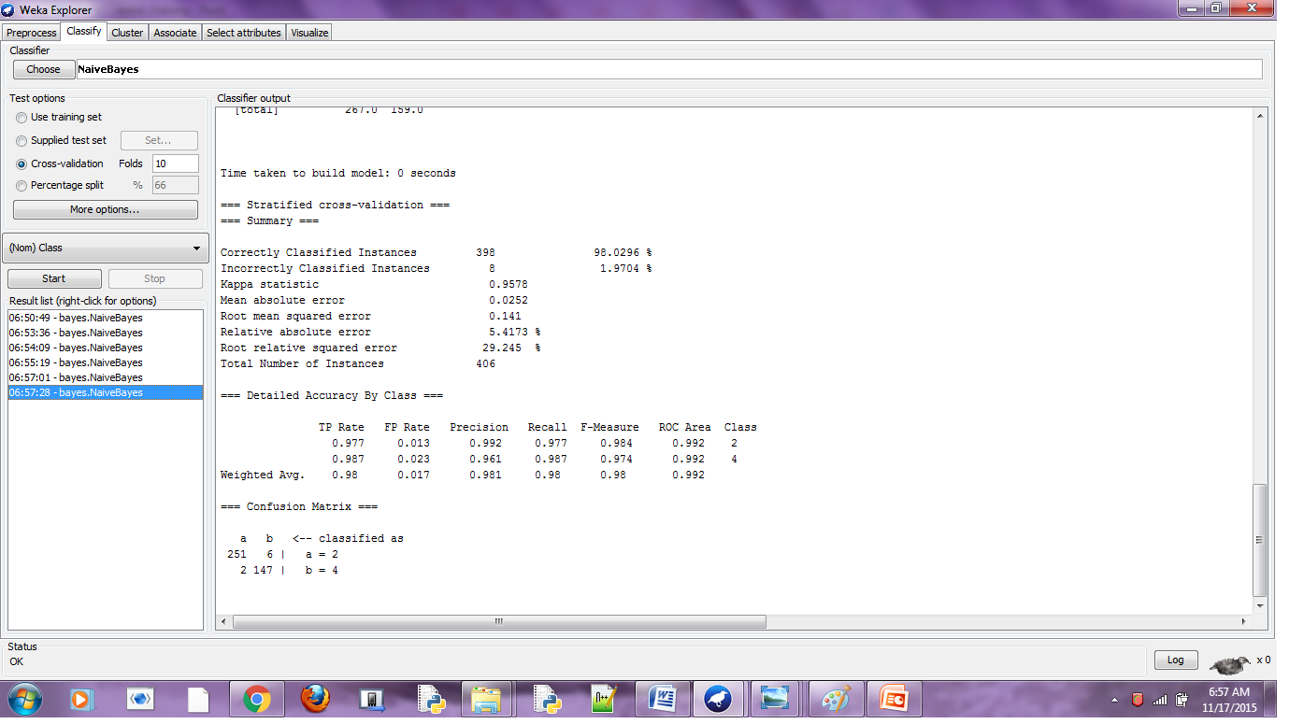
Fig 4.2.9- Naïve Bayes Best attributes-training

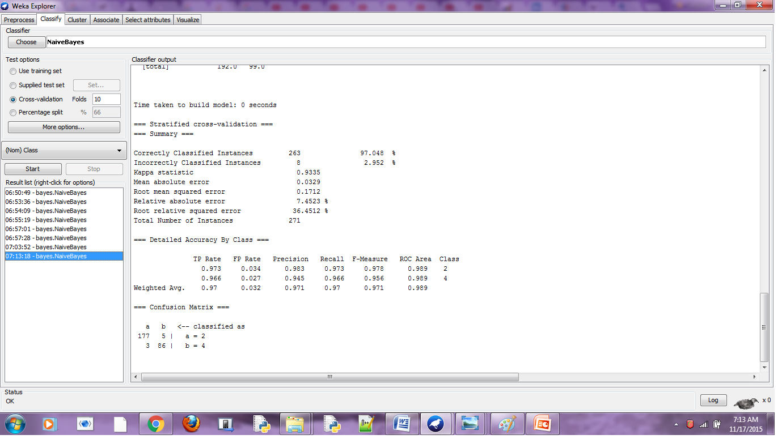
Fig 4.2.10-Naïve Bayes Best attributes-test

Observation:
On observing the performance measures like F-measure, precision and recall, we can see that for the feature vector containing the best suited attributes for classification give better performance measures than those with random attributes in the feature vector. We can also see that this is the case in both the sets, training and test.

- Association Rule Mining (Apriori)
- Find all frequent item sets: each of these item sets will occur at least as frequently as predetermined minimum support count (Apriori Algorithm).
- Generate strong association rules from the item sets: The rules must satisfy minimum support and confidence. These rules are called Strong Rules.

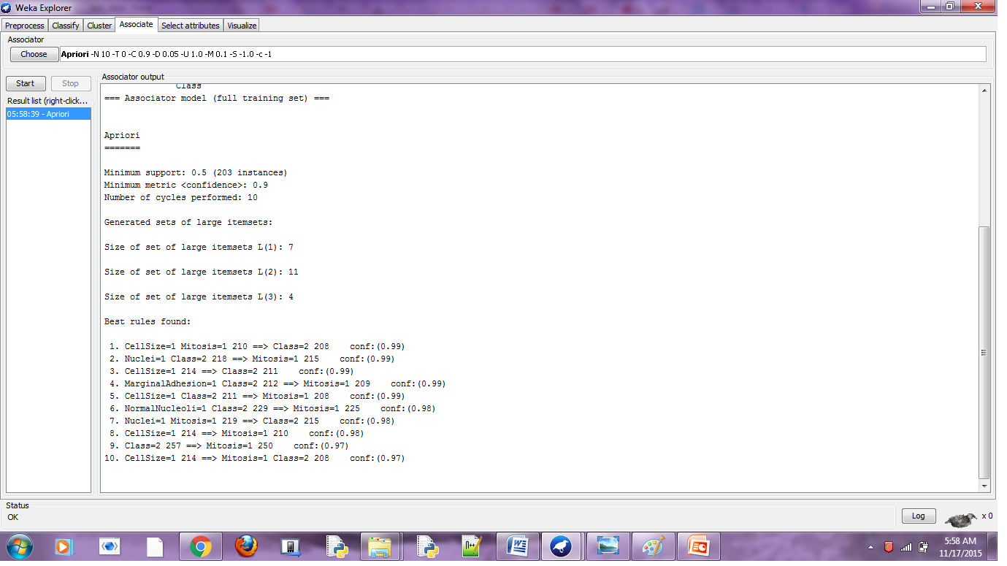
Fig 4.3.1 Apriori-Training set
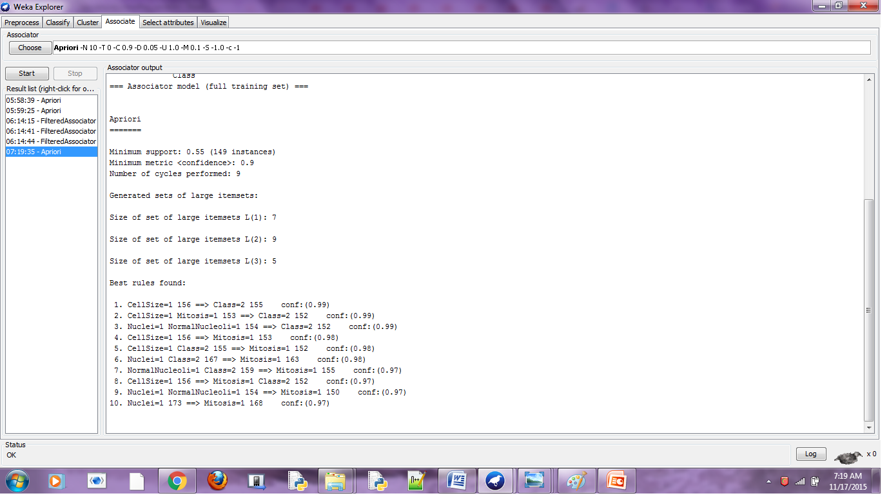
Fig 4.3.2 Apriori-Test set

V. CONCLUSION

On comparing Naives Bayes classification for Ranking and Best Fit, omission of too many lower ranked attributes will result in over fit. Hence, only up to a certain percentage of inconsistency is allowed. The performance measures Precision, F-Measure and Recall of Naives Bayes classification has improved as a result of Feature Selection.

Acknowledgment

The group would like to express their deep appreciation
and indebtedness to Dr Mamatha H R for her constant
guidance, Dr KNB Murthy and PES Institute of Technology
for providing with the opportunity for this case presentation.

References
- Jung-Ying-Wang, “Data Mining analysis(breast-cancer data)”, D9115007, May 2003. (references)
- UCI Ivrine Machine Leraning repository – archive.ics.uci.edu
- Classification into Training and test data, Data dimensionality, feature selection from weka Tutorial-Youtube.

