Bank Management System
ER Diagram and Overview | CSE3001 Database Management Systems

1. Overview
The database models the core operations of a bank: customers open accounts at branches, accounts record deposit and withdrawal transactions, and customers can take loans that are repaid in instalments. Employees work at branches and report to a manager. The design has 7 entities, and every relationship is one-to-many (1:N).

2. ER Diagram
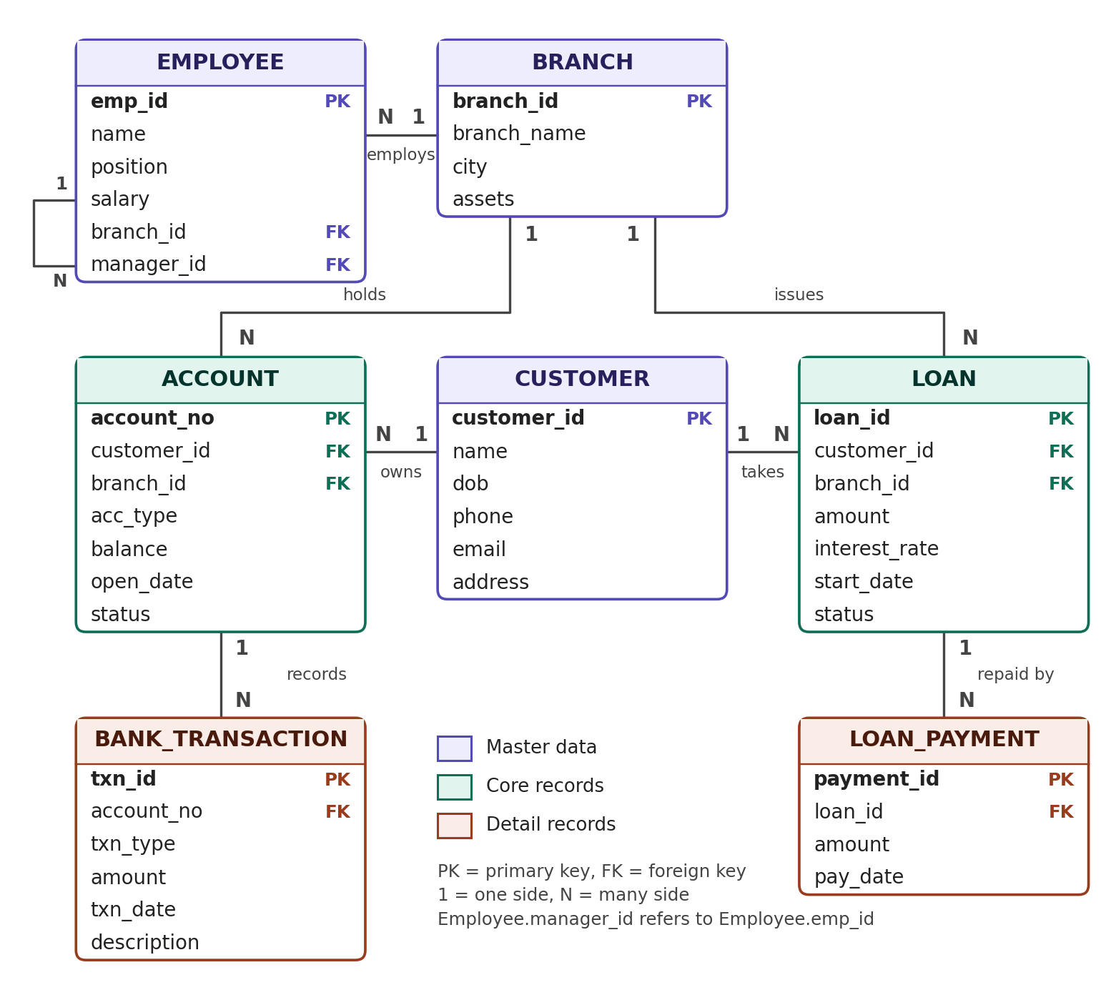
Figure 1: ER diagram of the bank management system (Crow's Foot style, 1 = one side, N = many side).

3. Entities
Entity | Description | Primary key
Branch | Physical bank branch with its city and total assets | branch_id
Customer | Person who banks with the institution | customer_id
Employee | Staff member working at a branch; may manage others | emp_id
Account | Savings, current or fixed account with balance and status | account_no
Bank_Transaction | Each deposit or withdrawal on an account | txn_id
Loan | Loan taken by a customer from a branch | loan_id
Loan_Payment | Repayment made against a loan | payment_id

4. Relationships
Relationship | Cardinality | Implemented by (foreign key)
Branch employs Employee | 1 : N | Employee.branch_id
Branch holds Account | 1 : N | Account.branch_id
Branch issues Loan | 1 : N | Loan.branch_id
Customer owns Account | 1 : N | Account.customer_id
Customer takes Loan | 1 : N | Loan.customer_id
Account records Bank_Transaction | 1 : N | Bank_Transaction.account_no
Loan is repaid by Loan_Payment | 1 : N | Loan_Payment.loan_id (ON DELETE CASCADE)
Employee manages Employee (recursive) | 1 : N | Employee.manager_id

5. Design notes
- Customer and Branch are not linked directly; they connect through Account and Loan, which avoids redundant data.
- Loan_Payment depends on Loan, so payments are deleted automatically when the loan is deleted (ON DELETE CASCADE).
- Recursive relationship: Employee.manager_id points to Employee.emp_id, so one employee can manage many others.
- Integrity: primary keys, foreign keys, CHECK constraints (account type, status, amount > 0, balance >= 0), UNIQUE phone and email, NOT NULL and DEFAULT values.
- Account_Audit is a log table filled by a trigger; it has no foreign keys, so it is not part of the ER diagram.
- Limitation: one customer per account (no joint accounts). A bridge table such as Account_Holder would add many-to-many support.

